Chapter 7 – Point Estimation of Parameters and Sampling Distributions

Sampling Distributions and the Central Limit Theorem
Random Sample
The random variables X₁, X₂, … , X_{n} are a random sample of size n if (a) the X_{i}’s are independent random variables and (b) every X_{i} has the same probability distribution.
A population that has an unknown probability distribution, the sampling distribution of the sample mean will still be approximately normal with mean 𝜇 and variance ${σ^{2}}/n$ if the sample size 𝑛 is large.
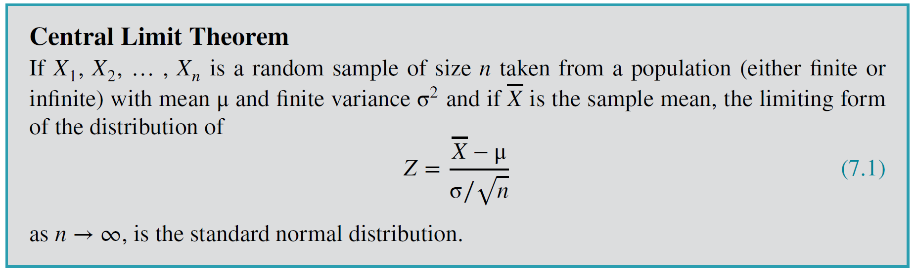

Example
Consider, the lognormal distribution has parameters θ = 2 (location parameter) and ω = 0.75 (scale parameter), resulting in mean $μ = 9.79$and standard deviation $σ = 8.51$. | 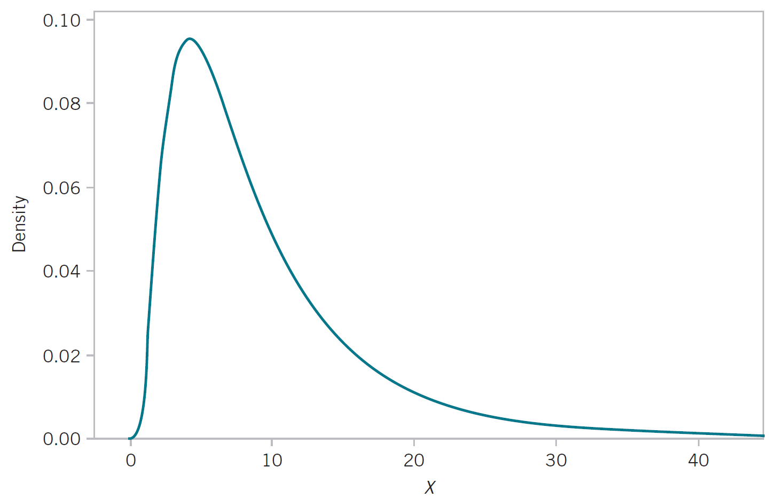

20 random samples with $n=10$ were drawn from the population
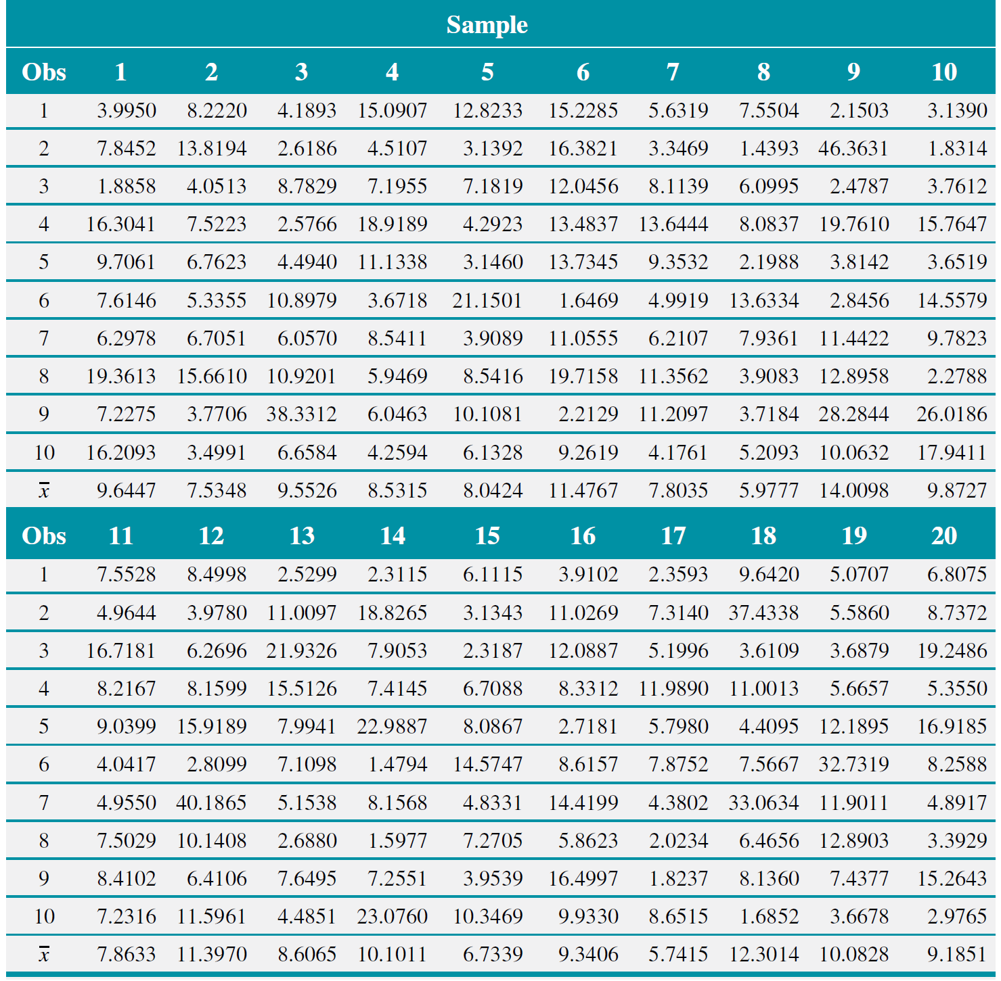
Normal Probability Plot
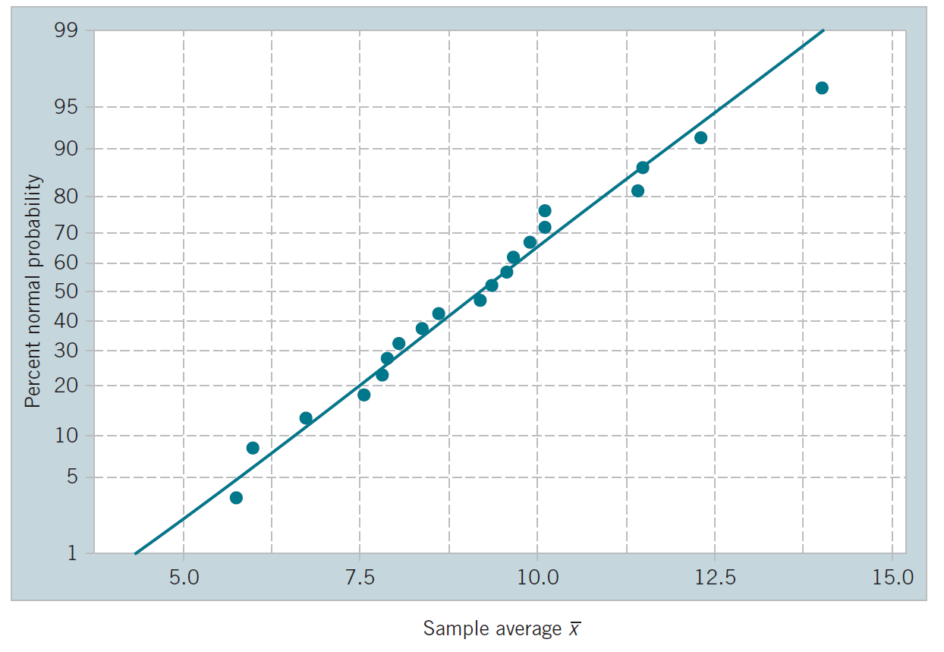

Example
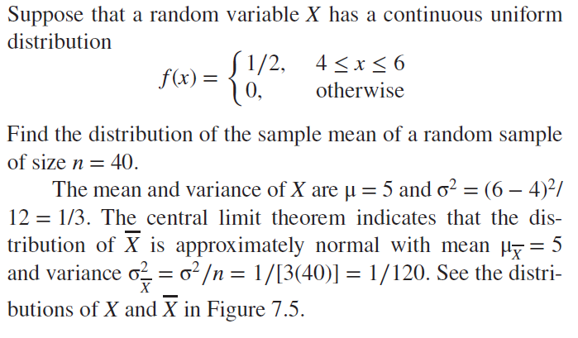 | 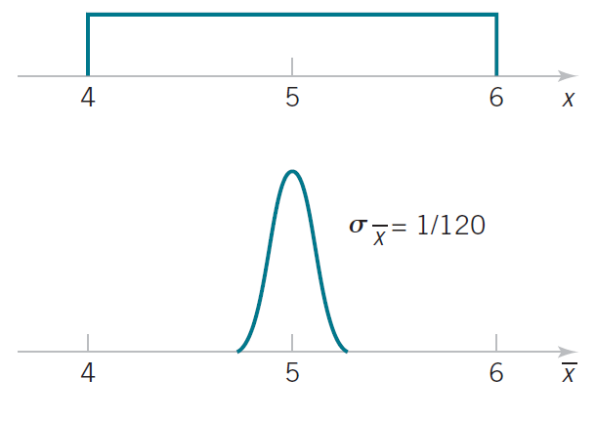

Example:
An electronics company manufactures resistors that have a mean resistance of 100 ohms and a standard deviation of 10 ohms. The distribution of resistance is normal. Find the probability that a random sample of n = 25 resistors will have an average resistance of fewer than 95 ohms.
Solution
Given, $μ_{\overline{X}}=100, σ_{\overline{X}}=\frac{σ}{\sqrt{n}}=\frac{10}{\sqrt{25}}=2$
$$P\left(\overline{X}<95\right)=P\left(Z<\frac{95-100}{2}\right)$$
$$=P\left(Z<-2.5\right)=Φ\left(-2.5\right)=0.0062$$
Interpretation: If the distribution of resistance is normal with mean 100 ohms and standard deviation of 10 ohms, finding a random sample of resistors with a sample mean less than 95 ohms is a rare event. If this actually happens, it casts doubt as to whether the true mean is really 100 ohms or if the true standard deviation is really 10 ohms.

