Chapter 5 – Joint Probability Distributions, Part 1
In Class Worksheet
Contents
1 Joint Probability Distributions for Two Random Variables 2
1.1 Introduction 2
1.2 Example 3
1.3 Marginal Probability Distributions 4
1.4 Example 4
1.5 Marginal Distribution Expectation 5
1.6 Example 5
1.7 Marginal Distribution Variance 6
1.8 Example 6
2 Conditional Probability Distributions and Independence 7
2.1 Example 7

A hardcopy of this handout is provided in class. I will work these problems on the board as we discuss the concepts.

Joint Probability Distributions for Two Random Variables

Introduction
Joint Probability Mass Function – If X and Y are discrete random variables, the joint distribution of X and Y is:
$$f\left(x,y\right)=P(X=x, Y=y)$$
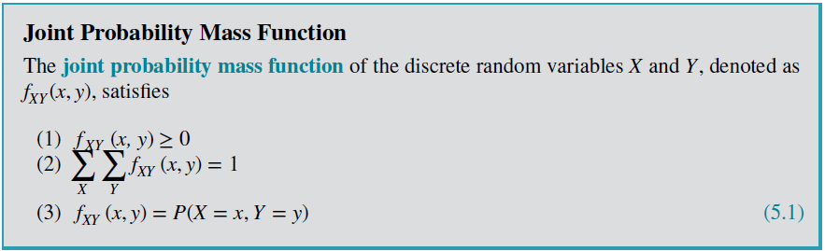

Example
The response time is the speed of page downloads and it is critical for a mobile Web site. As the response time increases, customers become more frustrated and potentially abandon the site for a competitive one.

- Let X denote the number of bars of service, and
- Let Y denote the response time (to the nearest second) for a particular user and site.

The table below is the joint distribution of X and Y.
The range of the random variables (X, Y) is the set of points (x, y) in two-dimensional space for which the probability that X = x and Y = y is positive.
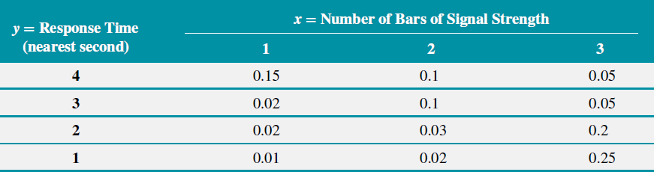
Some sample probability questions:
- What is the probability you pick up your phone and have 2 bars and it took 3 seconds to load?

- What is the probability you pick up your phone and have 1 bars and it took 1 second to load?

- What is the probability you pick up your phone and have 2 bars?

- What is the probability you pick up your phone and have a 2 second wait for a page to load?

Marginal Probability Distributions
$$f_{X}\left(x\right)=P\left(X=x\right)= \sum_{all y}{f(x,y)}$$ |  | $$f_{Y}\left(y\right)=P\left(Y=y\right)=\sum_{all x}{f(x,y)}$$

Example
- Determine marginal probability distribution of X and Y.
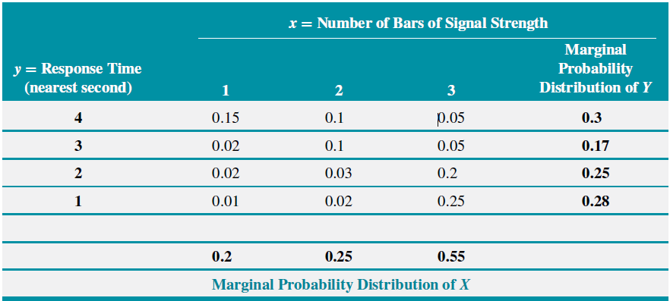
- Write the marginal distributions in functional form.

Marginal Distribution Expectation
$$μ_{x}=E\left(X\right)=\sum_{all x}{xf_{X}(x)}$$ |  | $$μ_{y}=E\left(Y\right)=\sum_{all y}{yf_{Y}(y)}$$

Example
Determine the: (a) mean of $X$, (b) mean of $Y$

Marginal Distribution Variance
$$σ_{X}^{2}=V\left(X\right)=\sum_{all x}{{\left(x-E\left(x\right)\right)}^{2}f_{X}\left(x\right)}$$  $$=\sum_{all x}{x^{2}f_{X}\left(x\right)}-{\left[E(X)\right]}^{2}$$ |  | $$σ_{Y}^{2}=V\left(Y\right)=\sum_{all y}{{\left(y-E\left(y\right)\right)}^{2}f_{Y}(y)}$$  $$=\sum_{all x}{y^{2}f_{Y}\left(y\right)}-{\left[E(Y)\right]}^{2}$$

Example
Determine the variance and standard deviation of: (a) $X$ and (b) $Y$:

Conditional Probability Distributions and Independence
$$f_{Y∣x}\left(y\right)=P(Y=y∣X=x)=\frac{f_{XY}\left(x,y\right)}{f_{X}\left(x\right)}$$ |  | $$f_{X∣y}\left(x\right)=P(X=x∣Y=y)=\frac{f_{XY}\left(x,y\right)}{f_{Y}\left(y\right)}$$
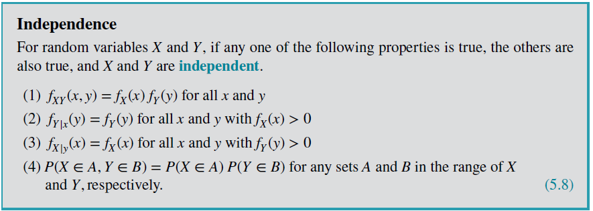

Example
Find:
- The probability of a 1 second response time when (given) there is 1 bar?
- What is the conditional distribution of the response time given the number of bars is 1?
- What is the conditional distribution of the response time given the number of bars is 2?
- What is the conditional distribution of the response time given the number of bars is 3?
- What is the conditional distribution of the number of bars when the response time is 1 second?
Determine
- The probability of a 1 second response time when (given) there is 1 bar?

- What is the conditional distribution of the response time given the number of bars is 1?

- What is the conditional distribution of the number of bars when the response time is 1 second?

