Chapter 5 – Joint Probability Distributions
Contents
1 Joint Probability Distributions for Two Random Variables 2
1.1 Introduction 2
1.2 Example 3
1.3 Marginal Probability Distributions 4
1.4 Example 4
1.5 Marginal Distribution Expectation 5
1.6 Example 5
1.7 Marginal Distribution Variance 6
1.8 Example 6
2 Conditional Probability Distributions and Independence 7
2.1 Example 7
3 (SKIP) Joint Probability Distributions for More Than Two Random Variables 9
4 Covariance and Correlation 9
5 (SKIP) Common Joint Distributions 12
6 Linear Functions of Random Variables 12
7 (SKIP) General Functions of Random Variables 13
8 (SKIP) Moment-Generating Functions 13

Joint Probability Distributions for Two Random Variables

Introduction
We consider probability distributions two or more random variables simultaneously.
Example:
- X: the length of one dimension of an injection-molded part
- Y: the length of another dimension
Suppose quality of the part is considered high if both X and Y are within their targeted ranges:
$$2.95<X<3.05$$
$$7.60<Y<7.80$$
Thus, we might be interested in a probability like this:
$P\left(2.95<X<3.05 and 7.60<Y<7.80 \right)$
The probability distribution that defines the simultaneous behavior of two or more random variable is called a joint probability distribution (frequently, we will just say; joint distribution).
Joint Probability Mass Function – If X and Y are discrete random variables, the joint distribution of X and Y is:
$$f\left(x,y\right)=P(X=x, Y=y)$$
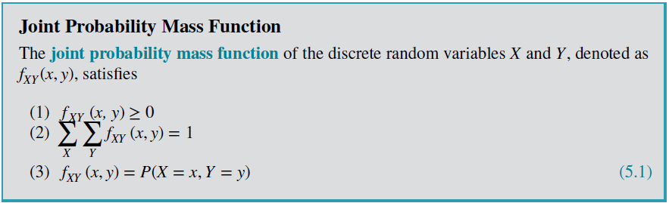
Sometimes referred to as the bivariate probability distribution or bivariate distribution of the random variables.

Example
The response time is the speed of page downloads and it is critical for a mobile Web site. As the response time increases, customers become more frustrated and potentially abandon the site for a competitive one.

- Let X denote the number of bars of service, and
- Let Y denote the response time (to the nearest second) for a particular user and site.

The table below is the joint distribution of X and Y.
The range of the random variables (X, Y) is the set of points (x, y) in two-dimensional space for which the probability that X = x and Y = y is positive.
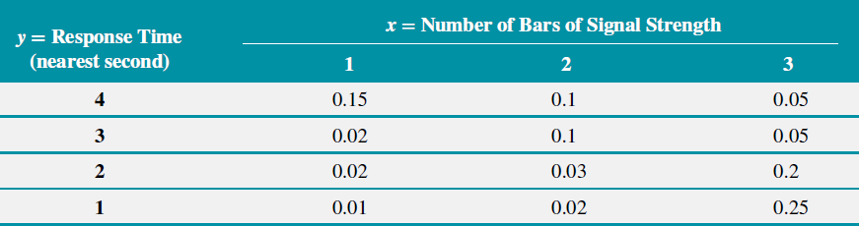
Some sample probability questions:
- What is the probability you pick up your phone and have 2 bars and it took 3 seconds to load?

P(X=2, Y=3) = f(2,3) = 0.1

- What is the probability you pick up your phone and have 1 bars and it took 1 second to load?
P(X=1, Y=1) = 0.01
- low chance of low bars and high speed
- What is the probability you pick up your phone and have 2 bars?
P(X=2) = P(X=2, Y=1) + P(X=2, Y=2) + P(X=2, Y=3) + P(X=2, Y=4)
= 0.02 + 0.03 + 0.1 + 0.1 = 0.25
- the sum of column 2
- What is the probability you pick up your phone and have a 2 second wait for a page to load?
P(Y=2) = P(X=1, Y=2) + P(X=2, Y=2) + P(X=3, Y=2)
= 0.02 + 0.03 + 0.2 = 0.25
- the sum of row 2

Marginal Probability Distributions
If more than one random variable is defined in a random experiment, the individual probability distribution of a random variable is referred to as its marginal probability distribution.
To determine P(X = x), we sum P(X = x, Y = y) over all points in the range of (X, Y) for which X = x.
$$f_{X}\left(x\right)=P\left(X=x\right)= \sum_{all y}{f(x,y)}$$ |  | $$f_{Y}\left(y\right)=P\left(Y=y\right)=\sum_{all x}{f(x,y)}$$

Example
Determine marginal probability distribution of X and Y.
Solution: sum the rows and columns!
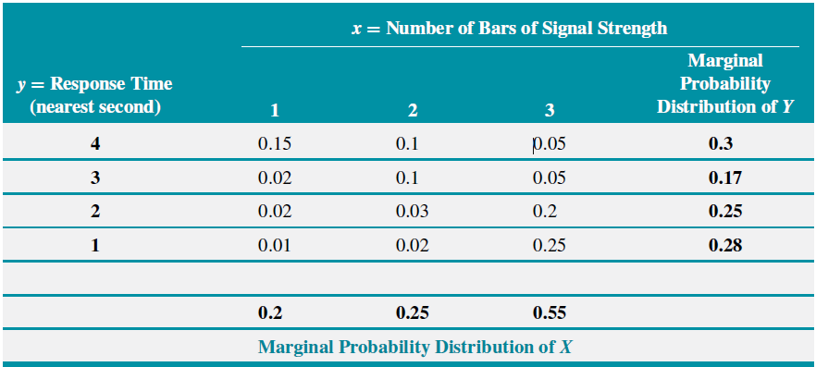
Or, they can be written in function form:
$$f_{X}\left(x\right)=\left\{\begin{matrix}0.20 & x=1 \\ 0.25 & x=2 \\ 0.55 & x=3 \\ 0 & otherwise\end{matrix}\right.$$ |  | $$f_{Y}\left(y\right)=\left\{\begin{matrix}0.30 & y=1 \\ 0.17 & y=2 \\ 0.25 & y=3 \\ 0.28 & y=4 \\ 0 & otherwise\end{matrix}\right.$$

Marginal Distribution Expectation
The expected values of the individual random variables follow the same pattern as when we considered a single random variable.
$$μ_{x}=E\left(X\right)=\sum_{all x}{xf_{X}(x)}$$ |  | $$μ_{y}=E\left(Y\right)=\sum_{all y}{yf_{Y}(y)}$$

Example
Determine the: (a) mean of $X$, (b) mean of $Y$

$$μ_{x}=E\left(X\right)=\sum_{all x}{xf_{X}(x)}=1f_{X}\left(1\right)+2f_{X}\left(2\right)+3f_{X}\left(3\right)$$
$$=1×0.2+2×0.25+3×0.55=2.35$$

$$μ_{y}=E\left(Y\right)=\sum_{all y}{yf_{Y}(y)}=1f_{Y}\left(1\right)+2f_{Y}\left(2\right)+3f_{Y}\left(3\right)+4f_{Y}\left(4\right)$$
$$=1×0.28+2×0.25+3×0.17+4×0.30=2.49$$

Marginal Distribution Variance
The variance of the individual random variables follow the same pattern as when we considered a single random variable.
$$σ_{X}^{2}=V\left(X\right)=\sum_{all x}{{\left(x-E\left(x\right)\right)}^{2}f_{X}\left(x\right)}$$  $$=\sum_{all x}{x^{2}f_{X}\left(x\right)}-{\left[E(X)\right]}^{2}$$ |  | $$σ_{Y}^{2}=V\left(Y\right)=\sum_{all y}{{\left(y-E\left(y\right)\right)}^{2}f_{Y}(y)}$$  $$=\sum_{all x}{y^{2}f_{Y}\left(y\right)}-{\left[E(Y)\right]}^{2}$$

Example
Determine the variance and standard deviation of: (a) $X$ and (b) $Y$:

$$σ_{X}^{2}=V\left(X\right)=\sum_{all x}{{\left(x-E\left(x\right)\right)}^{2}f_{X}(x)}$$
$$={\left(1-2.35\right)}^{2}×0.2+{\left(2-2.35\right)}^{2}×0.25+{\left(3-2.35\right)}^{2}×0.55=0.628$$
Or:
$$σ_{X}^{2}=V\left(X\right)=\sum_{all x}{x^{2}f_{X}\left(x\right)}-{\left[E\left(X\right)\right]}^{2}$$
$$=\left(1^{2}×0.2+2^{2}×0.25+3^{2}×0.55\right)-{2.35}^{2} =6.15-{2.35}^{2}=0.628$$
$$σ_{X}=\sqrt{V\left(X\right)}=\sqrt{0.628}=0.792$$

$$σ_{Y}^{2}=V\left(Y\right)=\sum_{all x}{y^{2}f_{Y}\left(xy\right)}-{\left[E\left(Y\right)\right]}^{2}$$
$$=\left(1^{2}×0.28+2^{2}×0.25+3^{2}×0.17+4^{2}×0.30\right)-{2.49}^{2}$$
$$=7.61-{2.49}^{2}=1.410$$
$$σ_{X}=\sqrt{V\left(X\right)}=\sqrt{0.628}=1.187$$

Conditional Probability Distributions and Independence
Given continuous random variables $X$and $Y$ with joint probability density function $f_{XY}(x, y)$, the conditional probability of Y given X is:
$$f_{Y∣x}\left(y\right)=P(Y=y∣X=x)=\frac{f_{XY}\left(x,y\right)}{f_{X}\left(x\right)}$$ |  | $$f_{X∣y}\left(x\right)=P(X=x∣Y=y)=\frac{f_{XY}\left(x,y\right)}{f_{Y}\left(y\right)}$$
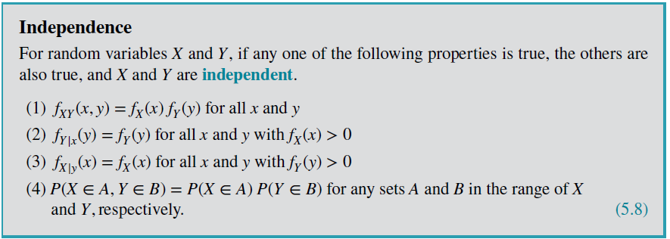

Example
Find:
- The probability of a 1 second response time when (given) there is 1 bar?
- What is the conditional distribution of the response time given the number of bars is 1?
- What is the conditional distribution of the response time given the number of bars is 2?
- What is the conditional distribution of the response time given the number of bars is 3?
- What is the conditional distribution of the number of bars when the response time is 1 second?
Determine
- The probability of a 1 second response time when (given) there is 3 bars?
$$P(Y=1|X=3)=\frac{P(X=3,Y=1)}{P(X=3)}=\frac{0.25}{0.55}=0.454$$
- The probability of 3 bars when (given) there is response time?
$$P(X=3|Y=1)=\frac{P(X=3,Y=1)}{P(Y=1)}=\frac{0.25}{0.28}=0.893$$
- The probability of a 2 second response time when (given) there is 3 bars?
$$P(Y=2|X=3)=\frac{P(X=3,Y=2)}{P(X=3)}=\frac{0.20}{0.55}=0.364$$
- What is the conditional distribution of the response time given the number of bars is 3?
$$P(Y=1|X=3)=\frac{f_{XY}\left(3,1\right)}{f_{X}\left(3\right)}=\frac{0.25}{0.55}=0.455$$
$$P(Y=2|X=3)=\frac{f_{XY}\left(3,2\right)}{f_{X}\left(3\right)}=\frac{0.20}{0.55}=0.364$$
$$P(Y=3|X=3)=\frac{f_{XY}\left(3,3\right)}{f_{X}\left(3\right)}=\frac{0.05}{0.55}=0.091$$
$$P(Y=4|X=3)=\frac{f_{XY}\left(3,4\right)}{f_{X}\left(3\right)}=\frac{0.05}{0.55}=0.091$$
- Notice that these probabilities add to 1 (due to rounding, they sum to 1.001)
- What is the conditional distribution of the response time given the number of bars is 1?
$$P(Y=1|X=1)=\frac{f_{XY}\left(1,1\right)}{f_{X}\left(1\right)}=\frac{0.01}{0.20}=0.05$$
$$P(Y=2|X=1)=\frac{f_{XY}\left(1,2\right)}{f_{X}\left(1\right)}=\frac{0.02}{0.20}=0.10$$
$$P(Y=3|X=1)=\frac{f_{XY}\left(1,3\right)}{f_{X}\left(1\right)}=\frac{0.02}{0.20}=0.10$$
$$P(Y=4|X=1)=\frac{f_{XY}\left(1,4\right)}{f_{X}\left(1\right)}=\frac{0.15}{0.20}=0.75$$
- Note that there are lots of these conditional distributions! For this problem there are 7.
- What is the conditional distribution of the number of bars when the response time is 1 second?
$$P(X=1|Y=1)=\frac{f_{XY}\left(1,1\right)}{f_{Y}\left(1\right)}=\frac{0.01}{0.28}=0.036$$
$$P(X=2|Y=1)=\frac{f_{XY}\left(2,1\right)}{f_{Y}\left(1\right)}=\frac{0.02}{0.28}=0.071$$
$$P(X=3|Y=1)=\frac{f_{XY}\left(3,1\right)}{f_{Y}\left(1\right)}=\frac{0.25}{0.28}=0.893$$

(SKIP) Joint Probability Distributions for More Than Two Random Variables

Covariance and Correlation
Mean of an RV X:
$$μ=E\left(X\right)=\sum_{all x}{xf(x)}$$
Variance of an RV X:
$$σ^{2}=V\left(X\right)=E\left[{\left(X-E\left(X\right)\right)}^{2} \right]=\sum_{all x}{{\left(X-E\left(X\right)\right)}^{2}f\left(x\right)}$$
$$=E\left[\left(X-E\left(X\right)\right)\left(X-E\left(X\right)\right)\right]$$
Covariance of RVs X & Y:
- A common measure of the relationship between two random variables.
$$Cov\left(X,Y\right)=σ_{XY}=E\left[\left(X-E\left(X\right)\right)\left(Y-E\left(Y\right)\right)\right]=\sum_{all y}{\sum_{all x}{\left(X-E\left(X\right)\right)\left(Y-E\left(Y\right)\right)f_{XY}\left(x,y\right)}}$$
Can also be expressed as (easier to calculate):
$$σ_{XY}=E\left[XY\right]-μ_{x}μ_{y}=\sum_{all y}{\sum_{all x}{xyf_{XY}\left(x,y\right)-μ_{x}μ_{y}}}$$

Example: Determine covariance between X and Y.
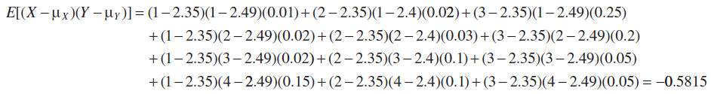
Variance is always positive or zero, while covariance can be positive, negative, or zero. Why?
- Covariance is a measure of linear relationship between the random variables.  - If the relationship between the random variables is nonlinear, the covariance might not be sensitive to the relationship. | 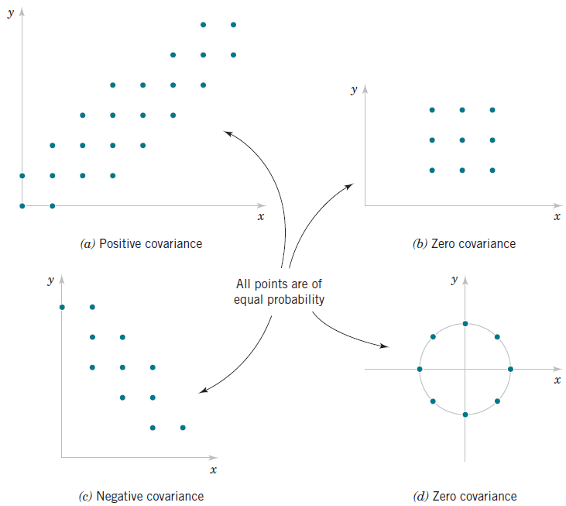

Correlation:
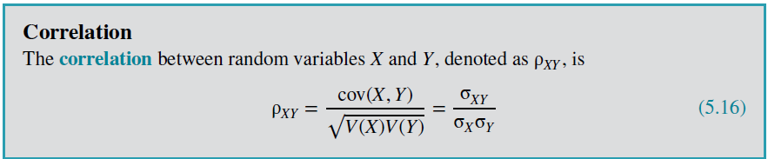
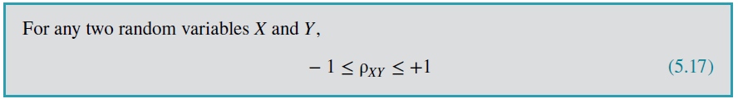
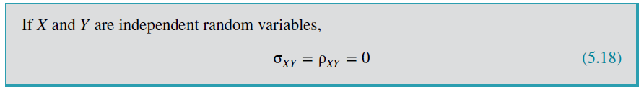
Example: Determine correlation between X and Y.
$$σ_{XY}=-0.5815$$
$$V\left(X\right)=0.6275, V\left(Y\right)=1.4099$$
$$ρ_{XY}=\frac{cov(X,Y)}{σ_{X}σ_{Y}}=\frac{σ_{XY}}{σ_{X}σ_{Y}}=\frac{-0.5815}{\sqrt{0.6275}\sqrt{1.4099}}=-0.62$$
Example:
Suppose that the random variable 𝑋 has the following distribution:
𝑃(𝑋=1)=0.2, 𝑃(𝑋=2)=0.6, 𝑃(𝑋=3)=0.2
Let 𝑌=2𝑋+5. That is,
𝑃(𝑌=7)=0.2, 𝑃(𝑌=9)=0.6, 𝑃(𝑌 = 11) = 0.2.
Determine the correlation between 𝑋 and 𝑌.
Solution:
Note, the joint distribution is:
$$X\backslash Y$$ | 7 | 9 | 11 | Marginal $P\left(X=x\right)$
1 | 0.2 | 0 | 0 | 0.2
2 | 0 | 0.6 | 0 | 0.6
3 | 0 | 0 | 0.2 | 0.2
Marginal $P\left(Y=y\right)$ | 0.2 | 0.6 | 0.2 | 1.0

- Intuitively, the correlation is 1 because Y is completely determined by X, i.e. Y=2X+5

Worked out:
Quantity | Value
E[X] | 2
Var(X) | 0.4
E[Y] | 9
Var(Y) | 1.6
Cov(X,Y) | 0.8

$$ρ_{XY}=\frac{cov(X,Y)}{σ_{X}σ_{Y}}=\frac{0.8}{\sqrt{0.4}\sqrt{1.6}}=\frac{0.8}{\sqrt{0.4*1.6}}=\frac{0.8}{\sqrt{0.64}}=\frac{0.8}{0.8}=1$$

(SKIP) Common Joint Distributions

Linear Functions of Random Variables
A random variable is sometimes defined as a function of one or more random variables.
A linear relationship:
$$Y=X_{1}+3X_{2}+5$$
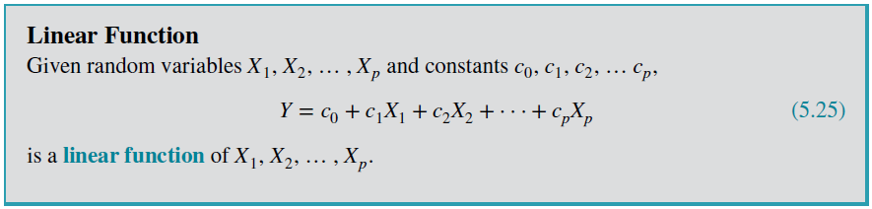
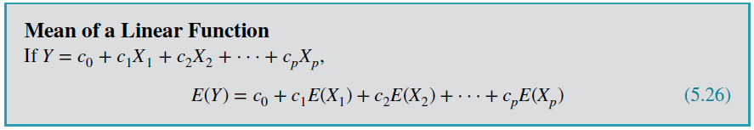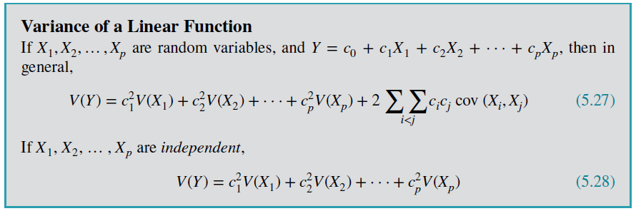
Example:
Suppose $X_{1}$ and $X_{2}$ are independent and $Y=X_{1}+3X_{2}+5$. Find the mean and variance of Y:
$$E\left(Y\right)=E\left(X_{1}\right)+3E\left(X_{2}\right)+5$$
$$V\left(Y\right)=V\left(X_{1}\right)+3^{2}V(X_{2})$$

Example:
Suppose $X_{1}$ and $X_{3}$ are independent and $Y={2X}_{1}+3X_{3}$. Assume that $X_{1}\text{is normal with} E(X_{1})=2$ and standard deviation $0.1$ and $X_{3}$ is normal with $E(X_{3}) = 5$ and standard deviation $0.2$. Find the mean and variance of Y.
$$E\left(Y\right)=2E\left(X_{1}\right)+3E\left(X_{3}\right)$$
$$=2×2+3×5=19$$
$$V\left(Y\right)=2^{2}V\left(X_{1}\right)+3^{2}V\left(X_{3}\right)$$
$$=2^{2}×0.1^{2}+3^{2}×0.2^{2}=0.4$$

(SKIP) General Functions of Random Variables

(SKIP) Moment-Generating Functions

