Chapter 4 – Continuous Random Variables and Probability Distributions
Contents
1 Probability Distributions and Probability Density Functions 2
2 Cumulative Distribution Functions 2
3 Mean and Variance of a Continuous Random Variable 3
4 (SKIP) Continuous Uniform Distribution 3
5 Normal Distribution 3
5.1 Standard Normal Distribution 4
6 Normal Approximation to the Binomial and Poisson Distributions 6
7 (SKIP) Exponential Distribution 8
8 (SKIP) Erlang and Gamma Distributions 8
9 Weibull Distribution 8
9.1 Example 10
9.2 Example 10
9.3 Example 10
10 Lognormal Distribution 12
10.1 Example 13
10.2 Example 13
11 (SKIP) Beta Distribution 13

Probability Distributions and Probability Density Functions
A random variable is a numerical description of the outcome of an experiment.
A continuous random variable is a random variable with an interval (either finite or infinite) of real numbers for its range.
i.e. a continuous random variable can take on any value in a specified range.
A probability density function f(x) can be used to describe the probability distribution of a continuous random variable X.
i.e.
- The area under f(x) is 1.
- The probability that X is between a and b is the area under f(x) between a and b

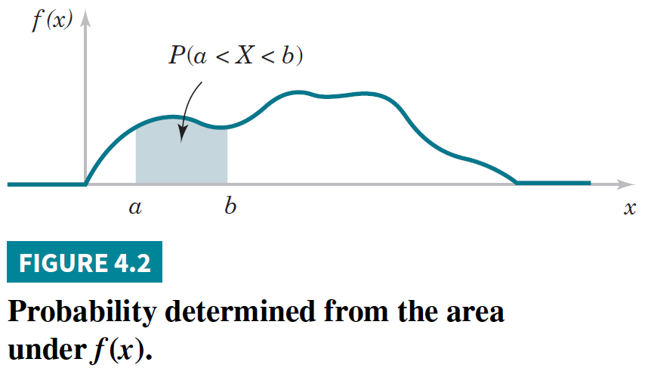
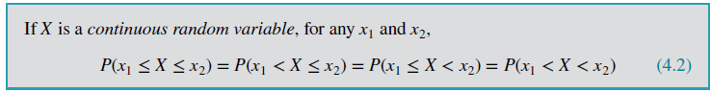
i.e. With a continuous RV:
- P(X=x) = 0, the “area” under a point (x) is 0
- Can only talk about probabilities over a range, P(a<X<b)
- < & <= are the same

Cumulative Distribution Functions
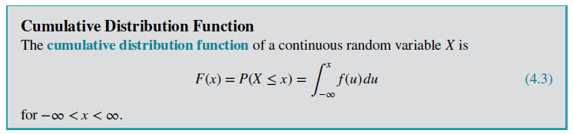
When we have F(x), we can compute probabilities directly, we don’t need to integrate.
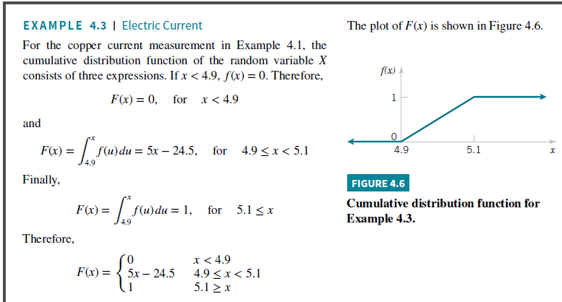
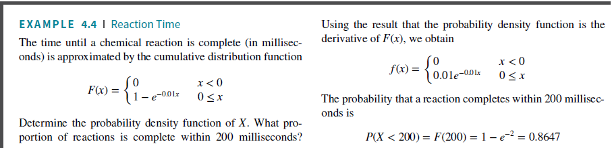

Mean and Variance of a Continuous Random Variable
Every random variable has a mean, $μ$, and variance, $σ^{2}$

(SKIP) Continuous Uniform Distribution

Normal Distribution
- The most widely used model for a continuous measurement is a normal random variable.
- Many populations have distributions that can be fit very closely by an appropriate normal (or Gaussian, bell) curve.
- Examples: height, weight, and other physical characteristics, scores on various tests, etc.
- A normal distribution is also referred to as a Gaussian distribution
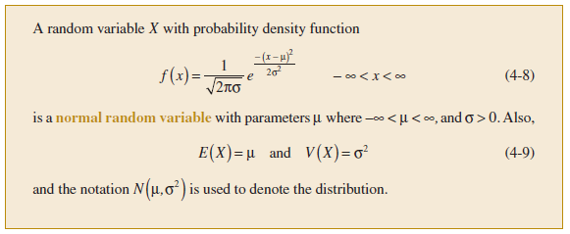
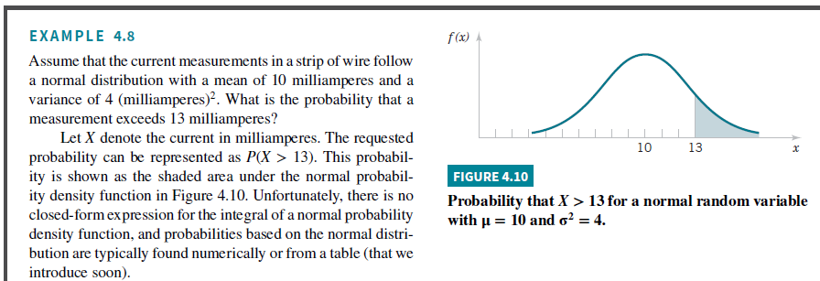

Properties
- The mean, median and mode are equal.
- Bell-shaped curve
- Symmetric about the mean
- The normal curve approaches, but never touches, the x-axis as it extends farther and farther away from the mean.
- Total area under the curve equal to 1.

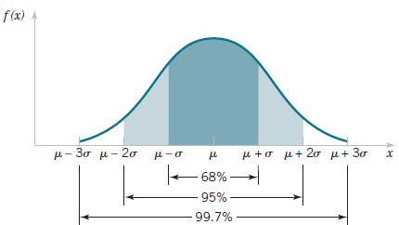
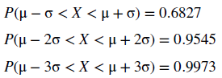

How can I test that a dataset is normally distributed or not?
- Visually assess a histogram
- Normal Probability Plot (Q-Q Plot): https://sixsigmastudyguide.com/normal-probability-plot/

Standard Normal Distribution
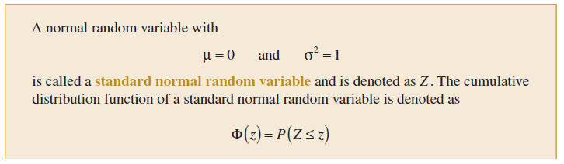
Appendix Table III provides cumulative probabilities for a standard normal random variable.
Example
$$i$$ | $$x_{i}$$ | $$x_{i}-μ$$ | $$z_{i}=\frac{x_{i}-μ}{σ}$$
1 | 3 | -3 | -1.5
2 | 5 | -1 | -0.5
3 | 4 | -2 | -1
4 | 6 | 0 | 0
5 | 7 | 1 | 0.5
6 | 8 | 2 | 1
7 | 9 | 3 | 1.5
$$μ$$ | 6 |  | 0
$$σ$$ | 2 |  | 1

$$z_{i}=\frac{x_{i}-μ}{σ}$$
$$⇒x_{i}-μ=z_{i}σ$$
$$⇒x_{i}=μ+z_{i}σ$$

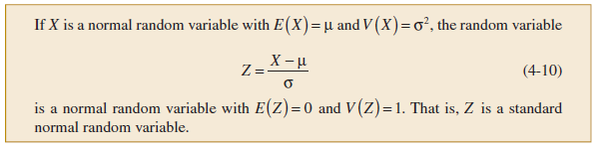
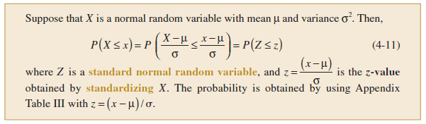
Example:
Determine the following probabilities for the standard normal random variable Z:
- $P(Z<1.32)$
- $P(Z>- 2.15)$

Normal Approximation to the Binomial and Poisson Distributions
- For extremely large value of $n$, it is difficult to calculate probabilities by using the binomial distribution.
- The normal distribution can be used to approximate binomial probabilities for cases in which $n$ is large.

Binomial Distribution (Review)
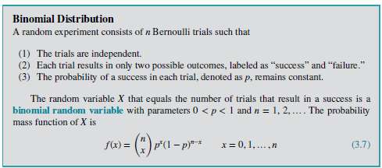
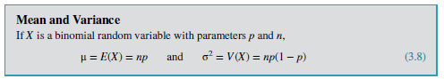

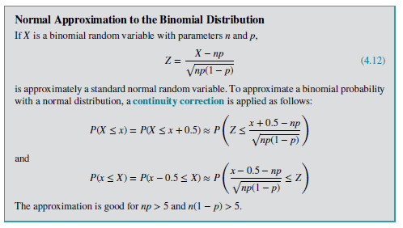

Continuity Correction
- $P(3 ≤ X ≤ 7)$ is better approximated by the area under the normal curve from 2.5 to 7.5.
- Consequently, a modified interval is used to better compensate for the difference between the continuous normal distribution and the discrete binomial distribution. This modification is called a continuity correction.
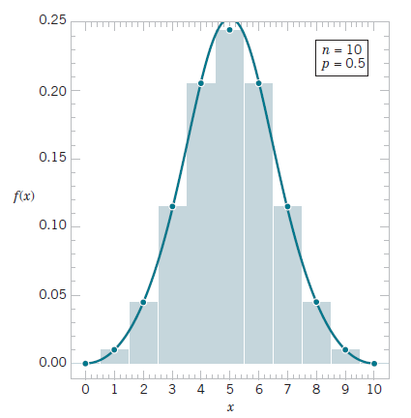

Example: Assume that in a digital communication channel, the number of bits received in error can be modeled by a binomial random variable, and assume that the probability that a bit is received in error is $1×{10}^{-5}$. If 16 million bits are transmitted, what is the probability that 150 or fewer errors occur?
Solution
Let: X = Number of bits received
$X\sim Bin(n=16×{10}^{6},p={10}^{-5})$
$P\left(X≤150\right)=P\left(X≤150+0.5\right)=P\left(X≤150.5\right)$
$=P\left(z≤\frac{X-np}{\sqrt{np\left(1-p\right)}}\right)=P\left(z≤\frac{150.5-16×{10}^{6}×{10}^{-5}}{\sqrt{16×{10}^{6}×{10}^{-5}\left(1-{10}^{-5}\right)}}\right)=P\left(z≤\frac{150.5-16×{10}^{1}}{\sqrt{16×{10}^{1}\left(1-{10}^{-5}\right)}}\right)$
$=P\left(z≤\frac{150.5-160}{\sqrt{160\left(0.99999\right)}}\right)=P\left(z≤\frac{-9.5}{12.649}\right)=P\left(z≤-0.75\right)=0.2266$

Exercise: The manufacturing of semiconductor chips produces 2% defective chips. Assume that the chips are independent and that a lot contains 1000 chips. Approximate the following probabilities:
- More than 25 chips are defective.
- Between 20 and 30 chips are defective.

(SKIP) Exponential Distribution

(SKIP) Erlang and Gamma Distributions

Weibull Distribution
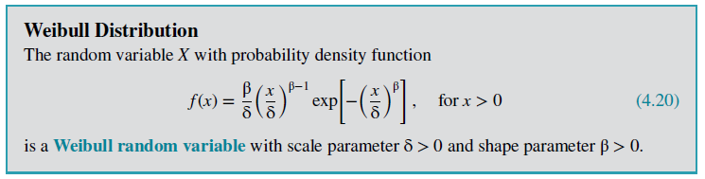
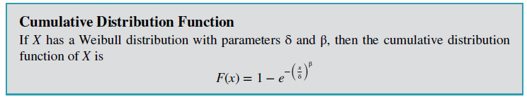
The shape parameter $(β)$ describes the shape of your data’s distribution. The shape parameter value equals the slope of the line on a probability plot.
The shape value between 3 and 4, the Weibull distribution becomes symmetric and bell-shaped, like the normal curve
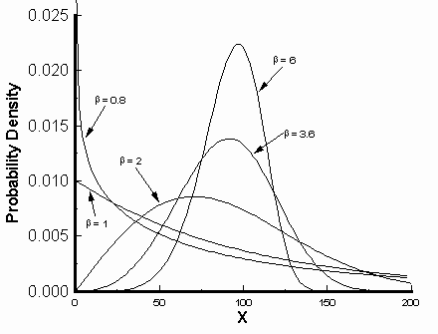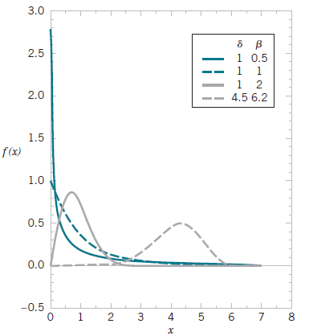

Great for visualizing the Weibull Distribution
- https://sesen.ai/distribution-explorer/weibull
- https://distflow.com/distributions/weibull?a=0.250000&b=0.750000
The value for the shape parameter (γ) determines the failure rates:
- If $β<1$, then the failure rate decreases with time (i.e. the process has a large number of infantile or early-life failures and fewer failures as time passes).
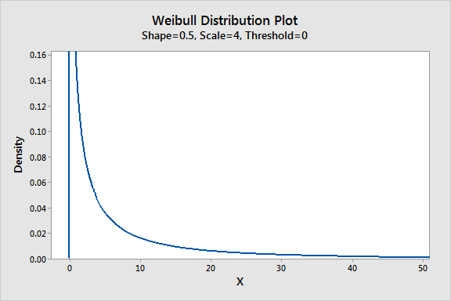
- For $β=1$: the failure rate is constant, which means it’s indicative of useful life or random failures.

- If $β>1$: the failure rate increases with time (i.e. the distribution models wear-out failures, which tend to happen after some time has passed).

Scale Parameter
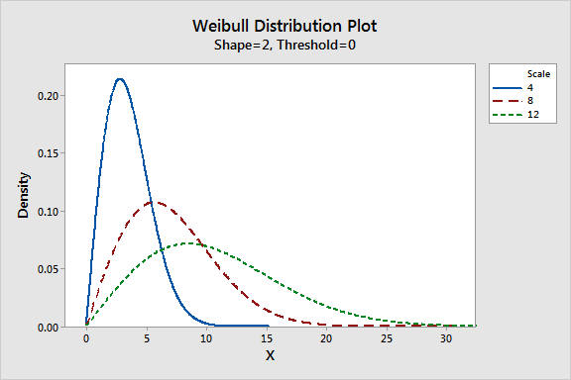

Example
The time to failure (in hours) of a bearing in a mechanical shaft is satisfactorily modeled as a Weibull random variable with $β=\frac{1}{2}$and $δ=5000$ hours. Determine the probability that a bearing lasts at least 6000 hours.
$P\left(X≥6000\right)=1-P\left(X<6000\right)$
$=1-\left(1-e^{-{\left(\frac{x}{δ}\right)}^{β}}\right)$
$=e^{-{\left(\frac{x}{δ}\right)}^{β}}$
$=e^{-{\left(\frac{6000}{5000}\right)}^{1/2}}=0.237$

Example
Assume that the life of a roller bearing follows a Weibull distribution with parameters $β=2$and $δ=10,000$hours. Determine the probability that a bearing lasts at most 8000 hours.

Example
An industrial engineering team is studying the reliability of conveyor belt motors used in an automated distribution center. Historical failure data indicate that the time until failure of a motor (hours), $T$(in hours) follows a Weibull distribution with:
- Shape parameter: $β=2.5$
- Scale parameter: $δ=10,000$hours
- What is the probability that a motor survives beyond 8,000 hours?
  - Let: $T=\text{time until failure of a motor (hours)}.$
$F\left(T\right)=P\left(T≤t\right)=1-e^{-{\left(\frac{t}{δ}\right)}^{β}}=1-e^{-{\left(\frac{t}{10,000}\right)}^{2.5}}$

  - P(motor survives beyond 8000 hours)
= P(motor fails after (beyond) at least 8000 hours)
$=P\left(T≥8,000\right)=1-P\left(T≤8,000\right)=1-F\left(8,000\right)=1-\left[1-e^{-{\left(\frac{8,000}{10,000}\right)}^{2.5}}\right]$
$=F\left(8,000\right)=1-e^{-{\left(\frac{8,000}{10,000}\right)}^{2.5}}=1-e^{-0.5724}=1-0.5641=0.4358$
  - Thus,
$P\left(T≥8,000\right)=1-0.4358=0.5641$
- What is the probability that a motor fails between 8,000 and 12,000 hours?
  - $P\left(8,000≤T≤12,000\right)=P\left(T≤12,000\right)-P\left(T≤8,000\right)=F\left(12,000\right)-F\left(8,000\right)=$

- $F\left(8,000\right)=0.4358$
- $F\left(12,000\right)=1-e^{-{\left(\frac{12,000}{10,000}\right)}^{2.5}}=1-e^{-1.5774}=1-0.2065=0.7935$

  - Thus,
$P\left(8,000≤T≤12,000\right)=0.7935-0.4358=0.3576$

- Determine the operating time t at which 10% of the motors are expected to have failed.
  - $F\left(T≤t\right)=0.1$
Thus,
$F\left(t\right)=0.1=1-e^{-{\left(\frac{t}{10,000}\right)}^{2.5}}$
  - Solve for t: $1-e^{-{\left(\frac{t}{10,000}\right)}^{2.5}}=0.1$
Rearrange: $e^{-{\left(\frac{t}{10,000}\right)}^{2.5}}=0.9$
Take ln of both sides: $ln\left[e^{-{\left(\frac{t}{10,000}\right)}^{2.5}}\right]=ln⁡(0.9)$
Note: $\ln\left(e^{x}\right)=x$: $-{\left(\frac{t}{10,000}\right)}^{2.5}=ln⁡(0.9)$
Multiply by -1: ${\left(\frac{t}{10,000}\right)}^{2.5}=-\ln\left(0.9\right)=0.1054$
Raise each side to 1/2.5 power: ${\left[{\left(\frac{t}{10,000}\right)}^{2.5}\right]}^{\frac{1}{2.5}}={\left(0.1054\right)}^{1/{2.5}}$
Simplify: $\frac{t}{10,000}={\left(0.1054\right)}^{1/{2.5}}=0.4065$
Multiply by 10,000: $t=10,000\left(0.4065\right)≈4065 hrs$
- The facility operates 200 identical motors. Assuming independent failures, how many motors would you expect to fail before reaching 8,000 hours?
  - Let $N=\text{number of failures at less than 8000 hours out of 200 motors}.$
$N\sim B\left(n=200, p=P\left(T≤8000\right)\right)=B(200, 0.4358)$

$μ=E\left[N\right]=np=200\left(0.4358\right)=87.16$

Lognormal Distribution
- A random variable is lognormally distributed if its logarithm is normally distributed.

$X\sim Lognormal(θ,ω^{2})$
If:

$W=ln⁡(X)\sim Normal(θ,ω^{2})$
- Skewed distributions with low mean values, large variance, and all-positive values often fit this type of distribution.
- Values must be positive as $ln⁡(x)$ exists only for positive values of $x$.
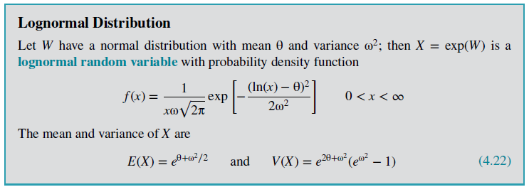
If, $X\sim Lognormal(θ,ω^{2})$, then it can be shown that:
$$F\left(x\right)=P\left(X≤x\right)=P\left(Z≤\frac{\ln\left(x\right)-θ}{ω}\right)=Φ\left(\frac{\ln\left(x\right)-θ}{ω}\right)$$
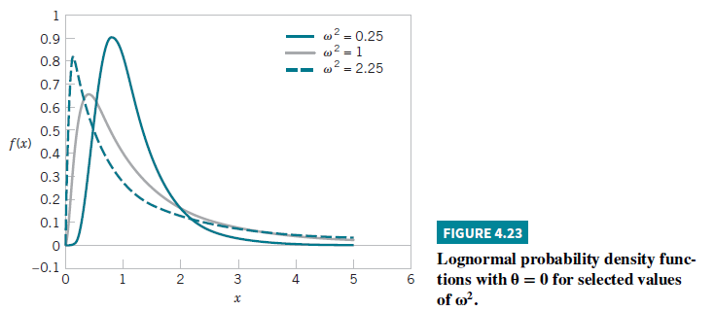

Example
The lifetime (in hours) of a semiconductor laser has a lognormal distribution with $θ = 10$and $ω = 1.5$.
- What is the probability that the lifetime exceeds 10,000 hours?
$P\left(X>10000\right)=1-P\left(X≤10000\right)$
$=1-Φ\left(\frac{ln({10000)-10}}{1.5}\right)$
$=1-Φ\left(-0.52\right)$
$=1-0.3=0.70$
- Determine the mean and standard deviation of lifetime.
  - $E\left(X\right)=e^{θ+ω^{2}/2}=e^{10+{1.5}^{2}/2}=67846.3$
  - $V\left(X\right)=e^{2θ+ω^{2}}(e^{ω^{2}}-1)$
$=e^{2×10+{1.5}^{2}}(e^{{1.5}^{2}}-1)$
$=39070059887$
Practical Interpretation: The standard deviation of a lognormal random variable can be large relative to the mean.

Example
Suppose that X has a lognormal distribution with parameters $θ=5$and $ω^{2}=9$. Determine the following:
- $P(X<13,300)$
- Value for $x$ such that $P(X≤x)=0.95$
- Mean and variance of $X$.

(SKIP) Beta Distribution

