2.4 – Measures of Central Tendency

- Sample Average – We use the symbol, $\overline{x}$ to denote the sample average. The sample average is also called the: average, sample mean, mean, x-bar. It is the numerical average of the data values obtained by adding up all data values and dividing by the sample size. The sample average is calculated with this formula: $\overline{x}=\frac{1}{n}\sum_{i=1}^{n}{x_{i}}$.

Example

Sample (Data) | 4 | 9 | 3 | 6 | 5
Data Labels | $$x_{1}$$ | $$x_{2}$$ | $$x_{3}$$ | $$x_{4}$$ | $$x_{5}$$

$$\overline{x}=\frac{1}{5}\sum_{i=1}^{5}{x_{i}}=\frac{1}{5}\left(4+9+3+6+5\right)=\frac{1}{5}\left(27\right)=5.4$$

2.7 – Measures of Spread (Variation)
When we collect data, say the time it takes to get an order at a drive through, all the values are different. Each order takes a different amount of time to fill. So, a natural question is, how much do the values vary? For instance, the high temperatures in July in Valdosta may vary from 89-100 degrees whereas the high temperatures in January may vary from 28-55 degrees. Which month has more variability in temperatures. In this section we consider several numerical measures of how much variability there is in the data. By doing this, we can determine how spread out the data is or how tightly grouped it is.
- Sample Variance and Standard Deviation – We use the sample variance and sample standard deviation as measures of the variability in data.
$$s^{2}=\frac{1}{n-1}\sum_{i=1}^{n}{{\left(x_{i}-\overline{x}\right)}^{2}}$$ | Sample Variance
$$s=\sqrt{s^{2}}$$ | Sample Standard Deviation
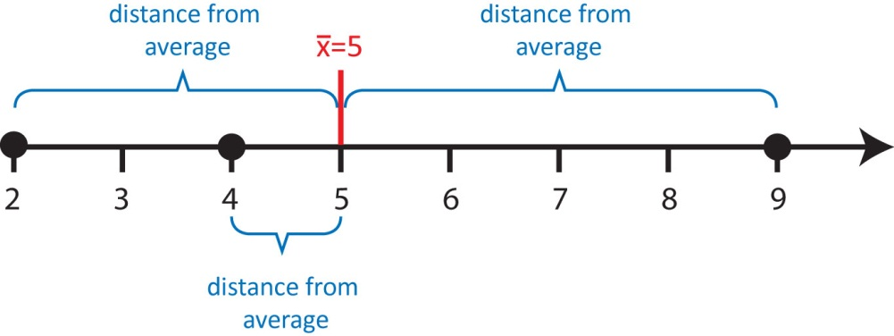
Let’s take a closer look at the formula for variance. Suppose we have the dataset: 2, 4, 9. What is the variance and standard deviation? The sample average of this data is 5. The formula for the standard deviation says:

- See how far each data value is from the average: $x_{i}-\overline{x}$

- Square each of the distances: ${{(x}_{i}-\overline{x})}^{2}$

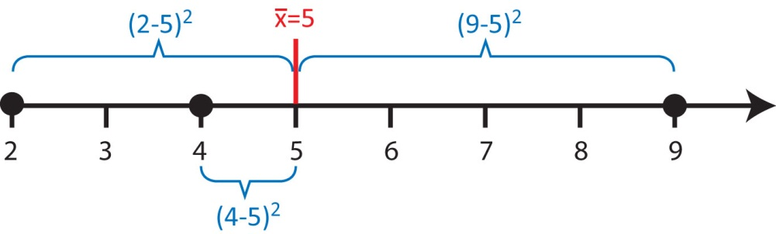
- Add up the squared distances: $\sum_{i=1}^{n}{{\left(x_{i}-\overline{x}\right)}^{2}{=3}^{2}+1^{2}+4^{2}=26 sec^{2}}$

- “Average” the squared distances to obtain the sample variance:

$s^{2}=\frac{1}{n-1}\sum_{i=1}^{n}{{\left(x_{i}-\overline{x}\right)}^{2}}=\frac{1}{3-1}26=13 sec^{2}$

Thus, in some sense, sample variance is the average squared distance of data values from their average. We can see from the formula that the larger the sample variance (or standard deviation), the more spread out the data is.

- Take square-root to obtain sample standard deviation: $s=\sqrt{13 sec^{2}}=3.6 sec$

The units of standard deviation are units of the data, for instance, sec in the example above. In statistics, we almost always use the sample standard deviation as opposed to the sample variance.

Thus, in some sense, sample standard deviation is the average distance of data values from their average.

- Degrees of freedom: The term degrees of freedom results from the fact that the n deviations $x_{1}-\overline{x}, x_{2},-\overline{x},…,x_{n}-\overline{x}$always sum to zero, and so specifying the values of any n −1 of these quantities automatically determines the remaining one. Only n−1 of the n deviations, $x_{i}-\overline{x}$are freely determined. the number of degrees of freedom as the number of independent pieces of information in the data

2.8 – Making a Histogram

- Histogram – A histogram is a graphical representation of the data that is similar to the bar chart we considered with qualitative data: it shows the distribution of data into different groups. The general idea is to:

- Divide the data into groups (classes),
- Count the data values in each group (class),
- Graph the counts (or relative frequencies) using bars.

- Example – Consider the salary data shown below which is a sample of size $n=50$, showing the starting salary (in thousands of dollars) of recent Computer Science graduates:

19.5 | 26.8 | 29.1 | 30.5 | 31.5 | 32.2 | 33.2 | 33.9 | 35.4 | 37.4
24.2 | 27.4 | 29.1 | 30.9 | 31.9 | 32.4 | 33.3 | 34.8 | 36.1 | 39.2
24.8 | 27.8 | 29.6 | 30.9 | 32.1 | 32.5 | 33.3 | 34.9 | 36.1 | 39.7
25.3 | 27.8 | 30.1 | 31.1 | 32.1 | 32.8 | 33.4 | 35.0 | 36.3 | 40.2
25.7 | 28.6 | 30.3 | 31.4 | 32.1 | 33.1 | 33.4 | 35.3 | 36.9 | 41.0

If we decide to define the classes as shown in the table below, we see that there is one salary in the range $\$18,000<salary<\$22,000$ and 4 salaries in the range, $\$22,000≤salary<\$26,000$, etc. We can also calculate the relative frequencies by dividing each frequency (count) by the sample size.

 | Frequency Distribution | Relative Frequency Distribution
Class | Frequency (count) | Relative Frequency
(18,22) | 1 | 1/50 = 0.02 = 2%
[22, 26) | 4 | 4/50 = 0.08 = 8%
[26, 30) | 8 | 8/50 = 0.16 = 16%
[30, 34) | 23 | 23/50 = 0.46 = 46%
[34, 38) | 10 | 10/50 = 0.20 = 20%
[38, 42) | 4 | 4/50 = 0.08 = 8%
 | n = 50 | sum = 100%

The graph on the left is the frequency histogram where the height of each bar is the count of the number of data values that fall in that class. The graph on the right is a relative frequency histogram and shows the percentage (or fraction) of data that falls in each class.
We notice that no matter whether we use the frequencies or the relative frequencies to draw the histogram, the shape is the same. In this case, we notice that the histogram is symmetric and bell-shaped (mound-shaped). Symmetric means that we can draw a line down the middle of the graph and the two halves are approximately mirror images of one another. When we say that day has a bell-shaped distribution, this implies that it is symmetric but it also conveys to us that relatively, most of the data is clustered around the center, but there are a few relatively small and large values.

- Guidelines for making a histogram:

- Choose number of bars (classes, groups, intervals). Choose between 5 and 20. A histogram is sensitive to the number of classes, so you may want to try several values in practice. A rule-of-thumb is to use about $\sqrt{n}$ classes for a histogram.

- A sample size of 30 means $\sqrt{30}=5.477$, thus we might use 5 or 6 classes in the histogram.
- A sample size of 250 means suggesting we might want anywhere from 14, 15, or 16 classes.

- Determine class width, beginning point of histogram and ending point. Keep in mind that:

- Classes have no overlap.

- The lower limit of the smallest class is usually less than the smallest data value. The upper limit of the largest class is usually greater than the largest data value. However, if the data cannot be negative, it doesn’t make sense to choose a starting point less than 0.

There is no single correct value for class width. A good place to start is to use this formula:

$approximate class width=\frac{Maximum-Minimum}{number of bars}=\frac{R}{number of bars}$

- For instance, considering the salary data above, there are 30 data values so we will begin with 6 bars. Thus, $approximate class width=\frac{41-19.5}{6}=3.58$ so that each bar represents $3,580. However, if we adhere to rule b.ii above, we need to choose a value a little larger than 41 for the ending point and a little smaller than 19.5 as the beginning point. If we choose 42 and 18, respectively, we see that the class width is $\frac{42-18}{6}=4$. Thus, the first class will go from 18 to 18+4, i.e. (18, 22). The second class will go from 22 to 22+4, i.e. [22, 26) as shown in the table above.

- Construct the frequency and relative frequency distributions.

- Graph the relative frequency distribution.

2.10 – Histogram Shapes and Skew

- Common Shapes of Distributions – To determine the shape of a distribution, we sketch a curve over the histogram and analyze the curve.

Symmetric, Bell-Shaped – Most of the data is towards the center but curve falls off rapidly in the larger and smaller directions. | 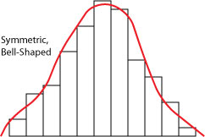
Right Skewed – Most of the data have small values but there are a few large data values | 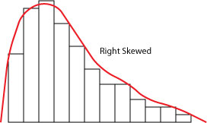
Left Skewed – Most of the data have large values but there are a few small values. | 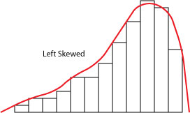
Symmetric, Uniform – Small, medium, and large data values occur with similar frequencies. | 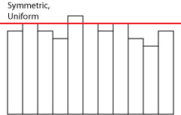
Bimodal – There are two distinct peaks in the data. This is not very common. Sometimes when we have bimodal data, we have inadvertently sampled from two populations. | 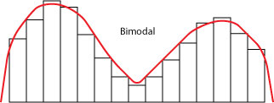

2.13 – Detecting Skew Numerically

- Detecting Skew Numerically – The difference between the mean and the median tells us about the skew of the data as the table below shows. The larger the difference, the more skew in the data. If there is little difference, the data has a symmetric distribution. We remember that outliers influence the mean more than the median. So, if the mean is larger than the median then the sample probably has some extra large data values and the histogram will appear skewed right. If the mean is smaller than the median then the sample probably has extra small data values and the histogram will appear skewed left.

Mean – Median |  | Interpretation
negative | $\overline{x}<M$ | Left Skew
about zero | $\overline{x}≈M$ | Symmetric
positive | $\overline{x}>M$ | Right Skew

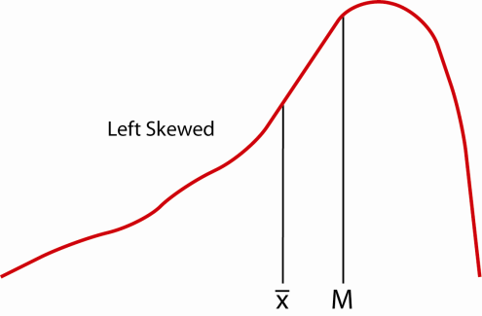 | 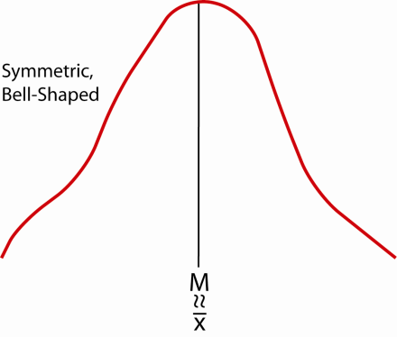 | 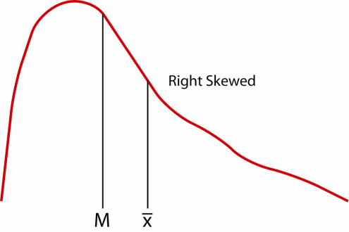

It does take a bit of judgment to determine if the difference between the Mean and Median is close to zero. Detailed knowledge of the problem at hand is useful in detecting skew numerically.
The mode is the tallest bar. Note:

- Left skewed data: mode > median > mean
- Right skewed data: mode < median < mean

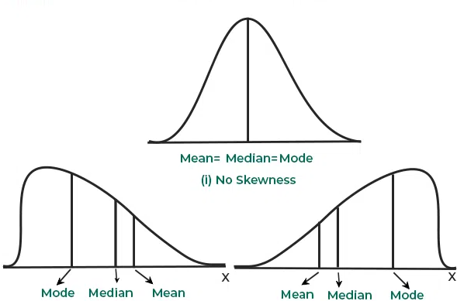

- Lack of symmetry is called skewness for a frequency distribution.
- If the distribution is not symmetric, the frequencies will not be uniformly distributed about the center of the distribution.
- Measure of skewness gives the direction and magnitude of the lack of symmetry.
- Variance tells us about the amount of variability while skewness gives the direction of variability.

Karl Pearson’s Coefficient of Skewness

- It is a relative measure of skewness.
- It is most frequently used for measuring skewness.
- There are two different versions:

$$S_{k}=\frac{mean-mode}{σ}$$
$$S_{k}=\frac{3(mean-median)}{σ}$$

Pearson Skewness | Interpretation
< -1 | Strong left skew
-1 to -0.5 | Moderate right skew
-0.5 to 0.5 | Roughly symmetric
0.5 to 1 | Moderate left skew
> 1 | Strong leftskew

Example
Calculate Pearson's skewness coefficient for a dataset: 85, 88, 92, 94, 96, 98, 100, 100, 100, 100.
Solution
$$mean=95.3$$
$$median=97$$
$$mode=100$$
$$σ=5.18$$

$$S_{k}=\frac{mean-mode}{σ}=\frac{95.3-100}{5.18}=-0.91$$

$$S_{k}=\frac{3(mean-median)}{σ}=\frac{3(95.3-97)}{5.18}=-0.98$$

Interpretation: The negative value of $S_{k}$ is indicating a negative skewness in the distribution. This means that the tail of the distribution is longer on the left side, and most of the scores are concentrated on the right side of the mean

Exercise
- Karl Pearson’s coefficient of skewness is 1.28, its mean is 164 and mode 100, find the standard deviation.

