Chapter 9 Notes – Composite Pattern

Definition & Use

- “The Composite Pattern allows you to compose objects into tree structures to represent part-whole hierarchies. Composite lets clients treat individual objects and compositions of objects uniformly.”[HFDP, 356][GOF, 163]

- “The Composite pattern allows you to build complex objects by recursively composing similar object in a tree-like manner. The Composite pattern also allows the object in the tree to be manipulated in a consistent manner, by requiring all of the objects in the tree to have a common interface or superclass.” [PIJ-1, 187]

- Use the Composite pattern when:

- You have a complex object that can be broken down into a part-whole hierarchy of smaller objects.

- The majority of the relationships do not need to be distinguished. In other words, mostly, the client doesn’t need to know the concrete classes and all manipulation can be carried out through the interface.

- General UML, two choices (a third choice is shown later):

Book’s Approach |  | Another Approach
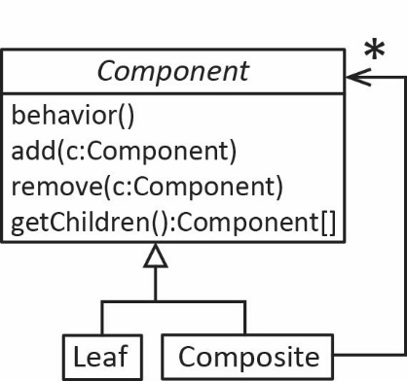 |  | 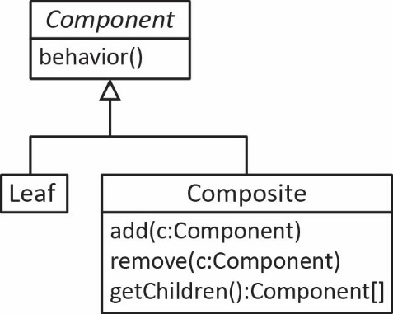

Examples

- File systems are organized with the Composite pattern. HTML elements are also.
- Consider the organization of a document composed of a number of components.

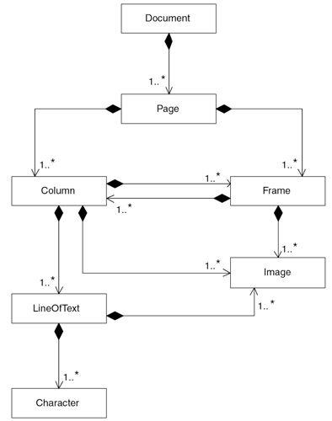

This can be organized using the Composite pattern.

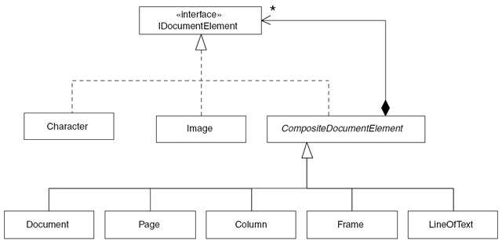

Text Example

- How does a menu get its list of components? There are three design options and three factors to consider:

- Flexibility – Can we modify the menu?
- Transparency – Do we have to know concrete classes?
- Safety – Can unsupported operations be called?

Approach | 1 | 2 | 3
Structure | 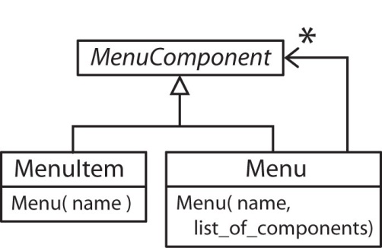 | 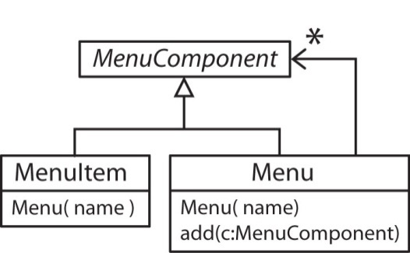 | 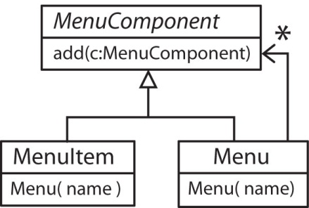
Flexibility | Menu’s cannot be changed | Menus can be changed | Menus can be changed
Transparency | All items can be referred to as MenuComponents | Must know class | All items can be referred to as MenuComponents
Safety |  |  | It is possible to call the add method on a MenuItem

- These three options demonstrate that a composite often has to decide between flexibility, transparency and safety when components are created. You can get any two of the three properties, but not all three.

For some reason, the text only mentions the third technique. However, this is not the common choice.

Java AWT Package

- The designers of the Java AWT classes chose the second technique. The add method is in the Container class. Thus, to add a Component to a Container, you must know that the Container is a Container. So, you can’t add a Button to a Button (safety?). However, in Swing, a JButton is a Container, so you can add a JButton to a JButton (see next example).

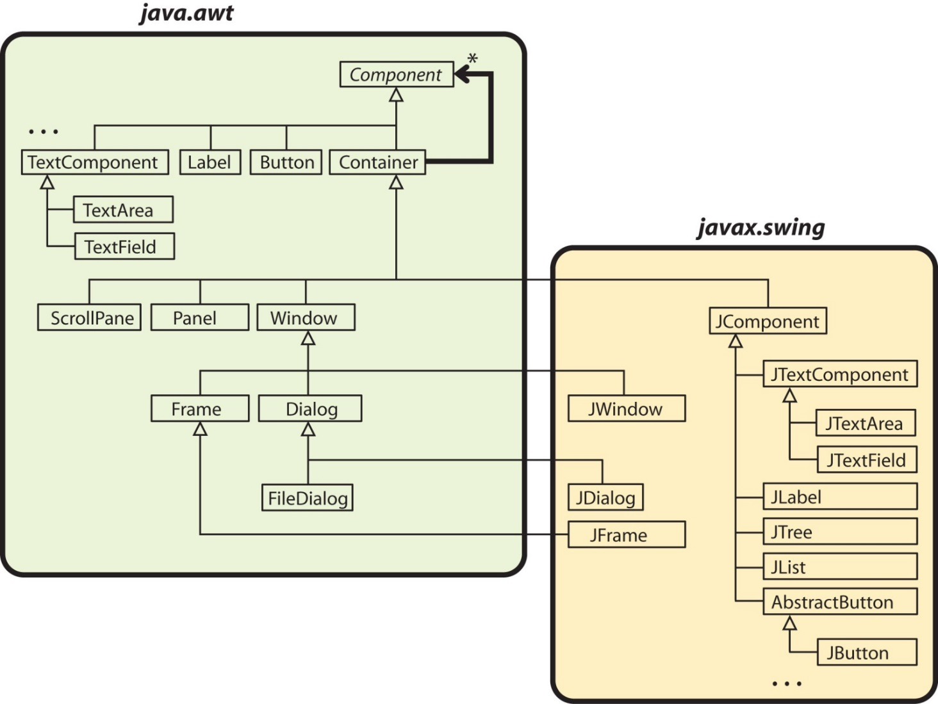

- As mentioned above, Swing makes all controls Containers. This design allows us create recursive menus and buttons with embedded buttons and radio buttons.

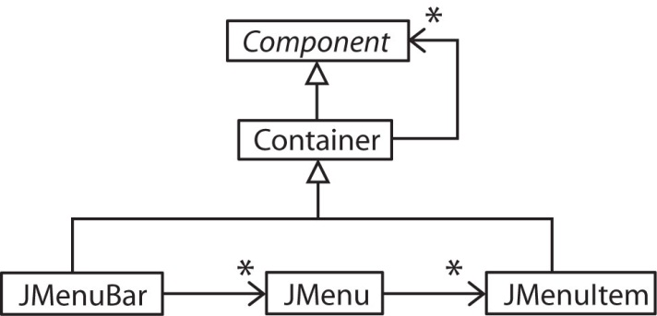 | 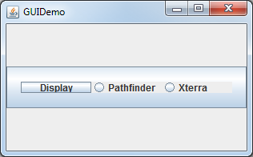

- – JavaFX – The Scene Class Hierarchy

- The figure below shows the framework for building a JavaFX GUI, which utilizes the second technique from above. Note that a Scene can contain a Pane, but in general, the association is more general; the Scene has an association with the Parent class of which Pane is a subclass. Note, also that a Pane can have many Node instances where each Node instance can be a GUI Control, another Pane, or other items such as a MediaView object.

