Delegation Notes

Design Principle: Law of Demeter – "Only talk to your neighbors." A class shouldn't have to know much about distant classes. A method/class should have limited knowledge of an object model.

Example

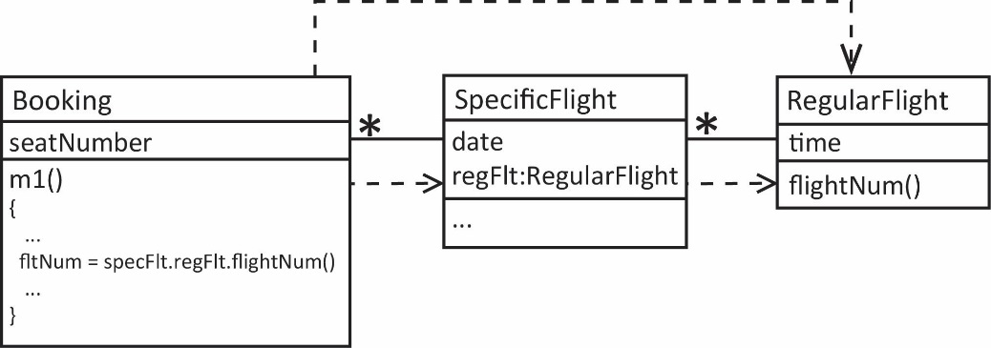
- Consider the collaboration shown below. A RegularFlight, for example Flight 482 flies from NYC/LaGuardia to Atlanta at 9am every weekday. A RegularFlight contains references to actual occurrences on specific dates, SpecificFlights, for example, instances of Flight 482 that occur on June 1,2,3,4,5. Each SpecificFlight has a number of Bookings where each Booking represents an individual person in a specific seat. As shown, the flightNum originates in the RegularFlight class. Suppose there is a method, m1 in the Booking class that needs the flightNum. The implementation shown below violates the Law of Demeter as Booking is talking directly to RegularFlight. As shown by the dashed arrows, there are three dependencies between the classes.

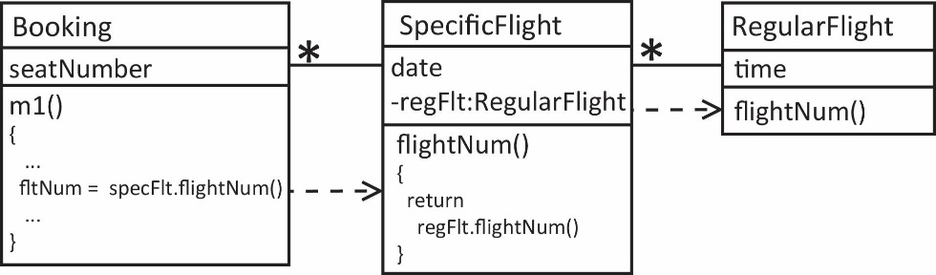
- A better way to handle this is to introduce a flightNum method in SpecificFlight that delegates to RegularFlight’s flightNum method. By making the reference to SpecificFlight’s reference to RegularFlight private, then we force Booking to use SpecificFlight’s flightNum method. Notice that now we have two dependencies. This adheres to the Law of Demeter.

- Suppose there are several methods in Booking that require the flightNum. The approach below now has two dependencies of Booking on SpecificFlight.

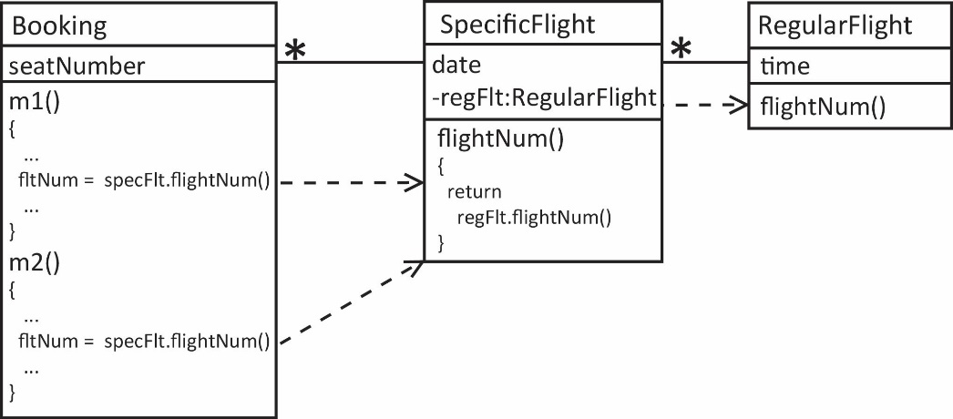

- A better approach is to have a flightNum method in Booking that delegates to SpecificFlight and then m1 and m2 use that method. This reduces the dependence.

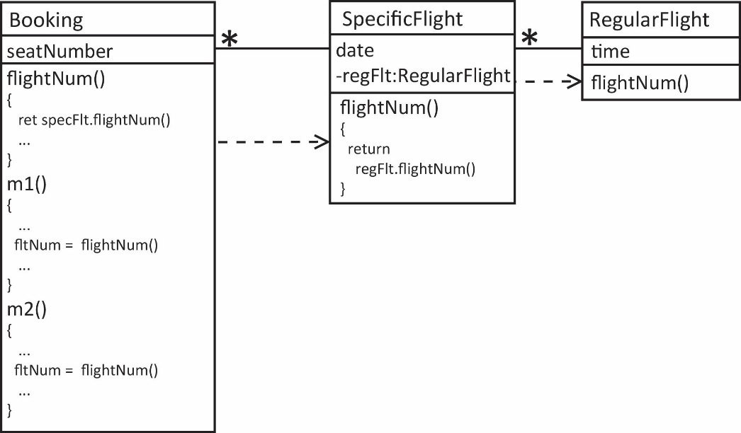

- Why is violation of the Law of Demeter a problem of changing requirements and debugging? If there is a change in RegularFlight not only do we have to look at its neighbors (SpecificFlight), but also the neighbors of neighbors (Booking) to assess the impact.

