Chapter 7 Notes – Adapter Pattern

Context

- Suppose you have a Client class programmed against a Vendor class. Thus, the Client is strongly coupled with the Vendor class and its methods.

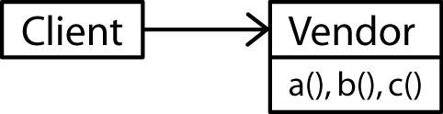

Later, it is decided to change vendors and Vendor2 is selected. Of course, Vendor2 goes about things a little bit differently than the first Vendor. So, the Client must be modified in order to adapt to the new vendor.

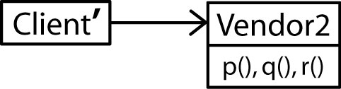

- The Client class encapsulates application logic, which is coupled with the Vendor class and its methods. Thus, modifying the Client code to adapt to the new vendor could result in errors being injected into the application logic. How do we mitigate this situation where we have a Client coded against a Vendor, where the Vendor will change? Two design principles are helpful:

- Identify the aspects of your application that vary and separate them from what stays the same.
- Program to an interface, not an implementation.

The first principle suggests that we separate the application logic from the code tied to the vendor. But, how do we do that? The second design principle provides the answer. We program against an abstraction of all Vendor classes and then use an Adapter to encapsulate vendor specific code required to implement the abstraction (interface). We can even require that Vendors supply the adapter.

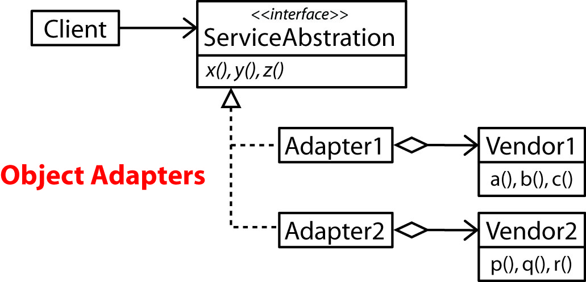

This is an example of the Adapter Pattern.

- The Adapter Pattern:

- Converts the interface of a class into another interface the clients expect.
- Adapter lets classes work together that couldn’t otherwise because of incompatible interfaces.
General Solution

- The general solution is to code the Client against an abstraction and then introduce an Adapter that is composed with the Adaptee and that implements the abstraction.

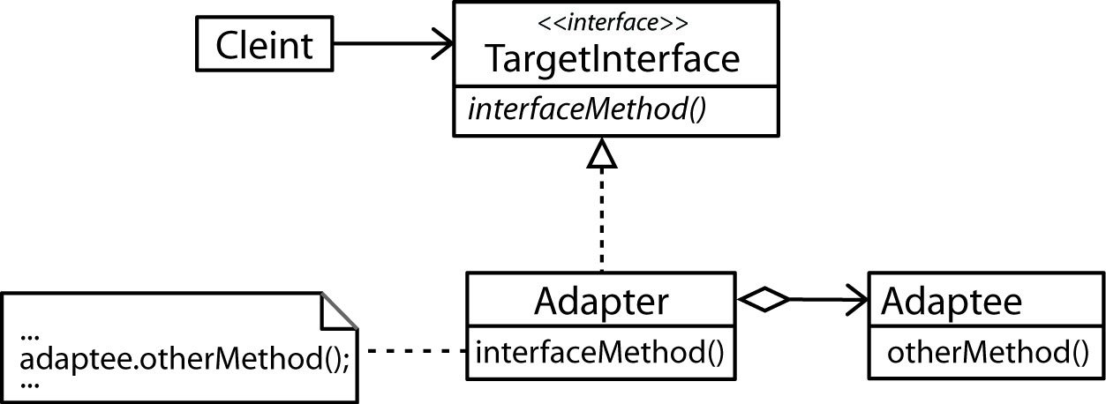

- Non-Software Example:

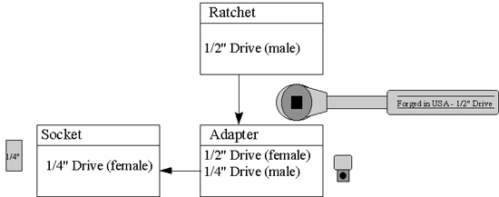

Object & Class Adapters

- The Adapters above are known as object adapters and result in 2 objects (Adapter and Adaptee) at runtime.

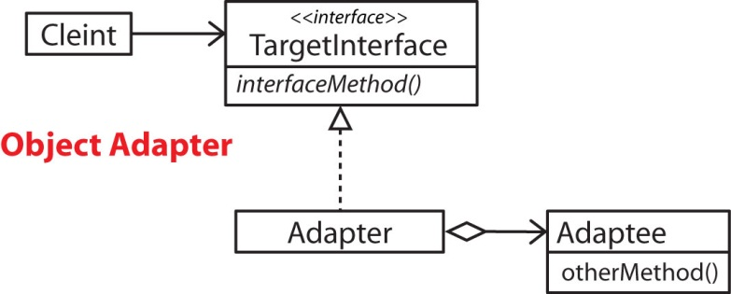 | 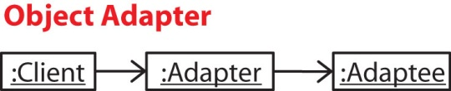

- Class Adapters implement the TargetInterface and extend the Adaptee. A Class Adapter results in 1 object at run-time (Adapter) at runtime.

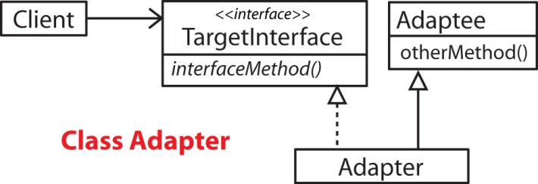 | 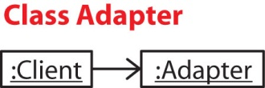

- An object adapter deals with subclasses better than a class adapter. A Vendor subclass can simply be composed with the Adapter when the Adapter is created.

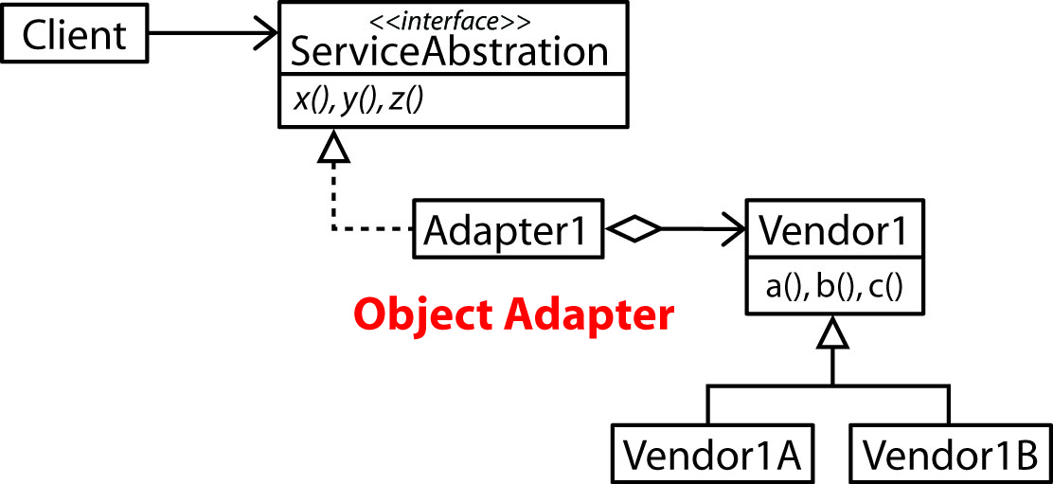

- Class adapters require an adapter for each sub-class.

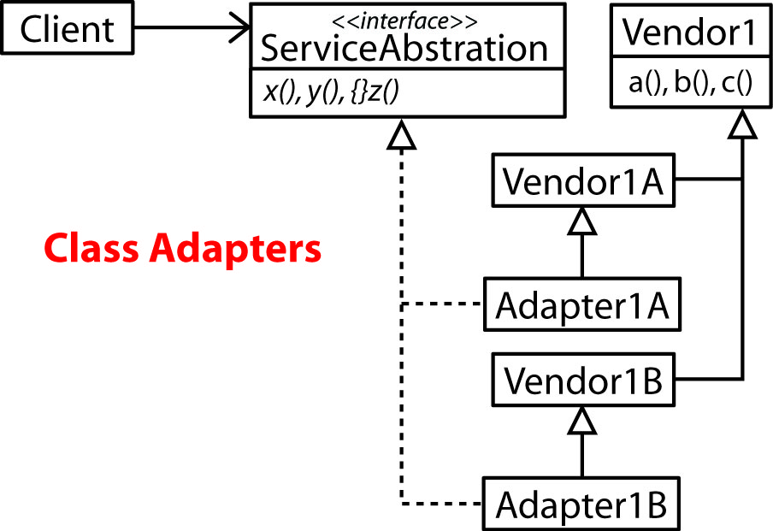

2-way Adapter

- There may be situations where we have an OldClient programmed against an OldInterface that we want to continue to support while a NewClient comes along that needs to be programmed against a NewInterface. In this situation we could use two adapters.

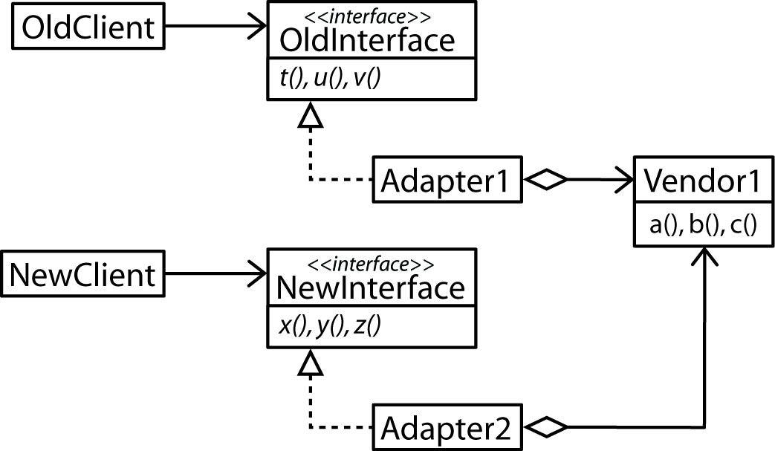

- Or, we could use a 2-way adapter that implements both interfaces.

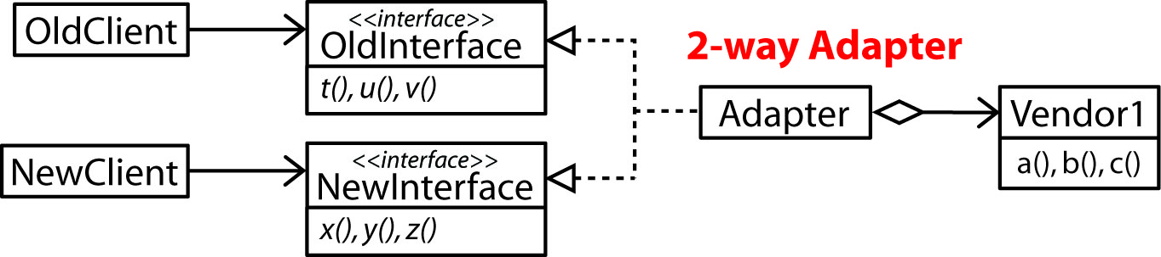

Adapters Facilitate Reuse

- The Adapter Pattern facilitates reuse. For instance, suppose there are some classes in a hierarchy that have potential for reuse, M1 and M2 (see figure below). It is desired to build a system that uses these classes. Instead of “designing around” the reuse classes, we can design a new hierarchy to fit a new problem, independent of the existing reuse classes. We simply use an adapter to connect the new and old hierarchies. In other words, ClassB fits in the new hierarchy, but its implementation delegates to the reuse classes, thus, acting as an adapter.

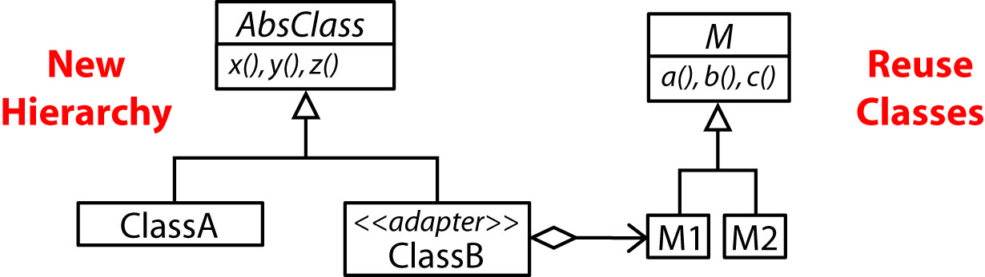

Pluggable Adapter

- A pluggable adapter is one where the adaptee’s interface is not known at compile time. When the adapter is created it is supplied the name of the adaptee’s methods to call (or a map) and an (Object) instance of the adaptee. It then uses reflection to invoke the correct method on the adaptee.

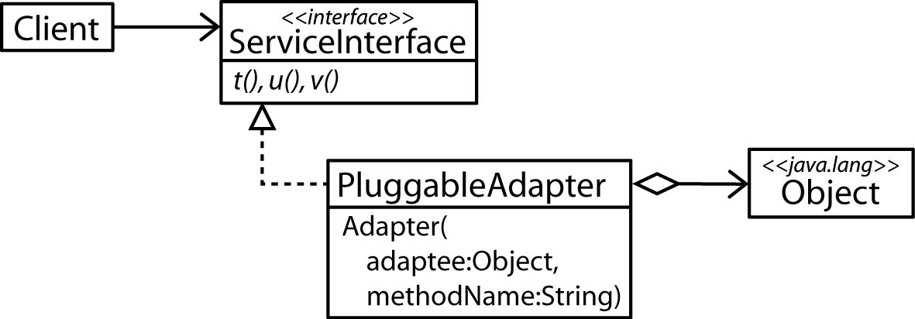

- A pluggable adapter might also use several constructors to differentiate the object being adapted.

Adapter Pattern in Java API

- The Java abstract class WindowAdapter is an adapter of sorts. The JFrame class has a WindowListener which responds to various window events. The WindowListener interface specifies 7 methods which may not all be necessary. Often, only one or two are required. The WindowAdapter is a convenience class as it implements all 7 WindowListener methods with “do-nothing” (e.g. {} ) implementations. Thus, a WindowAdapter subclass need only to implement the methods that it needs.

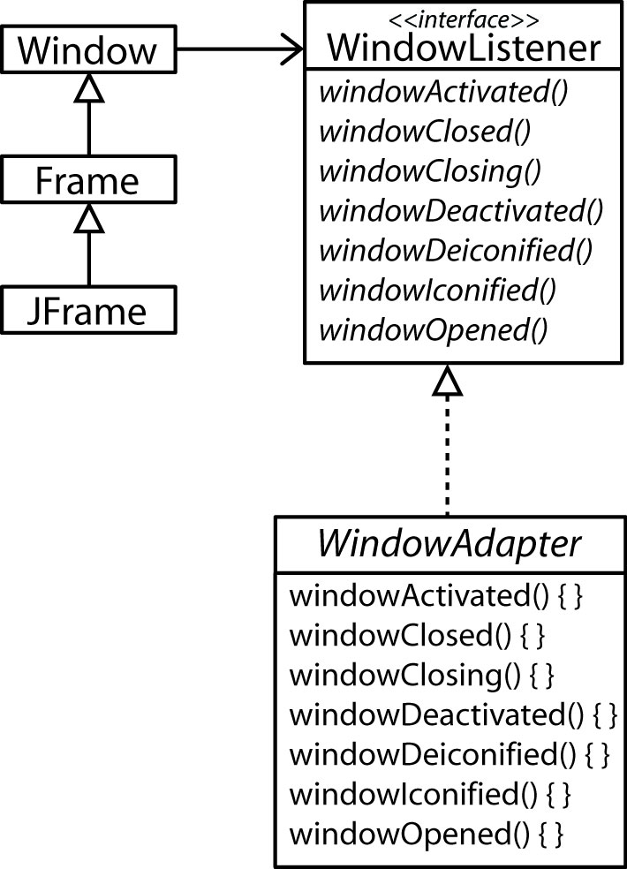

- Example:

JFrame frame = new JFrame();
frame.addWindowListener(
new WindowAdapter() {
public void windowClosing(WindowEvent e) {
System.exit();
}
} );

- There are many other adapters in Java, at least 35. Here are a few more that are similar to the WindowAdapter.

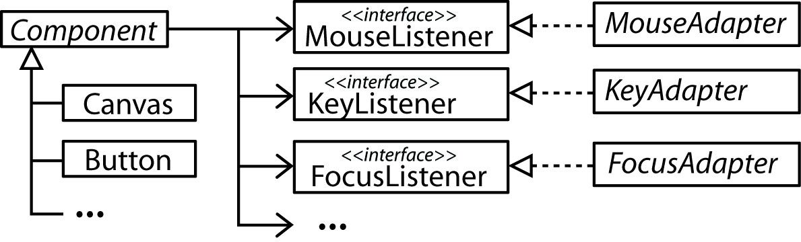

Homework

- Suppose a client needs use a class that provides methods a and b. A class exists, Foo that provides these services in a slightly different way. Foo has methods x,y,z. Service a is equivalent to Foo’s x method while service b is equivalent to calling Foo’s y and z methods in succession. How can we design a framework such that the client can use a and b with no explicit dependencies on Foo? (a) Model with a class diagram. (b) Write all code (in a proof of concept way), (c) write code to show how it is used.

- Explain the difference between an object adapter and a class adapter and also provide a class diagram of each.

- Explain what a 2-way adapter is and also provide a class diagram.

- Provide a simple example of how the Law of Demeter should be used to access a method in a class that is not it’s neighbor.

