Chapter 6 Notes – Command Pattern

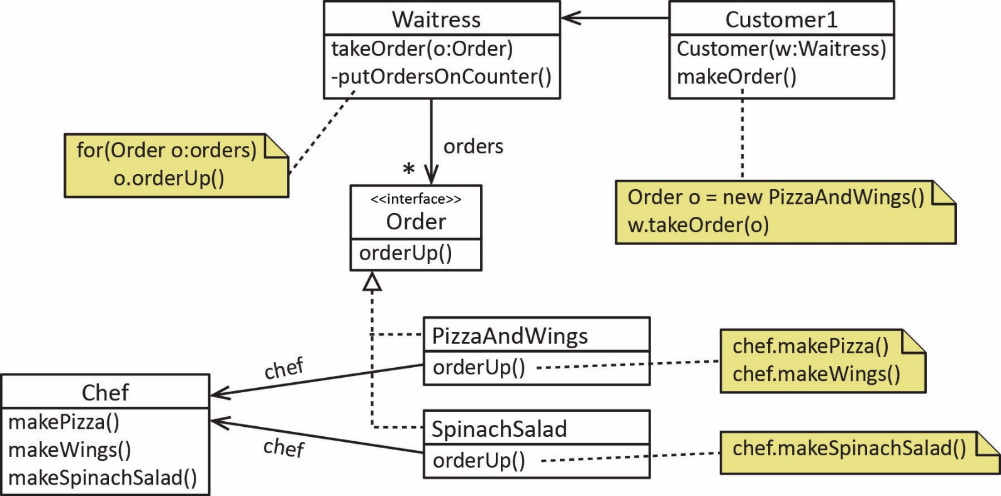

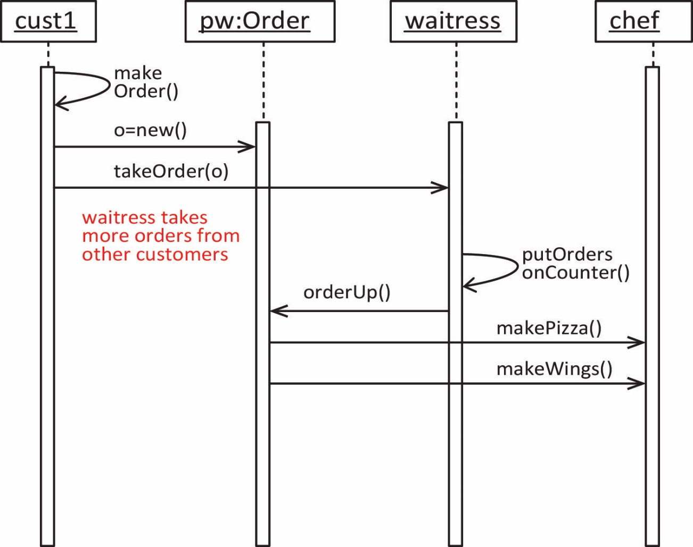

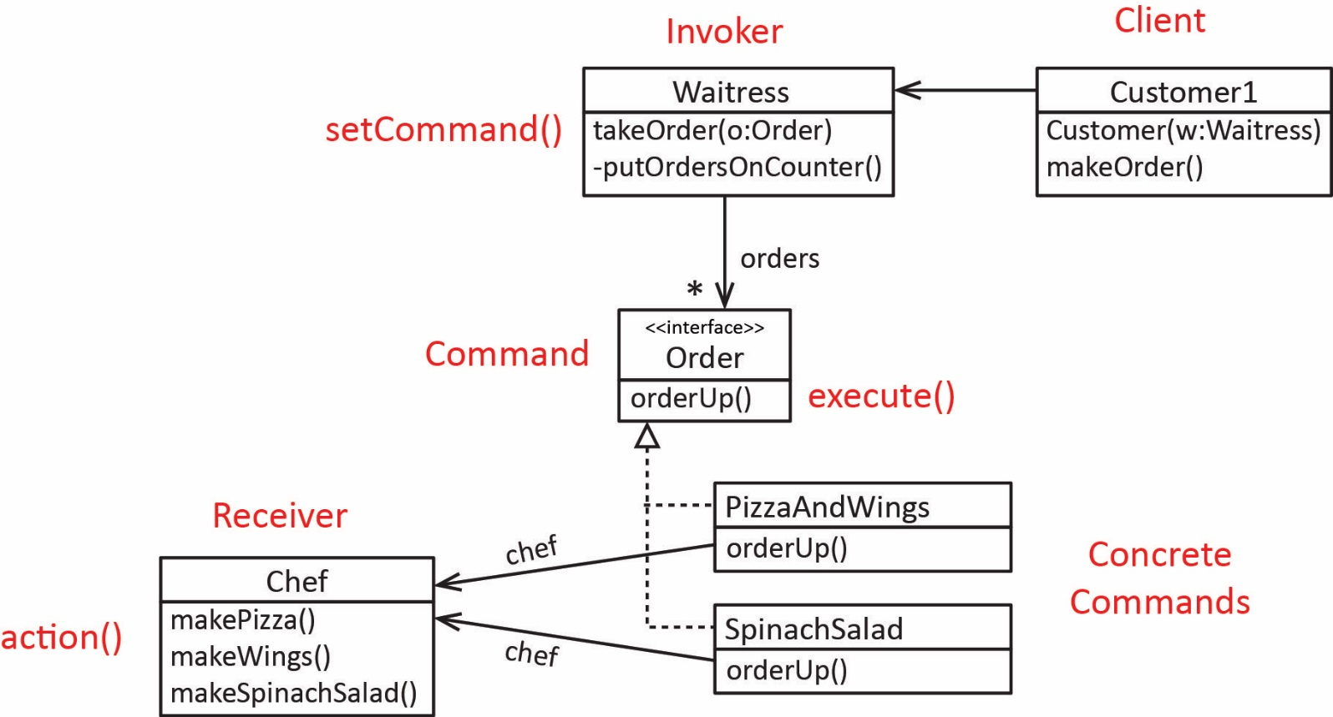

p.193 – “…Let’s check out the Remote Control…”
p.194 – “Taking a look at the vendor classes”
p.201 – “From the Diner to the Command Pattern”
p.203-204 – Simple example with Light
p.209 – “Assigning Commands to Slots”
p.210-213 – Example
p.215 – Documenting the remote API
p.216-218 – Programming the Undo button.
p.220-221 – Using state information to implement undo
p.224-226 – Macro Command

- The Command Pattern encapsulates a request as an object, thereby letting you parameterize other objects with different requests, queue or log requests, and support undoable operations.

You can use the Command Pattern when you need to:

- Control the sequencing , selection, or timing of command execution
- Support undo and redo operations
- Maintain a persistent log of commands that have been executed. You can enhance the doit and undoit methods to support this requirement.

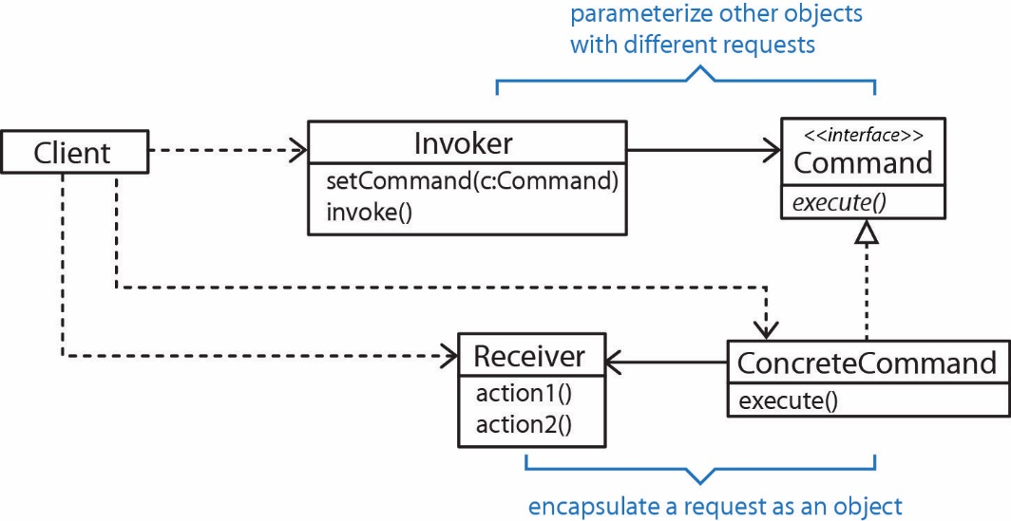

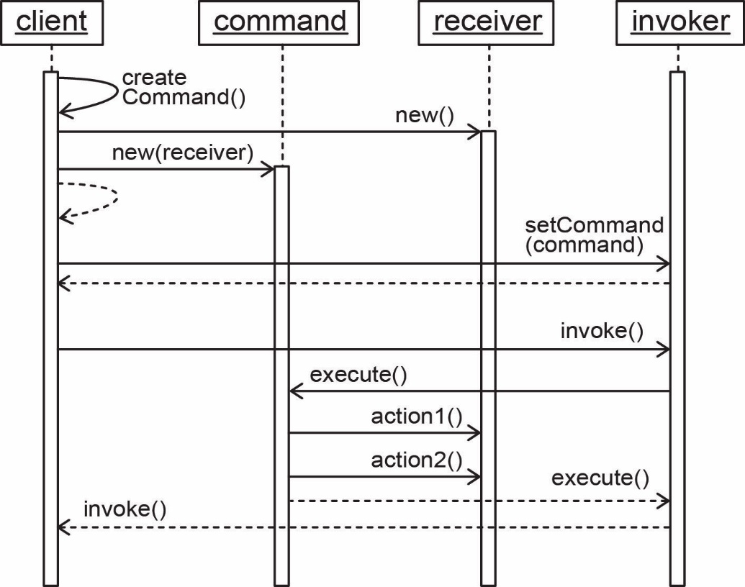

Supports mult-level undo

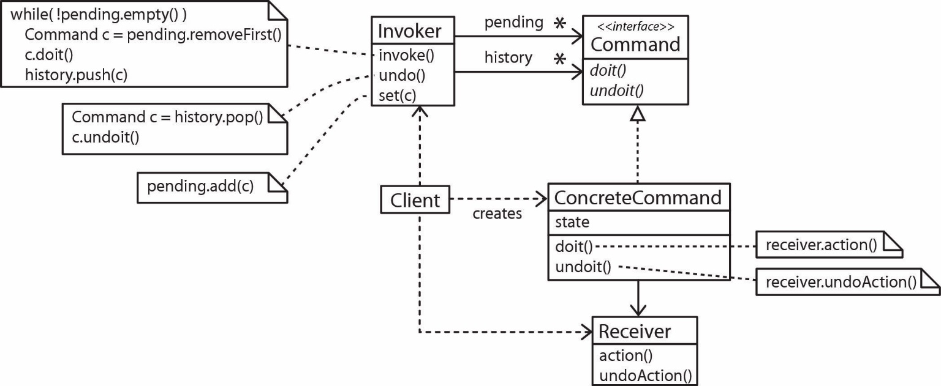
Supports macro commands

