CS 4322 – Coding Assignment 8

See Schedule for due date. You can work individually or in groups of two.

Overview

You have been provided Java code for a simple text editor that supports a few formatting features (bold, italics, underline). The code is organized in an MVC pattern that utilizes the Observer pattern. You will document how the MVC is implemented with a sequence diagram.

Design

In the download you will find 3 packages: model, view, controller. A high-level class diagram:

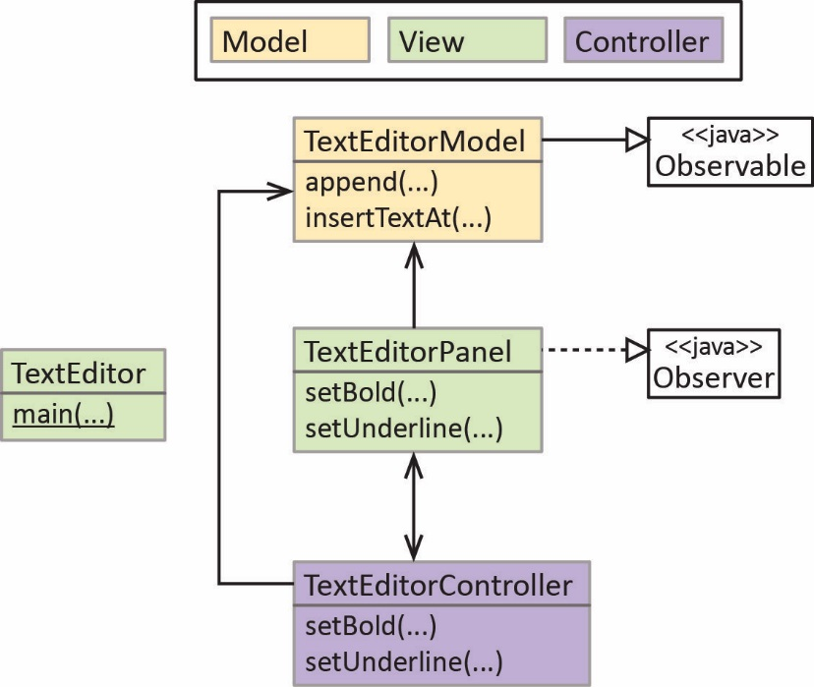

A full class diagram (but only shows 2 methods for each class):
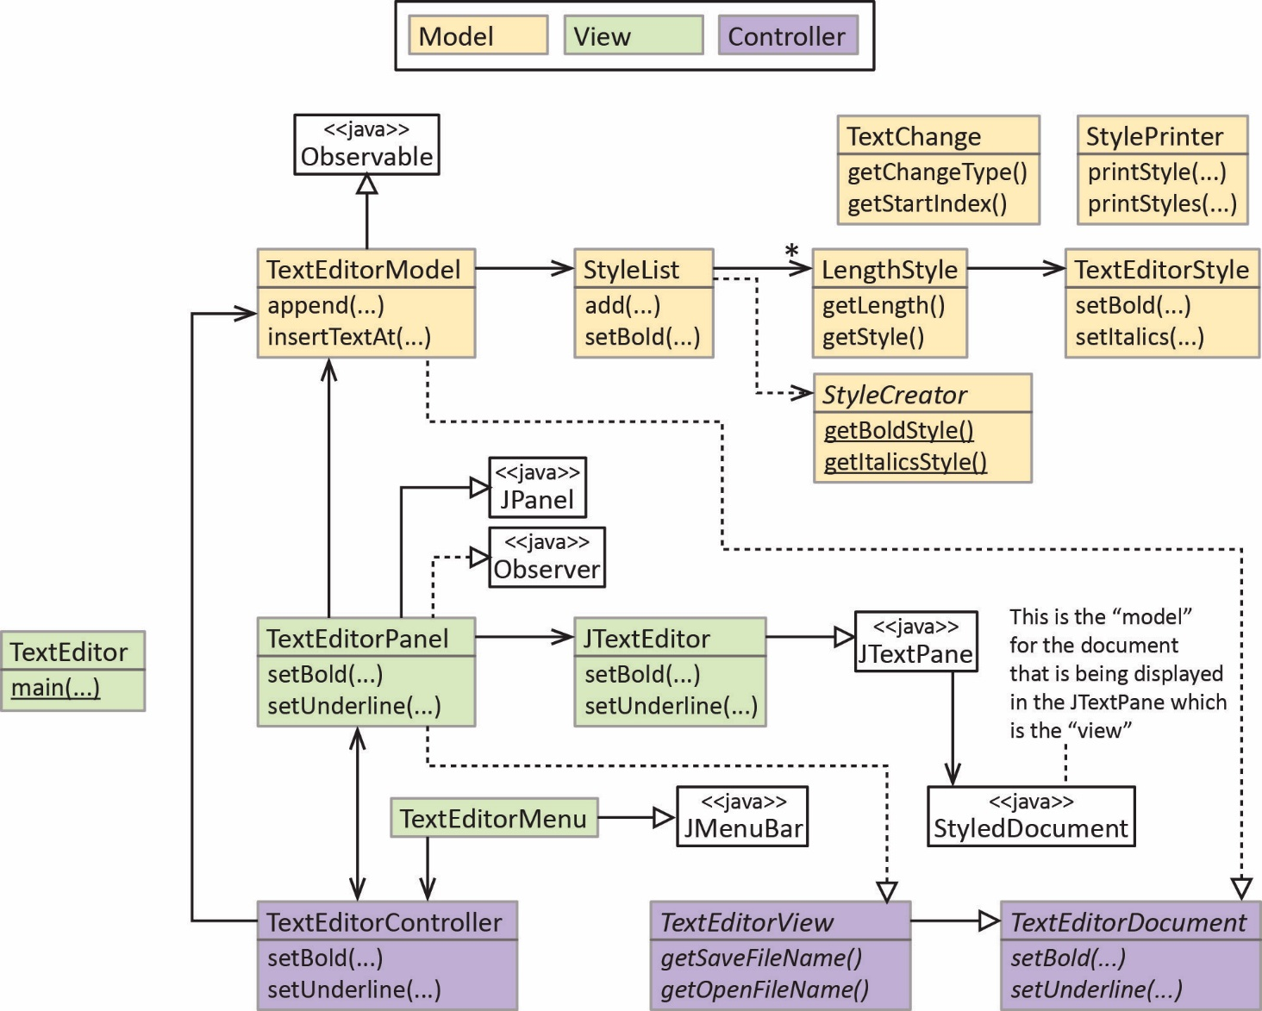

Requirements

- Neatly draw a sequence diagram that documents the use case where some text is set to bold. Use the template provided which lists all the classes of the instances that are involved.

Suggestions/Hints

- Start by opening view/TextEditorPanel and find the BoldActionListener internal class. When the user presses the bold button, actionPerformed is called; this is where the use case begins. Select the method call, setBold, right-click, and choose: Open Declaration. Continue doing this for all method calls. Some will lead to the Java API, ignore those. Continue until you reach doc.setCharacterAttributes(start, length, style, false); which is the line that actually updates the display and where the use case ends.
- At some point you will come across addStylesToRange. Show this call on your diagram, but do not document the internals (it has details that are not important).
- Don’t show any conditional or iterative behavior.
- No return arrows are required.
- No activation boxes are needed.
- No parameters are needed nor (), just the method name
Setup Code in Eclipse

- Create a folder on your drive: CA8_TextEditor
- Open Eclipse, set Workspace to the folder from previous step.
- In Eclipse, choose: File, New, Java Project and give the name: CA 8. Then choose: Finish.
- In Package Explorer, expand to find the src node.
- Download ca8.zip from the Schedule and and unzip. Drag the three folders: model, view, controller to the src folder in the Package Explorer in Eclipse.

Deliverable

Submit paper copy in class on the due date.

