Chapter 5 Notes – Singleton Pattern

Overview

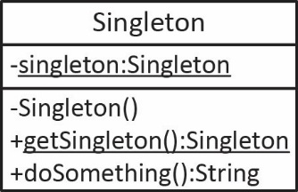
- The intent of the singleton pattern is to ensure that a class has only one instance and provide a global point of access to it. A generalized class diagram is shown on the right.

- Implementation of the classic singleton using lazy instantiation:

public class Singleton {
private static Singleton instance = null;

private Singleton() {
// Exists only to prevents instantiation.
}

public static Singleton getInstance() {
if(instance == null) {
instance = new Singleton();
}
return instance;
}

public String doSomething() {
return "I'm a Singleton";
}
}

Using the singleton:

Singleton singleton = Singleton.getInstance();
System.out.println(singleton.doSomething());

Singleton in Java API

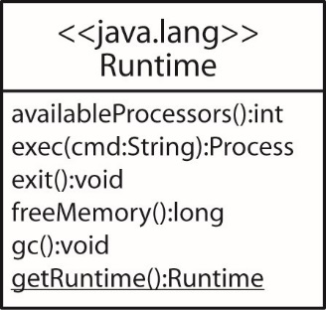
- The Runtime class is a singleton. Every Java application has a single instance of the Runtime class that allows the application to interface with the environment in which the application is running. The current runtime can be obtained from the getRuntime method.

Runtime runtime = Runtime.getRuntime();
// run any executable, in this case notepad
try {
runtime.exec( "notepad.exe" );
} catch (IOException e) {
e.printStackTrace();
}
System.out.println( "num processors=" + runtime.availableProcessors() );
System.out.println( "avail memory=" + runtime.freeMemory() );

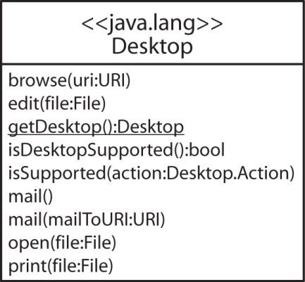
- The Desktop class is a singleton and allows a Java application to launch associated applications registered on the native desktop to handle a URI or a file. The getDesktop method returns the instance. Sample code is shown below (the File and URI instances must be surrounded with try/catch):

Desktop desktop = Desktop.getDesktop();
// Open outlook, can also specify a URI (to, from, etc)
String msg = "mailto:davegibson2@gmail.com?subject=Launched%20From%20Java";
URI uri = URI.create(msg);
desktop.mail(uri);
// Opens this file in notepad
desktop.edit( new File("src\\desktop\\stuff.txt") );
// Opens word with this file.
desktop.edit( new File("src\\desktop\\stuff.docx") );
// opens default browser with this page
desktop.browse( new URI("http://www.valdosta.edu") );
// prints from notepad
desktop.print( new File("src\\desktop\\stuff.txt") );
// prints from word.
desktop.print( new File("src\\desktop\\stuff.docx") );

- As we saw earlier, Toolkit is an abstract factory. Toolkit is also a singleton. The static method, getDefaultToolkit returns a concrete toolkit as a singleton.

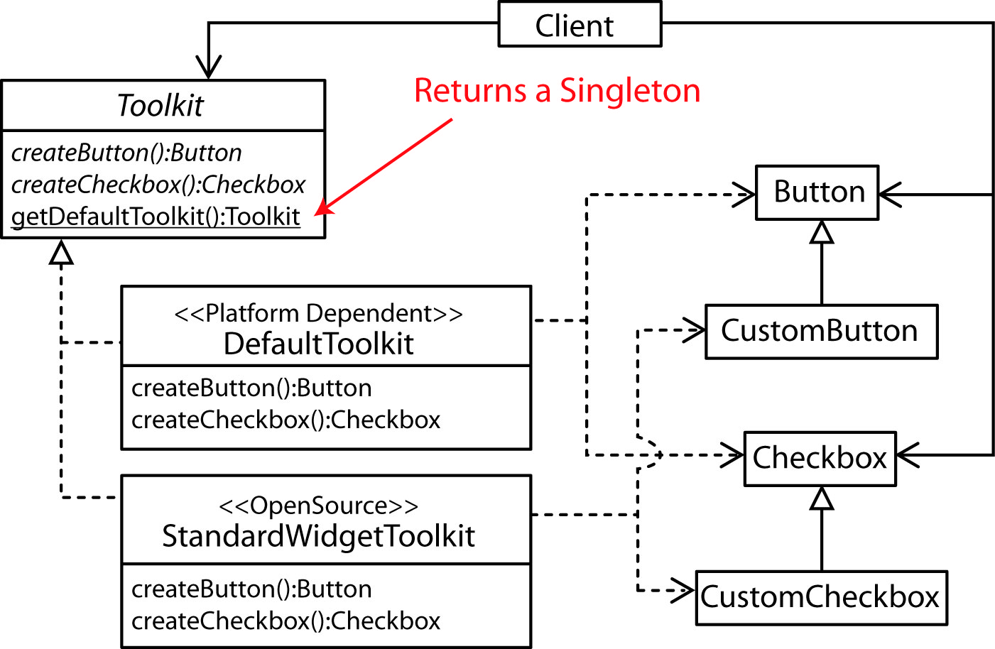

Singleton Issues

- Although rare, the Singleton, as written is not thread safe. If a thread is preempted at Line 2 before the assignment is made, the instance variable will still be null, and another thread can subsequently enter the if block. In that case, two distinct singleton instances will be created.

1: if(instance == null) {
2: instance = new Singleton();
3: }

- A solution is to use double-checked locking.

public static Singleton getInstance() {
if(singleton == null) {
synchronized(Singleton.class) {
if(singleton == null) {
singleton = new Singleton();
}
}
}
return singleton;
}

However, double-checked locking has its own issues:
https://en.wikipedia.org/wiki/Double-checked_locking#Usage_in_Java

- Another solution to the thread problem is to simply use an eagerly created instance:

public class Singleton {
private static Singleton singleton = new Singleton();
protected Singleton() {}

public static Singleton getInstance() {
return singleton;
}
}

- A better way to use the eagerly created singleton approach is to define the Singleton as a static inner class and employ the enclosing class (SingletonWrapper) to retrieve the instance. This has the benefit that inner classes are not loaded until they are referenced. Thus, perhaps we shouldn’t say “eagerly created.”

public class SingletonWrapper {
private static class Singleton {
public static final Singleton singleton = new Singleton();

public String doSomething() {
return "I'm a singleton";
}
}

public static Singleton getInstance() {
return Singleton.singleton;
}

public static void main(String[] args) {
Singleton s = SingletonWrapper.getInstance();
System.out.println(s.doSomething());
}
}

- Another problem with Singletons is that different applications can be using different class loaders. In such a case, each application will obtain a different (unique) singleton. The only solution to this is to specify the class loader to be the one that loaded the singleton originally. An incredibly thorough read in singleton can be found here:

https://www.securecoding.cert.org/confluence/display/java/MSC07-J.+Prevent+multiple+instantiations+of+singleton+objects

- This blog post, “Why Singletons are Evil” is a good read. In summary:

- Singleton, as any global variable, creates hidden dependencies in your code. Non-static objects are passed to methods and thus the dependency is explicit. With singleton you have to inspect the code to see where it is used.
- Violation of the “Single Responsibility Principle.” A class should not care whether it is a singleton; it should only be concerned with its business responsibilities.
- Classes that use the singleton are tightly coupled with the singleton and are harder to test.
- Singletons carry state with them as long as the program runs. This can hide bugs when testing as the state is carried from test to test.

https://blogs.msdn.microsoft.com/scottdensmore/2004/05/25/why-singletons-are-evil/

Real-World Singleton Examples

- Apache Tomcat is an open source servlet container (application server) which provides a "pure Java" HTTP web server environment for Java code to run. It utilizes a StringManager singleton registry to process error messages. Error messages are cataloged by the package that contains a class. It contains a getManager(packageName) method that returns a singleton from which error information can be obtained.

Source: http://onjava.com/onjava/2003/08/27/singleton.html

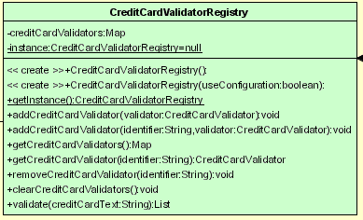
- Another real example is a component used for Credit Card Validation:

http://software.topcoder.com/catalog/c_component.jsp?comp=10515357&ver=1

Homework

- Consider a class, LogData that stores the date, and time that a resource was accessed. Suppose you need a Logger class that stores instances of LogData at various places in a software system. For example, in certain methods of the system you want to create an instance of LogData and have the Logger store it. The Logger class should also provide a list of LogData that has been stored. Write the Logger class as a singleton and provide code showing how it is used. For the purposes of this problem, simply define the LogData class like this:

import java.util.GregorianCalendar;

public class LogData {
private GregorianCalendar cal;

public LogData(GregorianCalendar cal) {
this.cal = cal;
}

@Override
public String toString() {
// Short Date Format
String date = String.format("%tm/%td/%ty",cal,cal,cal);
// Short Time Format
String time = String.format("%tl:%tM:%tS %tp",cal,cal,cal,cal);
return date + " " + time;
}

public static void main( String[] args ) throws InterruptedException {

LogData logData1 = new LogData(new GregorianCalendar());
Thread.sleep(2000);
LogData logData2 = new LogData(new GregorianCalendar());
System.out.println(logData1);
System.out.println(logData2);
}
}

