Chapter 4 – Factory Method Pattern Notes

Simple Factory

- The simple factory is not really a pattern, it is just something you should do based on basic design principles. It simply says that when object creation takes more than a few lines we should wrap up that creation in its own class. Many times the simple factory has static methods for creating objects, although it doesn’t have to

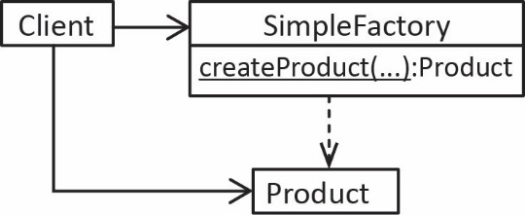 | 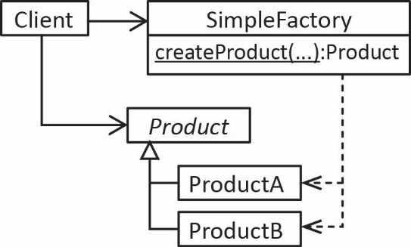
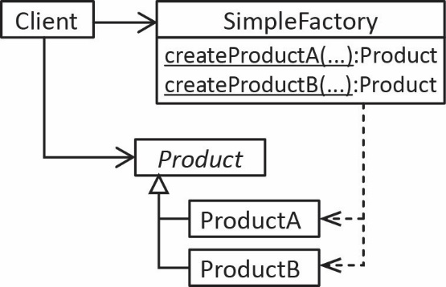

- The BorderFactory is a simple factory found in the Java API which has static methods for creating various borders. It also serves as a Façade to the Borders. One advantage to using the BorderFactory is that it provides shared instances. In other words, if two components each require a BevelBorder, then by using the BorderFactory only one instance of BevelBorder is created. Two other simple factories are: BasicIconFactory, ColorChooserComponentFactory.

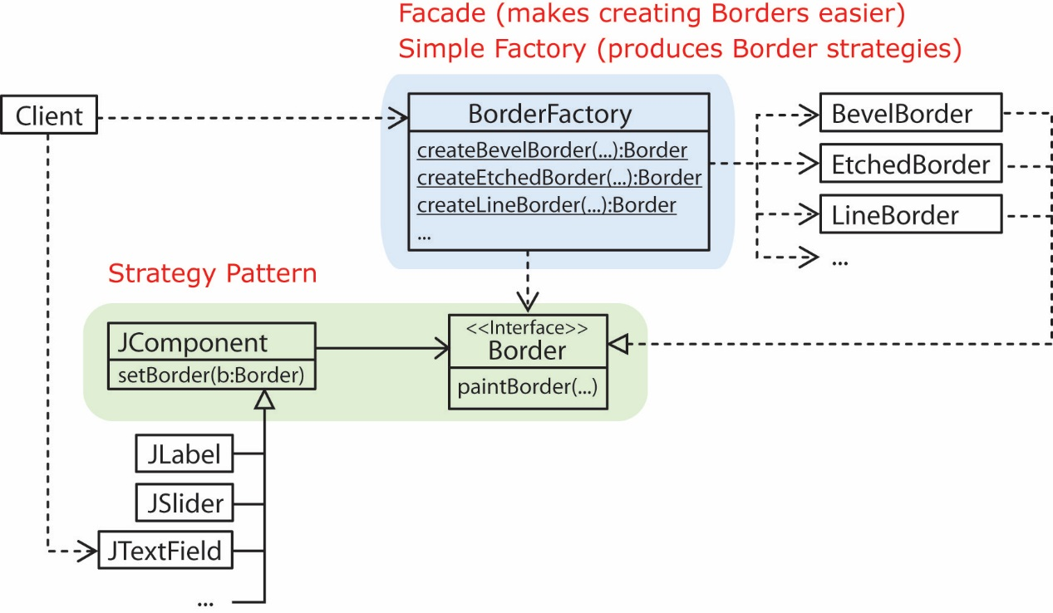
Factory Method Pattern

- The factory method pattern is simply an abstraction of the simple factory which allows new products to be added without modifying the factory. By doing so, it adheres to the design principle of programming to an interface, not an implementation.

- The Factory Method pattern defines an interface for creating an object, but lets subclasses decide which class to instantiate. Factory Method lets a class defer instantiation to subclasses. The intent of the Factory Method pattern is to relieve a client from having to know which class to instantiate.

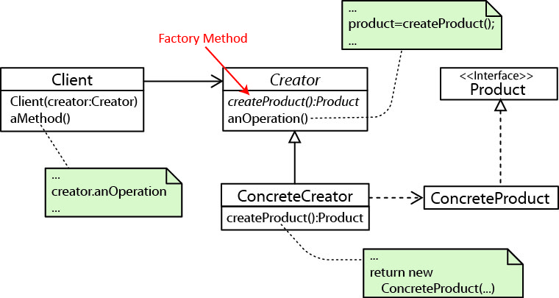

Usually, as shown in the UML above (and the example from the text), the Client calls a concrete method (anOperation) that that utilizes a factory method (createProduct) to create and product and manipulate it.

Client c = new Client( new ConcreteCreator );
c.anOperation();

In other cases, the Client calls the factory method directly in order to obtain a product.

- The example from the text shows that the driver calls the concrete orderPizza (template) method which creates a pizza with the factory method, createPizza, then builds the pizza, and returns it.

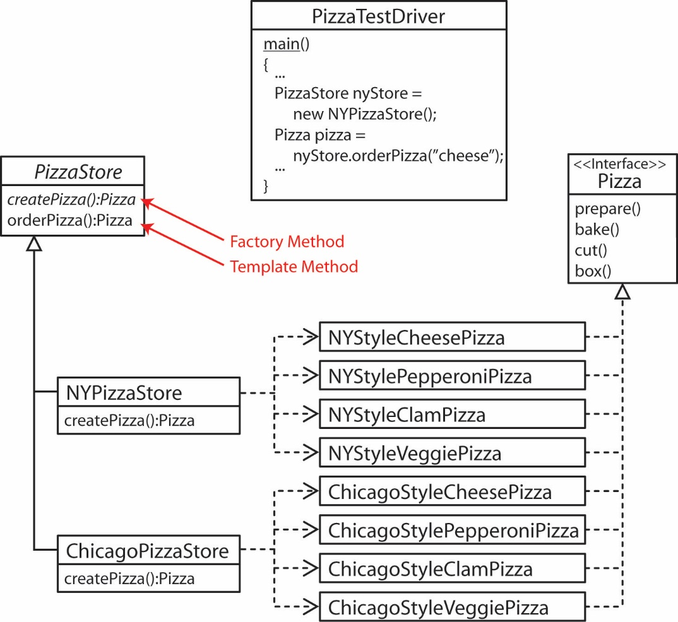

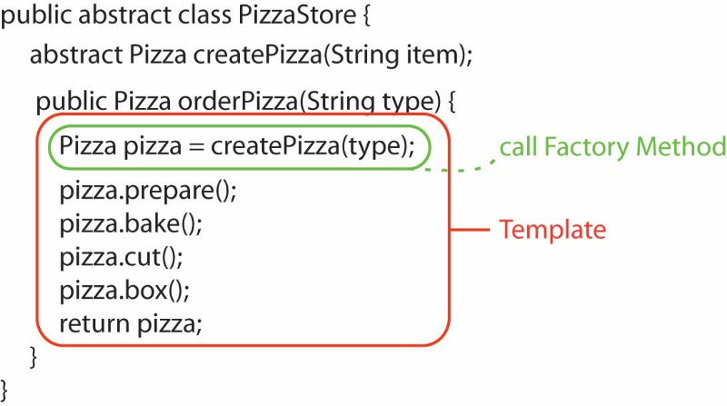

Factory Method in Java

- The iterator method specified in the Collection interface is a Factory Method. The Collection interface specifies that any class that wants to be a Collection must specify an iterator method that returns an instance that implements the Iterator interface.

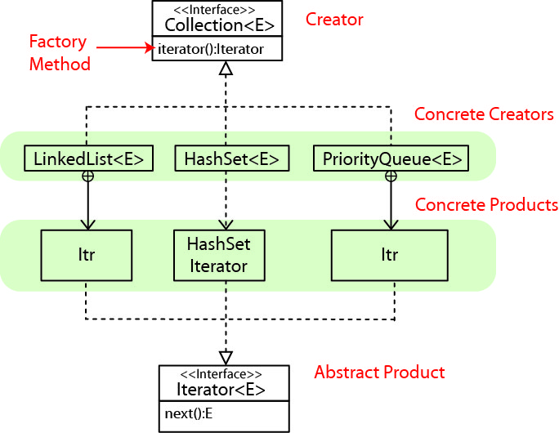

See the code in ArrayList class, lines 773, 780:
http://www.docjar.com/html/api/java/util/ArrayList.java.html

Clients of course can use the Iterator directly, but also the JVM utilizes an iterator when a client uses the enhanced for loop (for-each loop).

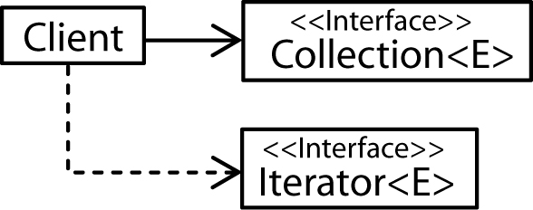

- Java provides a DataSource interface that provides a specification for a Factory Method, getConnection for use in accessing data bases. Vendors supply classes that implement the DataSource interface, thus an implementation for getConnection which returns a Connection object for that particular Vendor’s product. Thus, clients can be coded against the Connection interface and not have to even be aware of the concrete connection class.

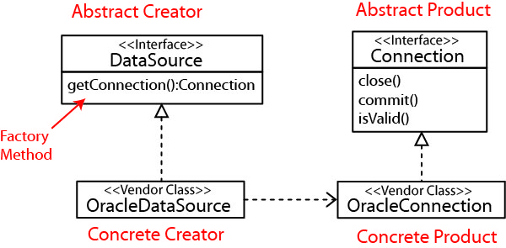

- ContentHandler’s are used to get the content from the URLConnection. The Java interface ContentHandlerFacotry has a factory method, createContentHandler which returns a ContentHandler (abstract product) for a specified MIME type (e.g. gif, text, etc). The ContentHandler has a method which provides a getContent method which returns the content of a URLConnection.

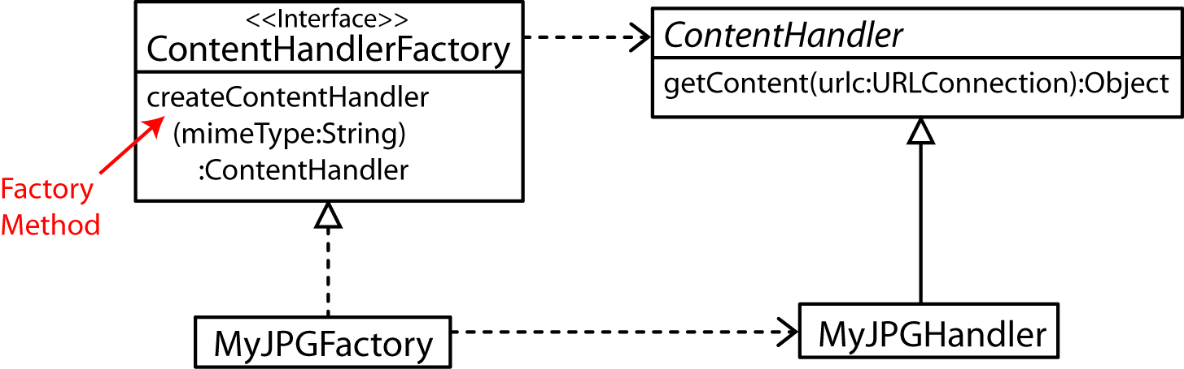

- The TableCellRenderer is a factory interface with a factory method: getTableCellRedererComponent used for drawing a cell in a JTable. The DefaultTableCellRenderer class implements this interface and is used for simple JTables. An Example.

Generic Editor Example

- Consider the Generic Editor that illustrates the Factory Method pattern as found in:
http://www.java2s.com/Code/Java/Design-Pattern/FactoryMethodPatterninJava.htm

One concrete factory produces a “Contact” editor: |  | Another concrete factory produces an “Employee” editor:
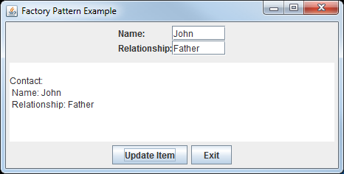 |  | 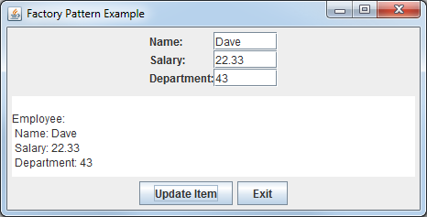

- Consider the design:

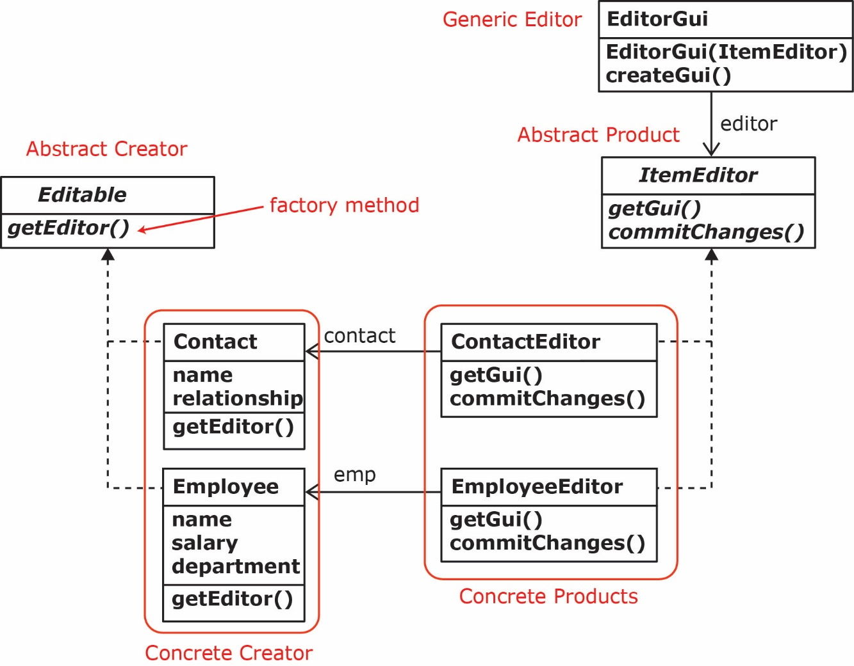

Homework

Suppose we have an abstract Shape class with subclasses: Triangle and Circle. We need a class with a method to draw a list of shapes. Drawing simply consists of looping through a list of shapes and displaying them on the console (toString). This method should accept a string that contains shape data. Sometimes we will use this class and method to parse the string to find all the triangles and display them. And, we can keep feeding different strings and displaying the triangles. Other times we need a different instance to display the circles. The string can contain any text and embedded within are triangles in the format: "triangle side1Len side2Len side3Len" and circles: "circle radius". For example, the string might look like this:

"When you are lost, a triangle 3.0 2.0 4.4 is a good thing to find. Often, though a circle 3.3 appears out of nowhere. Later you might find another triangle or a circle 5.0. Later you might drop a triangle 5.6 6.7 7.8 into a bucket."

This example had 2 triangles and 2 circles. Keep in mind that there could be any number. Also, that when parsing the string sometimes you are only interested in triangles. In another situation you are only interested in circles.
- Use the factory method pattern to model this situation with a class diagram.
- Write the code for all classes. Code for Shape, Triangle, and Circle provided below. Also supplied is code for doing the parsing. I supply all this code in case you want test out your design.
- Write some code to show how this works.

Code to do Triangle parsing

// Does not handle case where data ends with a punctuation mark. For example:
// s="...triangle 1.0 2.0 3.0. Green eggs and ham." will fail to detect the triangle.

String s = "When you are lost, a triangle 3.0 2.0 4.4 is a good thing to find. " +
"Often, though a circle 3.3 appears out of nowhere. " +
"Later you might find another triangle or a circle 5.0 . " +
"Later you might drop a triangle 5.6 6.7 7.8 into a bucket.";

List<Shape> shapes = new ArrayList<>();
String[] tokens = s.split(" ");
int i=0;
while(i<tokens.length) {
if(tokens[i++].equals("triangle")) {
double[] sides = getSides(tokens,i);
if(sides!=null) {
shapes.add(new Triangle(sides[0],sides[1],sides[2]));
}
i+=3;
}
}

// Helper methods
private boolean has3MoreTokens(String[] tokens, int i) {
return (i+2)<tokens.length;
}

private boolean areNext3TokensDoubles(String[] tokens, int i) {
for(int j=i; j<i+3; j++) {
try {
Double.parseDouble(tokens[j]);
}
catch(NumberFormatException e) {
return false;
}
}
return true;
}

public double[] getSides(String[] tokens, int i) {
if(!has3MoreTokens(tokens, i)) return null;
if(!areNext3TokensDoubles(tokens,i)) return null;
double[] sides = new double[3];
for(int j=0; j<3; j++) {
sides[j] = Double.parseDouble(tokens[i++]);
}
return sides;
}

Code to do Circle parsing

// Does not handle case where data ends with a punctuation mark. For example:
// s="...circle 3.3. Green eggs and ham." will fail to detect the circle.

String s = "When you are lost, a triangle 3.0 2.0 4.4 is a good thing to find. " +
"Often, though a circle 3.3 appears out of nowhere. " +
"Later you might find another triangle or a circle 5.0 . " +
"Later you might drop a triangle 5.6 6.7 7.8 into a bucket.";

List<Shape> shapes = new ArrayList<>();
String[] tokens = s.split(" ");
int i=0;
while(i<tokens.length) {
if(tokens[i++].equals("circle")) {
Double radius = getRadius(tokens,i);
if(radius!=null) {
shapes.add(new Circle(radius));
}
i++;
}
}

// Helper method
public Double getRadius(String[] tokens, int i) {
if(i>=tokens.length) return null;
Double radius = null;
try {
radius = Double.parseDouble(tokens[i]);
}
catch(NumberFormatException e) {
}
return radius;
}

Shape, Triangle, Circle classes

public abstract class Shape {
private String color;

protected Shape() {
this.color = "Purple";
}
protected Shape(String color) {
this.color = color;
}

public String getColor() {
return color;
}

public void setColor(String color) {
this.color = color;
}

public abstract double getArea();
}

public class Triangle extends Shape {
private double side1, side2, side3;

public Triangle(double side1, double side2, double side3) {
this.side1 = side1;
this.side2 = side2;
this.side3 = side3;
}

public double getSide1() {
return side1;
}

public double getSide2() {
return side2;
}

public double getSide3() {
return side3;
}

public double getArea() {
double s = (side1 + side2 + side3) / 2;
return Math.sqrt(s * (s - side1) * (s - side2) * (s - side3));
}

@Override
public String toString() {
return "Triangle: side1 = " + side1 + ", side2 = " + side2 +
", side3 = " + side3;
}
}

public class Circle extends Shape {
private double radius;

public Circle(double radius) {
this.radius = radius;
}

public double getRadius() {
return radius;
}

public void setRadius(double radius) {
this.radius = radius;
}

@Override /** Return area */
public double getArea() {
return radius * radius * Math.PI;
}

@Override
public String toString() {
return "Circle: radius = " + radius;
}
}

