Chapter 1 Notes – Strategy Pattern

Definition

- Intent: Define a family of algorithms, encapsulate each one, and make them interchangeable.

- By associating the client with a strategy/algorithm we allow different objects to use different algorithms and to swap algorithms at run-time.

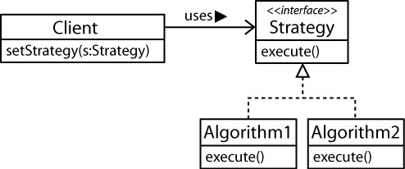

- Design Principles:

- Identify the aspects of your application that vary and separate them from what stays the same.
- Program to an interface, not an implementation.
- Favor composition over inheritance.

Describe how each of these principles is illustrated in the strategy pattern.

Strategy in Java

- The TreeSet constructor can take a Comparator.

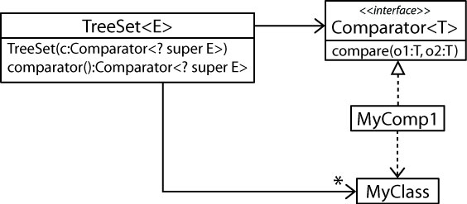

TreeMap, and Collections.sort are similar.

- The JComponent class utilizes strategy with the Border interface while the Container class utilizes strategy with the LayoutManager interface. JComponent utilizes the strategy pattern in a number of other places as well.

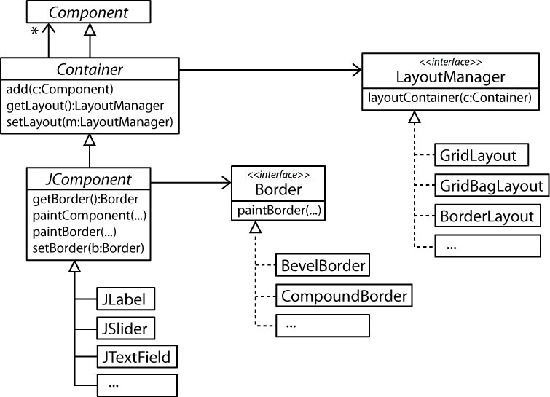

- A checksum is a value that can be used to verify the integrity of data and there are many different ways to calculate a checksum. Thus, the CheckedInputStream class utilizes the strategy pattern to associate a checksum algorithm (Adler32 or CRC32) with the input stream. As we will see in Chapter 3, CheckedInputStream is a Decorator.

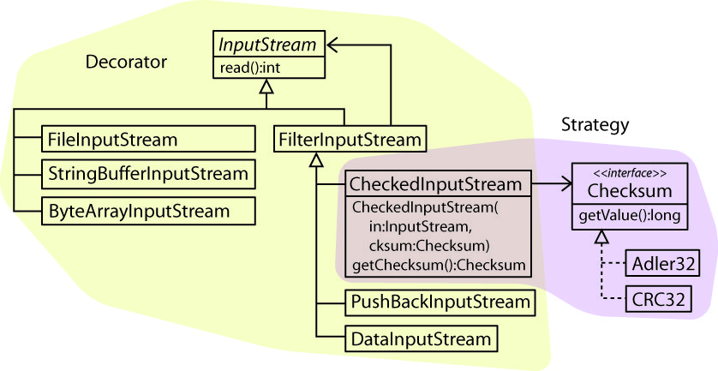

StackExchange – Software Engineering

- SMS & Email Password Reset - https://softwareengineering.stackexchange.com/questions/306836/strategy-pattern-implementation
- Strategy has strategies - https://softwareengineering.stackexchange.com/questions/326179/implementing-strategy-pattern-multiple-variables

Other Examples

- Almost any type of simulation/game. For example a basketball player could have an offensive strategy (set, motion, zone), defensive strategy (man-to-man, 2-3 zone, 1-3-1 zone), and maybe even a bench strategy (sullen, rowdy, poised).
- Chess – Pawn, Bishop, Rook, etc move differently.
- Animals in a simulation may have a number of strategies: forage, hunt, rest, sleep, eat
- Overtime pay – Different types of workers (Hourly, Salaried, Manager, etc) are paid overtime differently.
- Online shopping – A shopping website suggests products in a sidebar, perhaps depending on the type of user: anonymous or registered. Suggestions could be: random, best sellers, clearance, sales items, new products, etc.
- Online shopping – tax calculations for purchase orders depend on the state the purchaser is in.
- Online shopping – Different types of coupons have different discounts.
- File formats – read (or write) files in different formats.
- A date class that can format dates in numerous ways, including a custom format.
- A graph can be drawn as bar graph, line graph, pie chart, etc.
- A component to generate SQL statements for different databases (Oracle, SQL Server, MySQL)
- Compress files with different algorithms.
- Drawing graphics with different algorithms (anti-alias, direct, others)
- Forecasting demand (or anything) using different techniques.
- Line-breaking algorithms.

