Coding Assignment 2

You can work individually or in groups of 2.

Problem

Consider the Store and Employee classes below. The Employee class was considered in a previous assignment and you can consider it to be fully tested. You will use the category-partition method to construct a test specification and JUnit tests for the two Store methods: addEmp and removeEmployee.

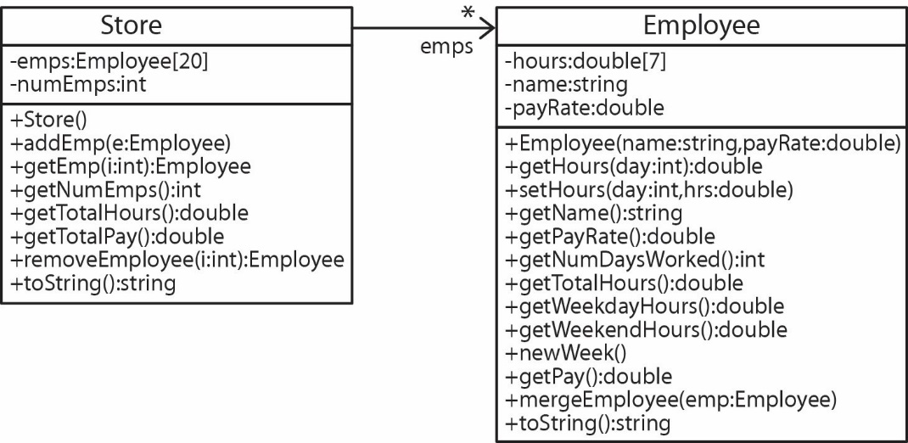

- emps – An instance variable, which is an array that can hold up to 20 Employee objects. Employees are stored sequentially, with no gaps, starting with position 0.
- numEmps – An instance variable that stores the total number of Employee objects in the emps array. Initially this value is 0.
- addEmp(e:Employee) – Adds the Employee, e in the next available position. If there are already 20 employees and there is an attempt to add another then this method should do nothing, but should not crash.
- getEmp(i:int):Employee – Returns the employee at position i if there is one, otherwise returns null.
- getNumEmps():int – Returns the number of employees.
- getTotalHours():double – Returns the total number of hours worked over all the employees.
- getTotalPay():double – Returns the total pay worked over all the employees.
- removeEmployee(i:int):Employee – Removes the employee at position i if there is one and returns it. All other employees to the right should be moved over one position to the left. If i is out of range then return null.
- toString():string – Returns a message with this format: like the one shown below (for example, if there are 3 employees).

Steps

- You will keep a Time Log for this (and all) assignments. Please see the Time Log section below.

- Use the category-partition method to develop a test specification for addEmp. Document the steps you took to arrive at this providing rationale as appropriate. The more I can see your thought process the better. Type your results in a document in the format shown in Appendix A.

- Repeat Step 2 using removeEmployee.

- Find the code link on the Schedule and download ca2.zip. Drag the Store class into an Eclipse project. Drag in the Employee class from CA 1.

- Develop JUnit tests for each method from the specification.

Deliverables

- Code – zip the prob1 package which includes your JUnit test class, Store class, Employee class, time log(s), and Test Derivation document, and possibly your time log(s) if not contained in Test Derivation Document. Name the zip file: LastName1_LastName2.zip and submit on Blazeview in the dropbox named, CA 2.

Time Log

If working in a group, each person should make a Time Log. They can be submitted as separate files or both on one page. If submitting with separate files, name the file: your_name_time_log.docx

Track your time using this table. Delete empty rows, add if needed. Put the total time at bottom. Delete everything above and submit (in your prob1 folder) everything below saved as a word document.

Coding Assignment 2 - Time Log

Name:

Time (hrs) | Task
 | Total Time (hrs)

Appendix A

Document template for submission. Delete this line and everything above it before submitting. Name file: ca2_lastName1_lastName2_testDerivation.docx.

Coding Assignment 2

Name(s)

addEmp(e:Employee) Test Derivation

[Format anyway you choose. Remove this comment before submitting.]

removeEmployee(pos:int):Employee Test Derivation

[Format anyway you choose. Remove this comment before submitting.]

Time Logs

[Can include the Time Log(s) here or as separate files. Remove this comment before submitting.]

