Sprint 1 – Demo

Contents
1 Deliverables 1
2 Constraints 1
3 Agenda 1
Appendix 1 Kaltura Instructions 2

Deliverables
- Put a link to your video at the very top of the README section of your GitHub repo titled: Sprint 1 Demo.

Constraints
Your Sprint 1 Demo will be a video, 11-20 minutes in length. Adhere to these constraints:
- Create a video using Kaltura Capture (directions in Appendix) or any other video recording software (but not a phone) following the agenda below.
- You can host the video in Kaltura, OneDrive, or YouTube.
- MAKE SURE I (dgibson@valdosta.edu) HAVE PERMISSIONS TO VIEW VIDEO!
- Your video must be narrated throughout.
- Speak clearly and loud enough as if someone 5 feet away could hear you.
- It is fine for your camera to be off.
- Where possible, the font size (or screen zoomed) should be increased for more accurate viewing.
- Do not scroll too quickly, i.e. don’t rush. However, adhere roughly to the suggested time ranges in the Agenda below.

Agenda
Your video should follow the agenda below.
Topic | Description | Time (min)
MVC | Show your code and briefly illustrate how MVC was adhered to. You can use a single example to trace through the code | 2-4
Persistance | Show your code and briefly illustrate how your system maintained persistence. You can use a single example to trace through the code. | 2-4
Unit Testing | Show and explain one unit test | 1-2
Integration Testing | Show and explain one integration test implemented as a unit test | 1-2
Demo | State the user story and acceptance test, demo, repeat, using happy path tests. Pick 3 user stories and show at least 1 sad path test for each. | 5-10
Total |  | 11-22

Appendix
- Kaltura Instructions
- Login into Blazeview for this course.
- In the upper-right, choose: Kaltura, My Media
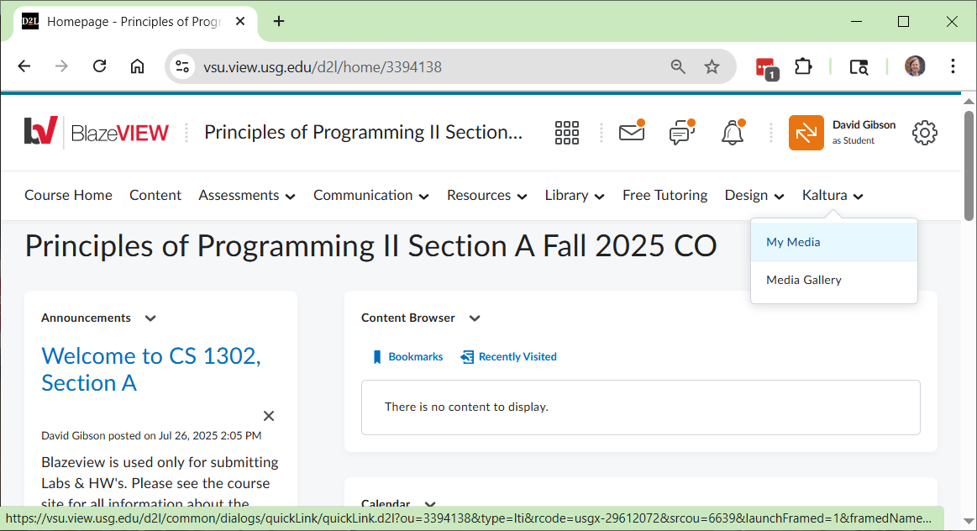
- Choose: Add New, Kaltura Capture
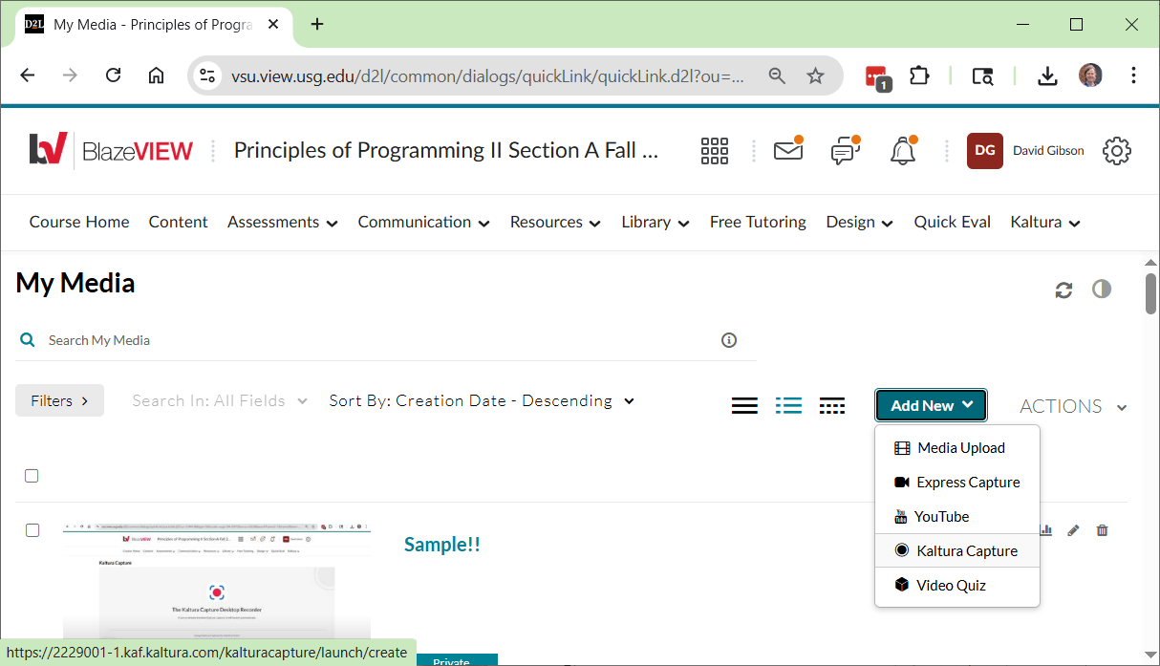

- The window below will be displayed. It will open Kaltura Capture from your computer, if you have it installed. Otherwise, as it says at the bottom, you need to download it (in which case, you may need to repeat the steps above).
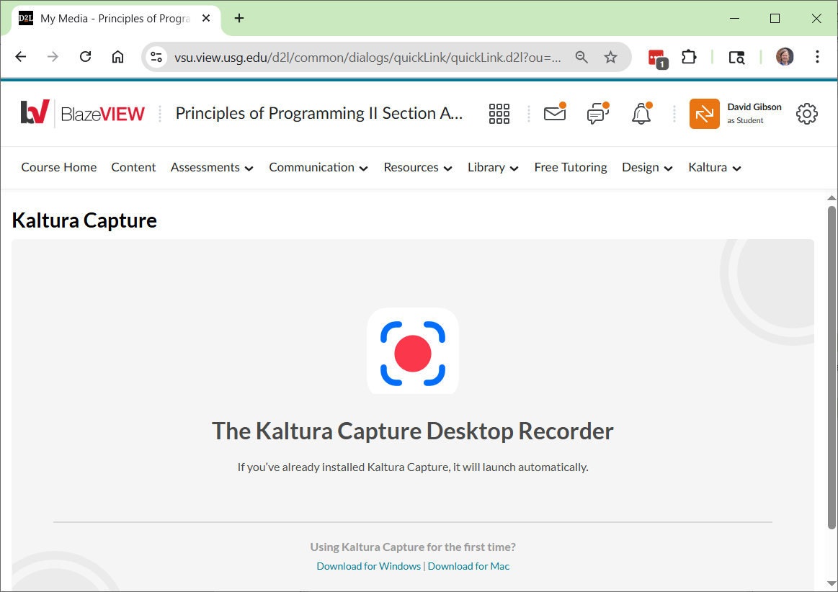
- Once Kaltura Capture is open, IF you see the screen below, if the upper-right, choose: New Recording. Otherwise, go to the next step.
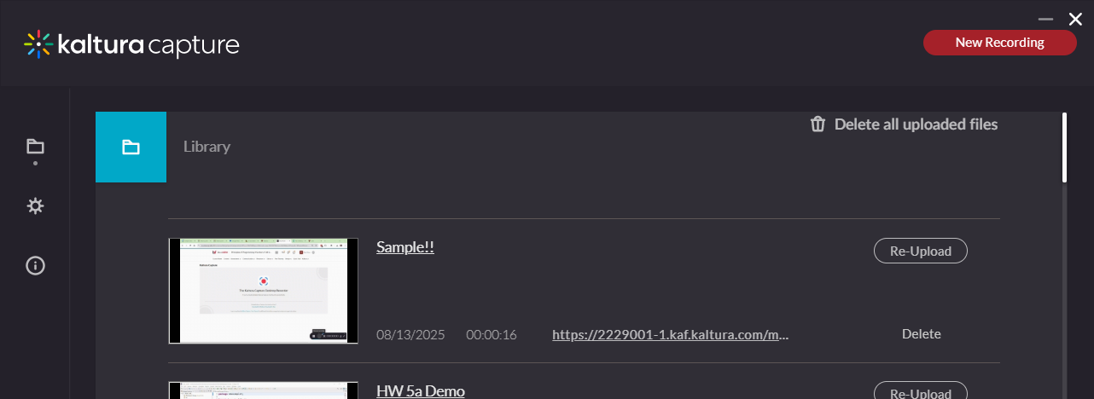
- You should now see the Kaltura Capture app. Do the following:
  - You can turn the camera off (as shown below).
  - Make sure “Screen” is showing your code in Eclipse.
  - Make sure your “Audio” is on.
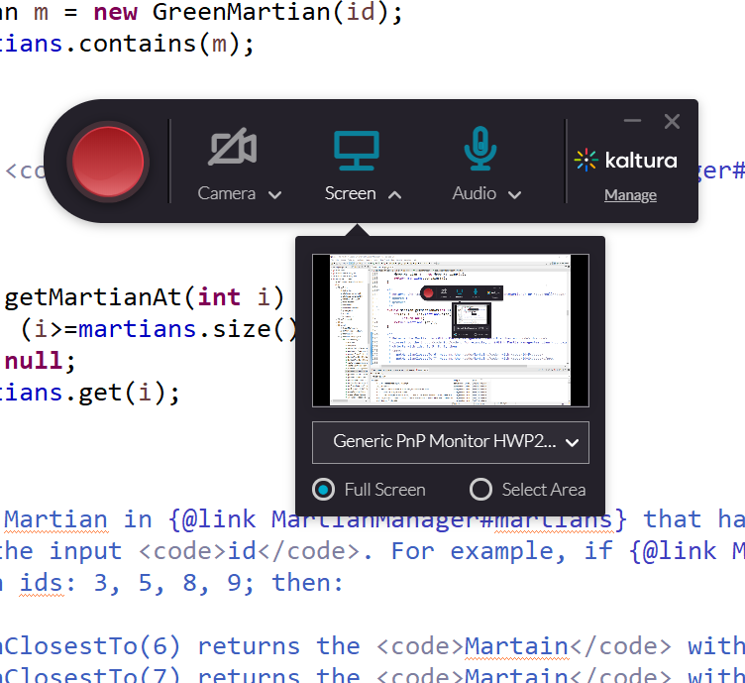

- When you press the Red button, the recording will start (after about a 3 sec delay). The app will drop to the lower-right of the screen and appear similar to what is shown below. If you have another monitor, you can drag the app off the screen being recorded (or you can minimize it).
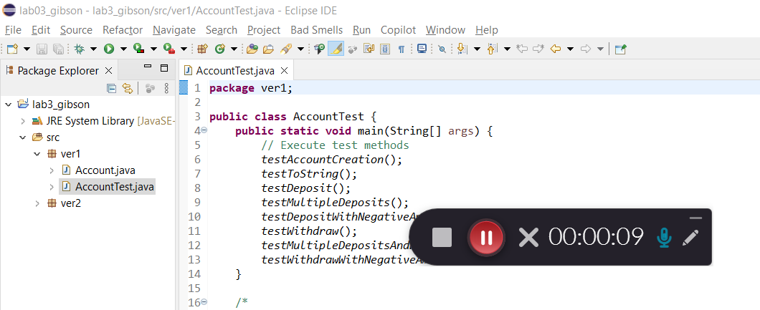
- Ending the video
  - Press the gray button to stop recording.
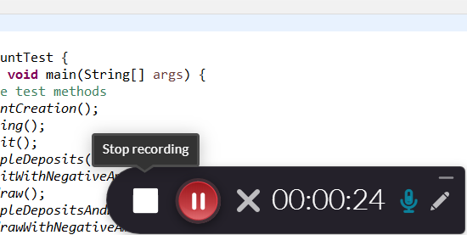
  - On the dialog that appears, choose: “Yes, Stop it”.
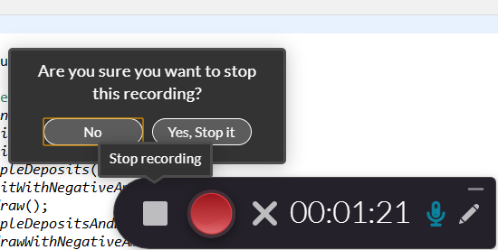

- The dialog below will be shown. Provide a title, Lab 3 Video, and choose: Save & Upload
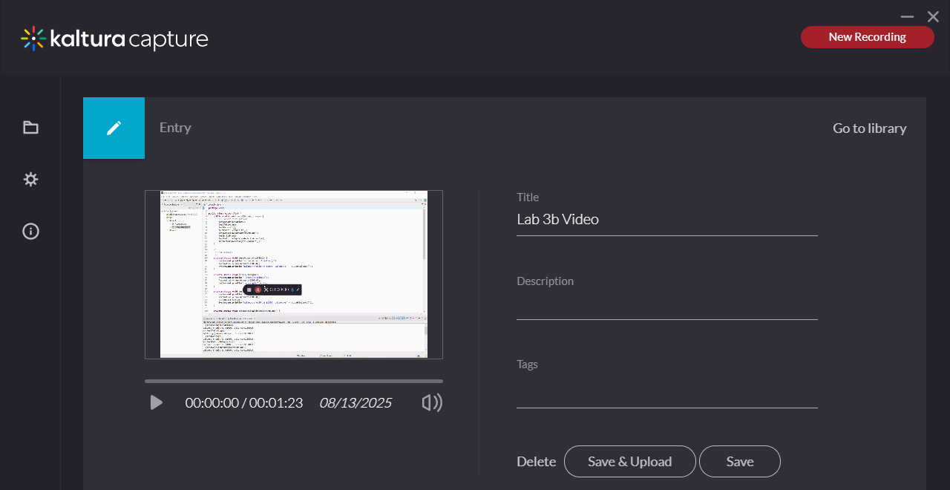
- The video will appear in the Library. It may say, “Pending”. When complete with the upload, it will say, “Re-Upload”.
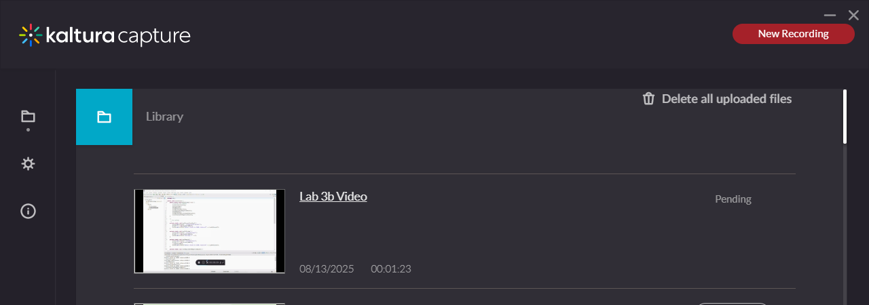
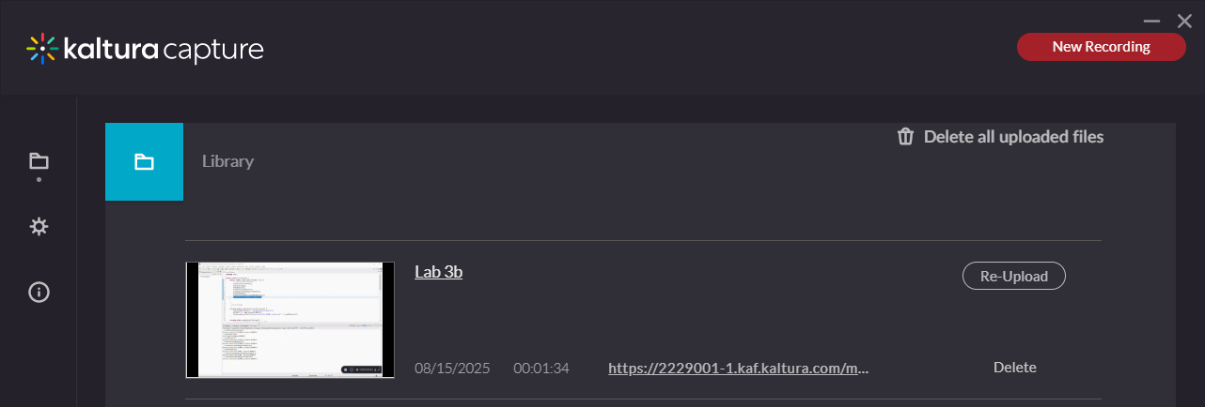

- Test your video – make sure the video plays and the audio is clear and audible!
- There is a link to the video. You’ll need to set the permissions so that I can see it. It is stored on the person making the video’s OneDrive (?). You can share there or probably in the dialogs above.

