Tutorial 12
Project Management

In this tutorial you will explore GitHub’s project management features. All software companies use a project management tool. In general, the way they work is that the work for the project is broken down in to smaller tasks (also called issues and other names). Issues include a title and description of the work to be done. They can be assigned to a team member(s) and they can be tracked with it project board. A project board shows the issues in columns such as: To do, In progress, Complete.

Steps to Complete

- On GitHub, choose: Branch, type the name, feature, and choose: Create branch: feature. The feature branch should be active now.
- Create a folder on your hard drive named: eclipse_ws3.
- Open Eclipse in that workspace.
- In Eclipse, choose: File, Import, Git, Projects from Git, Next, Clone URI, Next.
- Type the URI for the Acme-Systems repository on GitHub and choose, Next.
- Unselect master and choose: Next

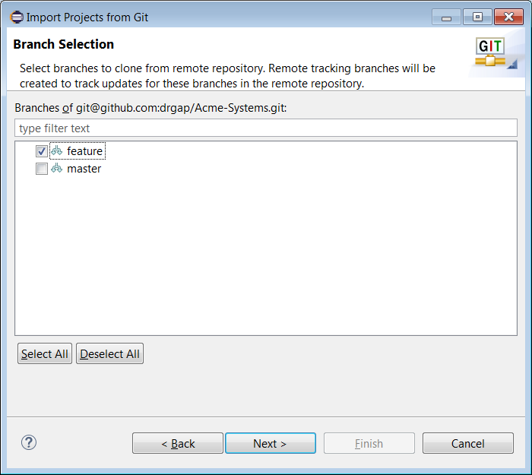

- Choose: Browse and navigate to your eclipse_ws3 folder

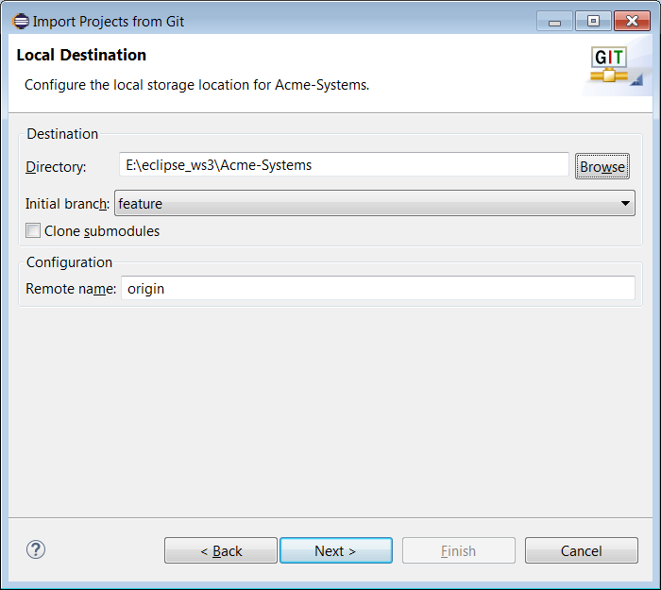

- Choose: Next, Next, Finish. Then, the Package Explorer should indicate that you are tracking the feature branch

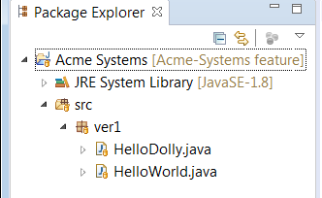

- (Read, no action required) Projects are a great way to manage your development. The idea is you add columns as shown below: Backlog, Assigned, In Progress (and the fourth one, not shown, Completed). Then you create issues which are small tasks of work that need to be done. In GitHub terminology, an issue is placed on a card and then added to a column. Then you can drag and drop the cards higher or lower in the column, or between columns. We will use this feature to manage our work flow.

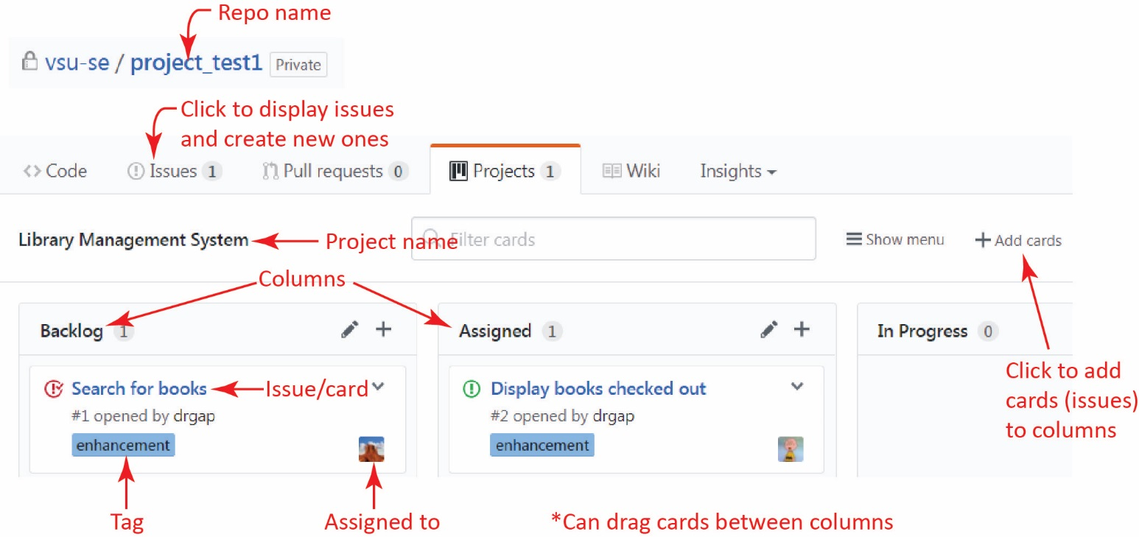

- Create a Project Board by doing the following:

- Open your Acme-Systems repository on GitHub.
- Choose the Projects tab and then Create a project.

- Type a project board name and description and then choose: Create Project | - Choose: Add a column and supply the values shown below, and then: Create column
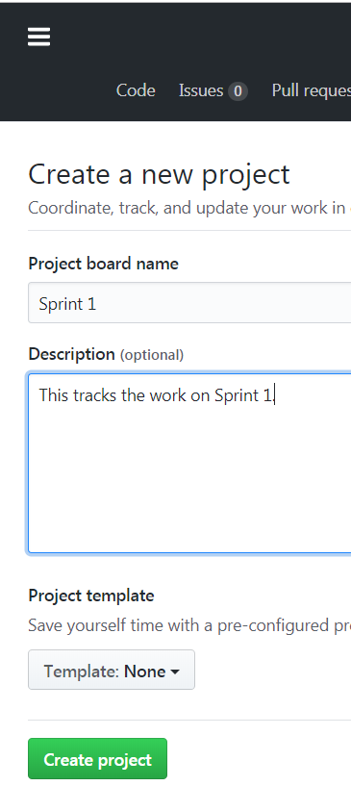 | 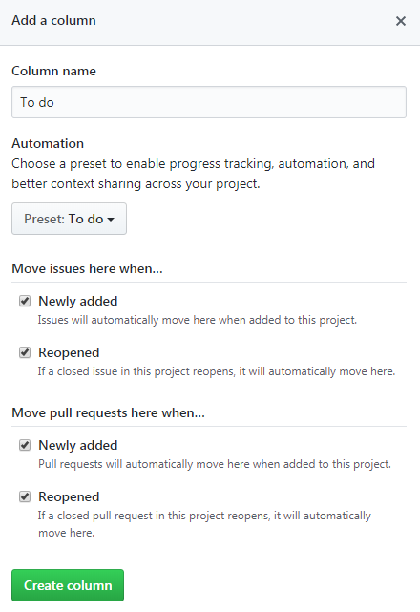

- Choose: Add a column and supply the values shown below, and then: Create column | - Choose: Add a column and supply the values shown below, and then: Create column
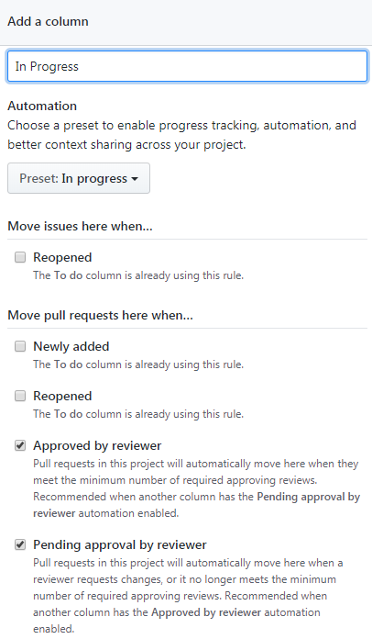 | 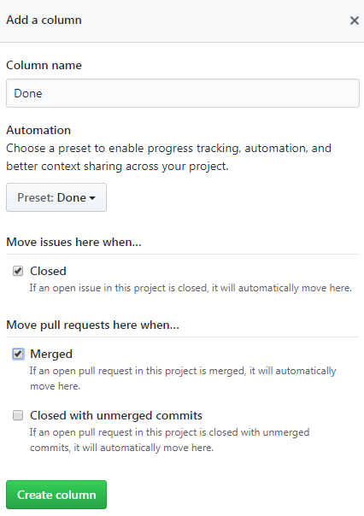

- When complete, the board will look like this:

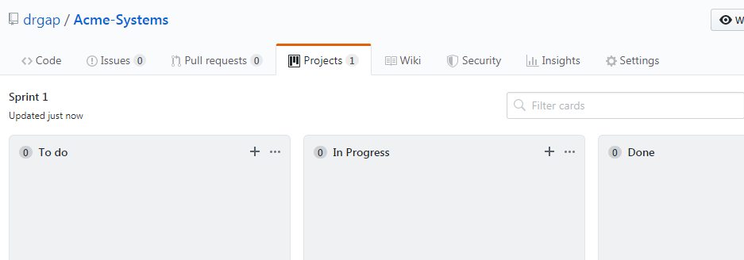

- Create some issues.

- Choose the Issues tab
- Choose: New issue and supply the values below. Be sure and supply values for Assignees and Labels. When done, choose: Submit new issue.

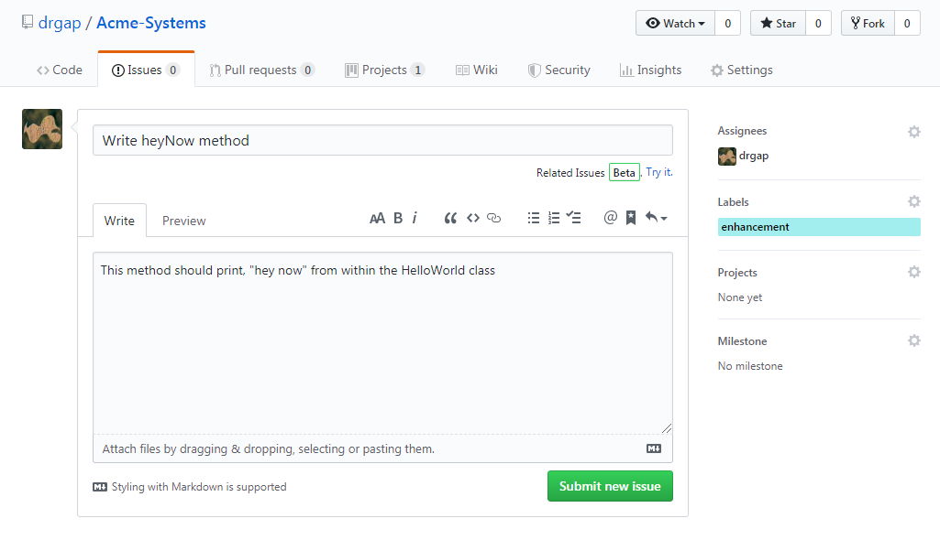

- Choose: New issue (again) and supply the values below. Be sure and supply values for Assignees and Labels. When done, choose: Submit new issue.

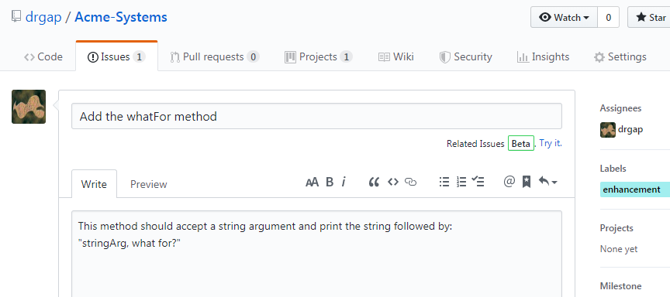

- Choose the Issues tab and the display will look like this:

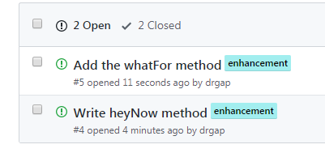

- Open the Sprint 1 project board (Select the Projects tab and then select the Sprint 1 project)

- Drag the two issues into the To do column.

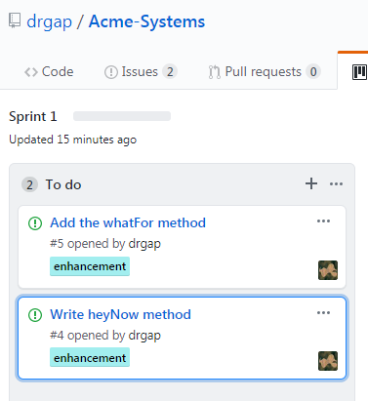

- Do the following in Eclipse

- Add the heyNow method to the HelloWorld class

public static void heyNow() {
String Msg = "Hey Now!";
System.out.println(Msg);
}

- Commit and push the change to GitHub.

- Do the following in GitHub

- Create a Pull Request

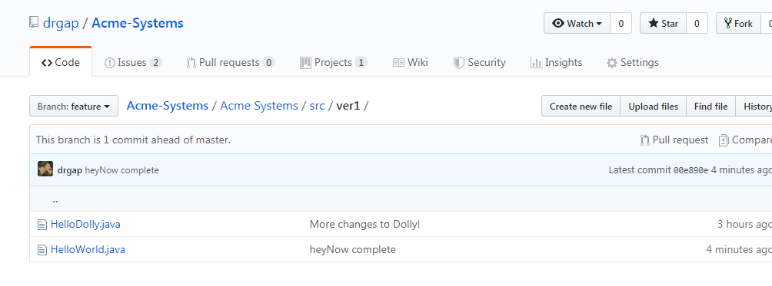

- Provide a title and description (I forgot to write the description), and choose: Draft pull request

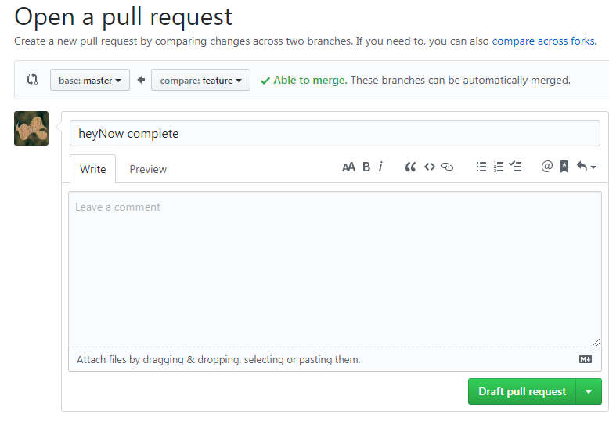

- Choose the Pull Requests tab

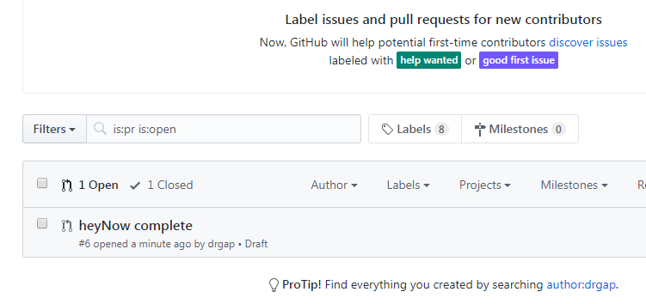

- Select the pull request. Select the value shown in Projects. This will add it to the To do on the project board.

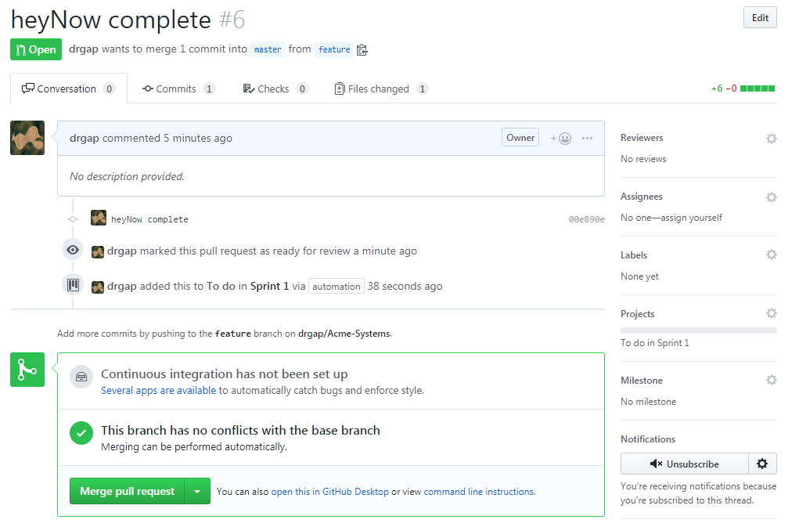

- Display the Project Board and see that an item has been added to the To do column

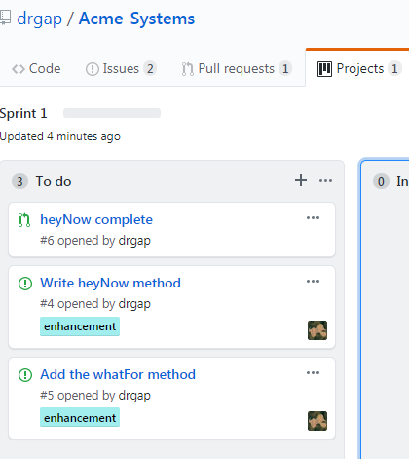

- Select the pull request, then in the lower right choose: Go to pull request for full details

- Drill down into the pull request and see the changes. Select: Review Changes and write a comment as shown below. Then, Submit Review.
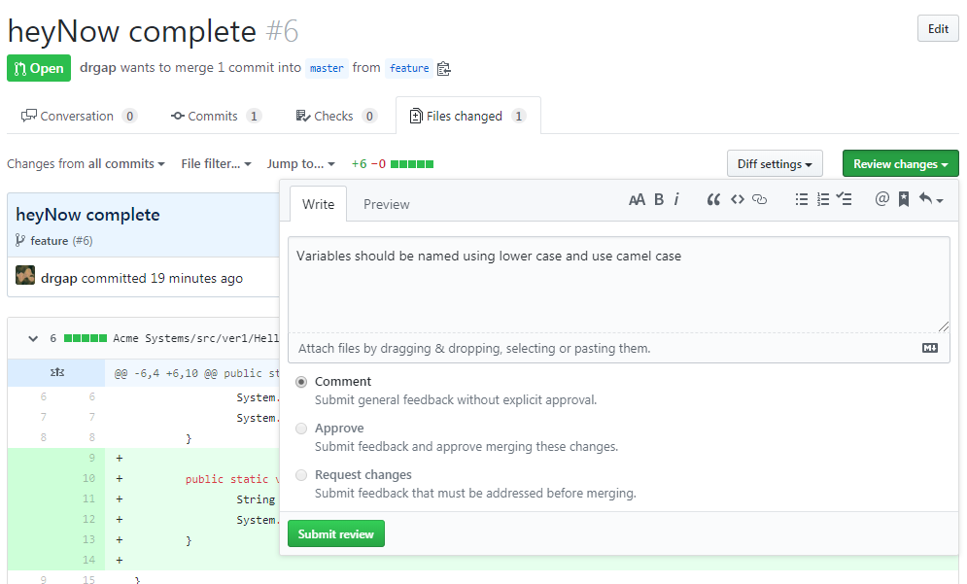

- View how the review comments are displayed and then select: Merge pull request, Confirm merge (but don’t delete branch).
- Go to the Project board and see that the pull request has been moved to the Done column.
- Drage the “Write heyNow method” issue to the Done column.

- [Read, no action required] Above, there is a way to tie the pull request to the issue so that it automatically moves it to done (or closes it?), but I’m not sure how.

- Repeat steps 14 and 15 for the, “Add the whatFor method” issue. Experiment some. When done,

- Make a screen shot similar to step 15g above. Make sure it shows your user name.
- Place the image in the HW VCS document in the appropriate place.
- The image should easily readable without zooming in or out.

