Sprint 1 – Artifacts
Contents
1 Class Diagram 1
2 Sprint Dashboard 1
Appendix 1 Class Diagrams Prompts 2
Appendix 1.1 Setup 2
Appendix 1.2 Domain Class Diagram 2
Appendix 1.3 Architecture Class Diagram 4
Appendix 2 Dashboard 6
Appendix 2.1 Dashboard – Manual Counts 6
Appendix 2.2 Dashboard – Automated Counts 7

Class Diagram
You will create two class diagrams that reflect the final implemented system "as-implemented", not an initial design proposal. Thus, your teams will make this near the end of the sprint. The purpose of this artifact is to communicate the overall design of your implemented system and provide a concise architectural overview for review during your live demo. The exact type of each diagram and prompts you can use are in Appendix 1. In summary, the diagrams are:
- Named: s1-cd1-teamX.png and s1-cd2-teamX.png, where X is your team number.
- Stored in a docs folder in your GitHub repo

Sprint Dashboard
You will create a dashboard which provides a concise snapshot of the team's Sprint 1 product and development effort. It should allow the instructor and team members to quickly understand the size, structure, testing effort, and development activity associated with the sprint. There are two parts to the dashboard: (a) items that an AI agent can determine, (b) other items that you will have count yourselves. The details are found in Appendix 2. In summary, the dashboard is stored in a Word document:
- Named: s1-dashboard.docx
- Stored in the docs folder of the GitHub repository.

- Class Diagrams Prompts
  - Setup
- In GitHub, go to your repo and choose: Copilot, “in immersive chat”
- Create a Space (see image below), give name: Sprint1
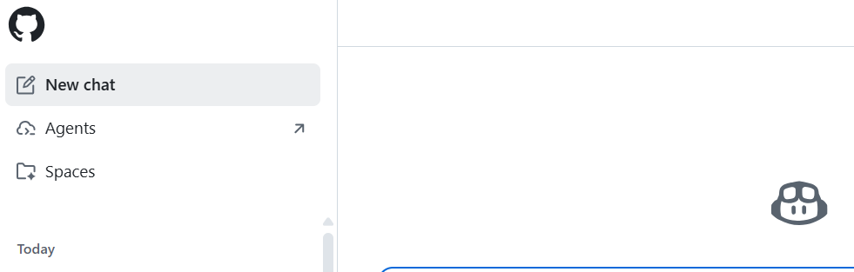
- Add Instructions (don’t think this is necessary):
I'll want you to generate several class diagrams at different levels of granularity and a sprint summary consisting of things such as number of pull requests, commits, test classes, test methods, etc.
- Add sources, Add files from repository, select your src folder or similar.
  - Mine said 99% context occupation percentage (how much of the AI model's token size limit is currently filled). Will let you go over 100%, but eventually blocks more files. If a problem, use: Add repository.
  - Add repository – gives this message: “Spaces work best with specific files added.”
- New Chat, link in Sprint1 Space created above.
  - Domain Class Diagram
- This should include all model and manager classes. Prompt (may have to change the highlighted words, or add, etc):
Make a mermaid syntax class diagram of all Java files in these sub folders: manager, model. Show only classes (no instance variables or methods). Use these guidelines:
- Show all associations: Use --> and <-- for navigable associations (arrowheads indicate direction).
- Show multiplicity for all associations.
- Do not show dependencies
- Show all instances of generalization:
  - Subclassing / inheritance (solid line with hollow triangle): Syntax: Parent <|-- Child Meaning: Child extends Parent (Child is-a Parent)
  - Interface realization / implementation (dashed line with hollow triangle): Syntax: Interface <|.. ImplementingClass Meaning: ImplementingClass implements Interface
- Copy mermaid code to mermaid.live, save as a .png file.
- You need to validate what is produced. It leaves things off sometimes, e.g. navagibility, etc.
- Save diagram with name: s1-cd1-teamX.jpg (or png), where X is your team number in the docs folder of your repo.
- The result from final product of a team’s code from a previous semester is shown on next page.
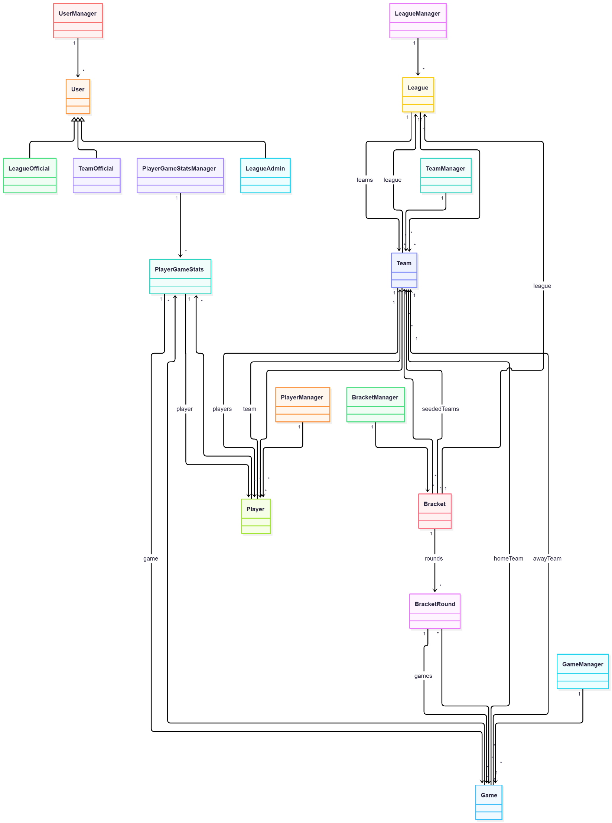
  - Architecture Class Diagram
- This should include all controller and view classes. Prompt (may have to change the highlighted words, or add, etc):
Make a mermaid syntax class diagram showing how the controllers interact with the top layer. Show only classes (no instance variables or methods). Use these guidelines:

- Show all associations: Use --> and <-- for navigable associations (arrowheads indicate direction).
- Show multiplicity for all associations.
- Do not show dependencies
- Show all instances of generalization:
  - Subclassing / inheritance (solid line with hollow triangle): Syntax: Parent <|-- Child Meaning: Child extends Parent (Child is-a Parent)
  - Interface realization / implementation (dashed line with hollow triangle): Syntax: Interface <|.. ImplementingClass Meaning: ImplementingClass implements Interface
- Replace navigation associations initiated by controllers with dependency arrows to indicate method-call/navigation rather than persistent association.
- Use dependency notation to reflect static-call usage.

- Copy mermaid code to mermaid.live, save as a .png file.
- You need to validate what is produced. It leave things off sometimes, e.g. navagibility, etc.
- Save diagram with name: s1-cd2-teamX.jpg (or png), where X is your team number in the docs folder of your repo.
- Result from final product of a team’s code from a previous class shown on next page.

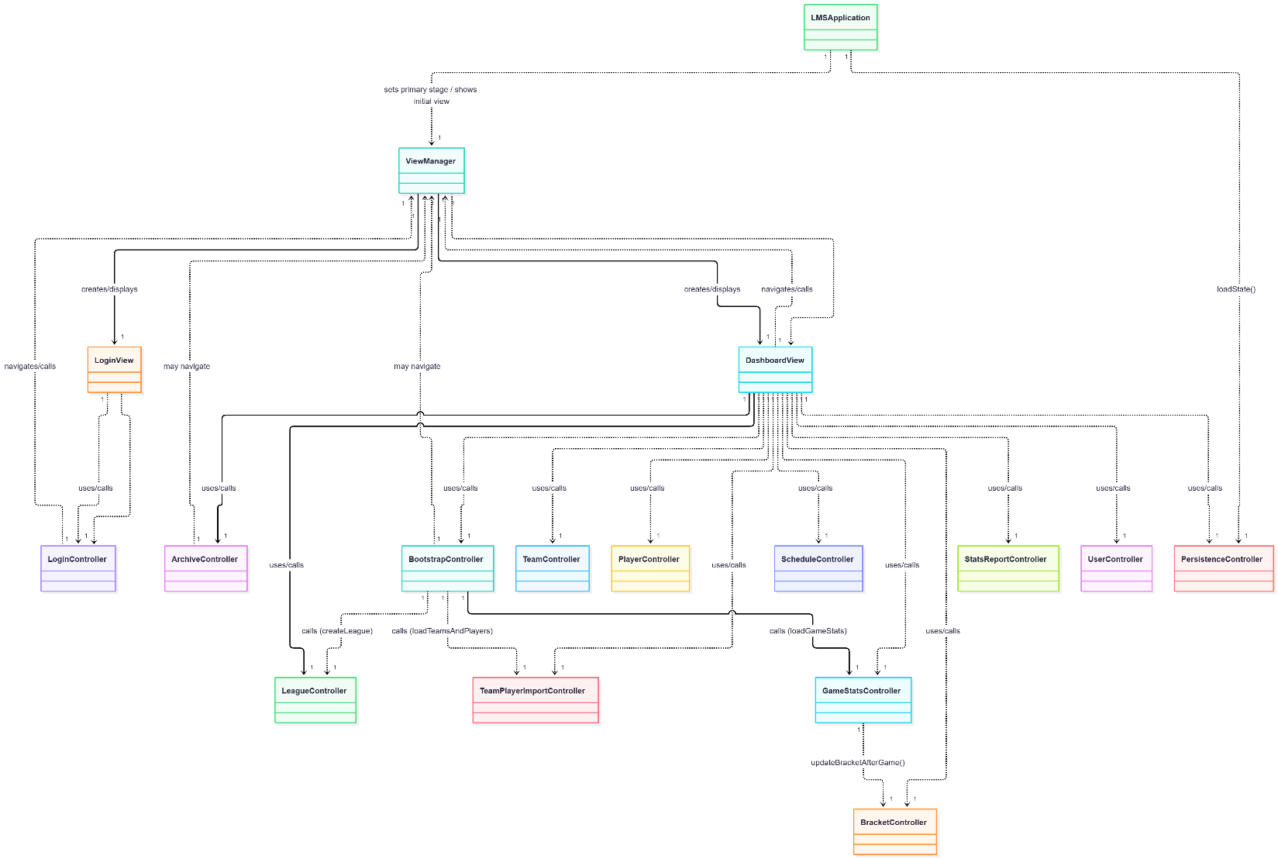

- Dashboard
Your team will create and complete the two tables below and place them in the Word document. All dashboard counts should be based on the contents of the main branch at the time of Sprint 1 submission. The first table requires a manual count and/or using the GitHub UI. The second can be calculated using an AI agent. There are two sections below corresponding to the two tables.
Artifact | Count
User Stories Implemented | /12
Acceptance Tests Passed | /35
GitHub Issues Completed
GitHub Pull Requests Closed
GitHub Commits

Artifact | Count
Model & Manager Classes
Controller Classes
UI/View Classes
Persistence Classes
Other Classes
Total Classes
Unit Test Classes
Unit Test Methods
Integration Test Classes
Integration Test Methods
Total Lines of Production Code
Total Lines of Test Code

  - Dashboard – Manual Counts
- Provide counts for the artifacts in the table below. The last three can be found in the GitHub UI.
Artifact | Count
User Stories Implemented | /12
Acceptance Tests Passed | /35
GitHub Issues Completed
GitHub Pull Requests Closed
GitHub Commits

  - Dashboard – Automated Counts
I tried using Copilot integrated in GitHub for these counts, but it wouldn’t count the lines of code. So, I used ChatGPT which worked well with a zip file of the code.
- Download a zip file of your codebase from GitHub. Navigate to your repo and choose the Code dropdown and then “Download ZIP”.
- Access ChatGPT, start a new chat, add the zip file to the chat.
- Use this (or similar) prompt:
Can you give me counts for this table?
Artifact | Count
Model & Manager Classes
Controller Classes
UI/View Classes
Persistence Classes
Other Classes
Total Classes
Unit Test Classes
Unit Test Methods
Integration Test Classes
Integration Test Methods
Total Lines of Production Code
Total Lines of Test Code

- Add the two tables to a single Word document
- Save document with name: s1-dashboard-teamX.docx, where X is your team number in the docs folder of your repo.

