Sprint 2 Demo

Contents
1 Sprint 2 Demo 1
2 Submission 1
Appendix 1 Kaltura Instructions 2

Due: Thursday, November 20, midnight.

Sprint 2 Demo
Your Sprint 2 Demo will be a video. Adhere to these constraints:
- Create a video using Kaltura Capture (directions in Appendix) or any other video recording software (bit not a phone) following the agenda below.
- Your video must be narrated throughout.
- It is fine for your camera to be off.
- Where possible, the font size should be increased for more accurate viewing.
- Do not scroll too quickly, i.e. don’t rush
- Speak clearly and loud enough as if someone 5 feet away could hear you.
Demo Agenda
- Display your US spreadsheet and discuss your progress since Sprint 1
- Demo the US’s you have implemented since Sprint 1
  - State the number of the US and then read the description of the US
  - Demo the US by running your program.

Submission
- Try to name the link to your video something like this: TeamXSprint2Demo…
- Make sure the video quality is good and the narration is loud enough to hear with the volume set to a moderate level.
- Make sure I (dgibson@valdosta.edu) have permission to view your video.
- Do one of the following:
  - Put the link in a Word document, save as: TeamXSprint2Demo.docx, and place this document in your docs folder on GitHub
OR
  - Put the link at the very top of the README section of your GitHub repo.

Appendix
- Kaltura Instructions
- Login into Blazeview for this course.
- In the upper-right, choose: Kaltura, My Media
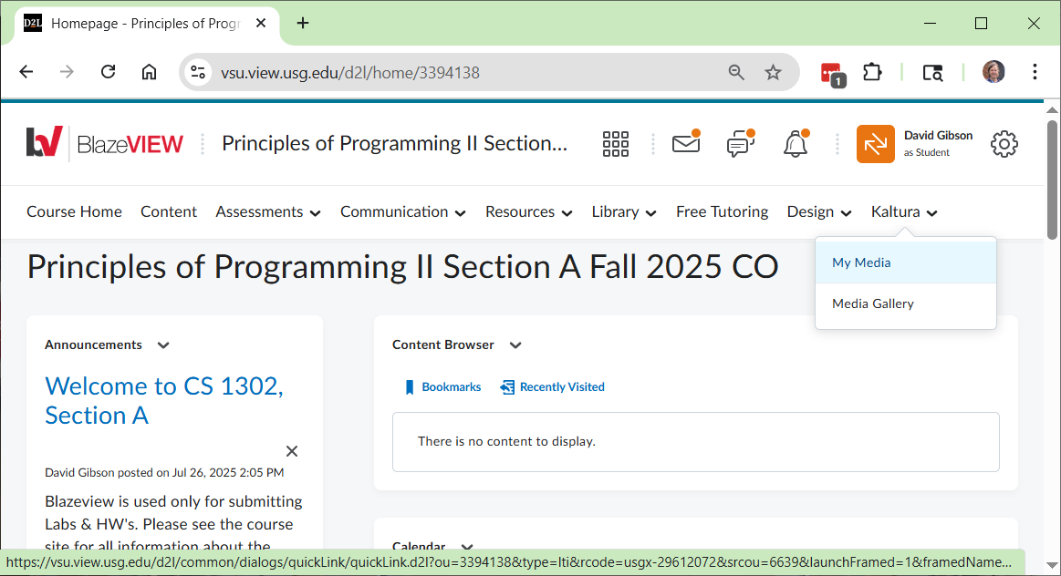
- Choose: Add New, Kaltura Capture
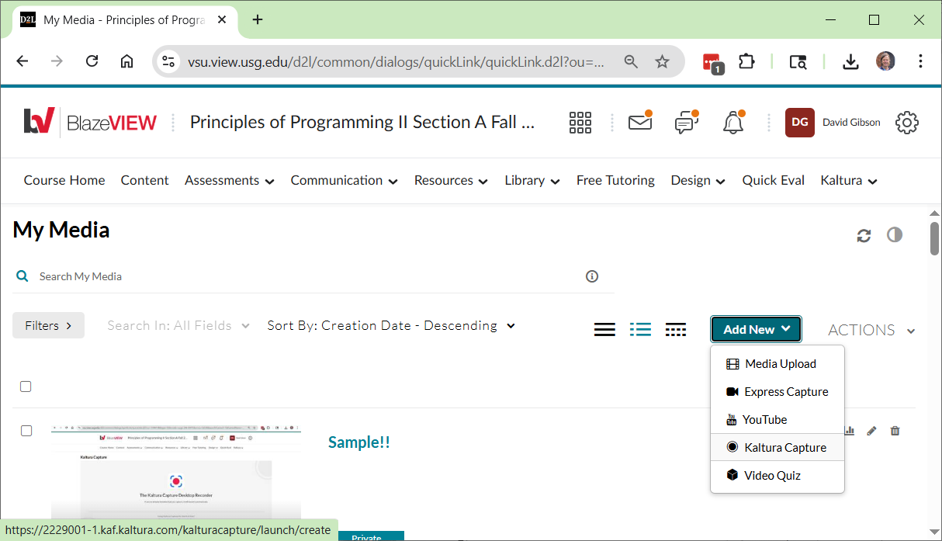

- The window below will be displayed. It will open Kaltura Capture from your computer, if you have it installed. Otherwise, as it says at the bottom, you need to download it (in which case, you may need to repeat the steps above).
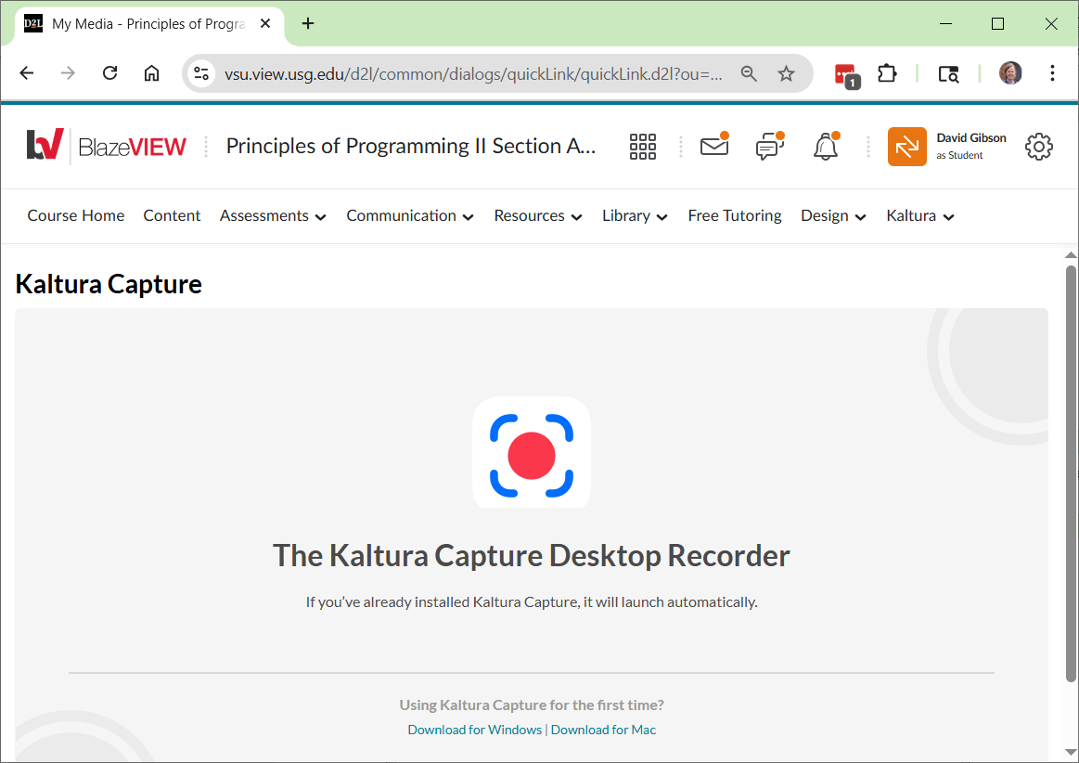
- Once Kaltura Capture is open, IF you see the screen below, if the upper-right, choose: New Recording. Otherwise, go to the next step.
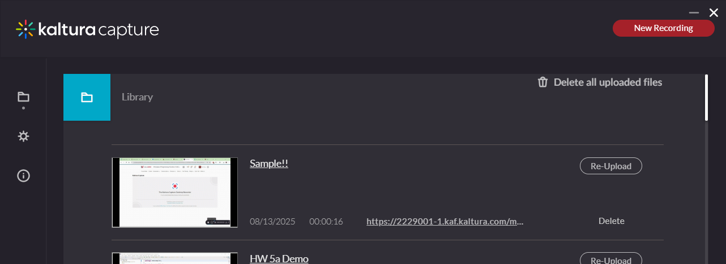
- You should now see the Kaltura Capture app. Do the following:
  - You can turn the camera off (as shown below).
  - Make sure “Screen” is showing your code in Eclipse.
  - Make sure your “Audio” is on.
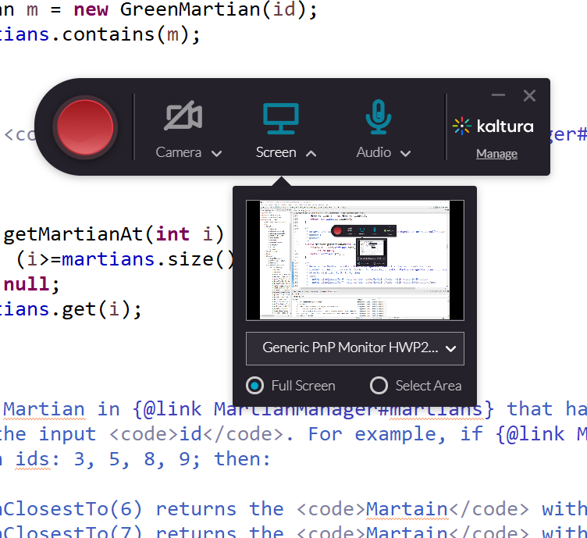

- When you press the Red button, the recording will start (after about a 3 sec delay). The app will drop to the lower-right of the screen and appear similar to what is shown below. If you have another monitor, you can drag the app off the screen being recorded (or you can minimize it).
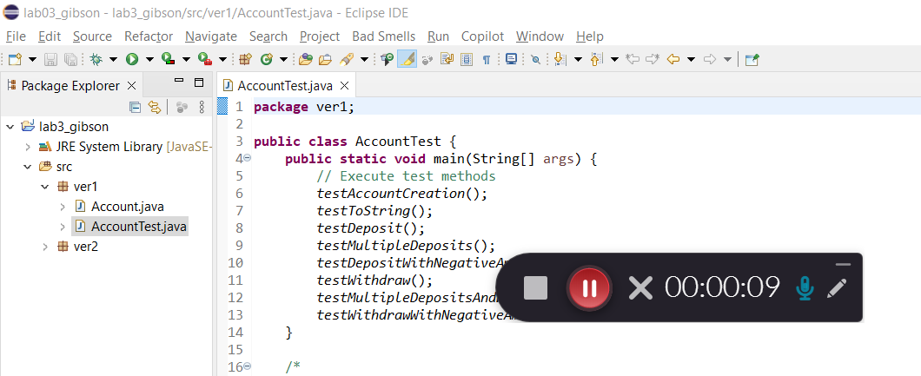
- Ending the video
  - Press the gray button to stop recording.
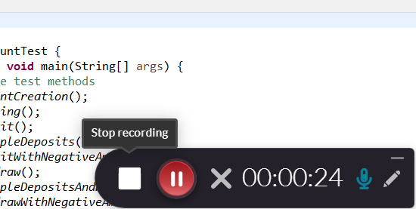
  - On the dialog that appears, choose: “Yes, Stop it”.
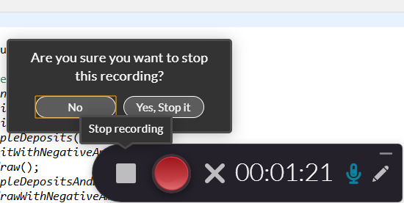

- The dialog below will be shown. Provide a title, Lab 3 Video, and choose: Save & Upload
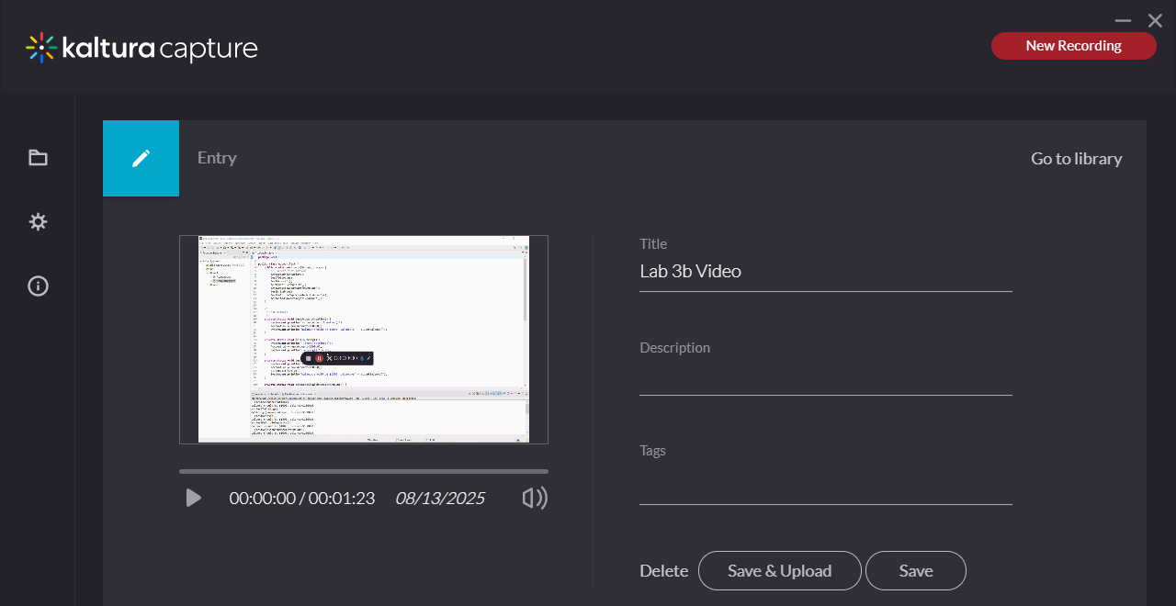
- The video will appear in the Library. It may say, “Pending”. When complete with the upload, it will say, “Re-Upload”.
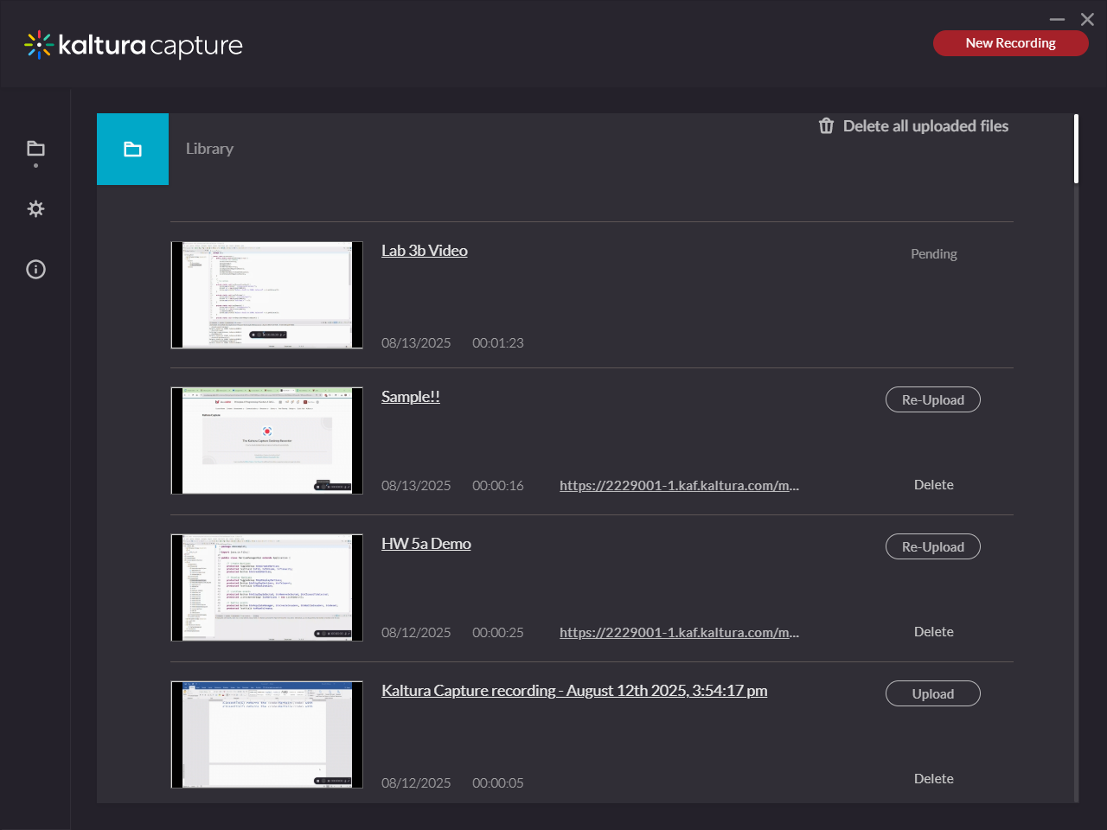
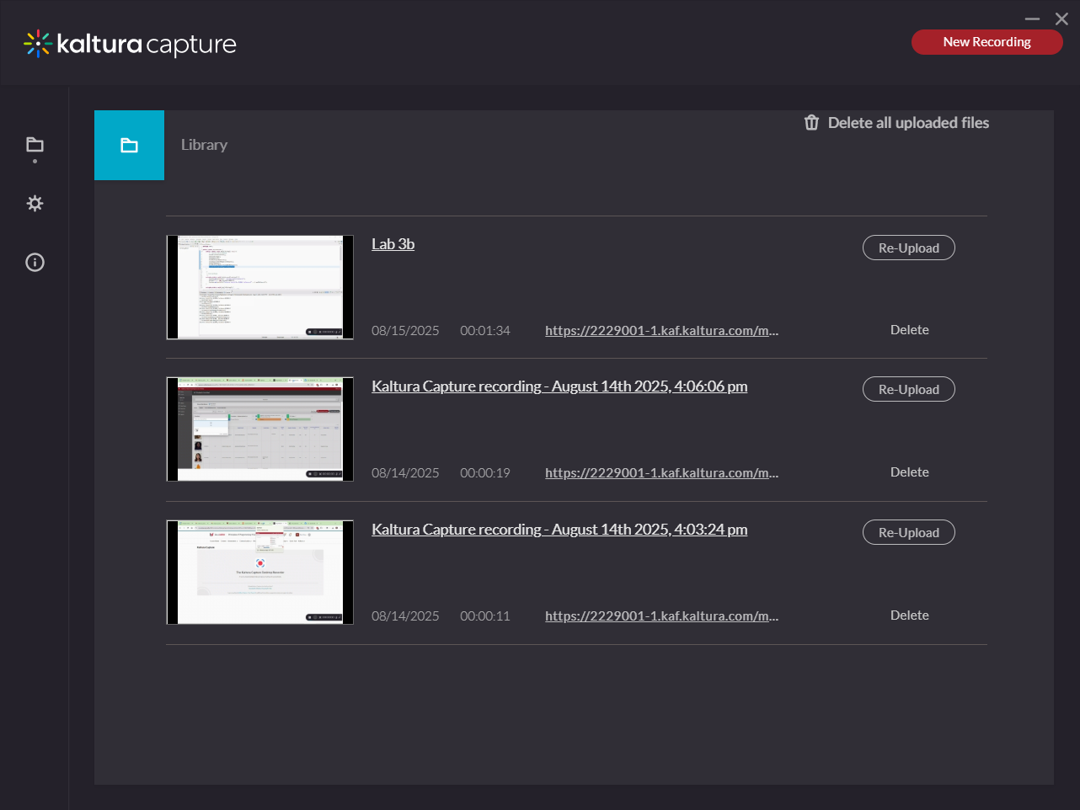

- Test your video – make sure the video plays and the audio is clear and audible!
- There is a link to the video. You’ll need to set the permissions so that I can see it. It is stored on the person making the video’s OneDrive (?). You can share there or probably in the dialogs above.

