**User Stories Assignment**

Contents

1 Overview 1

2 User Story Directions 1

2.1 Directions 1

2.2 Use of AI 2

3 Project Description 2

3.1 Glossary 2

3.2 Overview 2

4 Grading Rubric 4

5 Submission Requirement 4

# Overview

This is a part of your team project; thus, you will work with your project team to complete this assignment.

You will write and prioritize user stories for the Project Description below. You will write the user stories in a spreadsheet, *user_stories_SMS_team_X,* which you have been provided. You will **not** use these as the basis for producing a coded system. Instead, once these are submitted, I will provide you the prioritized user stories I wrote and you will use mine to code the system. This is so that each team will be working from the same user stories. The coding portion of the project is explained in a separate document.

The directions for writing the user stories are in the section immediately below.

# User Story Directions

## Directions

1. Rename this spreadsheet: user_stories_SMS_team_X.xlsx, where “X” is your team number.
2. Meet as a group and write the user stories keeping in mind best practices.
3. Column A (Priority) – I would ignore this for now. More on this below.
4. Column B (Title) – This is the title for the user story. It should be succinct, descriptive, and use an active verb.
5. Column C (User) – This is the type of user of the system that initiates the user story. In some (few) cases, it makes sense to have two or more actors for a user story, if they perform exactly the same steps.
6. Column D (User Story) – This is the user story in the format: “As a [description of user], I want to [functionality], so that [benefit].”
7. Column E (Notes) – Optional. You can write notes here if you like.

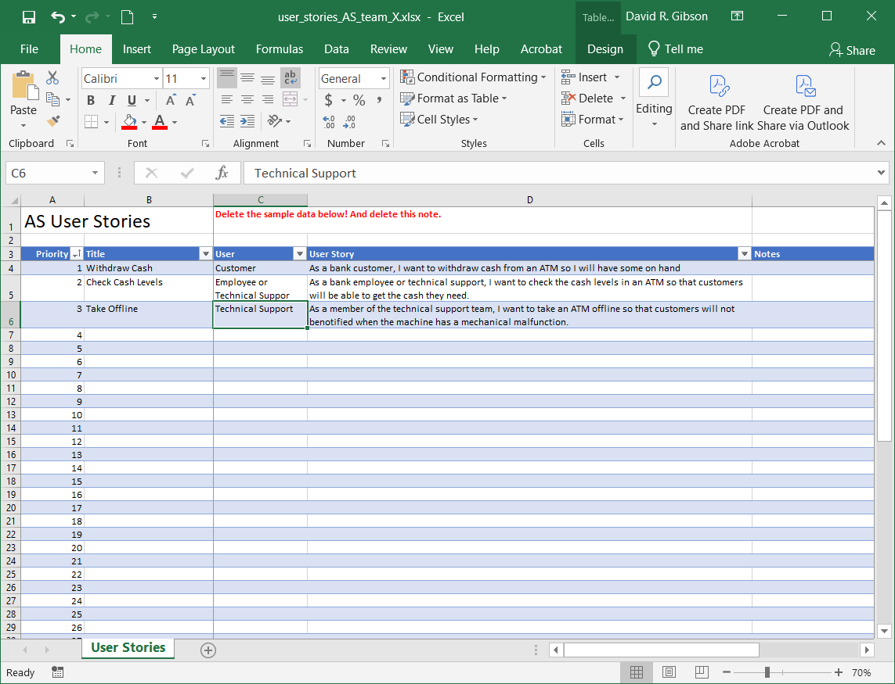

1. Prioritize the user stories. Priorities range from: 1 to the number of stories. All stories have a unique priority. The lower the priority, the more important in providing value to the customer. Use your judgement. However, keep in mind feasibility of priorities. For example, in an online store, you should not have the top priority, “cancel a purchase”, and the second (or later), “purchase a product”.

It can get confusing setting the priorities. One approach:

1. Write all the user stories without specifying priorities.
2. Sort on "User" column (Column C), so that you can see the stories grouped by the type of user.
3. Set the first few priorities (first 3, 5 whatever).
4. Sort on "Priority" (Column A), the ones with no priority will appear below the ones with a priority.
5. Decide on priority of next few.
6. Repeat steps 4 & 5

After you complete these, I recommend you revisit the priorities on another day – you will probably find some priorities that are not feasible or that you want to change.

1. When complete, make sure it is sorted completely on priority
2. Make sure all text in cells wraps
3. Make sure all cells are Top Aligned

## Use of AI

You can use AI to generate the user stories. If you choose this route, you must report all prompts you used (complete) in the *AI Prompts* tab on the spreadsheet. Obviously, you’ll want to very carefully to make sure they are complete, consistent, and that they don’t invent requirements.

# Project Description

## Glossary

1. *Auction* *System (AS)* – the software system under development
2. *Active auction* – An ongoing action meaning that the current date/time is between the beginning and ending date/times of the auction.
3. *User* – A person using the auction system.
4. *Registered User* – A person who is registered in the system and can buy, sell, and offer auctions. A registered user can take on different personas:
   * *Bidder* – A user who is bidding on an item that is placed for auction.
   * *Buyer* – A user who is chooses to “buy it now” (BIN)
   * *Seller –* A user who is either auctioning or selling an item;
5. *System Administrator (SA)* – A user who can control various management aspects of the system

## Overview

A seller can list an item for auction. The item must be specified as “new” or “used”. Items have a title, weight, description, category, and up to three tags, and each tag can contain up to 40 characters. Categories are added by the system administrator (SA) and are short phrases such as: Sporting Goods, Clothing, *etc.* A tag is a word or short phrase that describes the item. Tags are used to search for auction items. An auction item also has a starting bid; shipping cost; a start auction date and time, and an ending date and time; and optionally, a “buy it now” (BIN) price. The starting bid is considered the reserve price. In other words, if there are no bids, then the item is not sold. Generally, an auction item runs until its duration in which case the highest bidder wins. However, an auction item can be ended: (a) by the seller at any point, if there are any bids, the current highest bid wins the auction; (b) A SA can prematurely end an auction in the case of illegal or stolen items, *etc.* A buyer can BIN, which immediately halts the auction.

A SA can edit category names and delete them. However, a category cannot be deleted if there are active or pending auctions.

A user of the system can register in the system, becoming a registered user by supplying their name, a unique user name, and a password. A registered user can bid, sell, and offer auction items A registered user can login to the system. A user can change their password. A SA can reset a user’s password.

A bidder can bid on an item for auction by specifying a bid amount. If there are no bids, the bid amount must be at least the starting bid. If there are existing bids, then the bid amount must be higher than the current bid.

A seller’s commission is a fee charged to the seller (auction or BIN) by the AS for their services. A buyer’s premium is the amount any auction winner or BIN must pay to the AS. These values should be set as a percentage of the winning bid or BIN. These values apply to all auctions and can be changed at any time by a SA.

Registered users do not have a regular “account” as they would in a real system. In other words, a user can simply buy things, and when they do, they are added to a list of items they have previously bought. And from that list, various statistics can be calculated, *e.g* total amount bought, total buyer’s premiums paid, total shipping cost paid, *etc.* The situation is similar for items that are sold, they are maintained in a list from which various statistics can be calculated such as: total of winning bids, total shipping costs, total seller’s commissions, total profits (winning bids – seller’s commissions).

A seller can also list an item to sell. An item for sale is the same as an auction item except that there is no starting bid, nor start/end dates; however, it requires a “buy it now” price.

A user or SA can request to see all the active auctions where the items are displayed so that the auctions expiring soonest, are displayed first. A user can see also see all the active auctions in a category. Similarly, a user or SA can see a list of all items for sale, or all items for sale in a category.

A user or SA can search for active auctions and items for sale, at the same time, for items that match up to 3 tags. Items should be displayed, ordered by: (a) how many tags were matched, or partially matched, (b) then any items for sale are listed, (c), then auction items by expiration date, soonest first. [Your team can decide what “match” and “partially match” mean].

A user can request to see all the items they have current bids for, sorted by expiration date, soonest first, and should also show their current bid, and a higher bid by someone else, if there is one; and category (and any other data that would be useful). This should be displayed in a way to make items that the user is currently outbid on standout in some way.

A user can see all items they have bought (winning an auction, BIN, or bought), sorted on most recent first. The display should show date and time of purchase, winning bid/cost, shipping cost, buyer premium and the total. At the top of the display, it should show the totals of all these values.

The SA can display all concluded auctions (and BIN), sorted by most recent, and displaying winning bid/cost, shipping cost, buyer premium, total paid by buyer; sellers commission, seller’s profit; and category (and any other data that would be useful). At the top of the display, it should show the totals of all these values. Similarly, the SA can display such a report for a particular category. Similarly, the SA can view a list of all items bought (not auction nor BIN), and a list of all items bought in a category.

The AS runs in real time (as it would work when used in the real world) based on the system clock. However, a SA administrator can turn this off and set the system to run on discrete time intervals for testing purposes. Thus, the SA can set a time and this time remains until the SA sets a new time. A SA can turn this feature off and return to real time.

A SA can suspend a user’s ability to buy, sell, or both. A user whose rights to buy are suspended means that all active auctions where they have bids are retracted. A SA can also return a user to active buying status. A user whose rights to sell are suspended means that all active auctions they have posted are closed and no new auctions can be posed. A SA can also return a user to active selling status.

A user or SA can view the bid history for any auction that is ongoing. A SA can view the bid history for any auction that is completed. A registered user can view the bid history for any completed auction that they bid in.

A SA can view a report showing the AS’s total profit, and then broken down by category, highest first, over a specified date range, including over all time to current. Note, if the system is in discrete time mode, then the current time is the time last set by the SA.

# Grading Rubric

The grading criteria are shown below:

|  |  |  |
| --- | --- | --- |
| **Num** | **Worth** | **Requirement** |
| 1 | 10 | Succinct, descriptive title using an active verb |
| 2 | 25 | Each US is singular (not an epic) |
| 3 | 10 | Consistent priorities (*e.g.* you can’t see a list of auctions before the ability to create an auction) |
| 4 | 30 | The totality of US captures the project description completely. |
| 5 | 10 | Consistent title for users |
| 6 | 10 | No extraneous stories (*i.e.* stories that don’t exist in the project description) |
| 7 | 5 | Formatted correctly as specified in Section 2, Items 1,4,5 6 |
| **Total** | 100 |  |

# Submission Requirement

One person from each team submit the spreadsheet in the *User Stories* dropbox on Blazeview.