OO Design Principles

Contents
1 Single Responsibility Principle 1
2 MVC (Model-View-Controller) Architecture 2
3 Example 3
3.1 Domain Classes 3
3.2 System Classes 4
3.3 Starting the System 6
3.4 Use Case: Add a Blob 6
3.5 Design Principles 8
Appendix 1 Resources 8

Single Responsibility Principle
There are a number of OO design principles that help make software designs more understandable, flexible, and maintainable, and extensible. Dr. Robert C. Martin (Uncle Bob) proposed five design principles (among others), called the SOLID principles.
One import principle, is the Single Responsibility Principle. It states:
- A class should have only one responsibility
- A class should have only one reason to change
We say that a class that adheres to the SRP has high cohesion. As we develop a software system, classes can become bloated; they take on too much responsibility. If we look carefully at such classes, we can often break them into two (or more) classes each with a single responsibility.
Here is a simple example that violates the single responsibility principle: Suppose we have an Employee class with name, payrate, hours worked, etc attributes and a method to calculate their pay. Suppose this class also has a method to write the instance variables to a text file (or database, etc.). This is two responsibilities: one is to manage the employee’s attributes and the other is to persist it to disk. We should always have a separate class(es) to do data persistence.
Another example is building a GUI based system. The Gui class itself has the code to build and display the Gui. It should not also have code to implement the business logic nor to maintain the data associated with the system.
We will see examples of both of these in the detailed example that follows.
A good reference on architectural principles is: https://learn.microsoft.com/en-us/dotnet/architecture/modern-web-apps-azure/architectural-principles

MVC (Model-View-Controller) Architecture
The Model-View-Controller (MVC) is an architectural pattern that separates the modeling of the domain, the presentation, and the user actions into separate components.
- Model – The model manages the behavior and data of the application domain, responds to requests for information about its state (from the Controller or the View), and responds to instructions to change state (usually from the Controller).
- View – The view manages the display of information.
- Controller – The controller interprets the mouse and keyboard inputs from the user, informing the model and/or the view to change as appropriate.
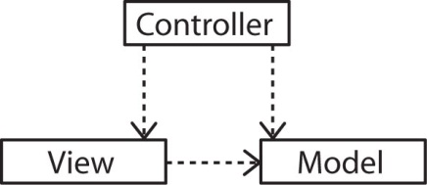
Consider the dependencies in this approach:
- Controller depends on View and Model
- View depends on Model
- Model does not depend on either
Some benefits of this separation:
- Model can be built and tested independently of the other components
- Model can be reused
- Alternate Views (or Controllers) can be integrated more easily.
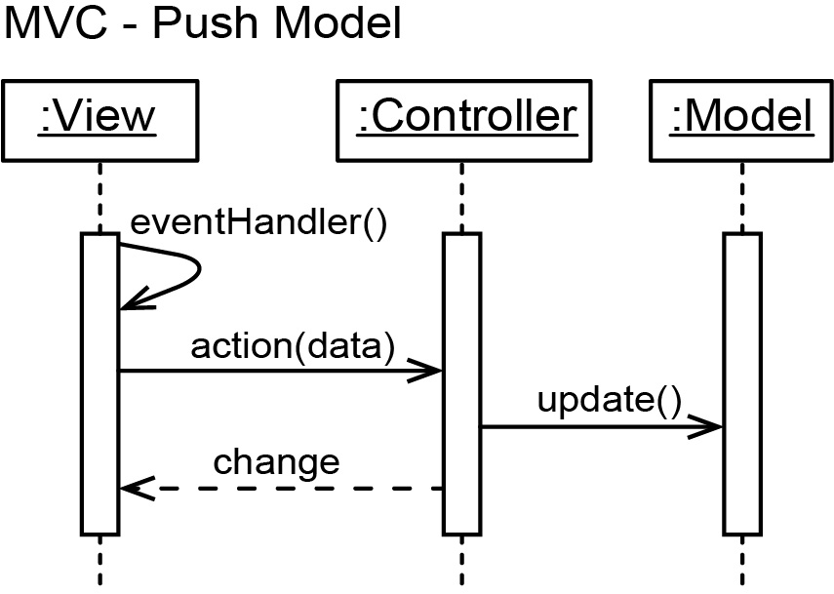
One approach to implementing this is to use the push model (which is what we use in the example below). Consider the sequence diagram below. There, the user interacts with a UI, which triggers an eventHandler. The eventHandler gathers any required data and sends it to the Controller via a call to its action method. The action method may do some processing, validate data, etc., and then it updates the Model. Next, the action method changes the View appropriately. It could do this directly (as shown below), or it could call a View method to achieve this.

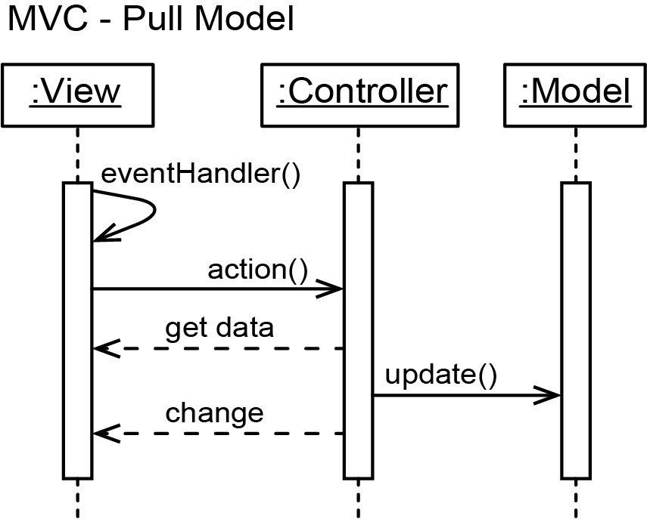
Another approach is the pull model where no data is pushed to the Controller. Instead, the Controller gets the required data itself, either directly (as shown below) or by calling a method(s).

Example
This is a very simple example that utilizes MVC. The code for this example is contained in a download on the Schedule.

Domain Classes
Domain classes are the classes that represent the naturally occurring objects in a problem. They are abstractions of the objects that must be represented in a system.
Consider the situation where we want to be able to create and manage a collection of Blob objects where blobs simply have an id which is composed of 4 digits and no two blobs can have the same id. The domain classes are:
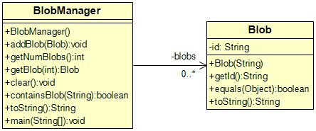

System Classes
To build a system, we must also provide classes to support the domain classes so that they can be used to fulfill the requirements of the system. Together, with the domain classes, we call these the system classes. The class diagram below shows these classes for the blob system. We have organized them using the MVC architectural pattern. We discuss this in class.
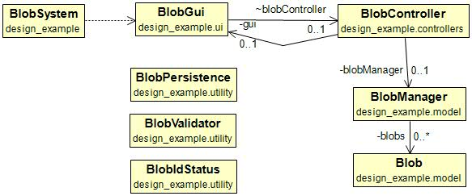
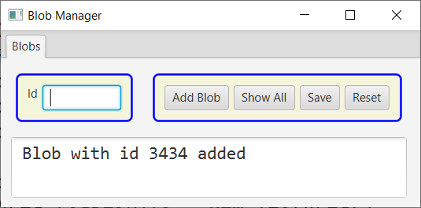

The full class diagram is shown below. We will discuss this in class (or video) as well as look carefully at the actual code. The code is available on the Schedule.
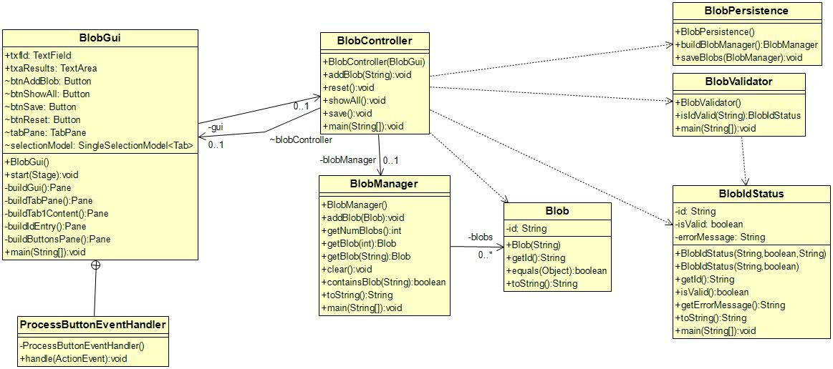

Starting the System
The BlobGui class creates the controller and passes a reference to itself:
public class BlobGui extends Application {
...
BlobController blobController;
@Override
public void start(Stage primaryStage) {
try {
blobController = new BlobController(this);

The BlobController’s constructor stores a reference to the GUI, and creates the BlobManager (model):
public class BlobController {
private BlobGui gui;
private BlobManager blobManager;

public BlobController(BlobGui gui) {
this.gui = gui; // Link Controller to View
// Link Controller to Model. Reads data from disc to build Model.
this.blobManager = BlobPersistence.buildBlobManager();
}

Use Case: Add a Blob
The sequence diagram below shows the method calls to add a Blob to the system:
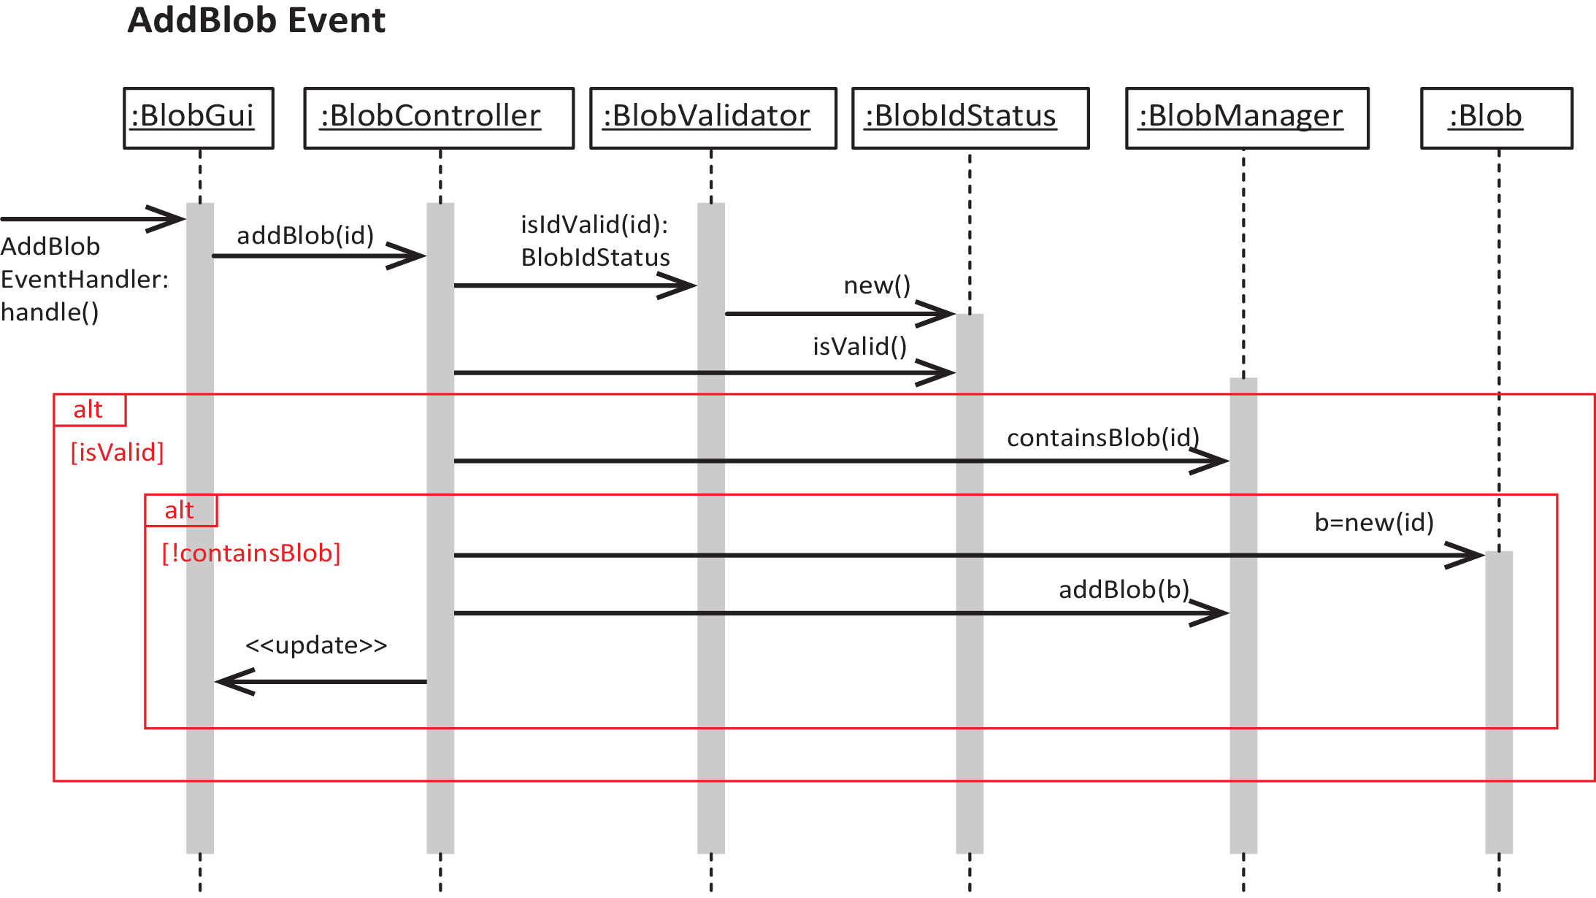

When the user enters an Id and presses: “Add Blob”, the event handler below, gets the id from the Gui and passes it to the controller’s addBlob method:
private class AddBlobEventHandler implements EventHandler<ActionEvent> {
@Override
public void handle(ActionEvent event) {
String id = txfId.getText();
blobController.addBlob(id);
}

}
The controller’s addBlob method first validates the id returning a BlobIdStatus object. Then the BlobIdStatus is queried to see if the id is valid. If it is, a check is made to see if there is a Blob with that id that already exists. Finally, if not, a Blob is created and passed to the BlobManager’s addBlob method to be added to the BlobManger, and the GUI is updated.
public void addBlob(String id) {
// Check to see if id is valid
BlobIdStatus blobMessage = BlobValidator.isIdValid(id);

if(blobMessage.isValid()) { // If id is valid
if(!blobManager.containsBlob(id)) { // If Blob with id doesn't already exist
// Update Model - add Blob to BlobManager
Blob b = new Blob(id);
blobManager.addBlob(b);
// Update View - display confirmation of add
gui.txfId.setText("");
gui.txfId.requestFocus();
gui.txaResults.setText(String.format("Blob with id %s added", b.getId()));
}
else { // If Blob with id already exists
// Update View - display not added message
gui.txfId.requestFocus();
gui.txaResults.setText(String.format("Blob with id: %s not added\nBlob with
that id already exists", id));
}
}
else { // If id is not valid
// Update View - display message about why id is invalid
gui.txfId.requestFocus();
gui.txaResults.setText(String.format("Blob with id: %s not added\nerror message=%s",
id, blobMessage.getErrorMessage()));
}

The BlobManager:

public class BlobManager {
private Map<String, Blob> blobs = new TreeMap<>();

public BlobManager() {}

public void addBlob(Blob b) {
blobs.put(b.getId(), b);
}

Design Principles
These are the Design Principles in Head First Design Patterns.
- Identify the aspects of your application that vary and separate them from what stays the same.
- Program to an interface, not an implementation.
- Favor composition over inheritance.
- Strive for loosely coupled designs between objects that interact.
- Classes should be open for extension, but closed for modification.
- Dependency Inversion Principle - Depend upon abstractions. Do not depend upon concrete classes.
- Principle of Least Knowledge – Talk only to your immediate friends
- Hollywood Principle – Don’t call us, we’ll call you.
- A class should have only one reason to change.

- Resources
Site | Description
codementor | Discusses 4 design principles, with examples, towards the end. Description for SRP is good, example is not so good.
Nishant Dania | Very short summary of HFDP and design principles. No examples.
Adil at Work | Short summary of HFDP and design principles. No examples.
StackExchange | Discussion of the Encapsulate what varies design principle from HFDP. Most of discussion doesn’t present in the light of using classes to encapsulate things that are subject to change.

https://www.baeldung.com/java-single-responsibility-principle
https://reflectoring.io/single-responsibility-principle/
https://www.oodesign.com/single-responsibility-principle
https://www.geeksforgeeks.org/single-responsibility-principle-in-java-with-examples/

