Sequence Diagrams

Contents
1 Introduction 1
2 Examples 3
3 Conditional Behavior 5
4 Iteration 6
5 Object Deletion 7
6 Blank Template for Sequence Diagram (next page) 7
Appendix 1 Resources 9
Appendix 2 Real Examples 10

Introduction
A sequence diagram is a UML diagram that shows the method calls that are necessary for a system to accomplish some task: (a) user story, (b) a method, (c) anything. For example, consider this code:
public class Driver {
public static void main(String[] args) {
A a = new A();
a.foo();
B b = new B();
b.fee();
}
}
A sequence diagram for the main method is:
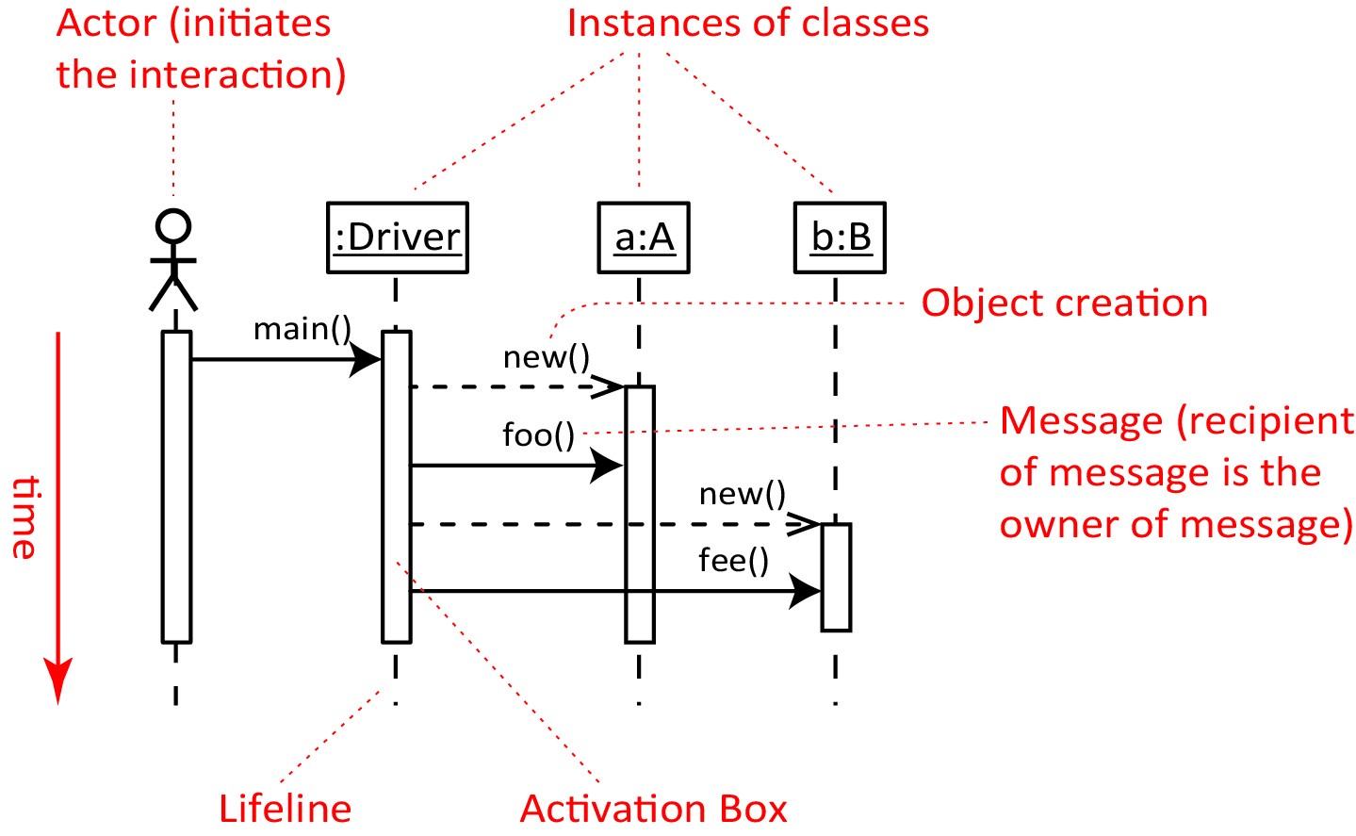

Another way of describing a sequence diagram is that it shows the sequence of messages exchanged by the set of objects performing a certain task.
A sequence diagram is a type of interaction diagram in UML and is used to model the dynamic aspects of a system. There are two types of interactions diagrams: Sequence Diagrams and Collaboration Diagrams, which are virtually identical. We will only consider the sequence diagram.
Sequence diagrams are created, as needed, to:
- Document/communicate the dynamic aspects of the design of some piece of (complex) functionality
- At the design stage they are useful for refining a class diagram, e.g. are the methods in the correct class? Are the parameters correct, missing, navigability, etc.
Anatomy of a Sequence Diagram:
- Instances of classes – Shown as boxes with the class and object identifier underlined
- The objects are arranged horizontally across the diagram. The order doesn’t matter; however, it is useful to order them in the order they are called. Sometimes, it is useful to rearrange them so the diagram is minimally cluttered.
- An actor that initiates the interaction is often shown on the left. Use the stick-person symbol as in use case diagrams. The actor is not necessarily a person, it is frequently “some other object”.
- The vertical dimension represents time.
- A vertical (dashed) line, called a lifeline, is attached to each object or actor.
- The lifeline becomes a broad box, called an activation box during the live activation period. In the figure above, this is the time that the object is in memory. Stricter adherence to the UML standards gives a slightly different meaning to the live activation period: the time when the method is active. In other words, the box stops when the method ends.
- A message is represented as an arrow between activation boxes of the sender and receiver.
- A message is labelled and can have an argument list and a return value.
- The recipient of the message is the owner of the message. In the diagram above, the foo method is defined in the A class and the fee method is defined in the B class.
- Technically, the arrows below are the correct representation for the corresponding message type.
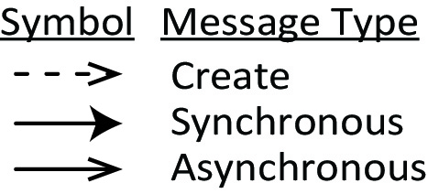
However, in much of this document, we will be much looser (due to my lack of understanding when I made these diagrams) and simply use the asynchronous arrow for both create and synchronous messages (we won’t use asynchronous messages)

Examples
Example 1 – For the example code above, if we had been given the code for the two classes A and B,
public class Driver {  public static void main(...) {  A a = new A();  a.foo();  B b = new B();  b.fee();  }  } | public class A {  public A() {}  public void foo() {}  } | public class B {  public B() {}  public void fee() {  fii();  }  public void fii() {}  }
and we wanted to draw a complete sequence diagram of all interactions, the diagram would need to reflect any messages sent inside other messages. For example, the fee method in B calls the fii method. In this case, the fii message is called a self-message.
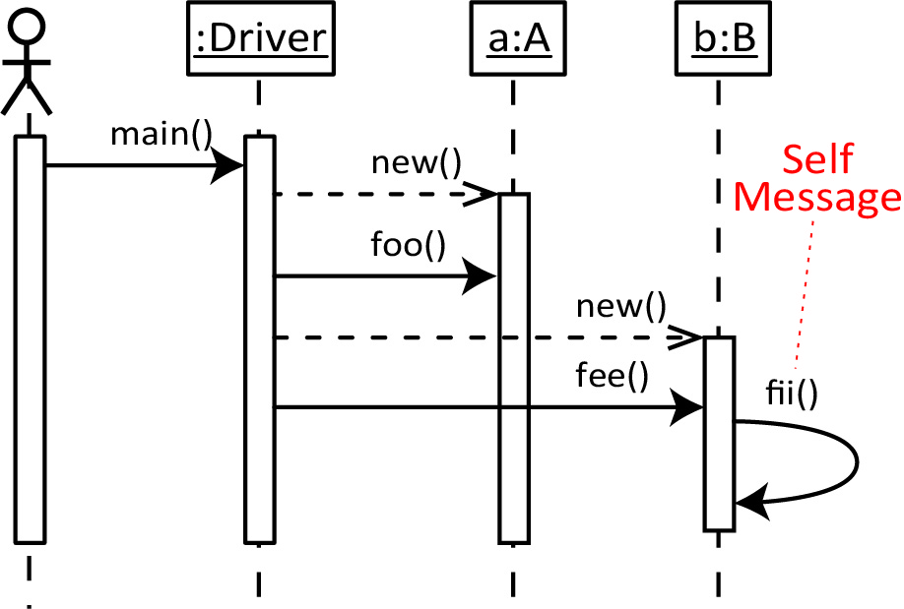
Example 2 – Consider the code below.
public class Driver {  public static void main(String[] args) {  B b = new B();  A a = new A(b);  a.fii();  }  } | public class A {  B b;  public A(B b) {  this.b=b;  b.fee();  foo();  }  public void foo() {}  public void fii() {}  }  public class B {  public B() {}  public void fee() {}  }
A complete sequence diagram for the case when the system is run is shown below. Notice that A’s constructor calls back to the b object with the fee method, then calls its own foo method.
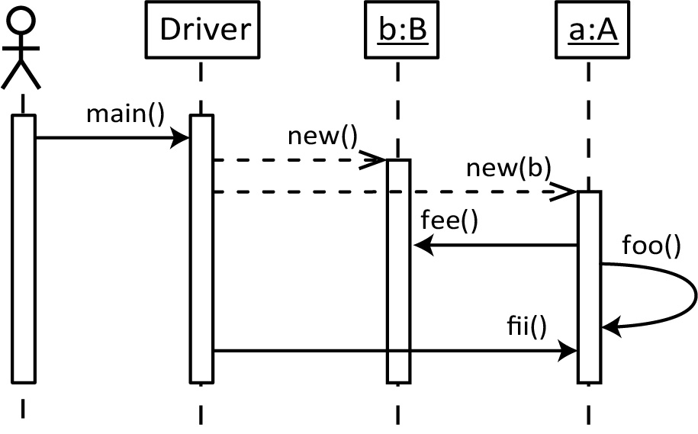
A sequence diagram can be ambiguous at times, without the indication of when a method finishes. Thus, we can add return (reply) arrows (dashed arrow with method name) when necessary. The example above with returns:

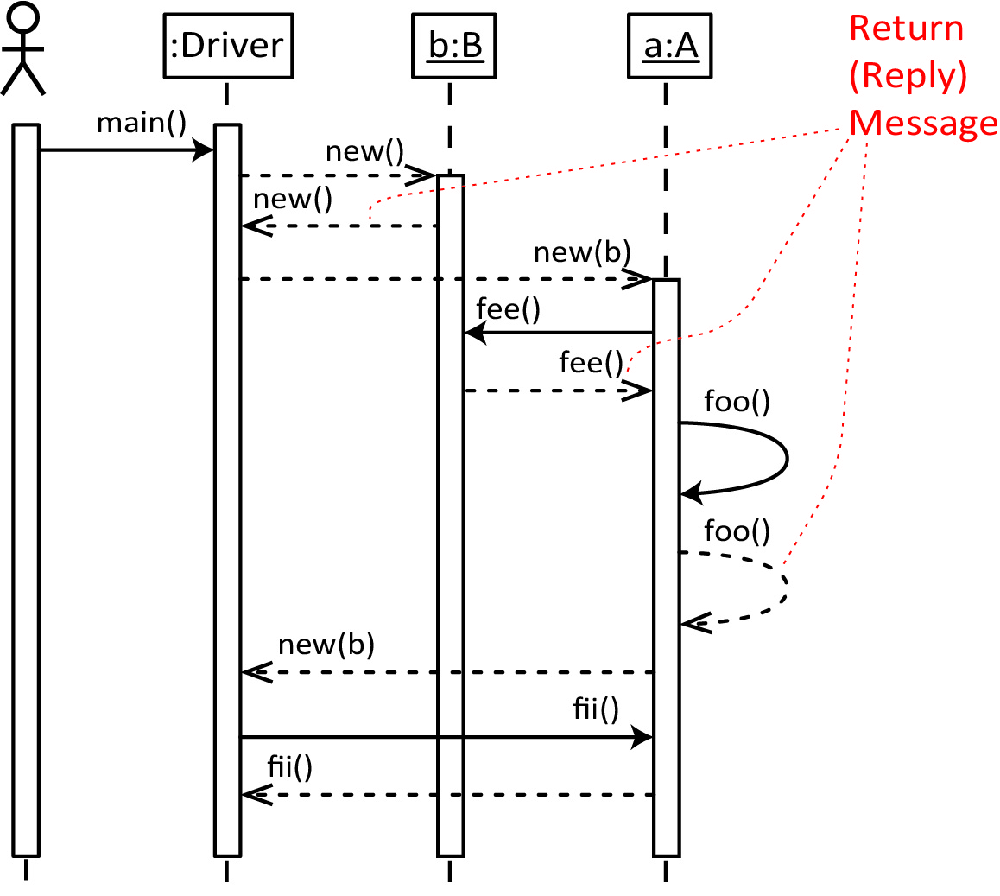

Conditional Behavior
Conditional behavior in a sequence diagram is indicated by putting a box around the conditional code, and labeled with an alt tag, as shown in the example below. The condition (guard) for entering is shown in brackets. An [else] block can be added. Technically, in UML this is called a combined fragment.
Example – Consider this code:
public class Driver {  public static void  main(String[] args) {  B b = new B(14);  A a = new A(b);  a.fii();  }  } | public class A {  B b;  public A(B b) {  this.b=b;  if(b.x>10) {  b.fee();  foo();  }  }  public void foo() {}  public void fii() {}  } | class B {  int x;  public B(int x) {  this.x=x;  }  public void fee() {}  }
A complete sequence diagram for the case when the system is run is shown below.
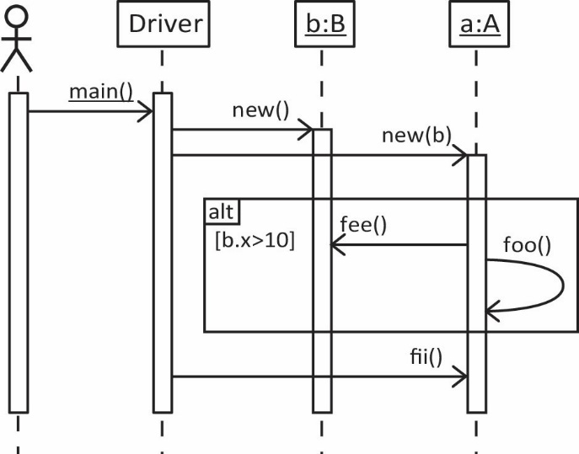
A multi-part conditional (unrelated to the example above) is shown below:
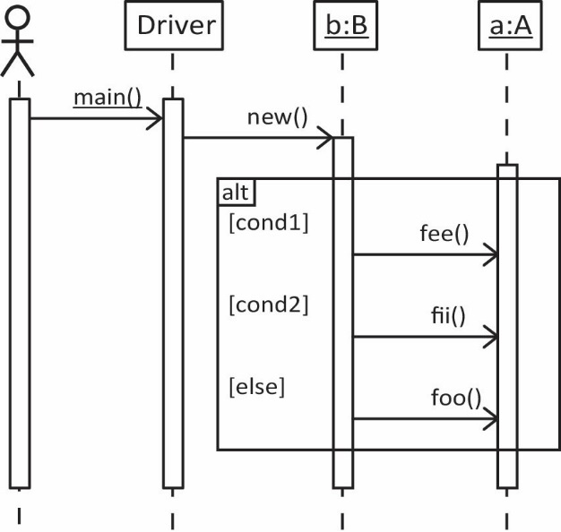

Iteration
Iteration in a sequence diagram is indicated by placing a box around code to be repeated, labeled with loop, and specifying how the iteration occurs as shown in the example below.
Consider this code:
class Product {  double price;  public double getPrice() {  return price;  }  public Product(double price) {  this.price = price;  }  } | public class Order {  List<Product> prods = new ArrayList<>();  public Order() {}  public void addProd(Product p) {  prods.add(p);  }  public double getTotal() {  double sum = 0.0;  for(Product p : prods) {  sum += p.getPrice();  }  return sum;  }  }
A sequence diagram for the case when the getTotal is called is shown below using slightly different depictions for the collection of Products.
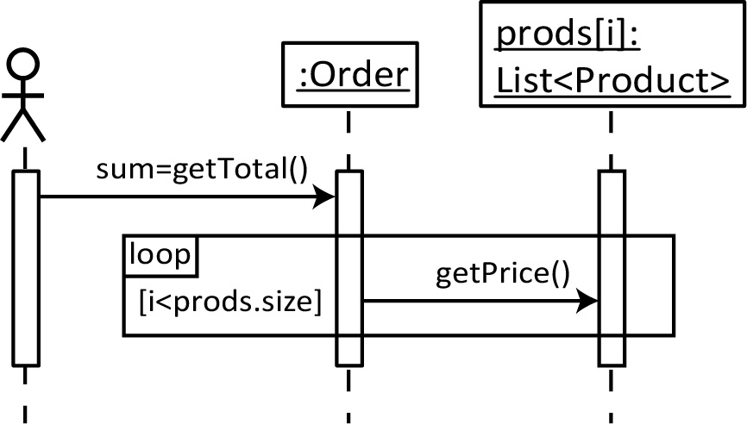 |  | 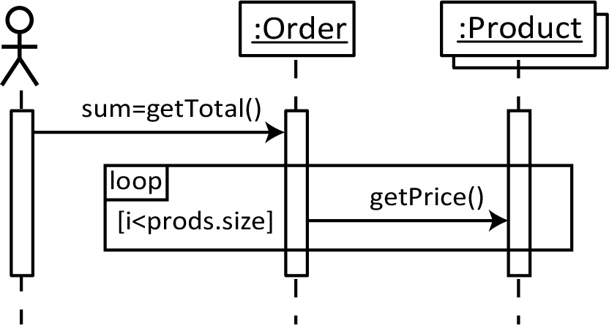
As another example, consider the use case and class diagram shown below to draw the corresponding sequence diagram.
Class diagram: A Bill contains a number of LineItems where each LineItem corresponds to one Item (Product). A LineItem specifies how many of the Item we want (and possibly other things).
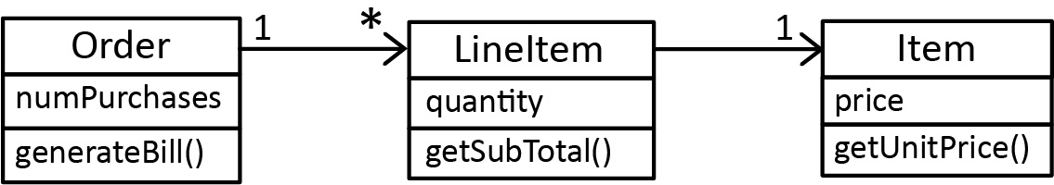
Use case: ObtainBill – Obtain the total bill.

Sequence diagram:

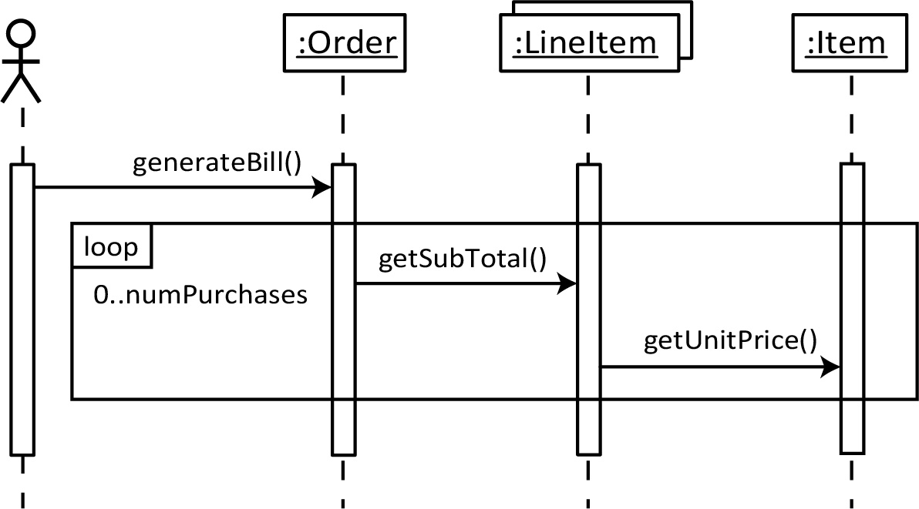

Object Deletion
Object deletion in a sequence diagram is indicated by placing an “X” where the deletion occurs.
Example – Consider the use case and class diagram shown below to draw the corresponding sequence diagram.
Class diagram: This is the same situation as Example 1, except that we have added 4 methods: cancelRegistration and deleteFromRegistrationList in the CourseSection class, deleteFromSchedule in the Student class, and cancel in the Registration class.

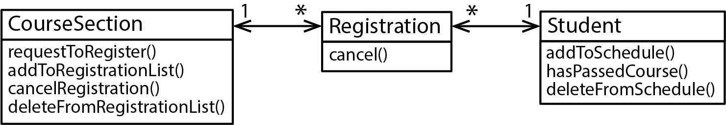

Use case: CancelRegistration – Cancel the registration for a course.

Sequence diagram:

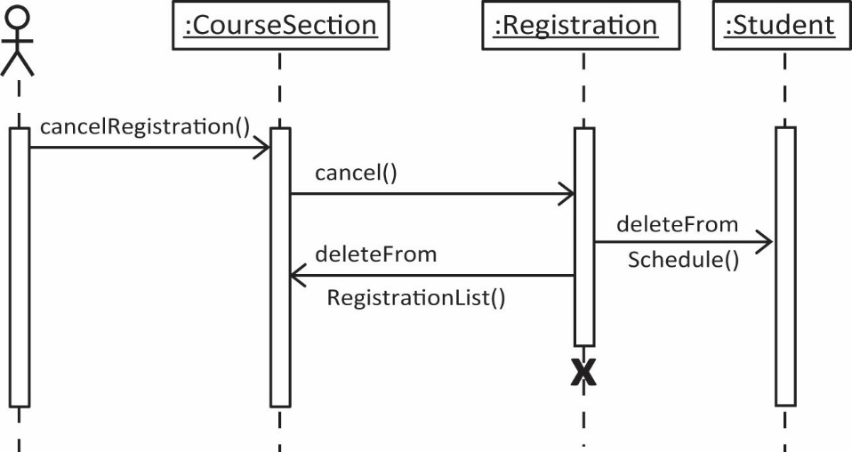

Blank Template for Sequence Diagram (next page)

Appendix
- Resources
https://www.visual-paradigm.com/guide/uml-unified-modeling-language/what-is-sequence-diagram/
https://www.uml-diagrams.org/sequence-diagrams.html
http://www.uml-diagrams.org/sequence-diagrams-reference.html

- Real Examples
This is from a system I wrote, jGrader, to automatically grade java programs:
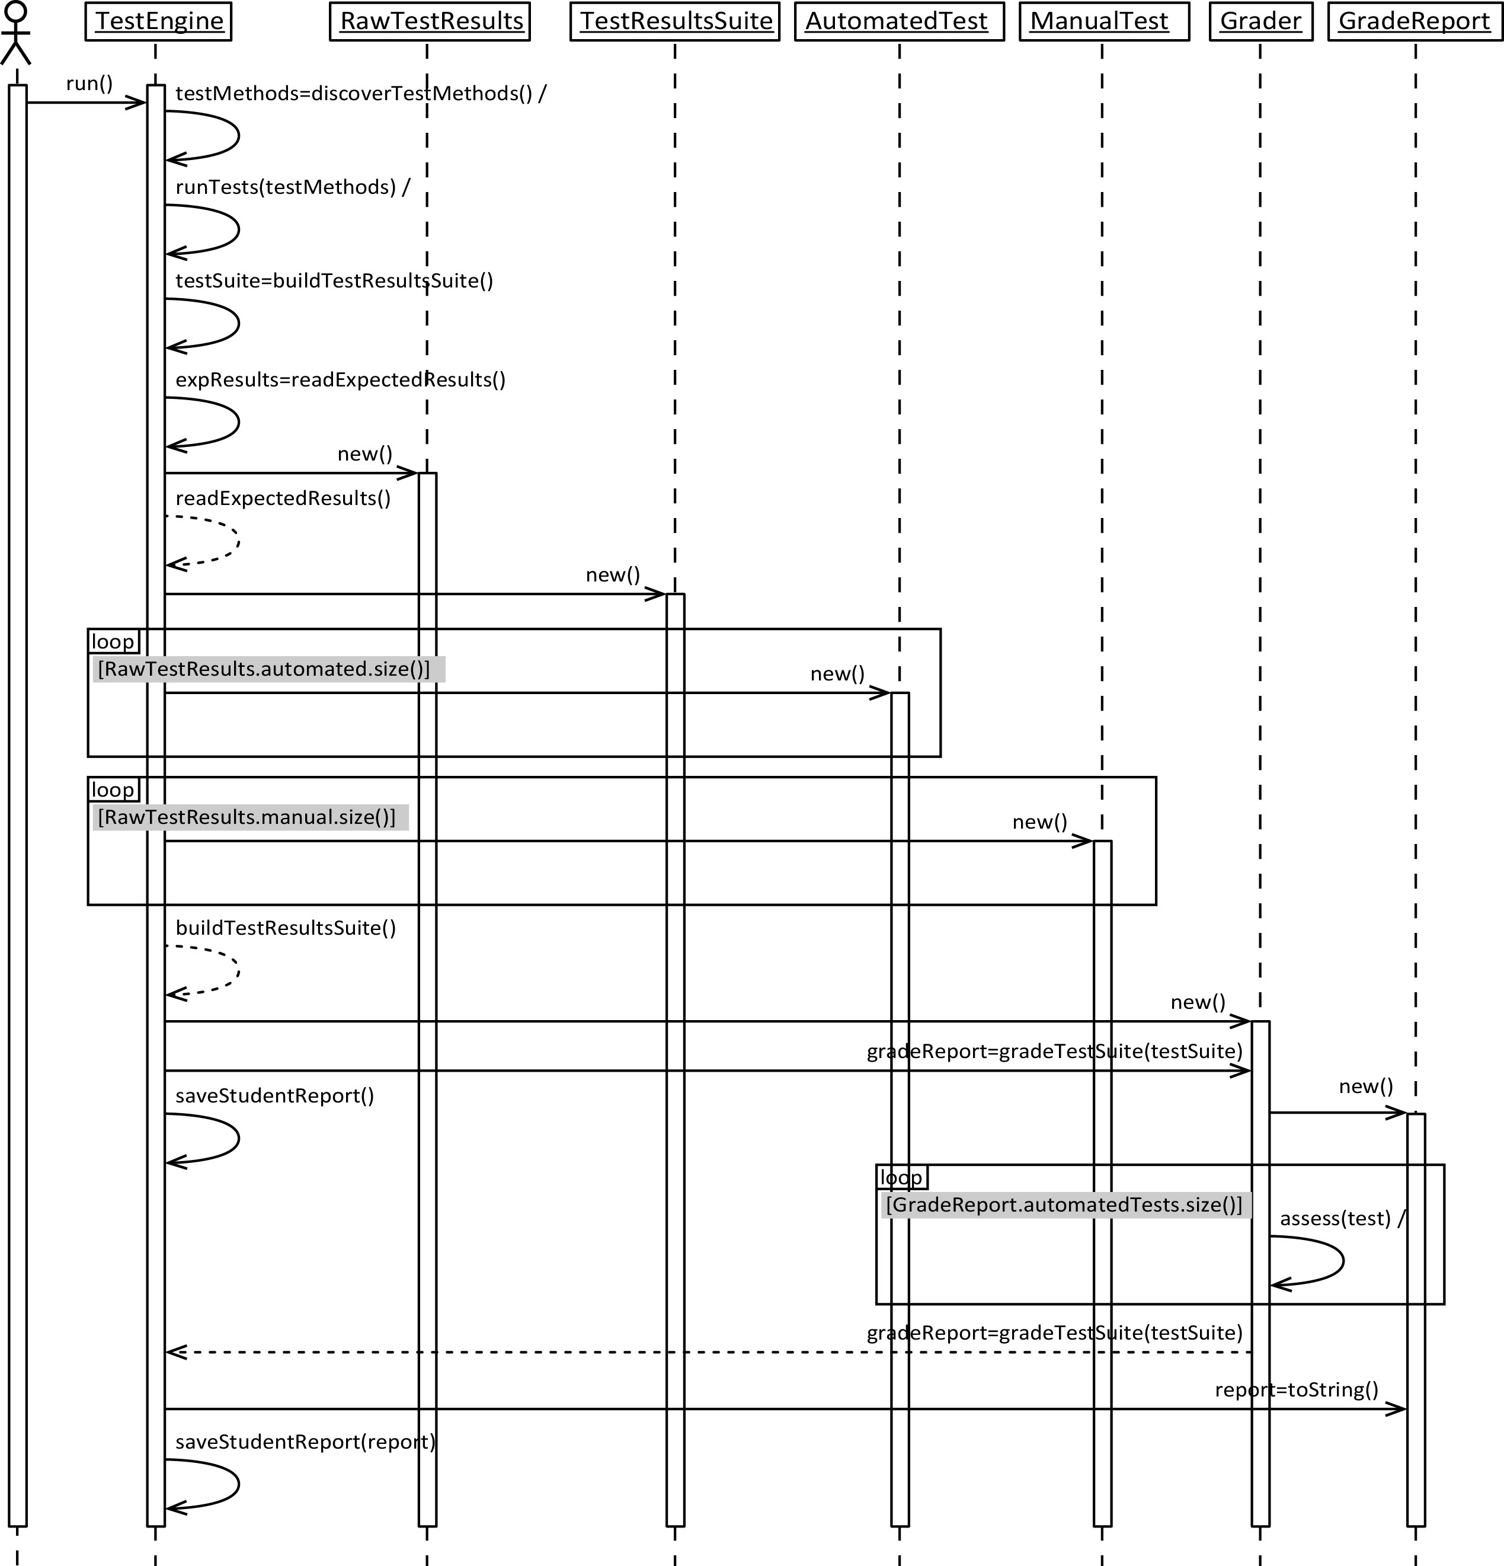

The gradeTestSuite method above has a bit more detail than shown
