Implementing Many-to-Many Associations
Contents
1 Introduction 1
2 Implementation 1
3 Associations 2
4 Enforcing Uniqueness 2
5 Adding a Support Class, Registrar 3
6 Adding a Registration 3
7 Setting Grades 4
8 Generating a Report Card 5
9 Unit Testing a Package Visible Method 5

Introduction
Consider the situation where a Student class is in a many-to-many relationship with a Course class. Thus, each Student can have many Courses and each Course can have many Students.
We introduce the Registration class to hold data associated with a student enrolled in a course: hwAvg, getAvg, finalExam.
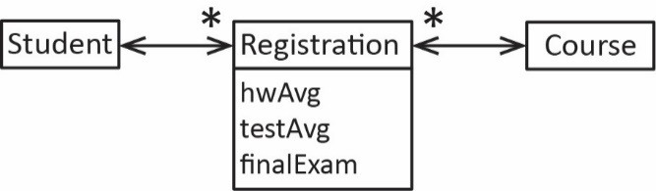

Implementation
Consider the class diagram below. In what follows, we discuss how to implement this. The code for this example is found on the Schedule. There are two packages: ver4, which contains the code and ver4_test which contains the unit tests.
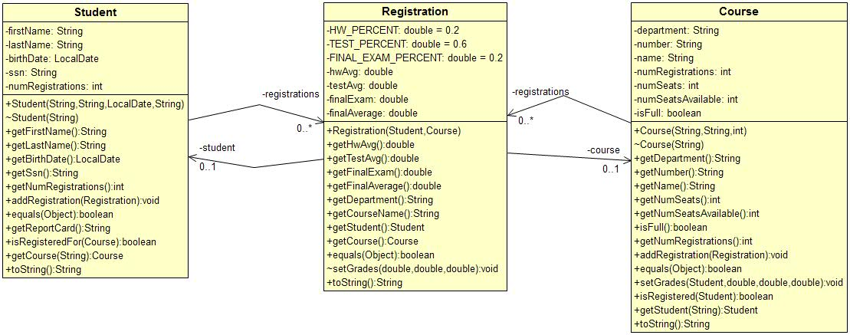

Associations
We assume that the ssn in the Student class is required to be unique as well as the name in the Course class. The name is composed of the department and the number. For example, department=”CS” and number=”4321”, then the name=”CS 4321”. Thus, we use a map to implement the relationship between Student and Registration, where the key is ssn:
public class Student {
...
private TreeMap<String,Registration> registrations;

Similarly, we also use a map to implement the relationship between Course and Registration, where the key is name:
public class Course {
...
private TreeMap<String,Registration> registrations;

Finally, the Registration class maintains associations with both Student and Course:
public class Registration {
...
private Student student;
private Course course;

Enforcing Uniqueness
The equals method is overridden in each of the classes to enforce uniqueness if needed. In this example, I don’t believe they are used. If there were methods, that return lists, then these implementations of equals would be useful as they support the list operations: contains(Object o), indexOf(Object o), lastIndexOf(Object o), remove(Object o).
Student Class | Course Class
public boolean equals(Object o) {  if(o instanceof Student s) {  return this.ssn.equals(s.ssn);  }  return false;  } | public boolean equals(Object o) {  if(o instanceof Course c) {  return this.name.equals(c.name);  }  return false;  }

Registration Class
public boolean equals(Object o) {
if(o instanceof Registration r) {
return this.student.equals(r.student) &&
this.course.equals(r.course);
}
return false;
}

Adding a Support Class, Registrar
In addition to the domain classes mentioned above, we introduce a Registrar class which maintains a map of Students and a map of Courses as well as a method, register to register a student in a course.
public class Registrar {

private TreeMap<String,Student> students;
private TreeMap<String,Course> courses;

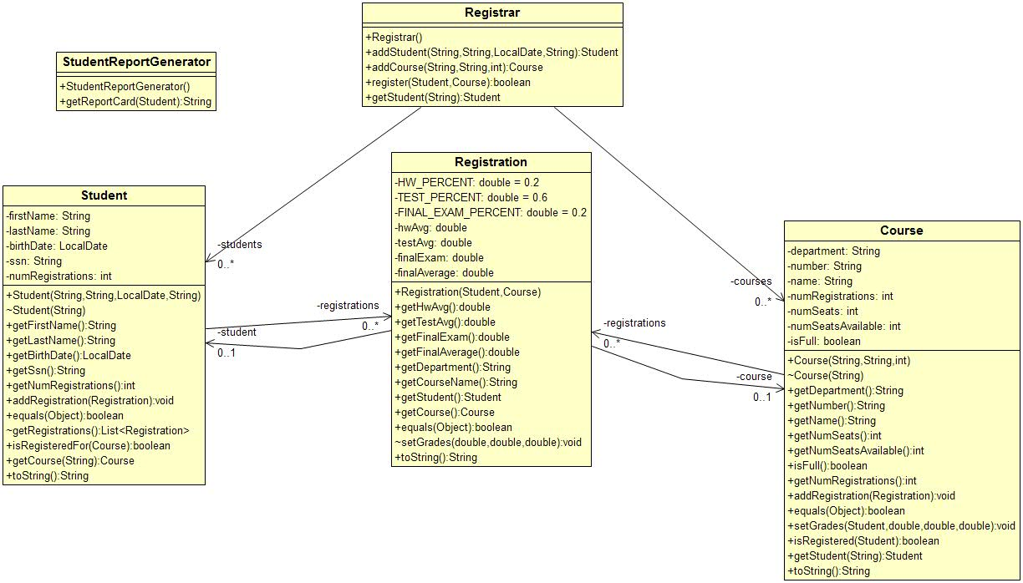

Adding a Registration
The Registrar class has a register method:
public boolean register(Student s, Course c) {
// Registrar must contain reference to student and course before registering,
// and student must not already be registered for course.
if(!students.containsKey(s.getSsn()) ||
!courses.containsKey(c.getName()) ||
s.isRegisteredFor(c) ) {
return false;
}
Registration r = new Registration(s,c);
s.addRegistration(r);
c.addRegistration(r);
return true;
}

The Student class has an addRegistration method:
public boolean addRegistration(Registration r) {
if(registrations.containsKey(r.getCourseName())) {
return false;
}
registrations.put(r.getCourseName(),r);
return true;
}
The Course class has an addRegistration method:
public boolean addRegistration(Registration r) {
if(registrations.containsKey(r.getStudent().getSsn())) {
return false;
}
if(isFull()) {
return false;
}
registrations.put(r.getStudent().getSsn(),r);
numSeatsAvailable--;
if(numSeatsAvailable==0) {
isFull = true;
}
return true;
}

Setting Grades
The Course class is responsible for setting grades:
public boolean setGrades(Student s, double hwAvg, double testAvg, double finalExam) {
if(!registrations.containsKey(s.getSsn())) {
return false;
}
Registration r = registrations.get(s.getSsn());
r.setGrades(hwAvg, testAvg, finalExam);
return true;
}
The Registration class records the grades and computes the finalAverage as shown below. The method is given package level visibility to prevent other classes outside the package from directly modifying the grades.
void setGrades(double hwAvg, double testAvg, double finalExam) {
this.hwAvg = hwAvg;
this.testAvg = testAvg;
this.finalExam = finalExam;
this.finalAverage = HW_PERCENT * hwAvg +
TEST_PERCENT * testAvg +
FINAL_EXAM_PERCENT * finalExam;
}

Generating a Report Card
We introduce the StudentReportGenerator class to build a report card for a student:
public static String getReportCard(Student s) {
StringBuilder sb = new StringBuilder();
sb.append("Report Card\n-------------------\n");
if(s.getNumRegistrations()==0) {
sb.append("No courses registered for");
return sb.toString();
}
int i=0;
for(Registration r : s.getRegistrations()) {
String line = String.format("%d. %s, final avg=%.1f\n", ++i, r.getCourseName(), r.getFinalAverage());
sb.append(line);
}
return sb.toString();
}
Above, we utilized the getRegistrations method found in the Student class. We’ve given the class package level visibility and have it return an unmodifiable list in order to practice defensive programming:
// In practice, may or may not need to be unmodifiable
List<Registration> getRegistrations() {
List<Registration> list = new ArrayList<>(registrations.values());
return Collections.unmodifiableList(list);
}

Unit Testing a Package Visible Method
The setGrades method in the Registration class has package level visibility. Assuming the unit tests are in a separate test package, then reflection must be used to access the method.
@Test
void testSetGrades() throws NoSuchMethodException, IllegalAccessException,
InvocationTargetException {
String date = "1999-04-26";
LocalDate bDate = LocalDate.parse(date);
Student s1 = new Student("Dave", "Gibson", bDate, "222348834");
Course c1 = new Course("CS", "3326", 3);
Registration r = new Registration(s1, c1);

Method m = getSetGradesMethod();
m.invoke(r, 90, 80, 70);
double actualFinalAverage = r.getFinalAverage();
double expectedFinalAverge = 0.2* 90 + 0.6 * 80 + 0.2*70;
assertEquals(expectedFinalAverge, actualFinalAverage);
}

private Method getSetGradesMethod() throws NoSuchMethodException {
Method method = Registration.class.getDeclaredMethod("setGrades", double.class,
double.class, double.class);
method.setAccessible(true);
return method;
}

