HW-CD StarUML
This is an individual homework assignment. In this HW, you will learn about StarUML, a UML tool. Along the way, you will answer some questions.
Contents
1 Answers 1
2 Introduction 2
3 Configure for First Use 3
4 Build Class Diagram 5
5 Forward Engineer: Generate Code 8
6 Reverse Engineer Code: Generate Diagram 9
Appendix 1 Configuration 15
Appendix 2 Resources & Sources 15

Answers
The answers to the questions in Section 6 go here:
Answer: Section 6, Step 14

Answer: Section 6, Step 16

Answer: Section 6, Step 18

Answer: Section 6, Step 20

Introduction
StarUML is a very good tool that supports many UML diagrams: class, object, package, use case, sequence, collaboration, state, activity, component, and deployment. However, here, we only consider the class diagram.
StarUML (with an extension) class diagrams support forward engineering (code generation). The feature allows the user to draw a class diagram with the visual editor and then generate the actual code from the diagram. It also reverse engineering which is the process of generating a class diagram from code. This homework assignment will show you how to do both of these. For your project, you might want to use forward engineering, i.e. create a model before generating the code. Or, using the agile approach, you may want to just begin coding the basic features of classes needed to get started. You will definitely need to use reverse engineering so that you can generate various class diagrams of your code base.
StarUML provides an open API so there are a number of plugins available: https://staruml.io/extensions. We will use three: (a) Java – which allows code generation and reverse engineering; (b) Generate Getters & Setters – when you add an instance variable, this will provide a way to automatically generate a getter and setter; (c) Merge Generalizations – when you have two or more subclasses with a common superclass, this allows all the separate generalization arrows to be merged into one.
Resources:
- https://docs.staruml.io/ – Official documentation. Although not necessary, if you want to get better insight on how StarUML could be used in practice, read the brief pages: Introduction, Basic Concepts, Managing Projects, Managing Diagrams, User Interface. A very slightly different version of this, with some screen shots (and many missing) is here.
- https://www.clear.rice.edu/comp201/07-spring/info/staruml/ – Brief overview of class diagram construction.
- http://www.cs.sjsu.edu/~pearce/modules/tutorials/uml/index.htm – Four videos, two on class diagram (43min total)

Configure for First Use
- Download and install StarUML: https://staruml.io/
- Run StarUML, choose: Evaluate. A nag screen appears, but informs you that there is no time limit for the evaluation of the software.
- Next, we install the three extensions mentioned earlier. Choose: Tools, Extension Manager and search for “Java”. Install this (the second one listed in the figure below). It will say it needs to Reload. Choose: Close instead, as we will reload when we have installed all three.
The source is (probably not needed): https://github.com/staruml/staruml-java
- The Extension Manager should still be open. Search for, “merge generalizations”. Install this. It will say it needs to Reload. Choose: Close instead, as we will reload when we have installed all three.
The source is (probably not needed): https://github.com/niklauslee/staruml-merge-generalizations
- The Extension Manager should still be open. Search for, “generate getters”. Install this. When prompted, choose: Reload.
The source is (probably not needed): https://github.com/niklauslee/staruml-gettersetter
- To verify the extensions have been added, choose the Tools menu and verify that you see the three extensions installed above.

Build Class Diagram
- Choose: Model, Apply Profile, UML Standard Profile (v2) (not sure what this does, nor if we actually need it). It adds a node in the Model Explorer (upper-right of your screen) as shown on the right.

- In the Model Explorer (upper-right), right-click the Model node and choose: Add, Package. A Package1 node is added to the Model Explorer (ME).
- In the Properties dialog (lower-right), change the name from Package1 to animals.

- In the Model Explorer (upper-right), right-click the Model node and choose: Add Diagram, Class Diagram. Notice that a ClassDiagram1 element was placed inside the Model node in the Model Explorer.

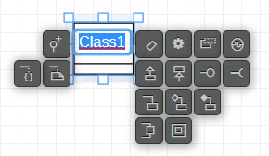
- In the Toolbox (lower-left), select the Class icon, then click on the design surface. A class rectangle will appear. As shown on the right, with the class name selected, a number of contextual icons appear as shown in the figure below. We will be using some of these as we go along.

- Change the name of the class to: Person. Then, Enter. (or, you could have done that through the Properties dialog (lower-right).

- Right-click the class and choose: Add, Attribute.
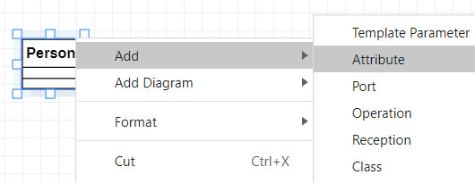
- Double-click the text, +Attribute1, and type: -name:String and Enter. Then, click on the design surface and the rectangle will resize. Notice the name node in the ME under the Person node.

- Select the name attribute in the diagram and then choose: Tools, Generate Getters Setters.
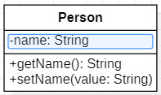
- To delete an element, right-click it either in the ME or on the design surface, and choose: Delete from Model. Verify that you see this option, but don’t delete anything. Note: if you simple select and element and press Delete, it removes it from the diagram, but not the model.
- Right-click the class and choose: Add, Operation. Operation1 was added in the diagram and as a node in the ME.
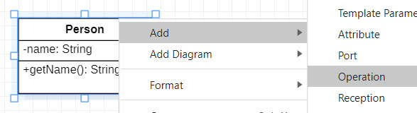
- Double-click the text, Operation1 and type: Person(name:String) and Enter. As we will see later, this did not create a constructor, it created a void method named Person. We will say more about this later.
- In the Model Explorer, right-click the Person operation (not the class) and choose: Move Up. Repeat to put it at the top of the methods list.
- Right-click the class and choose: Add, Operation.
- Double-click the text and type: talk():String and Enter

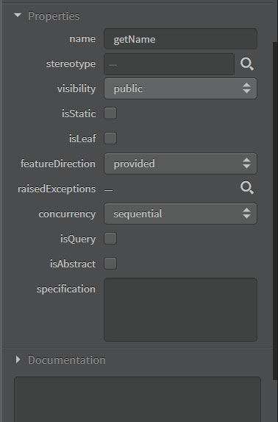
- Select the getName method (or any method or instance variable) and look at the Properties dialog (lower-right of UI). Just scroll through and see the options that are available. Notice that we can change the visibility, or make it abstract, etc.
- Add a class named Dog.
- In the Toolbox (lower-left of UI), select the Association icon, then click, hold and drag on the Person class, dragging to the Dog class and release.
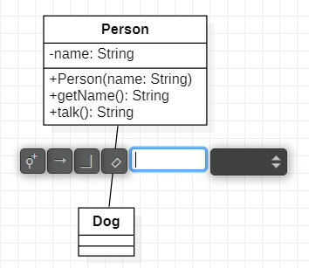
- You are prompted to type a name. Don’t. Simply click on the design surface to dismiss the prompt.
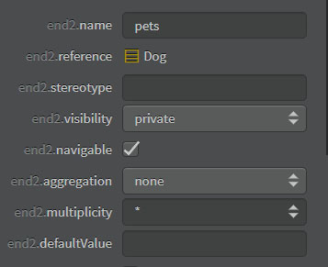
- Select the association and then look in the Properties (lower-right). Set the following properties:
- end1.navigable – uncheck
You will need to scroll down in the Properties window to see the following:
- end2.name – type: “pets”
- end2.visibility – change to: private
- end2.navigable – Make sure it is checked
- end2.multiplicity – choose: “*”
Note that 2 steps above, you could have used a “Directed Association” instead of an “Association” which would have taken care of the navigability for the two ends.
- In Windows, use File Explorer to create a folder, mysystem, on your harddrive. This is where we will store your project and the code that is generated.
- In StarUML, choose: File, Save, and navigate to the mysystem folder. Supply the project name: mysystem.mdj and choose: Save (you will get the nag screen again).

Forward Engineer: Generate Code
- To generate the code from these classes, they must be in a package. The classes shown in the Model Explorer are probably not in the animal package. If not, drag them there. The result is shown on the right.
- Choose: Tools, Java, Generate Code.
- Expand the Model node in the “Select a base model…” dialog. Then, select the animals package and OK.
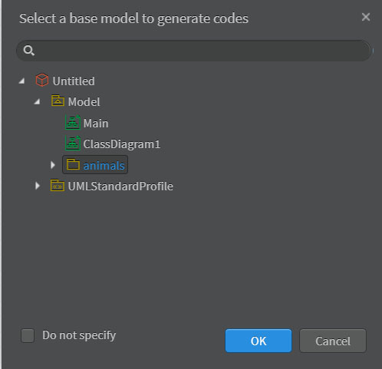
- A Select Folder dialog appears (). Navigate to the mysystem (when I did this, it was already inside the mysystem folder, so, I had to go up one level in the folder hierarchy folder), select it, and choose: Select Folder. Note the following:
- The code was generated, although no message appeared confirming this. We will inspect the code in just a minute.
- Very important: If you make more changes to your diagram and then repeat this process to generate code, it will NOT generate any code (and again, it will not tell you this). If you need to make changes to the diagram and you want to generate code again, it will only work if you either: (a) specify a new location, or (b) delete the package in File Explorer (Windows) first.
- Use File Explorer (Windows) to navigate to the mysystem folder and there you will see the animal folder and inside the Person and Dog classes. Use Notepad (or any program) to open the Person class and note the following:
- It automatically provided a no-arg constructor.
- Our constructor has been turned into a method.
public void Person(String name) {
// TODO implement here
}
This can be corrected in StarUML with the proper syntax/property. However, I was unable to figure it out.
- For the 1-many relationship (Person has many Dogs), it probably generated:
private Set<Dog> pets;
  - The default implementation in UML for a collection is Set. You can select the association and “check” the end2.isOordered property and then the code will generate a List. However, it puts a tag on the diagram that reads: “{ordered}” which I was unable to remove.
  - StarUML is template-driven which means that there are templates (probably XML) that specify how diagram elements are transformed into code. These can be modified as needed. However, I provide no instructions for this.
- In summary, even though the code is not perfect, it is a starting place. And, as you’ll see next, when you start implementing the code and then reverse engineer it in StarUML, the diagram will be generated properly, without some of the caveats mentioned above.

Reverse Engineer Code: Generate Diagram
- Download the supplied code, hw_cd_staruml_code.zip and unzip. There, you will find this path:
com\yattasolutions\umllab\examples\shop
Inside, you will find a number of Java files. Next, we will reverse engineer this code to produce a class diagram.
- Open StarUML and choose: Tools, Java, Reverse Code…
- Navigate to the location of the top package: com (from the path above), select it, and then choose: Select Folder.
- You will see a JavaReverse node in the Model Explorer with nodes for the package structure and all the classes (partially shown in the figure further below on the left).
- Select the Model node in the Model Explorer, right-click, and choose: Add Diagram, Class Diagram.
- From the Model Explorer, select the Person class (shown in figure below, on left) and drag unto the diagram (result shown in figure below, on right).
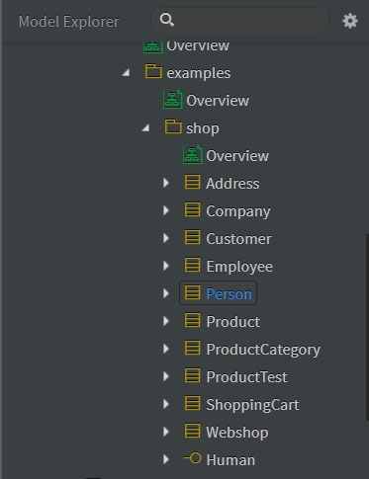 | 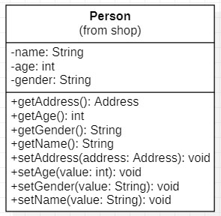

- Repeat for the Employee and Customer classes, and the Human interface. Rearrange the diagram so that it looks as shown below (next page). Note:
- These classes don’t have constructors. I borrowed the code, and that is the way it came. In the future, I may add these.
- Collections are indicated with the notation “[*]”. For example, the getCompany method in the Employee class returns a collection of companies, denoted by: “Company[*]”. In other words, it doesn’t specify the type of collection. Those of you who have had my CS 1302 course know that we would specify this as:
getCompany():ArrayList<Company>
- The getCompany method is poorly named. It should be getCompanies since it is returning a collection of companies.
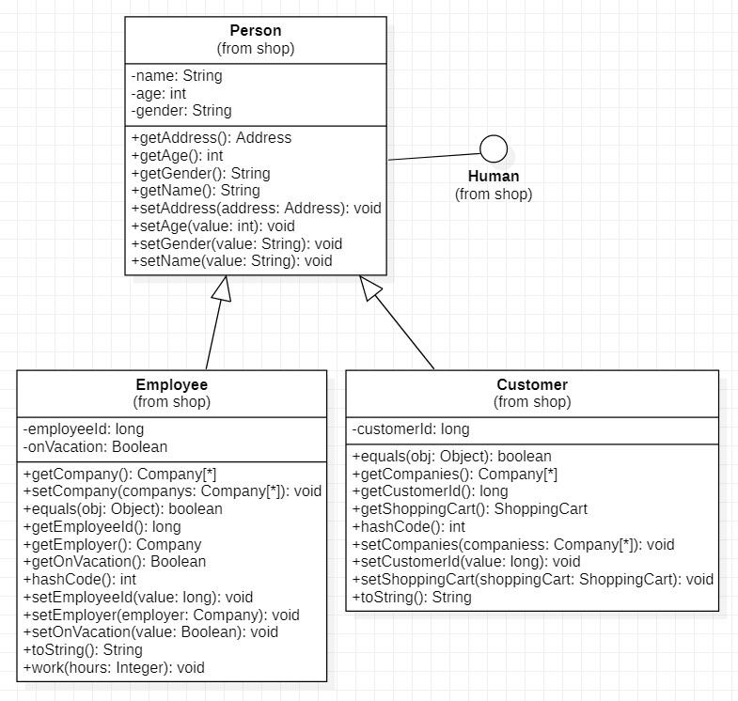
- Next, we are going to:
- Hide the display of package (shop)
- Change the interface (Human) lollipop display to the standard rectangular one.
- Combine the two subclass arrows.
- Select all diagram elements (the 3 classes and the interface) by dragging the mouse around them.
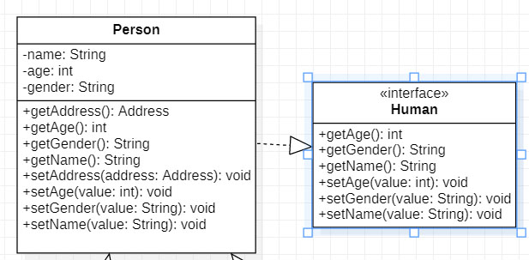
- Right-click and choose: Format and then uncheck, “Show Namespace”
- Select the Human interface, right-click, and choose: Format, Stereotype Display, Label.
- With the Human interface selected, right-click, and choose: Format and uncheck, “Suppress Operations”

- Select the superclass (Person) in the diagram and choose: Tools, Merge Generalizations. Note, you can select an endpoint of the resulting lines and drag them to a different location to make the diagram look nicer. The result should look similar to this:
- Describe in a complete sentence(s) the relationship between the Customer, Employee, Human, Person classes and interface. If you are not sure what this means, see the Class Diagrams document on the Schedule. Your answer should be type in Section 1 – Answers.

- From the Model Explorer, select the ShoppingCart class and drag unto the diagram. Select a role name (shoppingCart) and drag to move so that it doesn’t intersect with the class. Do the same for the other role name.
- Describe in a complete sentence(s) the relationship between the ShoppingCart and Customer classes. Your answer should be type in Section 1 – Answers.
- Drag the Product class onto the diagram. Rearrange to make it look nice and readable. I’m not sure how to hide the ‘collection=”Set” ’ comment, it is tied to the association. The default 1-many association in UML is Set. Probably with the aforementioned templates this can be changed.
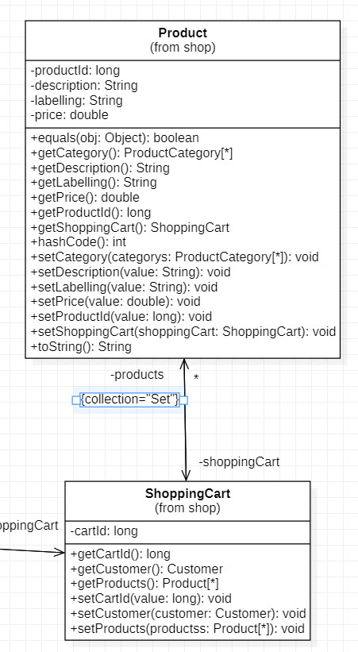

- Describe in a complete sentence(s) the relationship between the ShoppingCart and Product classes. Your answer should be type in Section 1 – Answers.

- Drag the Company class onto the diagram. Rearrange to look nice. Don’t worry about the relationship between Company and Employee, just Company and Customer.

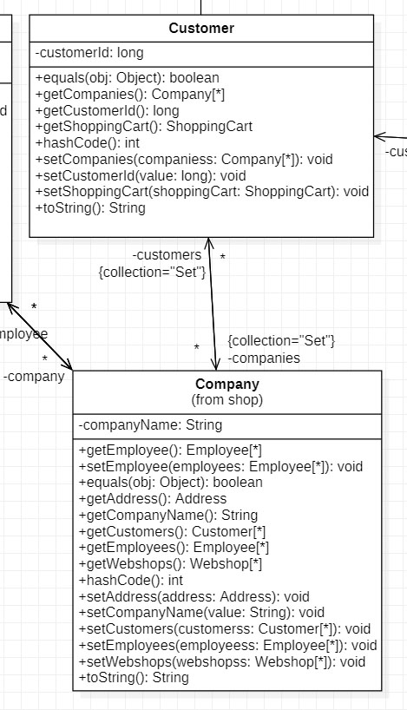

- Describe in complete sentences the relationship between the Company and Customer classes. You do not need to describe the relationship between the Company and Employee classes. Your answer should be type in Section 1 – Answers.

- Try this: drag the ProductTest class onto the diagram. There will probably not be any relationship shown between the ProductTest and Product classes. If not, select Dependency icon from the Toolbox, click on ProductTest and drag and release on Product. You will be prompted to type something, just leave it blank.

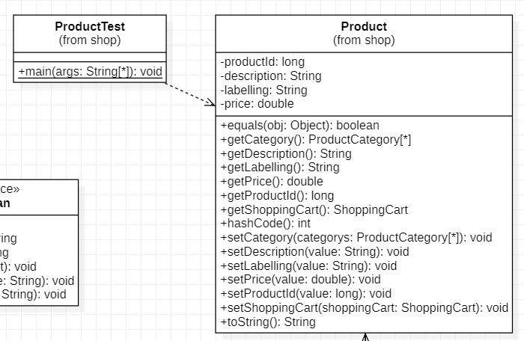

- In the box below, describe in complete sentences the relationship between the ProductTest and Product classes. (I’ll do this one for you!).

There is a dependency relationship between the ProductTest and classes. A dependency relationship exists when a class uses another class, but does not possess it as an instance variable. We usually do not show dependency relationships on a class diagram unless there is something special we want to illustrate.

- Choose: File, Save.
- Save your diagram: File, Export Diagram As, JPG (don’t use PNG, it is poor quality. SVG is the nicest, but I don’t know if it will display in Blazeview).

Submission: Turn in these 3 items in the HW-CD-StarUML dropbox on Blazeview:

- This document
- The class diagram from the last step
- The .mdj file

YOU ARE NOW DONE.

Appendix
- Configuration
[Fall 2022, Not sure if this is relevant, or exactly what I wrote] This post suggests that it is possible to configure StarUML, for example to always use text for the visibility of class members as opposed to icons. I just quickly read it and don’t see immediately how to do this. There are at least a handful of settings I’d like to make the defaults. I’ve searched a fair amount and this is the only link that seems related.
https://sourceforge.net/p/staruml/discussion/510443/thread/8d2b9dfe/
- Resources & Sources
- https://www.clear.rice.edu/comp201/07-spring/info/staruml/
- https://docs.staruml.io/user-guide/formatting-diagram - Formatting elements
- Ctrl+-, Ctrl+=. Zoom out/in.
- https://staruml.sourceforge.net/docs/user-guide(en)/ch11.html - comprehensive guide to UI

