Class, Object, & Package Diagrams
Contents
1 Unified Modeling Language 1
2 Class Diagram Basics 2
3 Association Relationships 3
3.1 One-to-One Associations 3
3.1.1 One-way Navigability 3
3.1.2 Two-way Navigability 5
3.2 One-to-Many Associations 6
3.3 Many-to-Many Associations 8
3.4 Aggregation & Composition 9
4 Dependency Relationships 10
5 Generalization & Interface Relationships 11
6 Package Diagrams 12
7 Software 13
8 Exercises 13
Appendix 1 Exercise Solutions 16

Unified Modeling Language
The Unified Modelling Language (UML) is a standardized graphical language for modelling object-oriented software. It is used to produce models of a software system.
UML is composed of a number of different diagrams:
- Class – shows the classes in a system and their relationships. They show what interacts but not how they interact.
- Object – Shows instances of classes. Used to help explain complicated relationships. It shows an example of what happens at run-time.
- Package – A grouping of related classes. Used to simplify complex systems and provide a mechanism for information hiding at the class level.
- Use Case – describes what the system does from the customer’s perspective
- Sequence – Shows how operations are carried out, what messages are sent and when.
- Collaboration – Same as sequence except they focus on object roles instead of time.
- State – Objects and systems have behaviors and state. A State diagram shows the possible states of an object/system and how transitions occur.
- Activity – Similar to a flowchart and related to a State diagram. An Activity diagram focuses on the activities in a process while a State diagram focuses on the state of a process.
- Component – A component is a code module. A Component diagram is used to model the high-level software components.
- Deployment – Shows the physical configurations of software and hardware.
This document only considers class, object, and package diagrams.

UML can be used for:
- forward engineering – producing code from graphical models
- reverse engineering – producing graphical models from code
- round-trip engineering – models generate code, then changes to code update the models
History of UML – At the end of the 1980s and the beginning of 1990s, the first object-oriented development processes appeared. The proliferation of methods and notations tended to cause considerable confusion. Two important contributors, James Rumbaugh and Grady Booch decided to merge their approaches in 1994. They worked together at Rational Software (bought by IBM in 2003). In 1995, another methodologist, Ivar Jacobson, who focused on use cases joined the team. In 1997 the Object Management Group (OMG) started the process of UML standardization. Today, the UML specification is maintained by the OMG.

Class Diagram Basics
A class diagram is used to show the static structure of a system. It depicts the classes and their relationships. The items below should be clear except perhaps the dependency relationship which we consider later. Note: static methods are underlined.
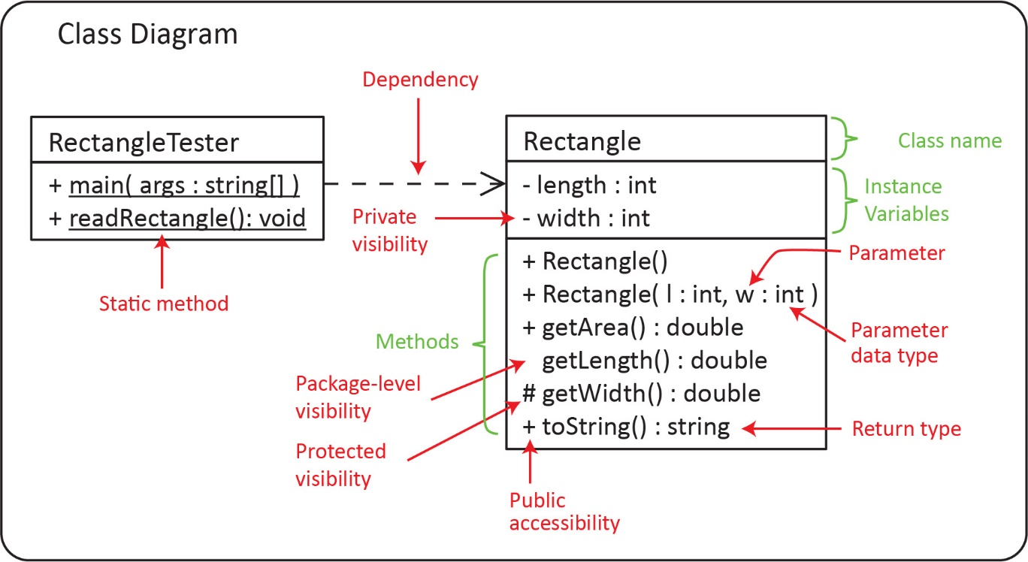
The notation for instance variables, parameters, and return types is show below:
Instance Variables: varName : datatype
Methods: method( paramName : dataType ) : returnType
We can show a class in various degrees of detail as shown below, depending on the stage of modeling.
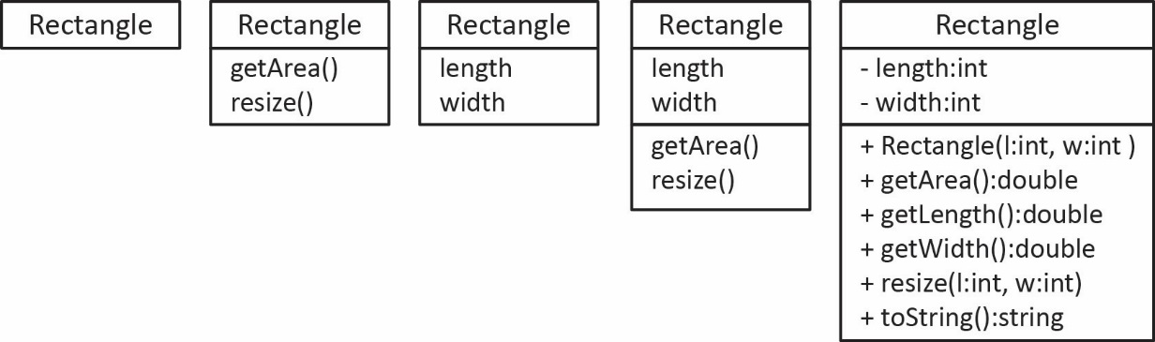

Association Relationships
There are a number of types of relationships between classes: association (has-a), generalization (is-a), interface, and dependency. In this section, we consider the association relationship. In general, there are three types of associations:
- One-to-one association (relationship): each Person has one Dog, each Dog has one Person.
- One-to-many relationship: each Person has many Dogs, each Dog has one Person.
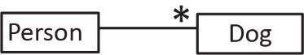
- Many-to-many relationship: each Course has many Students; each Student has many Courses.
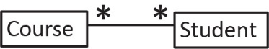

One-to-One Associations

One-way Navigability
- Association, Role Name, Navigability, and Multiplicity
- Example:
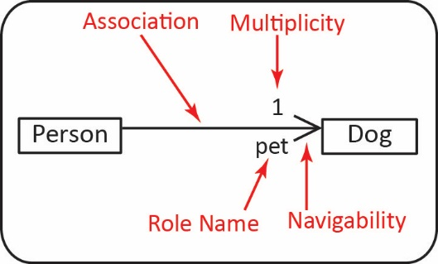
- Note the following:
- The association is read: “A Person has-a Dog.”
- The multiplicity indicates that a Person has exactly one Dog.
- The navigability indicates that a Person knows who her pet is but a Dog does not know who its owner is.
- The role name indicates that the Person class has an instance variable pet of type Dog. Note that the class diagram does not show this instance variable. You can show it; however, it is understood because of the association arrow and the role name.
- The code implied by the diagram:
public class Person {  private Dog pet;  } |  | public class Dog {  }

- Object Diagram – An object diagram shows instances of classes at run-time. It shows objects not classes. Objects are underlined to differentiate them from classes. It is useful sometimes to visualize what could/might exist at some point in time as a program runs. An object diagram does not show abstract classes nor interfaces.
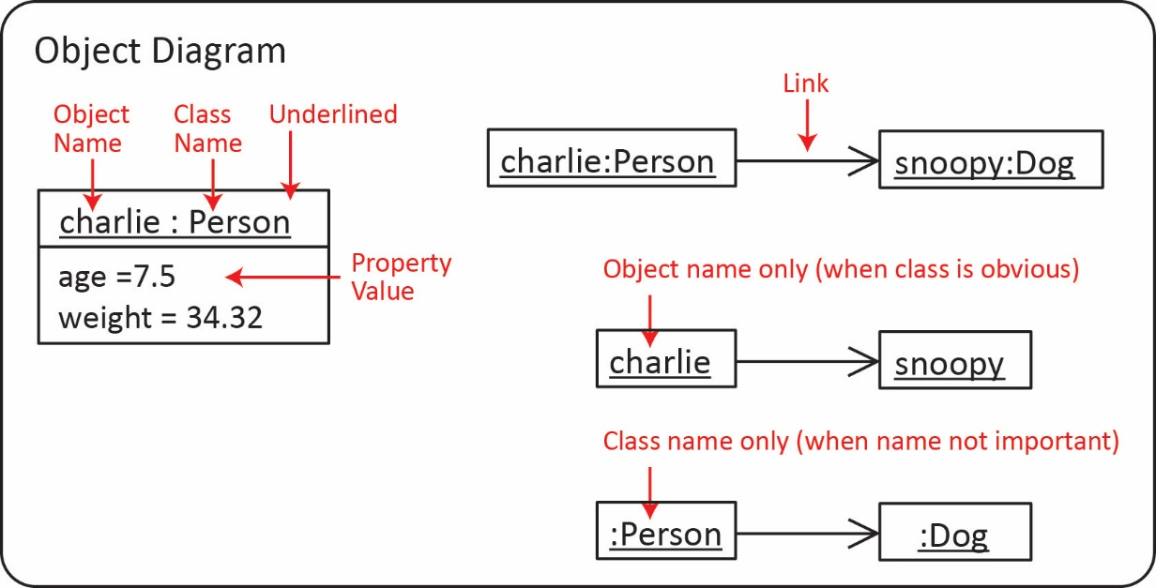
- Example:

Class Diagram |  | Code |  | Object Diagram
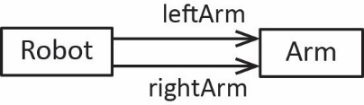 |  | public class Robot {  private Arm leftArm;  private Arm rightArm;  } |  | 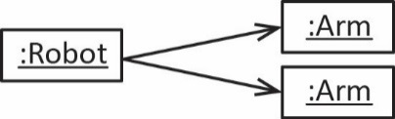

- Example – Reflexive Association:

Class Diagram |  | Code |  | Object Diagram
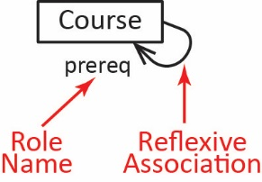 |  | public class Course {  private Course prereq;  } |  | 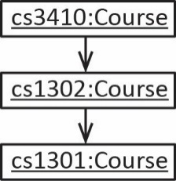
- Example – A linked list is modelled with a reflexive association.
Class Diagram |  | Object Diagram (LinkedList<Dog>)
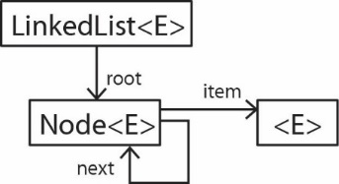 |  | 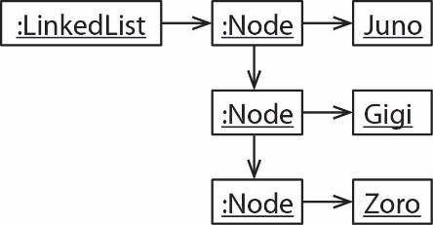

Two-way Navigability
- Technically, if no navigability is shown (diagram on the left) then there is two-way navigability. In the figure below, a Person has a pet which is a Dog and a Dog has an owner who is a Person. I prefer to use the explicit specification of two-way navigability as shown on the right.
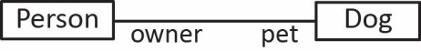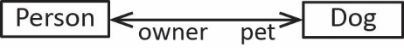
- Implementing two-way navigability –The preferred approach:
public class Person {  private Dog pet;  public Person(Dog pet) {  this.pet = pet;  }  } |  | public class Dog {  private Person owner;  public void setOwner(Person owner) {  this.owner = owner;  }  }
Thus, the assignment of navigability is explicit:
Dog d = new Dog();
Person p = new Person(d);
d.setOwner(p);
- Implementing two-way navigability – Inferior approach:
public class Person {  private Dog pet;  public Person(Dog pet) {  this.pet = pet;  this.pet.setOwner(this);  }  } |  | public class Dog {  private Person owner;  public void setOwner(Person owner) {  this.owner = owner;  }  }
Notice the Person constructor calls the Dog’s setOwner method. However, this is not the preferred solution. In general, it is an expectation that a constructor will not have side-effects; its job is to initialize the instance variables. To someone using the person class, it is not obvious that the Dog’s owner is being set. For example:
Dog d = new Dog();
Person p = new Person(d);

One-to-Many Associations
- Multiplicity
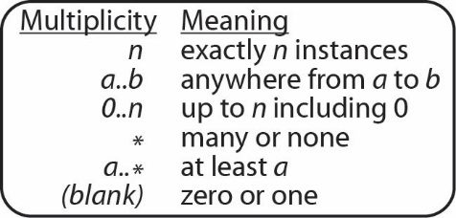
- The multiplicity of an association can take on any of the values shown on the right.

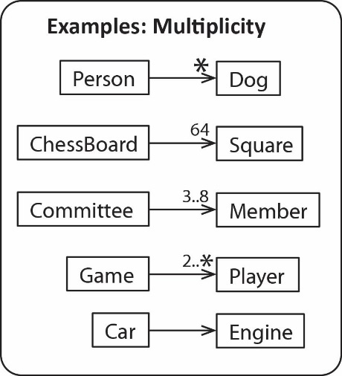
- Examples are shown on the right are called 1-to-many relationships. These are read:
- Each Person has many Dogs; each Dog has one Person. (Technically, it would be: each Person has zero-to-many Dogs and each Dog has zero or one Person; however, frequently we will use the later statement)
- Each ChessBoard has 64 Squares; each Square has one ChessBoard.
- Each Committee has 3-8 Members; each Member has one Committee.
- Each Games has at least 2 Players; each Player has one Game.
- A Car has an Engine, an Engine has a Car.
- In other words, when reading left to right:
Singular for the class on the left, multiplicity on the right class.
And when reading right to left:
Singular for the class on the right, multiplicity on the left class.
- Implementing 1-to-many – Example:
Class Diagram |  | Code
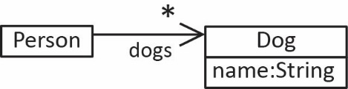 |  | // Can use Collection  public class Person {  private List<Dog> dogs;  }  // or Map where the key is name (assuming unique)  public class Person {  private Map<String,Dog> dogs2;  }
Object Diagram
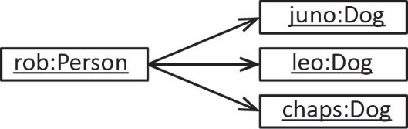

- Example:

Class Diagram |  | ReportManager instance variables
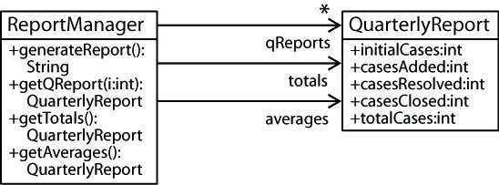 |  | ArrayList<QuarterlyReport> qReports;  QuarterlyReport totals;  QuarterlyReport averages;
Object Diagram
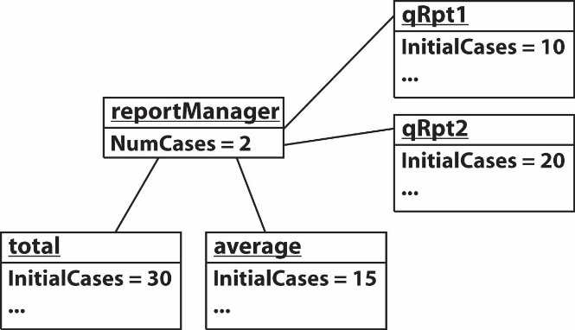

Many-to-Many Associations
- Implementing many-to-many – The example on the right is a many-to-many relationship. In the early stages of modelling we might model this situation like this. However, we rarely implement many-to-many relationships as we did with one-to-many associations, as they are complex to manage. For example, which class do grades belong in? Which class does the date registered go in?
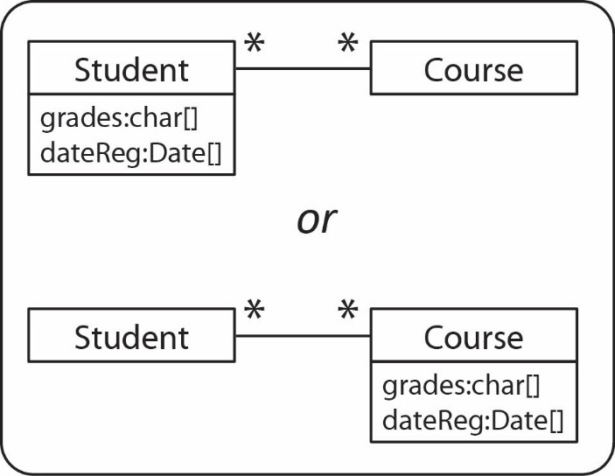
Notice in the top figure on the right that grades is a char array representing the student’s grade for each course she is enrolled in. To illustrate the complexity, suppose the Course class needs a method to calculate the gpa for the entire course. The Course knows (has a reference to) all the Students, but which grade from the grades array would it pull? Of course, we could use Maps to hold the grades and dates registered. However, these parallel structures are less than ideal.
In the bottom figure we have placed the grades array in the Course class. Suppose the Student class needs a method to calculate her gpa. She can access each course she is enrolled in, but which grade would she choose from the Course’s grades array?
The solution is almost always to introduce another class to make the implementation simpler.
A later lesson, “Implementing Many-to-Many” will provide guidance on how to write code for this situation.

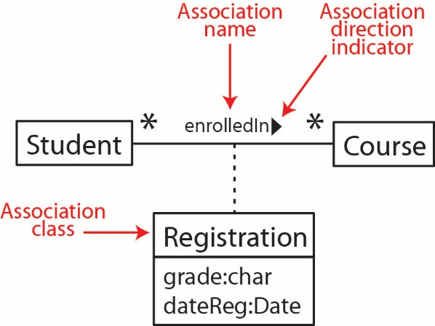
- Association Class
- In the situation above, we should realize that a student’s grade for a course is not exclusively a property of the Student nor the Course; it is a property of the relationship between a Student and a Course. Thus, there is an implicit class, called an association class that is a product of this relationship which is shown in the figure on the right. There is an instance of the Registration class for each instance of a Student being associated with a Course.

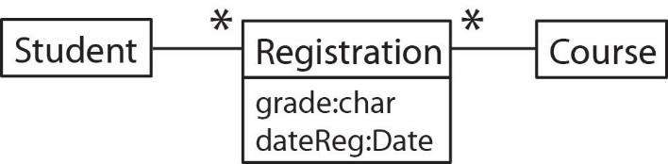
- What this means in terms of implementation is shown in the class diagram on the right. We read this diagram:
- Each Student has many Registrations and each Registration is associated with exactly one Course.
- Each Course has many Registrations and each Registration is for exactly one Student.
- Either of the two representations above is acceptable. I prefer the second one.
- An object diagram of this situation is:

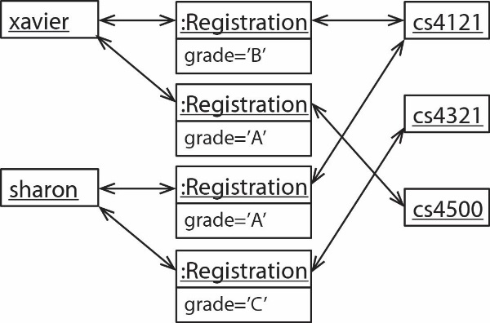
- Association Class – Another example. A Person has many Flights, each Flight has many Persons.

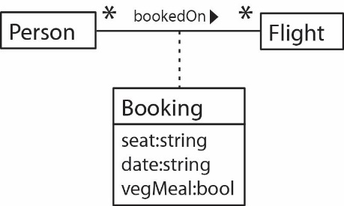 |  | 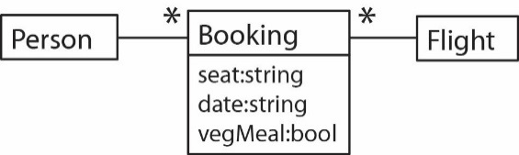

Aggregation & Composition
- Aggregation – This is a stronger form of association which indicates a part-whole relationship. In the example below, a Corporation is an aggregate of a number of Companies. This has no implication for implementation; in other words, it is implemented the same as an association. This should be used sparingly, only when it is important to illustrate a stronger association. Sometimes we use aggregation to illustrate an aggregation hierarchy. Some UML software shows all associations as aggregation.
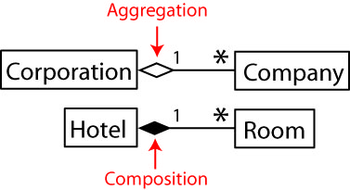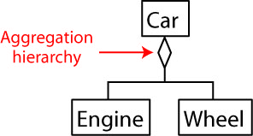
- Composition – This a stronger form of aggregation. It means that the parts cannot exist without the whole. For example, in the figure below, a Room object cannot exist unless it is associated with a Hotel. Composition is usually implemented so that the whole creates the parts. In the example below, the Hotel would create the Room objects.

Dependency Relationships
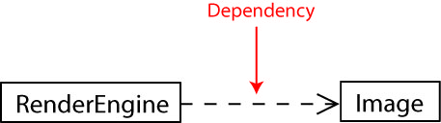
- Dependency –
- A dependency exists between two classes when one class uses another class and is depicted as a dashed arrow with an angle bracket on the end pointing to the dependency as shown in the diagram on the right.
- An association is a stronger form of a dependency and is always depicted with a solid line between the two classes. We use the dependency arrow when the dependency is not an association. In other words, a class has a method that uses an object of another class in some way, but it does not possess that class as an instance variable. This will be detailed further shortly.
- There are usually many dependencies in a system. I suggest using them only when you need to illustrate a particularly important dependency and many times not at all.
- A dependency exists when:
- An instance of one class is passed as an argument to a method in another class, but that class doesn’t own the instance (as an instance variable), it simply uses it.
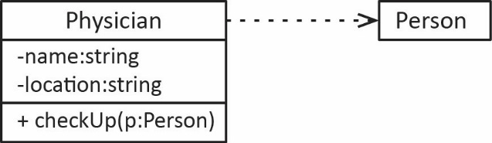
- A method in one class creates an instance of another class and returns it, but doesn’t possess one as an instance variable.
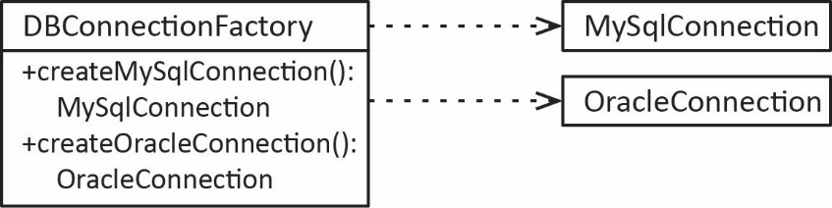
- A method in one class creates an instance of another class and simply uses it. For example, frequently, a driver class (or test class) will have a main that instantiates classes and uses them, but doesn’t possess them as instance variables.
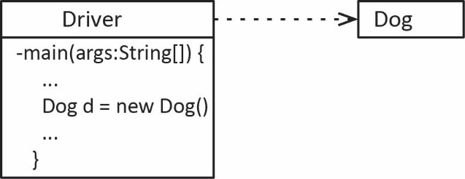

Generalization & Interface Relationships
- Abstract Classes and Interfaces. The points below relate to the figure further below.

- An abstract class name and abstract methods are always italicized. When drawing by hand, I use double-quotes.
- A class that extends another class is depicted by showing a solid line with an open triangle on the end pointing to the superclass.
- An interface name is usually italicized, though some authors do not. Sometimes an interface name has an <<interface>> stereotype
- A class that implements an interface is depicted by showing a dashed line with an open triangle on the ending pointing to the interface.
- An alternate form for depicting an interface is with an open circle with the name above. This is used when it is not important to display the methods in the interface.
- A class that is extending another class, or implementing an interface, should show in non-italics the abstract methods it is implementing.
- A note can be added to any diagram by enclosing the text in a box and drawing a dashed line (as shown in the figure below).
- Abstract classes and interfaces are not shown in an object diagram.

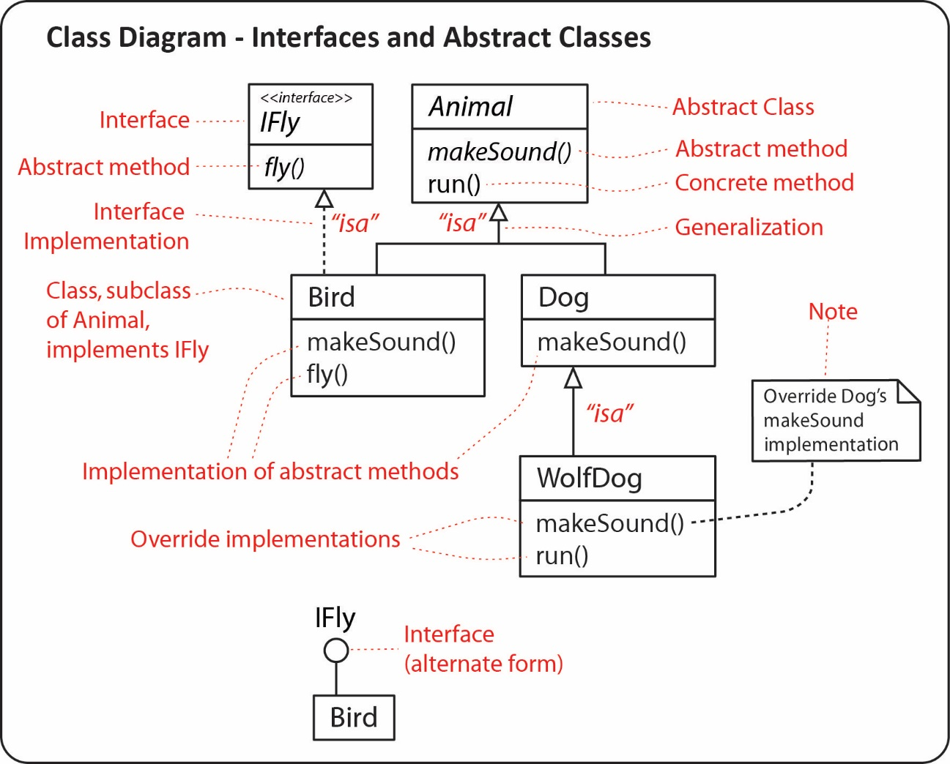

Package Diagrams
- A package is depicted as a larger rectangle with a smaller rectangle on top which contains the name of the package. The larger rectangle may show the classes it contains, for example, the domain, ui, and common packages shown on the figure on the left. Usually, the contained classes are not shown, as in the figure on the right. In this case, there would be a separate class diagram for each package. A dashed arrow indicates that one class is importing (dependency) the classes in the package pointed to by the arrow.

Example 1 |  | Example 2
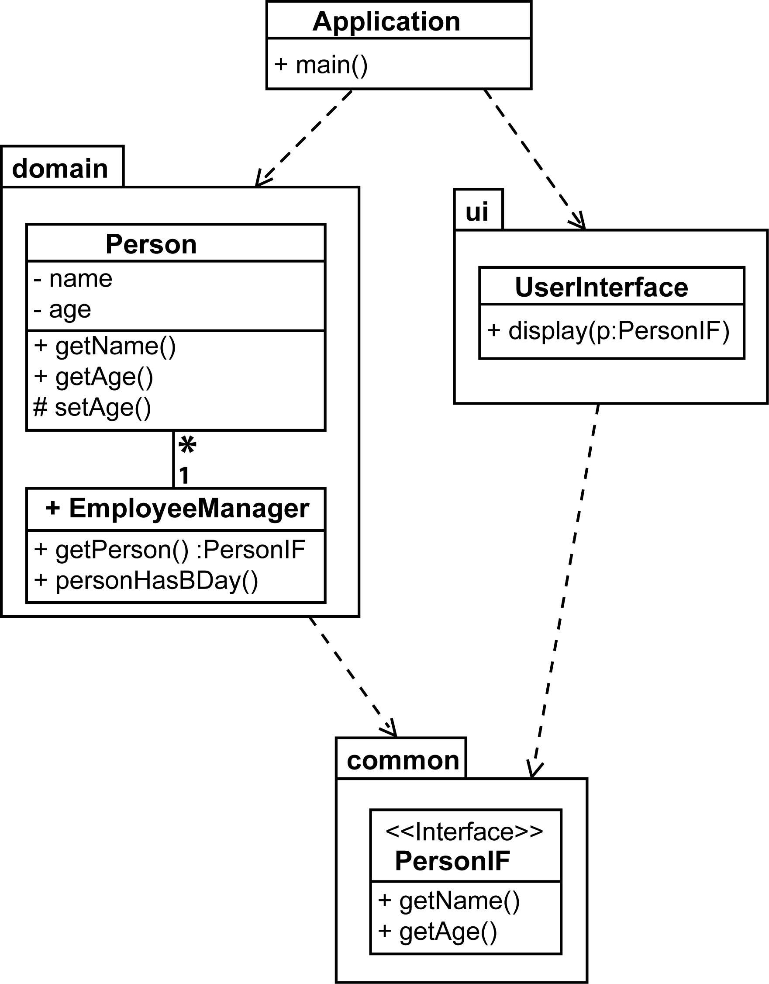 |  | 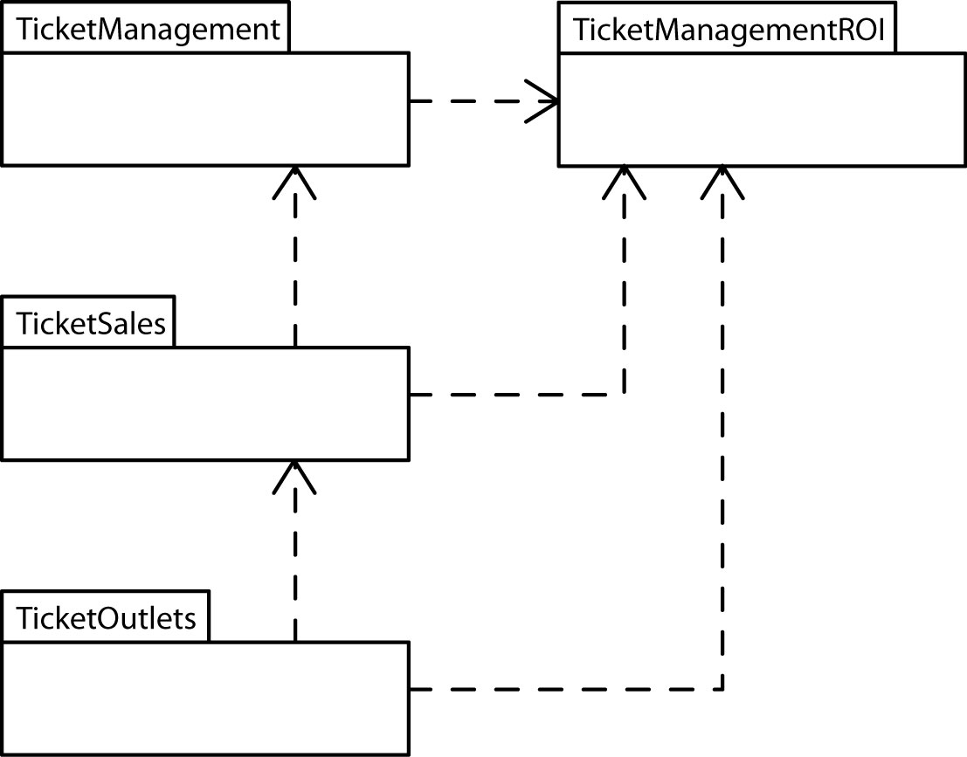

Example 3 – JUnit 5 Dependency diagram – The figure below technically shows components (rectangle with two protruding boxes). A component is a mechanism for the logical organization of code. Each component may contain multiple packages (or classes), etc. We will study these later.
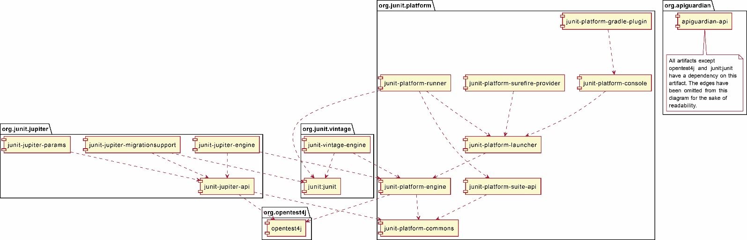
Source: https://junit.org/junit5/docs/current/user-guide/#dependency-diagram

Software
There are
List of UML software: https://en.wikipedia.org/wiki/List_of_Unified_Modeling_Language_tools
The best, free, product I have tried is StarUML: https://staruml.io/. It supports many/most UML diagrams and does forward and reverse engineering for class diagrams. StarUML references:
https://staruml.readthedocs.io/en/latest/modeling-with-uml/working-with-class-diagram.html
Others I have tried:
Name | Comments
ObjectAid | Free plugin for eclipse. Used for years, website gone! 9.29.2021. Still listed on Eclipse marketplace, but can’t get integrate b/c site down. Only did reverse engineering, but did it reasonably well. You can find it archived, though with a search.
Yatta – UML Lab | Plugin for eclipse, got free academic license. To challenging to figure out. Uses templates for code generation. Preset to use Sets for 1-many. Defaults associations to many-to-many. Tedious and non-obvious to change in diagram. Reverse engineering doesn’t show my arraylist associations.
Visual Paradigm | Stand-alone software. Community edition is free, but doesn’t do reverse engineering. Academic price is $1200/year for department license. Does do reverse, but haven’t tried b/c have community. Supports all UML diagrams.
Umple | Text description of uml, generates code and diagram. Online version lets you modify diagram and it updates the UML specification. Probably a great tool for a quick diagram. Incorporates in Eclipse and Docker.
Bouml | Free. Downloaded and installed. Looks tedious, definitely homegrown. Sample videos have no sound, so super tedious! Says it does forward & reverse engineering.
StarUML | Best so far.
Mermaid | Uses text to describe UML and then generates diagram.
Rational | Had site license years ago. Very sophisticated.
Papyrus | Have evaluated in past, but don’t remember
MagicDraw | Have evaluated in past, but don’t remember
Modelio | Have evaluated in past, but don’t remember. Have used in CS 4321 before.
Visio | Have used in CS 4321 long ago. At the time it didn’t forward/reverse Java
Diagrams.net | Very manual, not too good, for example, to make multiplicity, you use a “title”. Might be easy for CS 1302
Umbrello | Haven’t tried this.

Exercises
Not required Fall 2021, 2022, 2023
- Draw the exact UML symbol, notation to represent: classes, associations, role names, association names, attributes, operations, generalizations, abstract classes, interfaces, dependency, packages, multiplicity, navigability, association class, reflexive association, aggregation, composition.
- (a) Draw a UML Class Diagram that represents the following situation. There is an abstract class A with a public instance variable x of type integer and with a private instance variable y of type integer. This class has an abstract method m1 that takes no arguments and returns an integer. It also has a public, concrete method m2 which takes a single integer argument and doesn’t return anything. Class B is a concrete subclass of A. Class C implements the D interface which specifies a single method, display. Class C also maintains a list of three A objects and a link to an E object. Class E has a link to another object of class E. Any E object can also reference a C object. (b) Draw a UML Object Diagram for the situation described above. *Solution at very end.
- (a) Draw a UML Class Diagram that represents the following situation. There is a class A with an ArrayList of B objects. Class B is abstract with subclasses C and D. Class C is composed of four D object. Also, class A is dependent on class E. (b) Draw a UML Object Diagram for the situation described above.
- (a) Draw a UML Class Diagram that represents the following situation. There are two classes, A and B. Class A maintains a list of up to 2 objects of type B on its "left" and a list of up to 3 objects of type B on its "right." Similarly, a type B object maintains "left" and "right" lists of up to 2 and 3, respectively for different objects of type A. (b) Draw a UML Object Diagram for the situation described above.
- Consider the code below. (a) Draw the corresponding UML Static Structure Diagram (Class Diagram). (b) Draw an object diagram representing the code in main.
public class Driver {  public static void main(String[] args) {  E e1 = new E();  E e2 = new E();  D d1 = new D();  e2.addSub(d1);  e1.addSub(e2);  D d2 = new D();  e1.addSub(d2);  B b = new B(e1);  }  }  public interface A {  int m1( String s );  }  public class B implements A {  protected C myC;  protected B( C c ) {  myC = c;  myC.m3();  }  public int m1(String s){  return 3;  }  } | public abstract class C {  protected void m2(){  System.out.println("hi");  }  public abstract void m3();  }  public class D extends C {  public void m3() {  System.out.println("yes");  }  }  public class E extends C {  private ArrayList<C> subs = new ArrayList();  public void m3() {  for(C c : subs) {  c.m2();  }  }  public void addSub(C c ) { subs.add(c); }  }

- Write the code for this system.
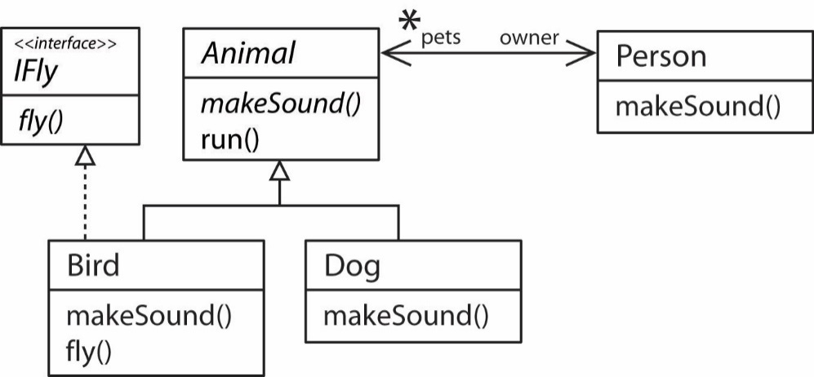
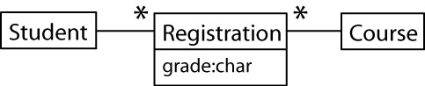
- Draw an object diagram for the class diagram on the right.

- An airline flight reservation system is being developed where customers can book flights. A customer needs to know his seat number for each flight. Model with a class diagram.
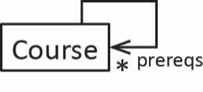
- Draw an object diagram for the class diagram on the right.

Appendix
- Exercise Solutions
Problem 2 Solution

(a) | (b)
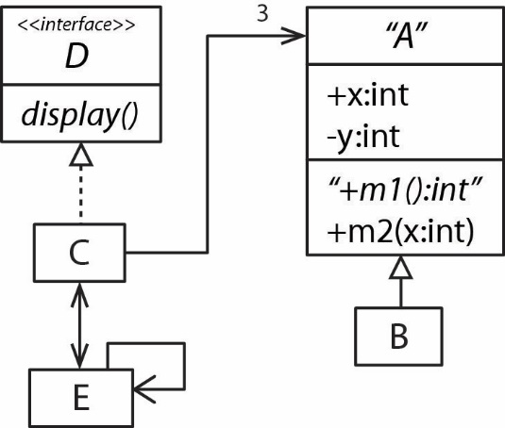 | 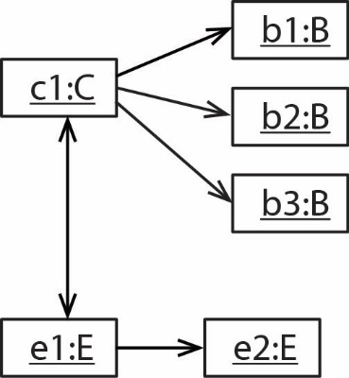

Problem 3 solution:

(a) | (b)
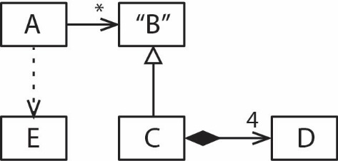 | 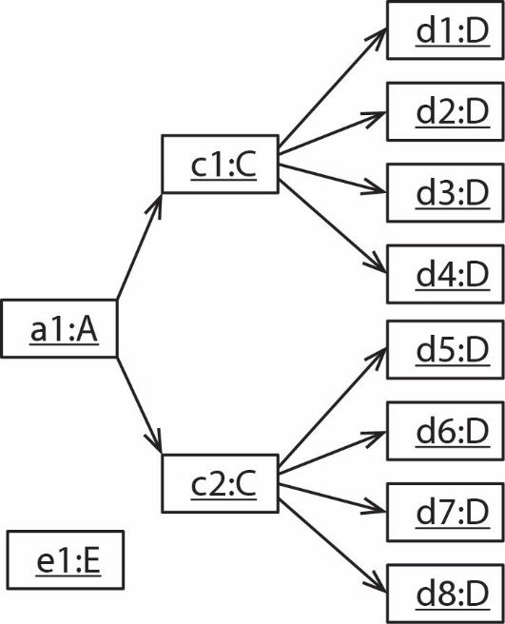

Problem 4 solution:

(a) | (b)
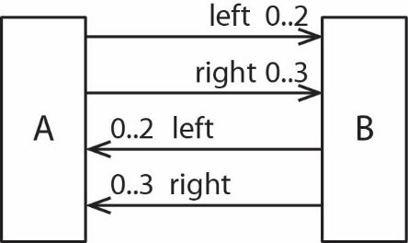 | 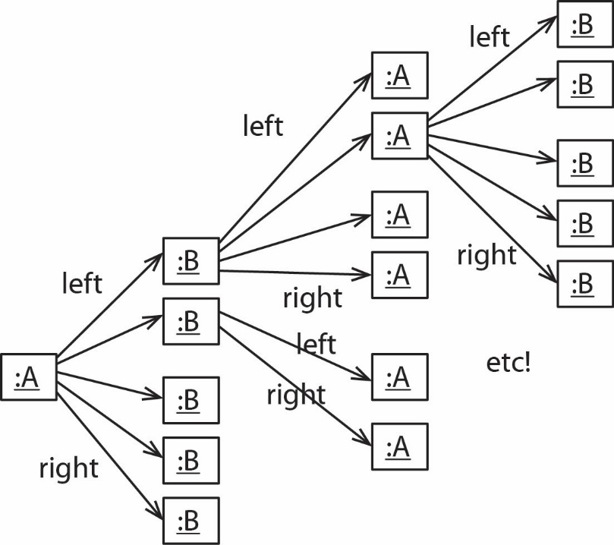

Problem 5 solution:

(a)  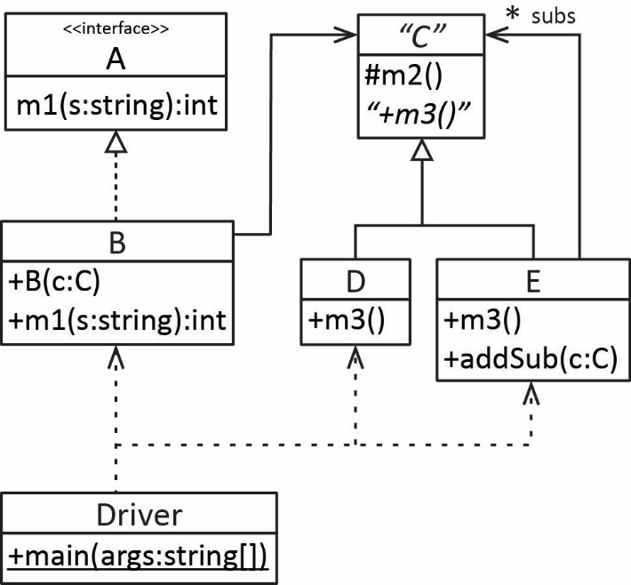 | (b)  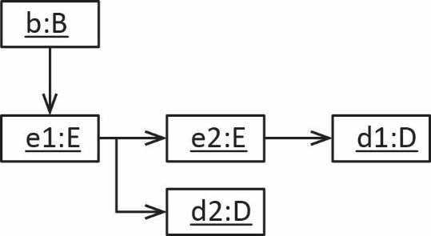

Problem 7 solution:

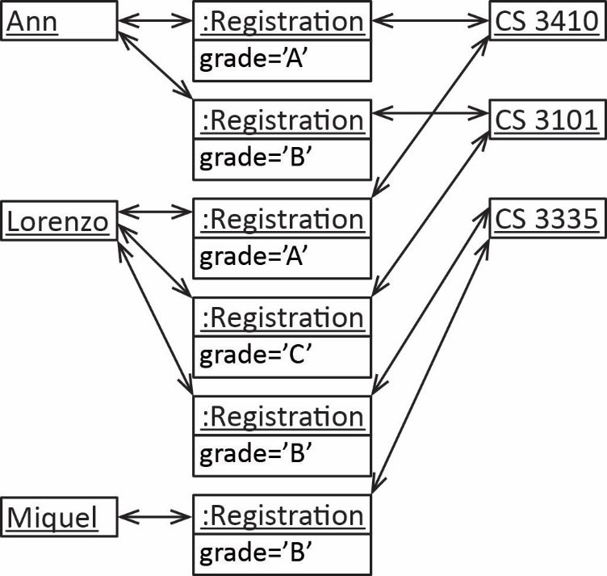

Problem 8 solution:

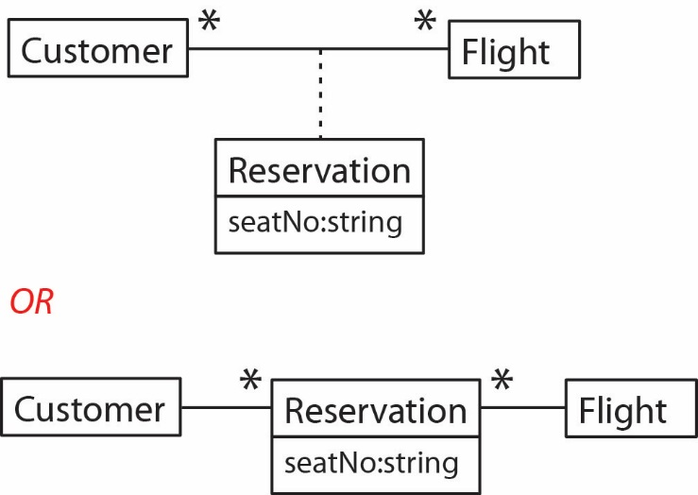

Problem 9 solution:

