CS 4321 - Video Lecture Expectations

Video P1L1 – Introduction & Overview (22 min)

Watch the P1L1-Introduction & Overview video on Udacity. We will be watching a bunch of videos on Udacity. To access the video:

- Visit: https://www.udacity.com/course/software-development-process--ud805
- Choose: Start Free Course
- Fill out the data to create an account and then log in.
- You may have to prowl around to find the video. If you get lost, the course is: Software Development Process. The table of contents for the course is:

- The table of contents for this video is:

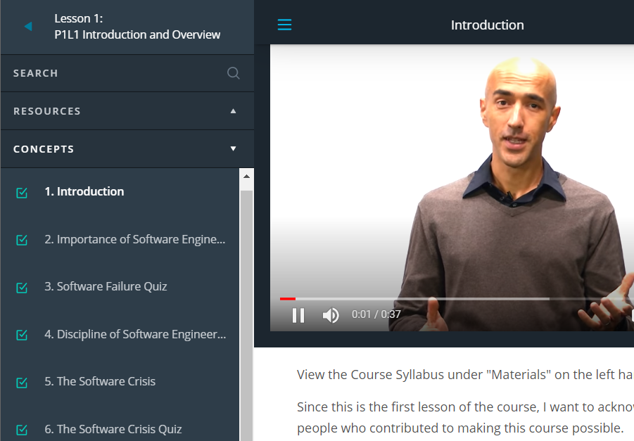

Answer the questions below and submit on Blazeview (HW- P1L1). Instructions:

- Do not remove the questions.
- You can provide the answer(s) where the blank is, but preserve the underline (or use a different color for the answers)
- Or, you can provide the answers below the questions. For example, you could type: Answer: x, y, z.

The video begins with interviews with software engineers (academic and industry). I’ve provided the transcript below (and highlighted key points that I normally discuss in class) in case it is useful. Below this, you will find the questions.

Transcript of Initial Interviews

What is software engineering? Why is it important?

Tevfik Bultan, University of California, Santa Barbara: “…software engineering is the discipline that investigates program development. So, how can it been done more efficiently? What's the best way of doing program development? And how can you develop reliable programs?”

Jane Cleland-Huang, University of Norte Dame: “Software engineering is the systematic application of methods to build software in a rigorous way. And I think one of the aspects that I like to bring into the notion of software engineering is that it's something that involves not only kind of technically building the system but understanding the requirements, working with stake holders. Trying to find a solution that balances all of the stakeholder needs in order to deliver the software in a way that’s tested and its rigorous to meet the needs of a stakeholder. “

“In the U.S we've all seen an unfortunate example with a system that went badly wrong in healthcare.gov and that system wasn't engineered correctly. And I think if we look at the reasons for that, trace them back to somewhere at the intersection between requirements and architecture and politics and project management, and all of these things are important concepts that have to go into the software engineering mix.”

Mukul Prasad, Fujitsu Laboratories of America: “…software engineering is the whole process of creation of software using engineering principles.”

If it's not done in a principled way it will be bad and every user will suffer.

Margaret M. Burnett, Oregon State University: “My view is kind of a holistic view and I think about it from the perspective of how is software engineering different from programming. So, I think that research about programming is all about the create part of software. And that software engineering is about the entire life cycle. So, that's one aspect. And the other aspect of the definition is it's about quality, the quality of software. Software engineering even considers things long after you ship which we all know is one of the, it is the largest economic piece of software development.”

Tao Xie, University of Illinois at Urbana-Champaign: “So, improve, software engineering process for better software productivity and quality.”

“I mean these two goal, productivity, faster, in developing software. And higher quality would be apparently important. Software is everywhere.”

Wolfgang Emmerich, CEO at Zuhlke Engineering: “The set of activities that one engages in when building software systems or software products. It's fundamentally a venue-creating activity*. It involves social processes.”

*”Value creation is the primary aim of any business entity. Creating value for customers helps sell products and services, while creating value for shareholders…The first step in achieving an organization-wide focus on value creation is understanding the sources and drivers of value creation within the industry, company, and marketplace. Understanding what creates value will help managers focus capital and talent on the most profitable opportunities for growth.
Source: https://www.referenceforbusiness.com/management/Tr-Z/Value-Creation.html

Andreas Zeller, Saarland University: “Software engineering is the act of many people working together and putting together many versions of large and complex systems. And our world depends on software, software is immensely complex and we need many, many smart people to build these things.”

“It would end up in lots and lots of chaos because people wouldn't know how to organize themselves and wouldn't know how to organize software. Many of software engineering has very simple rules that you need to apply properly in order to get things done. And people who look at these rules and think, these rules are so super simple. This is totally obvious. But once you try to apply them, you'll find out they're not obvious at all.”

Kevin Sullivan, University of Virginia: “Well, engineering I think is the activity of envisioning and realizing valuable new functions with sufficient and justifiable confidence that the resulting system will have all of the critical quality attributes that are necessary for the system to be a success. And software engineering is the activity of doing this not only for the software components of engineering systems but for the system overall, given that it's so heavily reliant on it's underlying software technologies.”

John Penix, Google: “So, I would say software engineering is the art and practice of building software systems.”

“…if you don't think about how you're building this system and how you're trading off different aspects, like performance and scalability and reliability, then it's going to end up breaking or not lasting very long or not, not doing everything that you want it to do, or being really expensive.”

Nenad Medvidovic, University of Southern California: “Software engineering, in a nutshell, is a set of methods and principles and techniques that we have developed to enable us to engineer, or build, large software systems that outstrip or outpace one engineer's or even a small team of engineer's ability or abilities to understand and construct and maintain over time. So it requires a lot of people, it requires a long, term investment by an organization or a number of organizations, and often times it requires support for systems that that are intended for one purpose but end up getting used for many additional purposes in addition to the original one.”

“It's important because software is everywhere around us and the way we build it, and the way we maintain it, is something that determines almost a basic quality of life nowadays. And getting that software right can make a difference, oftentimes, between a really fun product and one that you won't like to use a reasonably successful company, or one that fails. And in more extreme cases even the difference between life and death, if you think about the software that runs in the airplane on which many of you fly on a regular basis.”

Jonathan Maletic, Kent State University: “Software engineering is about building and constructing very large-scale high-quality systems, so the high quality is the big issue.”

“It's important because we use software in everyday life. Everything's built on software systems. And these are ubiquitous across our society.”

Lionel Briand, University of Luxembourg: “Software engineering is engineering discipline of developing software-based systems, usually embedded into larger systems composed of hardware and and humans and business processes and processes in general.”

“because software is pervasive in all industry sectors and therefore systems must be reliable, safe and secure. >> Why can't we just get that by sitting down and writing software? >> Well, you could if software was small and simple enough to be developed by one or two people together in a room. But software development now is distributed, involves teams of people with different backgrounds who have to communicate with each other. It also involves customers, clients, users. Software engineers have to work with hardware engineers, with domain experts and therefore, well, no, we can't simply sit down and start coding.”

Willem Visser, Stellen Bosch University: “…And if you don't use software engineering practices, you're not going to be able to put them together? >> Well, you're not going to be able to reliably put them together. So basically, you could maybe hack something up, but it's not going to necessarily stand the test of time. If somebody wants to change it it's probably going to break.”

Questions to be answered

- Pretend like you are talking with a close friend/relative/etc who is not in the computing field. Explain what software engineering is and why it is important.

- What are the three causes of the software crisis?

- In a study by Davis, 1990, about 71% (5/7) of the cost of the software developed was software that was _______________________________________ or ___________________________________________.

- A __________________________ is a formal, or semiformal, way of discussing, or describing, how software should be developed.

- The family of _____________ software processes sacrifices discipline a little bit in order to be more flexible and be more able to account for changes in requirements.

- What are the five phases that characterize all software processes?

- What are three “tools of the trade” that have helped increase programmers’ productivity?

