CS 3410 – Ch 21 – Priority Queue: Binary Heap

Sections | Pages
21.1-21.5 | 807-826

21

21.1 – Basic Ideas

- The priority queue is a data structure that provides access to the item with minimum key. We can implement a priority in many different ways:

- Linked List  Operation Average Worst Case  findMin $O(n)$ $O(n)$  deleteMin $O(n)$ $O(n)$  insert $O(1)$ $O\left(1\right)$  - Sorted Linked List  Operation Average Worst Case  findMin $O\left(1\right)$ $O\left(1\right)$  deleteMin $O\left(1\right)$ $O\left(1\right)$  insert $O(n)$ $O(n)$  - Binary Search Tree  Operation Average Worst Case  findMin $$O(\log{n})$$ $O(n)$  deleteMin $$O(\log{n})$$ $O(n)$  insert $$O(\log{n})$$ $O(n)$ | - Balanced Search Tree (red-black tree, aa-tree)  Operation Average Worst Case  findMin $$O(\log{n})$$ $O(\log{n})$  deleteMin $$O(\log{n})$$ $O(\log{n})$  insert $$O(\log{n})$$ $O(\log{n})$  - Splay Tree – Ch. 22 (not covered)  Operation Amortized Worst Case  findMin $O(\log{n})$  deleteMin $O(\log{n})$  insert $O(\log{n})$  - Binary Heap  Operation Average Worst Case  findMin $O(1)$ $O(1)$  deleteMin $O(\log{n})$ $O(\log{n})$  insert $O(1)$ $O(\log{n})$

- In this chapter, we study the binary heap, which is the classic method for implementing a priority queue. Like the binary search tree it imposes a structure property and an order property.

21.1.1 – Structure Property

- The binary heap’s data is organized as a tree.

- A complete binary tree is a tree that is completely filled with the possible exception of the bottom level, which is filled from left to right with no missing nodes. In the figure below, the tree is complete. If node J were a right child of E, then it would not be complete.

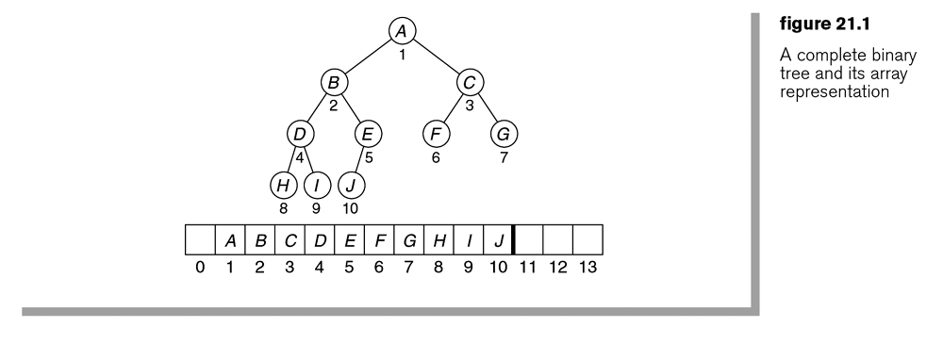
- The height of a complete binary tree is at most $\left\lfloor \log{n}\right\rfloor$.

- As shown in the figure above, we can represent a complete binary tree by storing its level order traversal in an array because, by definition, there are not gaps. Thus, the left and right child links are not needed in a complete binary tree. However, inserting or removing an element will require us to modify things to maintain this structure.

- For any node/element in position $i$, we can simply find it’s children, parent, and sibling as shown in the figure below.

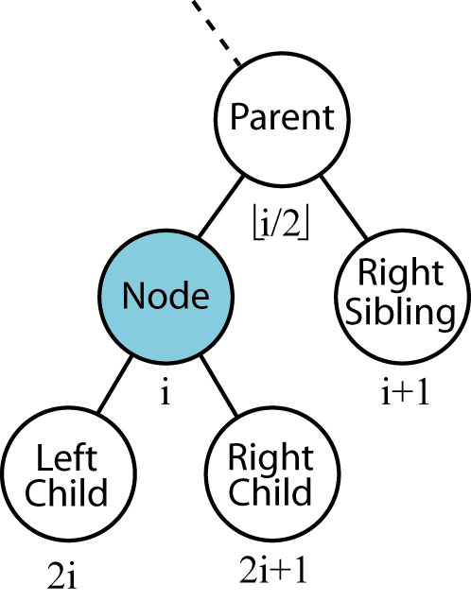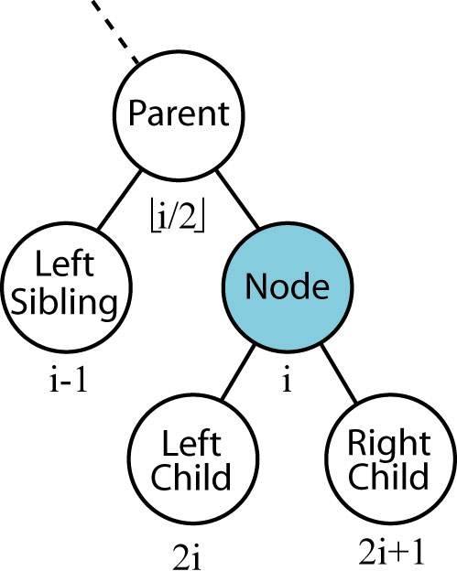

- We will reserve position 0 in the array for a dummy node that will represent the root node’s parent. This will help when we look at implementation.

- Using an array to store a tree is called an implicit representation of a tree. Using the implicit representation we can see that traversing the tree is simple if we follow the rules above.

- Thus, a heap is simply a binary tree represented as an array of objects.
Homework 21.1

- Consider an implicit representation of a heap of size 17. Is the 11th element (a) a leaf? (b) a left child?, (c) What level is the 11th element on (assume the root element is on level 1). Demonstrate that your answers are true.
- Generalize your result from problem 1 to the case where the size is $n$ and we are considering the $i^{th}$ element. (a) Develop a rule that tells whether the $i^{th}$ element is (a) a leaf, (b) a left child, (c) what level it is on.
- Consider a heap of size $n$. In the implicit representation, what positions are the leaves found in? e.g. the range of indices.

21.1.2 – Heap-Order Property

- Heap-Order property: A heap always stores the smallest element at the root. Recursively, then any node should be smaller than any of its descendants. Thus, the heap-order property is that for any node P, its key must be less than or equal to the key for any of its descendants. Note that this is a weaker definition of order than the one we use with the binary search tree.

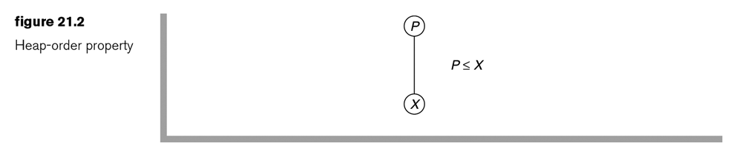
- Figure 21.3 a shows a heap and Figure 21.3 b shows a binary tree that is not a heap because 21 is not less than or equal to 6.

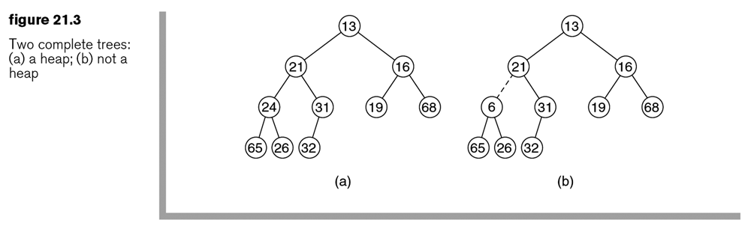

- We use the value of $-∞$ for the dummy node in position 0.

- By the heap-order property, we see that the minimum is always in the root of the tree, or the item with index 1 using the implicit representation. Thus, findMin is a constant time operation.

Homework 21.2

- Problem 21.1 & 21.2 from text.
- Explain why a maximum element must always be a leaf.
- Suppose that a heap always stores the largest element at the root. Define a heap-order property such that the findMax operation is $O(1)$.
21.1.3 – Data Structure – Allowed Operations

- The historical names: findMin, deleteMin, insert are replaced in our implementation with element, remove, and add, respectively, to follow the java.util.PriorityQueue conventions.

Operation | Method¹ | Method² | Descriptions
Insert | add(item) | offer(item) | adds item to queue
Remove | remove() | poll() | retrieves and removes head of queue
Examine | element() | peek() | retrieves, but does not remove head of queue

1 – Throws an exception upon failure
2 – Returns a special value upon failure (null or false)

- Below, the PriorityQueue interface is shown.

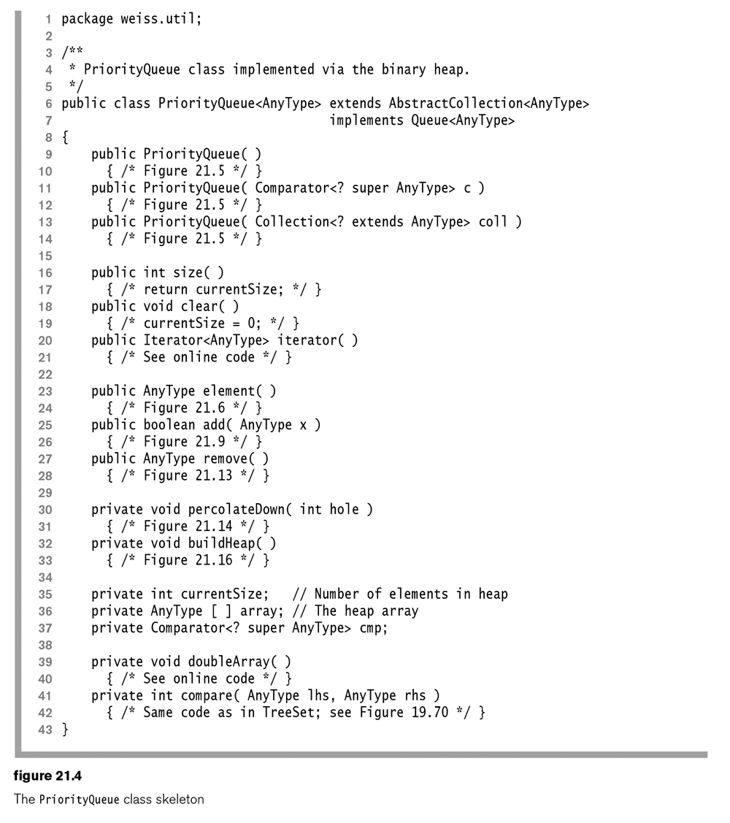
- The implementation of the constructors is shown below. Notice that an Object array is used and then cast to an array of the appropriate (generic) type since we cannot create generic arrays in Java.
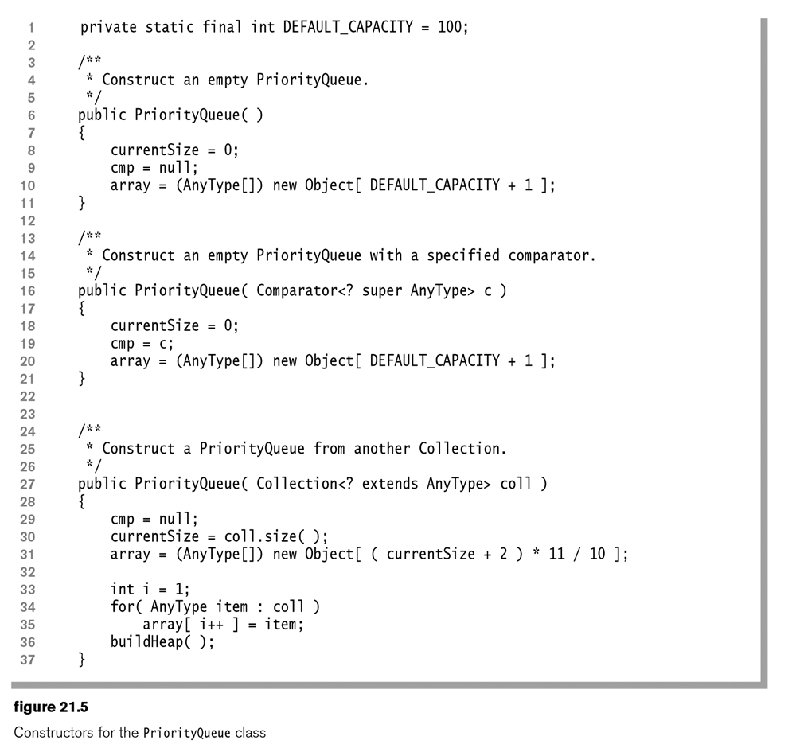
A
B
- Notice the implementation of the third constructor in Figure 21.5 above. Initially, the items in the array are inserted sloppily (see A in figure 21.5), e.g without regard to heap-order. Then, a method, buildHeap is called to establish heap-order (see B in figure 21.5). This will be examined later.

- The element method implementation is shown below and simply returns the element in the first position, if it exists. Otherwise, it throws an exception.
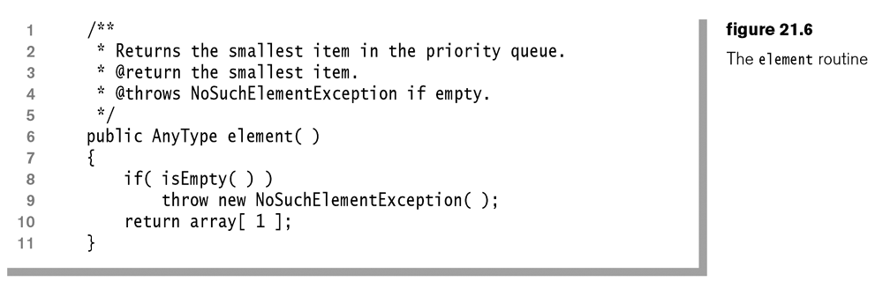
21.2 – Implementation of Basic Operations

21.2.1 – The add Method Implementation

- To add an element, X in the heap, we must add a node to the tree which must be in the next position in order to preserve the structure property. Thus, the node we must add will necessarily occupy the location ++currentSize in the backing array. However, the element to insert, X, does not necessarily belong in this node, as we must preserve the order property as well. To implement insert, we return to the tree representation. We refer to the newly created node as a hole in the tree.

- If X can be placed in the hole without violating the heap-order property, then we are done. If not, simply move the hole’s parent into the hole and repeat this process, asking if X can be placed in the new hole. This process is known as percolate up. Thus, the algorithm for add is to create a hole at the next available position and bubble it up until the correct location is found for the new item, X.

- Example:

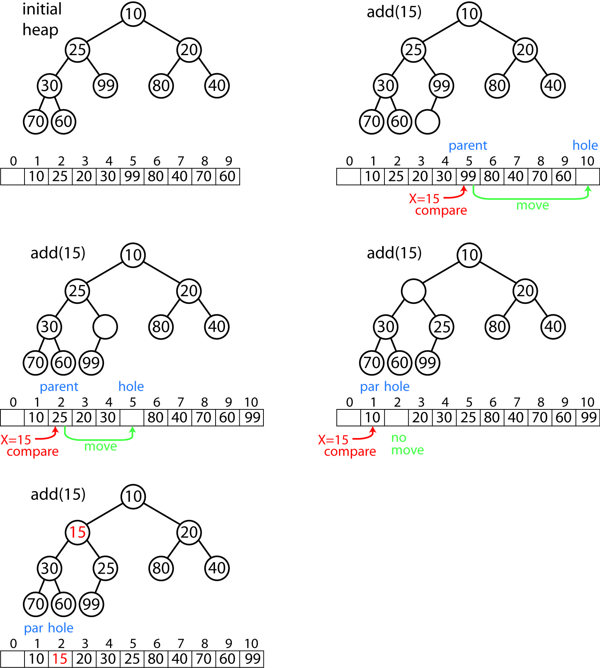

- Example from text: In the figure below, we are trying to add 14. Clearly, it cannot go in the hole in figure 21.7a since 31 is larger than 14. So, we percolate the hole up and move the parent (31) down. Again, we see that 14 cannot go there as 21 is larger than 14.
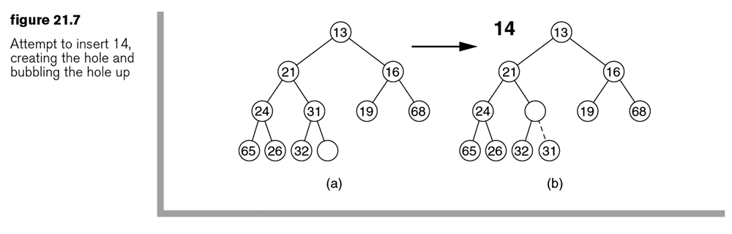
- So, we percolate the hole up again and move the parent (21) down. Finally, we see that 14 can go in the hole now without violating the heap-order property.

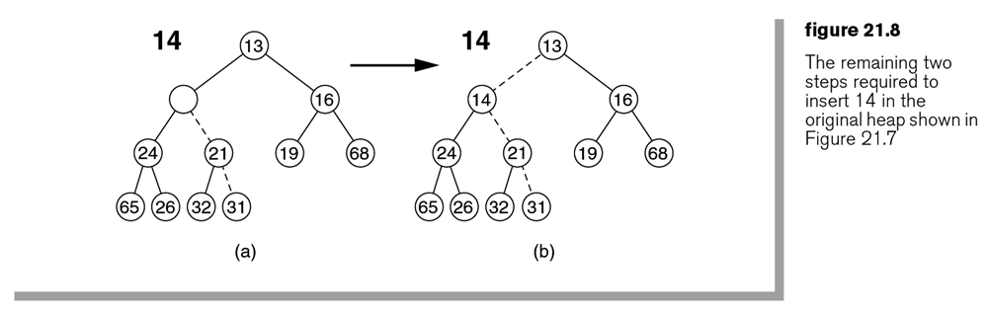

- The add algorithm:

add( x )

// Create position for hole
hole = ++currentSize
// Put value in location 0 (not a part of heap)
// Used to stop the loop below if x belongs in position 1,
// e.g. it is the smallest.
array[ 0 ] = x;

// While heap-order property is not met,
// e.g. x is less than parent
while x.key < array[hole/2].key
// Move parent down
bubble hole up: array[hole] = array[ hole/2 ]
// Move hole up
hole /= 2

// Put x in the array.
array[ hole ] = x;

- Example – Shows how array[0] is used to stop the percolation when the root is reached:

Tree |  | Code
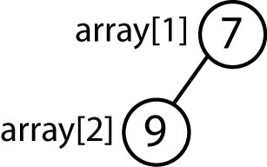 |  | add(5)

Tree |  | Code
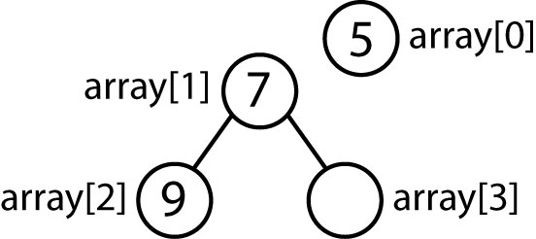 |  | hole = 3  array[0] = 5

Tree |  | Code
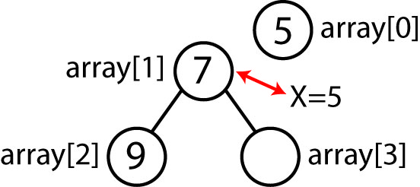  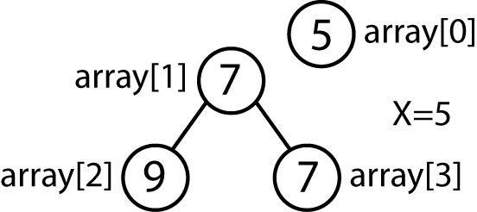 |  | while( 5 < array[hole/2]=7 )  array[hole=3] = array[hole/2=1]  hole = hole / 2 = 1

Tree |  | Code
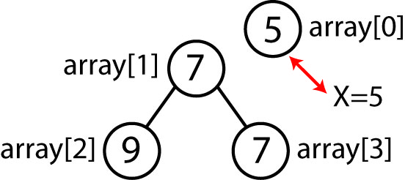  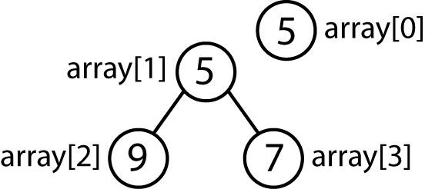 |  | while( 5 < array[hole/2]=5 ) --> false  array[hole=1] = 5

- The implementation of the add method:
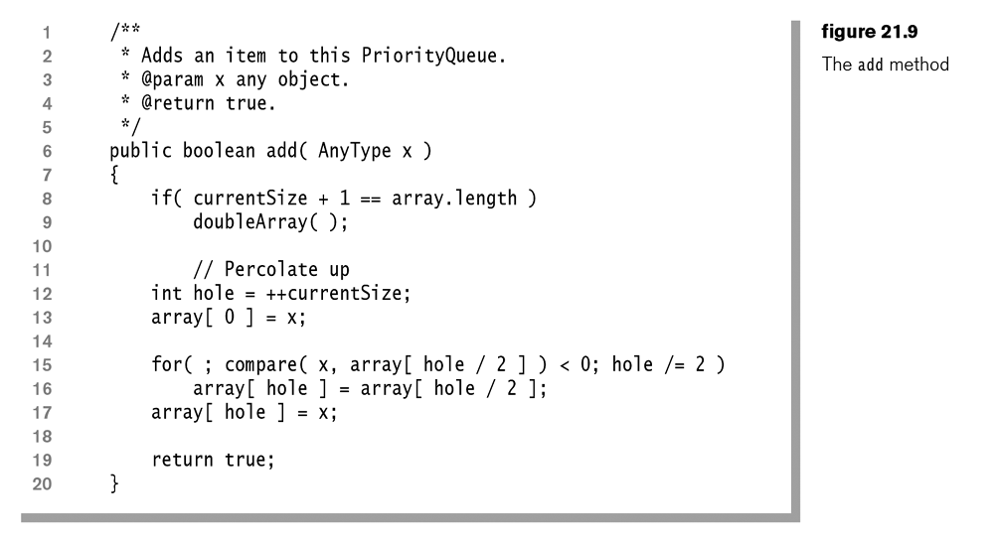
- Thus, in the worst case, when the item being inserted is the minimum, the complexity is $O(\log{n)}$ because the height of the complete binary tree is $\log{n}$. It has been shown that on average, a random add does 2.6 comparisons so that it moves an element up an average of 1.6 levels. Thus, add is $O(1)$ on average.

Homework 21.3

- Add these items to a heap (in this order): 4, 10, 3, 1, 7, 6, 9, 5, 2. (a) Show a tree representation at each step. (b) Show the final implicit representation.

21.2.3 – The remove Method Implementation

- The deleteMin (remove) operation will remove and return the minimum item. If we consider this as removing the root node, then this creates a hole in the root and reduces the size by one. Now, if we consider the array representation, this means that position 1 is empty and the last item doesn’t have a valid position (because we have reduced the size by one). Let’s call this last item, X. So, essentially, we need to add X, but instead of the hole being in the last position, the hole is in the first position.

- The solution to this problem is to percolate down to find where X needs to be placed to preserve the heap-order property. At each step, find the smallest child of the hole, S. If X<S, then put X in the hole. Otherwise, swap the hole with S and repeat.

- Example:

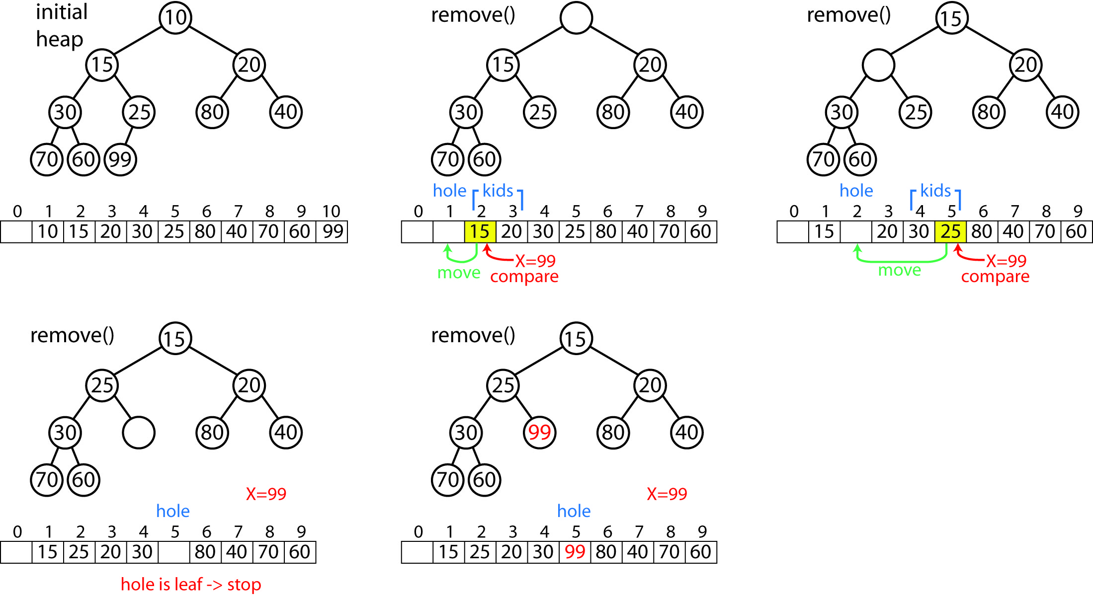

- Example from text:

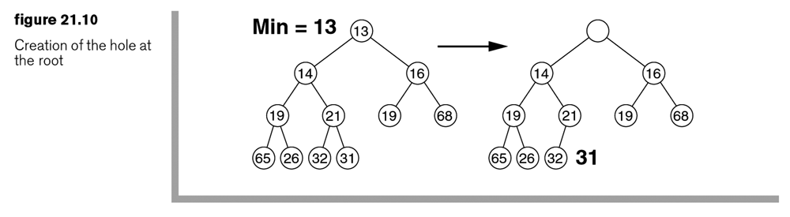
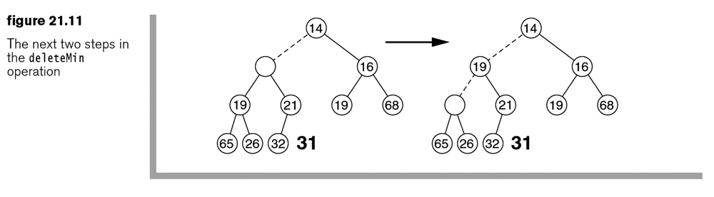
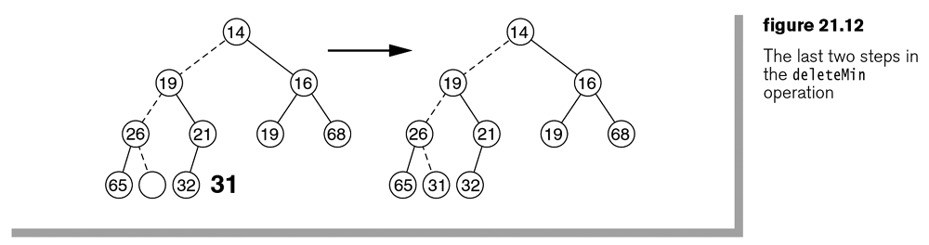

- The remove algorithm:

remove()

// Get minimum
min = array[1];
// Get last item
X = array[ currentSize ]
// Set hole location
hole = 1

// while hole not a leaf nor position found
while hole has a left child
// Find smallest child
S = smallest child
// If X is bigger than hole’s children...
if( S < X )
// Bubble hole down...
// Set hole to smallest child
array[hole] = S
// Move hole down to smallest child
hole = position of S
// If X is smaller than hole’s children...
else
// X belongs in hole
break

// Put X in hole
array[ hole ] = x;

return min

- The implementation of the remove method is shown below. Since the percolate down procedure is a bit more complex than percolate up, it is implemented as a helper method. Also, it will be used by the buildHeap method as we will see later.
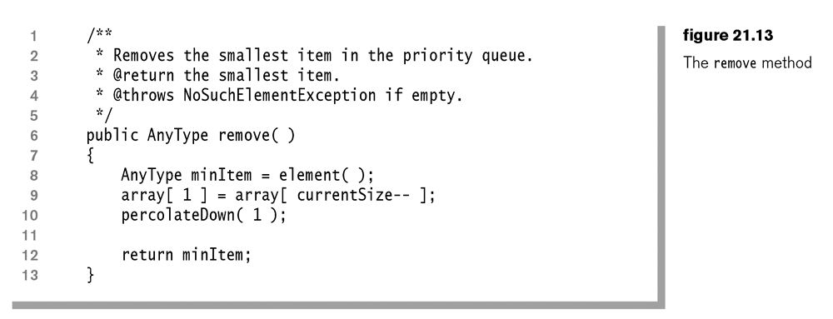
A better description of what percolateDown does is that it puts whatever is in hole initially into the correct (preserve heap-order) location which is the initial hole, or any of its descendants, following the path of the smallest child at each step.
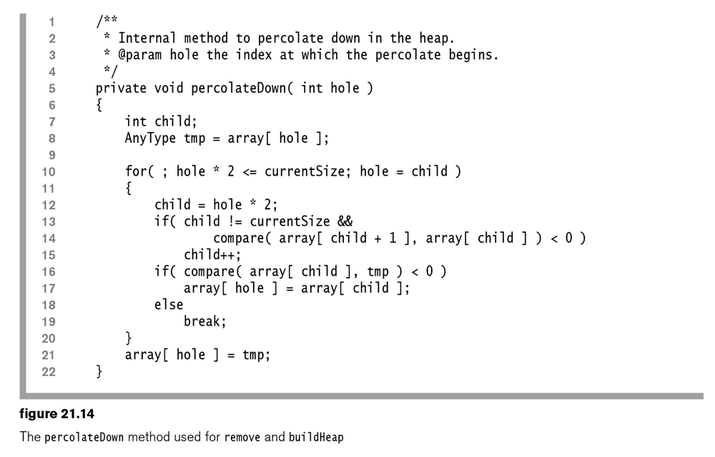
J
H
F
C
E
G
B
D
A
Key:
A – Check to see if hole has a left child.  B – Get left child position  C – Check to see if (left) child has a sibling  D – Check to see if right child is less than left child  E – If C and D are true, then make the right child the smallest | F – Check to see if item to insert (tmp) is larger than smallest child  G – If F is true, then put the value of smallest child in hole  H – If F is false, e.g. item to insert is smaller than smallest child, then item blongs in hole.  J – Move the hole down to the smallest child.

- Thus, in the worst case, remove has complexity is $O(\log{n)}$ because the height of the complete binary tree is $\log{n}$. Not surprisingly, the average case is also $O(\log{n)}$. This is so because we are taking a relatively “larger” item (the last one) and starting from the top of the tree, working our way down, to see where it belongs. Empirical evidence indicates that this percolation down rarely terminates after just a level or two.

Homework 21.4

- Consider Homework 21.3, Problem 1. Call remove 3 times. (a) Show the resulting tree at each step. (b) Show the implicit representation at the final step.
- Consider a min-heap data structure where when we call remove we remove the smallest item (and return it), but also remove the largest item. Describe an algorithm to do this as efficiently as possible. Hint: Use the result from Homework 21.1, Problem 3 and the results from this section.

21.3 – The buildHeap Operation

- Remember the PriorityQueue has a constructor that creates a PriorityQueue from any Collection:

A
B
Initially, the items in the collection, coll are inserted sloppily (see A in figure 21.5), e.g without regard to heap-order. Then, a method, buildHeap is called to establish heap-order (see B in figure 21.5). We will show shortly that buildHeap is $O(n)$. The complexity of the sloppy inserts is $O(n)$. Thus, the complexity of this constructor is $O\left(n\right)+O\left(n\right)=O(n)$. Another strategy would be to simply use the PriorityQueue’s add method to add each of the items in the collection. As shown previously, the add method is $O(\log{n})$, so that $n$ adds would have $O(n\log{n})$ which is slower than the constructor shown above.

- Thus, the buildHeap operation takes a complete tree that does not have heap order and reinstates it.

- A simple way to achieve this is to call percolateDown on the nodes in reverse level-order. Thus, when we call percolateDown(i), then we know that the heap has the heap-order property for all of i’s descendants. Notice that this process does not need to call percolateDown on leaf nodes, so we start with the highest numbered non-leaf node, currentSize/2.

- The Java implementation
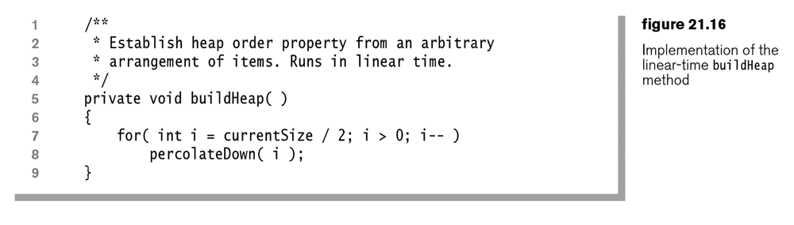

- Example:

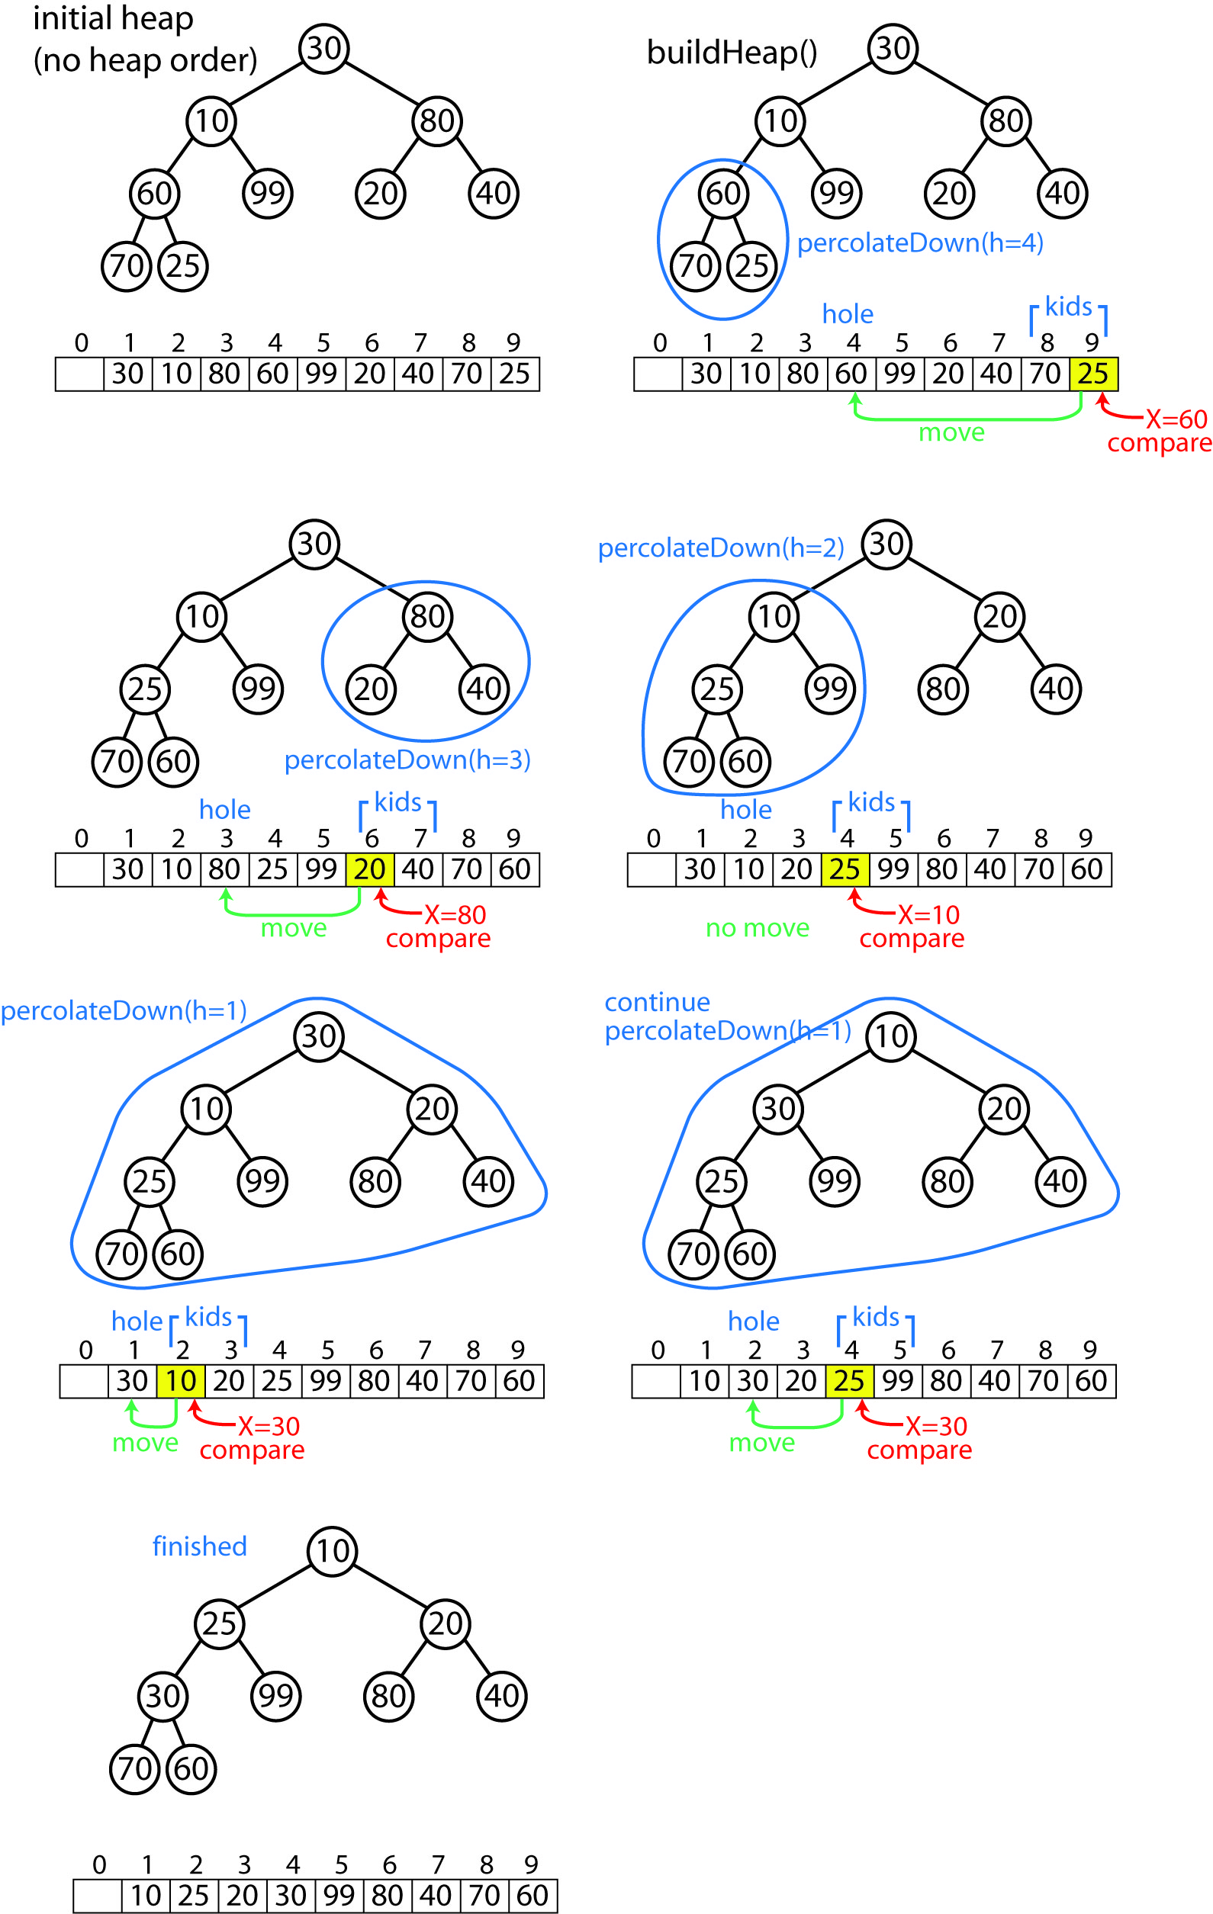

- Example from text:
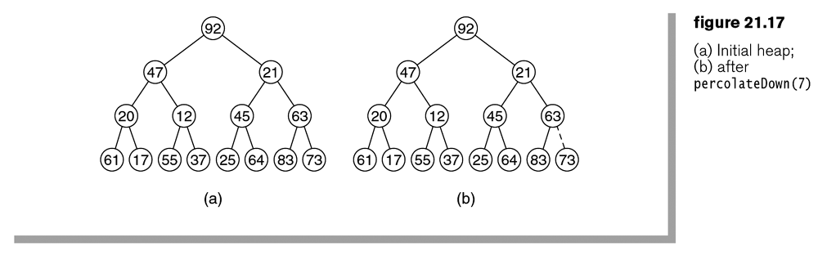
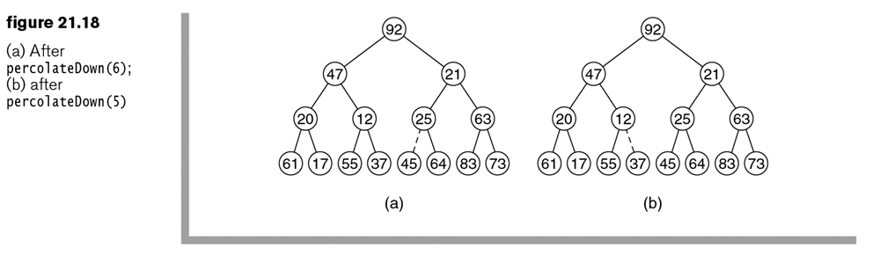
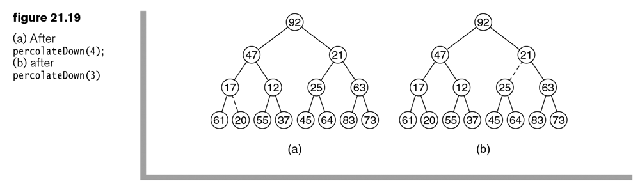
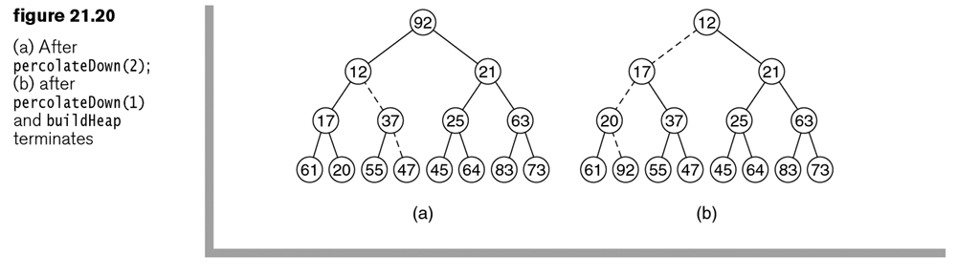

- It can be shown that buildHeap is $O(n)$.

Homework 21.5

- Consider this input to buildHeap: 4, 10, 3, 1, 7, 6, 9, 5, 2. (a) Show a tree representation at each step of buildHeap. (b) Show the final implicit representation.

21.4 – Advanced Operations: decreaseKey and merge

- Sometimes, a priority queue needs to support a decreaseKey(location,value) operation that lowers the value of an item in the priority queue, which can destroy the heap-order property. The solution is simple, keep percolating up until the order is restored.

- Another operation that sometimes needs support is merge where two priority queues are merged. The most efficient solution is to copy the elements from the smaller queue to the larger and then call buildHeap.

21.5 – Internal Sorting: heapsort

- The priority queue can be used to sort N items by:

Put all items in priority queue
Extract each item by calling remove

Thus, the items will be removed in ascending order.

- The most efficient way to do this is to use the priority queue constructor that takes a collection of items, places them sloppily into the array, and then calls buildHeap. Thus, a heapSort sorting algorithm is:

- Copy each item into the binary heap, $O(n)$
- Call buildHeap, $O(n)$
- Call remove, n times, $O(n\log{n})$

- Notice that if we are sorting an array of items, we can do a heap sort without a priority queue, by simply applying the heap concepts to the input array, and, introducing a second array to store the order items that are removed from the input array, and then when all items have been removed from the input array, copy the second array back to the first.

- This can be done without a second array. Since every remove shrinks the heap by 1, we can use the last cell to store the item that was just deleted. At the completion, all the items will be in decreasing order.

- Example

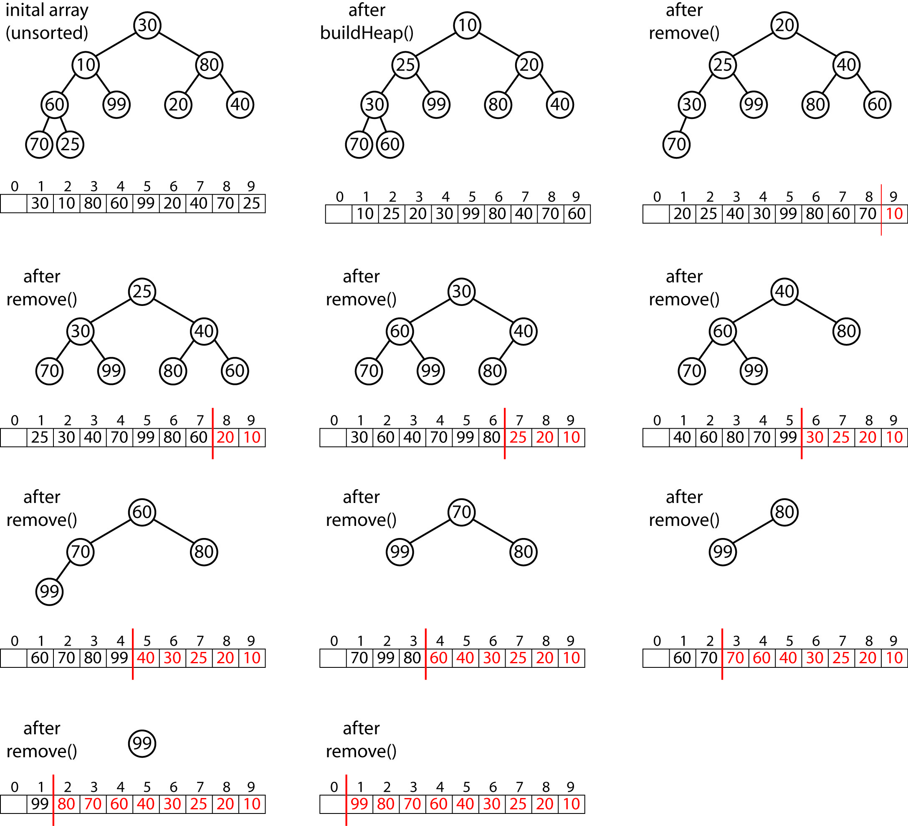

- To return the array in the more usual ascending sorted order, we can just slightly alter the logic, so that we are using the concept of a max heap, where the parent is always larger than the children.

- The Java implementation:

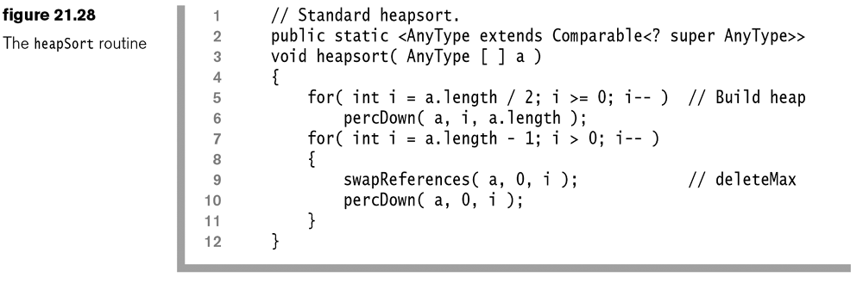

- The percDown method has 3 subtleties:

- Since we are using a max heap, the comparison logic must switch to > instead of <
- There is no sentinel item in position 0, as arrays typically use position 0. This affects the calculation of the parent of a node and it’s children.
- It must be informed of the current heap size which is lowered by 1 every time an item is removed

- The average and worst case complexity of heasort is $O(n\log{n})$. This is so because we essentially do buildHeap, $O(n)$ followed by $n$ percDown calls, $O(n\log{n})$. Thus, $O\left(n\right)+O\left(n\log{n}\right)=O(n\log{n})$.

Homework 21.6

- Describe in detail a heap-sort algorithm that accepts an array as input and returns the sorted array in ascending order and does not create any additional arrays. You may use some of the methods from the heap data structure (properly modified).
- Problem 21.7 from text.

