19.6 – AA-Trees

- Interactive demo of a number of tree structures: http://people.ksp.sk/~kuko/bak/

- An AA-tree is a red-black tree such that no left child is red (i.e red nodes must be right children). This restriction greatly simplifies the insert and remove algorithms.

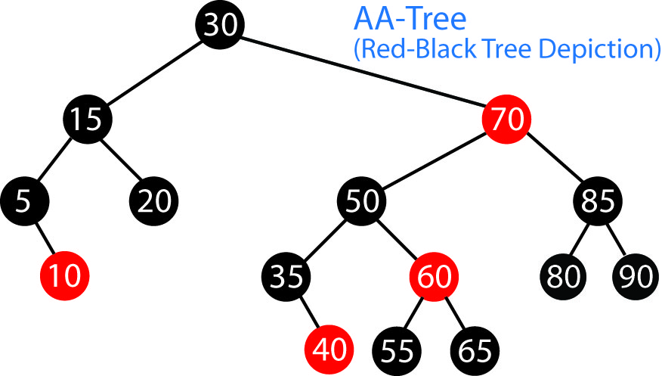

- The implementation of this idea is simplified by re-introducing balance information in the following way:

- Red children are at the same level as their parent
- Black children are below their parent

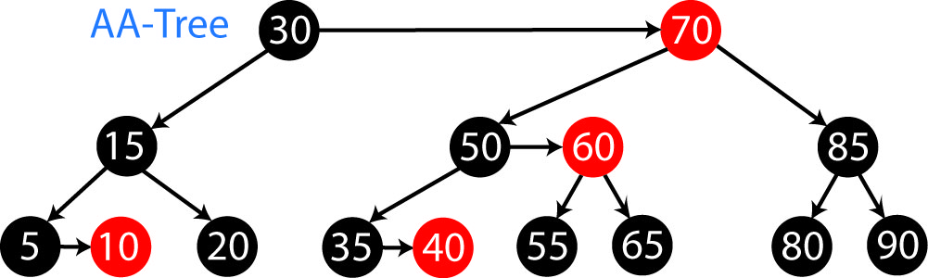

- The level of a node is the number of left links on the path to a null node. An AA-tree can then be defined as follows. The level of a node is:

- 1, if the node is a leaf
- the level of its parent, if node is red
- one less than the level of its parent, if node is black

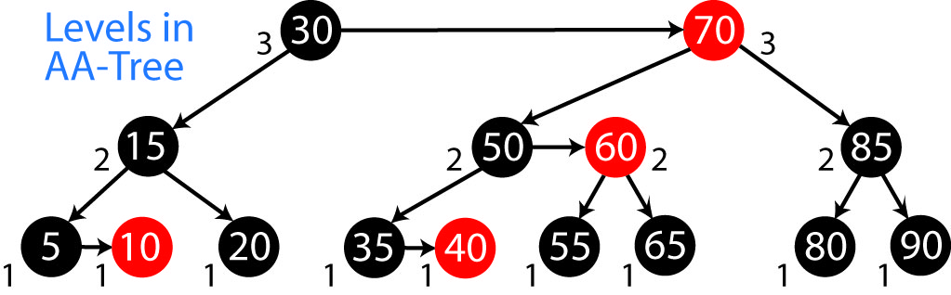

In an AA-tree, with the addition of the level information, we no longer need the red/black coloring information, so it is eliminated from the coming algorithms. We will retain it in some of the pictures for emphasis.

- Implications of definition

- Left children must be one level lower than parent. (Left can’t be red).
- Right children can be at same level as parent (if red), or below (if black)

A horizontal link indicates two nodes at the same level. Horizontal links must be right links (only right children can be red, and red’s are at the same level as parent)

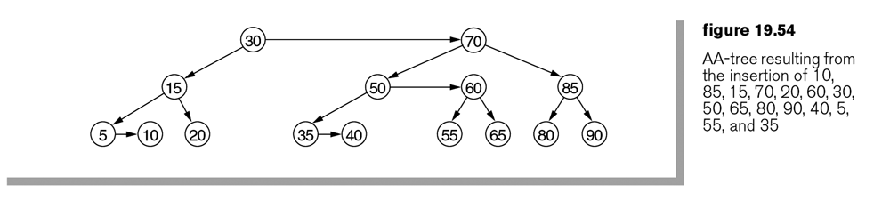
- There cannot be two consecutive horizontal links (can’t have 2 be two consecutive red nodes)
- Nodes at level 2 or higher must have 2 children
- If a node does not have a right horizontal link, then its two children are on the same level.

- As with the Red-Black tree, we always insert a red node. This can lead to two types of problems. Consider inserting 2 or 45 into the tree above.

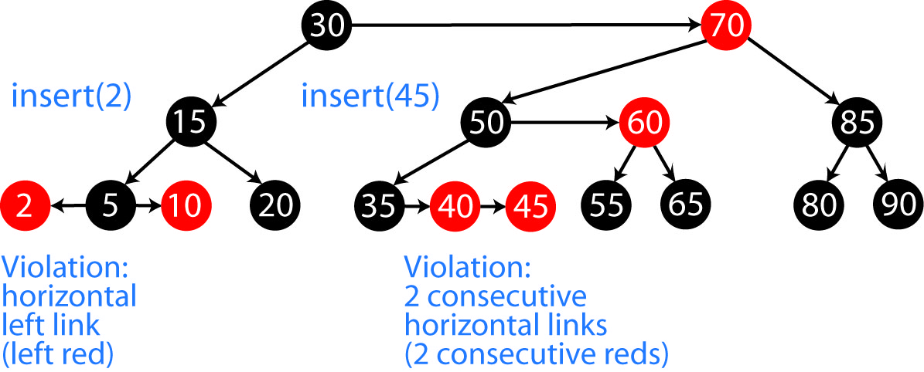

Thus, when we insert a node, there are three cases:

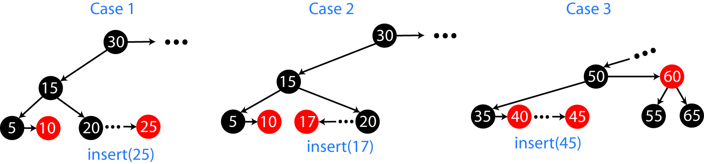

- Case 1 – If the node to insert is to the right of its parent, then we insert it at the same level, as a horizontal (right) link. If the grandparent is at a higher level, then we are done.

- Case 2 – If the node to insert is to the left of its parent, then it will be at the same level as its parent, which is a violation. To fix a horizontal left link, we use a procedure called skew.

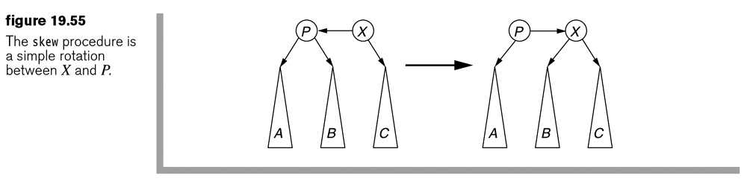

Example:

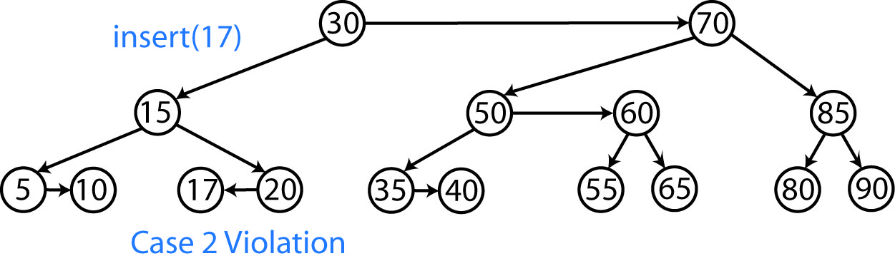

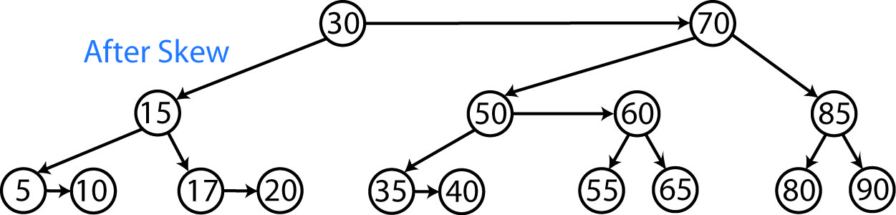

- Case 3 – If the grandparent is at the same level, then we have 2 consecutive horizontal links (reds), which is a violation. This is fixed by a procedure called split.

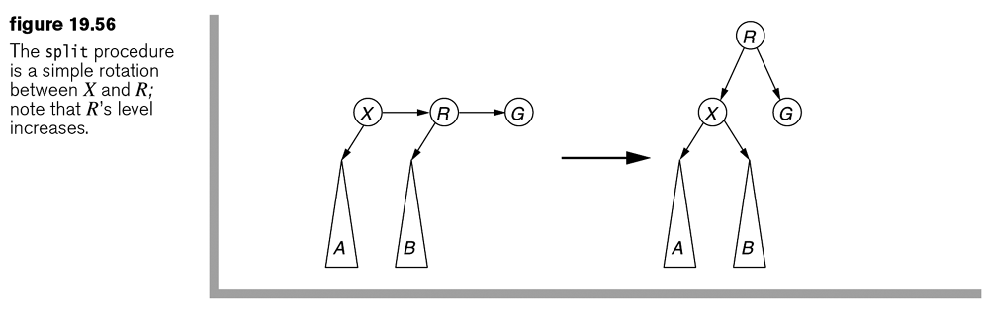

Example:
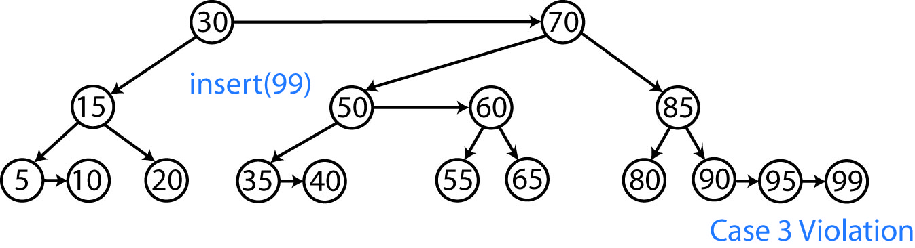

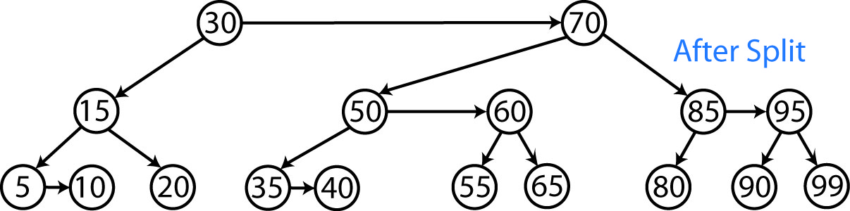

- Example: Sometimes a Split or Skew will introduce a new violation. So, we continue to Split or Skew until there are no violations.

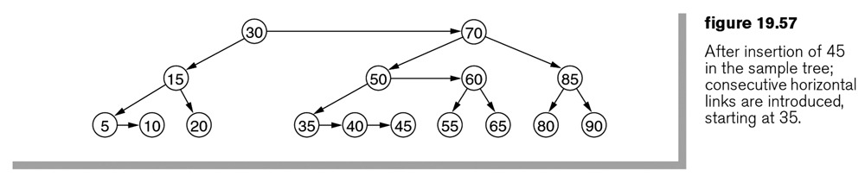

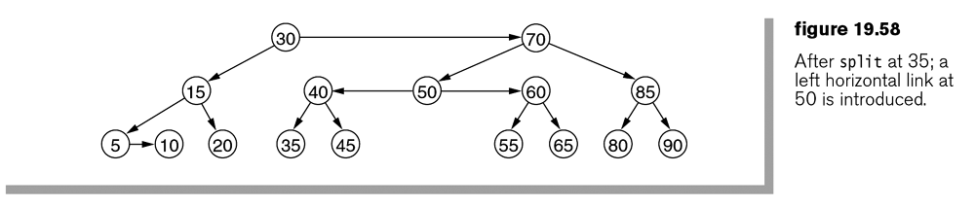
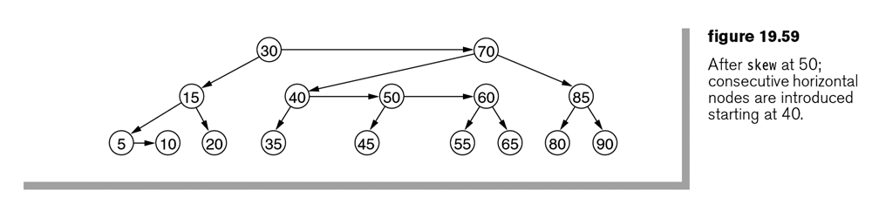
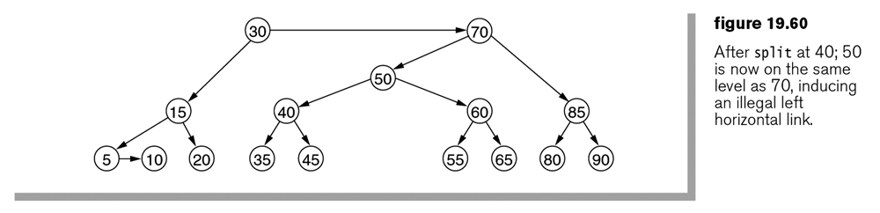
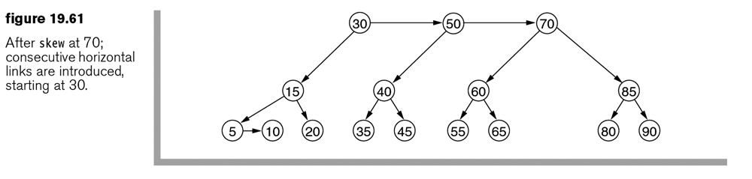
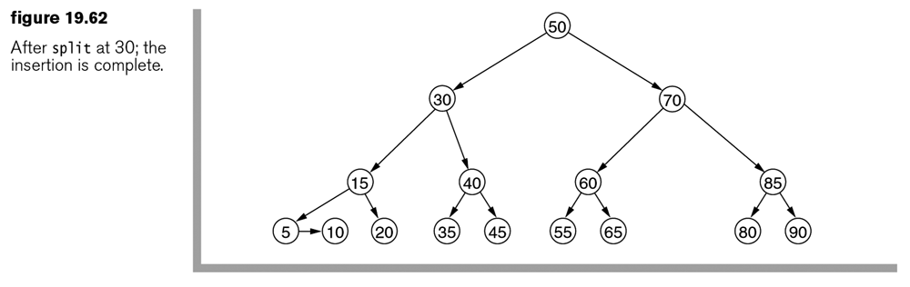

- Below is an algorithm for insert for AA-tree. This is not the way we would implement this, but it shows the overall idea.

insert( key ) : newNode
{
return insert( root, key )
}

insert( node, key ) : newNode
{
while node is not null

if key is less than node
if node has left child
Advance to left child: node = node.left
else
X = new Node(key)
Connect node to new node: node.left = X
Repeat until no violations:
Skew if necessary
Split if necessary
return X

if key is greater than node
if node has right child
Advance to right child: node = node.right
else
X = new Node(key)
Connect node to new node: node.right = X
Repeat until no violations:
Skew if necessary
Split if necessary
return X

- Example: Build this tree:

Homework 19.12

- Build an AA tree by inserting nodes in this order: 1,2,3,4,5,6,7,8,9

