PHP Web Development, Lesson 4
Contents
1 Laravel Overview 1
1.1 Laravel Flow 1
1.2 Routing 1
1.3 Controller 2
1.4 Folder Structure 2
1.5 View 3
1.6 Model 4
1.7 More Controller Methods 4
Appendix 1 n/a 5

Laravel Overview
Site | Notes
What is Laravel | See first 6 headings, through, “Blade template engine.” Doesn’t explain routing, migrations, and template engine in enough detail.
Laravel Tutorial | Reasonable, but description of folder structure is different than my project, some are the same. Maybe mine is a simplified structure.

Laravel Flow
User (Interacts, Submits) View
(HTTP Request) Routing
(method call) Controller
(method call) Model
(returns data) Controller
(sends to browser) View

Routing
The routing file, web.php, contains this line:
Route::resource('teams', TeamController::class)->except(['show']);
It tells Laravel to automatically create the standard CRUD routes for teams, using TeamController, but skip the show route. It creates routes like:
- GET /teams → index()
- GET /teams/create → create()
- POST /teams → store()
- GET /teams/{team}/edit → edit()
- PUT/PATCH /teams/{team} → update()
- DELETE /teams/{team} → destroy()

Controller
Controller requests data which is returned as a list ($teams) of Team objects. Then, the data is passed as a key-value pair to the index.blade.php view.
class TeamController extends Controller {
public function index() {
$teams = Team::orderBy('Name')->get();
return view('teams.index', compact('teams'));
}
...

Note that: compact('teams') is shorthand for: ['teams' => $teams] which defines the key, teams and the value, $teams.

Folder Structure
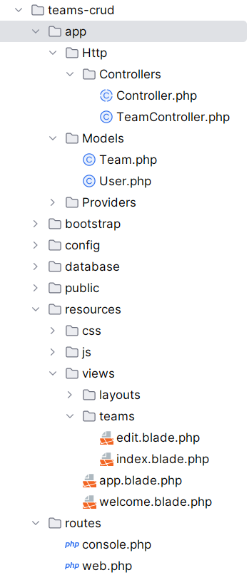

View
The View is constructed and returned to the controller. Laravel then renders the blade file as HTML and sends it to the browser. Note
- forelse is a Blade construct.
- The Edit button redirects to the edit method in the controller
- The Delete button posts back and is routed to the destroy method in the controller.
- Edit is just requesting a page, no data is changed, so no POST is required. Delete is changing data, so a POST is considered safer as it does @csrf checks. It adds a hidden field to the postback that helps protect your app from cross-site request forgery attacks by proving the form submit came from your app.
<table>
<thead>
<tr>
<th>Name</th>
<th>Coach First Name</th>
<th>Coach Last Name</th>
<th>Actions</th>
</tr>
</thead>
<tbody>
@forelse ($teams as $team)
<tr>
<td>{{ $team->Name }}</td>
<td>{{ $team->CoachFirstName }}</td>
<td>{{ $team->CoachLastName }}</td>
<td>
<a class="btn btn-secondary"
href="{{ route('teams.edit', $team) }}">Edit</a>
<form action="{{ route('teams.destroy', $team) }}"
method="POST" style="display:inline;">
@csrf
@method('DELETE')
<button class="btn btn-danger" type="submit"
onclick="return confirm('Delete this team?')">
Delete
</button>
</form>
</td>
</tr>
@empty
<tr>
<td colspan="4">No teams found.</td>
</tr>
@endforelse
</tbody>
</table>

Model
The Team class maps the database fields to class. The $fillable variable says that an array of values can be passed to the constructor (inherited) to initialize.
<?php
namespace App\Models;
use Illuminate\Database\Eloquent\Model;
class Team extends Model
{
protected $table = 'teams';
protected $primaryKey = 'TeamID';
public $timestamps = false;
protected $fillable = [
'Name',
'CoachFirstName',
'CoachLastName',
];
}

More Controller Methods
public function store(Request $request) {
$data = $request->validate([
'Name' => 'required|string|max:255',
'CoachFirstName' => 'nullable|string|max:255',
'CoachLastName' => 'nullable|string|max:255',
]);
Team::create($data);
return redirect()->route('teams.index')->with('message', 'Team added successfully.');
}
public function edit(Team $team)
{
return view('teams.edit', compact('team'));
}
public function update(Request $request, Team $team)
{
$data = $request->validate([
'Name' => 'required|string|max:255',
'CoachFirstName' => 'nullable|string|max:255',
'CoachLastName' => 'nullable|string|max:255',
]);
$team->update($data);
return redirect()->route('teams.index')->with('message', 'Team updated successfully.');
}
public function destroy(Team $team)
{
$team->delete();
return redirect()->route('teams.index')->with('message', 'Team deleted successfully.');
}

Appendix
- n/a

