HW 7 – Teams CRUD App
Contents
1 Overview 1
2 1
3 General Tips & Recommendations 2
4 Requirements 2
5 Submission 2
Appendix 1 n/a 2

Overview
You are going to create a Laravel PHP application with the two pages shown below. The app allows a user to add, edit, and delete teams from the league database
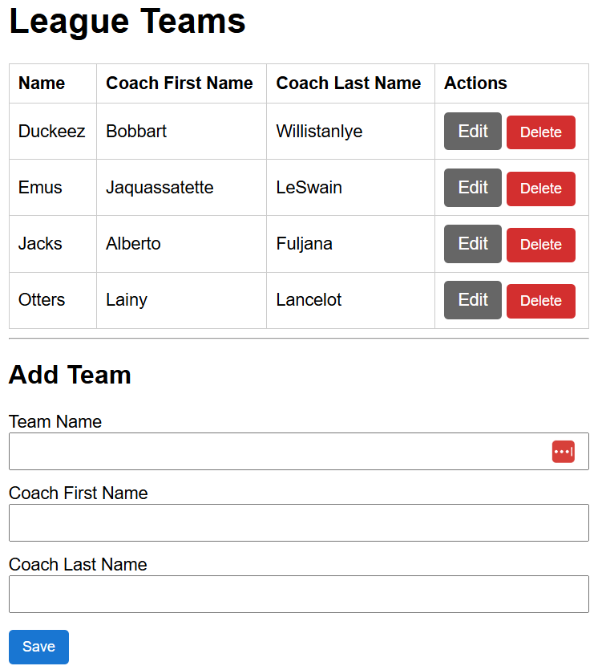 | 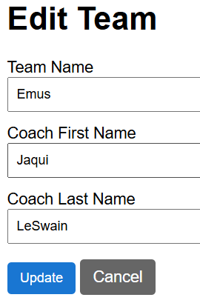

General Tips & Recommendations
- Us the AI Chat in PHPStorm with a prompt like this:
How do I get setup to create a Laravel application?
You’ll need to install some programs from the command line (or Terminal for Mac): Git, Composer, maybe another one. Note: you’ll be working sometimes in PHPStorm and sometimes from the command line.
When you complete the installations, you’ll launch a server from one command line and that will stay running until you kill the server. Meanwhile, you’ll need another command prompt to issue various commands as proceed through the creation of this appl
- Once you are setup, you can ask it something like this:
Create a CRUD Laravel app for the Teams table in the league database. It should have two pages: (1) one for displaying teams from the league database and also adding new teams, there should also be edit and delete buttons on each row of the team’s display. When edit is pressed, go to the second page, (2) a page to allow editing of a time.
- You’ll probably have to ask it lots of questions to help you. The prompt above will probably give you: (a) an overview of what needs to be done, (b) possibly some details of things to do, (c) ask you if you want it to step you through accomplishing those things.
So, scan the whole answer before doing anything and see if it offers to step you through. If not, ask it to step you through!
Many times, it will show, for example, 4 numbered steps that need to be done. If you don’t understand, for example, prompt it with: “please give me more help with step 2”

Requirements
- (85 points) Build a Laravel app as shown. Must utilize your MySQL league database.
- (5 points) Add sorting capabilities for all fields for the initial display.
- (5 points) Validate the Team Name must be at least 3 characters when adding a new team or updating a team.
- (5 points) Validate that the Team Name is unique when adding a new team or updating a team.

Submission
- Zip your files into a file named: hw07_lastName.zip.
- Submit on Blazeview in the HW 7 dropbox.

Appendix
- n/a

