PHP Web Development, Lesson 3
Contents
1 Overview 2
2 File Details 3
3 Design Principles & Architecture 3
Appendix 1 ConnectionFactory.php 4
Appendix 2 ConnectionFactory.php 4
Appendix 3 Team.php & Player.php 5
Appendix 4 render-helpers.php 6
Appendix 5 db-select-styled.php 7

The code for the examples below is on the Schedule. The index.html contains links to: db-select.php & db-select-styled.php.

Overview
This lesson has two pages:
db-select.php | db-select-styled.php
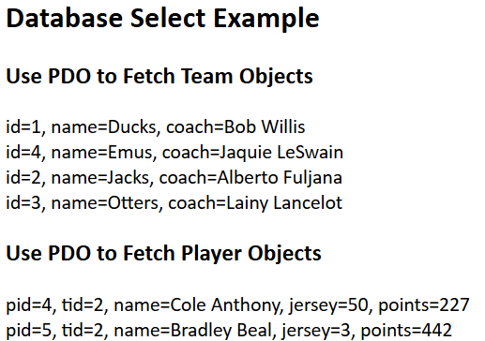 | 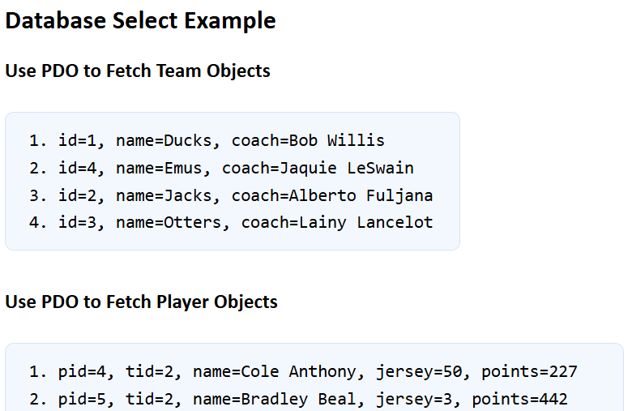
Each page uses PDO to fetch data from a MySQL database with these two tables:
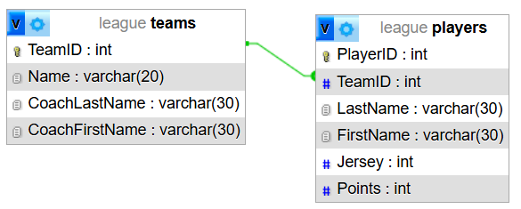
The first page, db-select.php simply echo’s the data to the page. The second page, db-select-styled uses a presentation layer to style the data. We will only consider the second page, db-select-styled.php.
The goal of this example is to show how PHP can connect to MySQL using PDO (PHP Data Objects), fetch database rows as objects, and keep database logic separate from HTML output and separate from domain (entity) classes
This example is split into several parts, each with a different job. This separation shows how object-oriented design works in a web application.
- ConnectionFactory.php – Creates the database connection
- LeagueRepository.php – Fetches teams and players from the database
- Team.php, Player.php – Domain (entity) classes, representing a team or a player
- render-helpers.php – Format HTML output
- db-select-styled.php – The presentation layer, coordinates everything.

File Details
- ConnectionFactory.php – The connection factory’s job is to create a PDO object. This object builds the database connection so the rest of the app can just use it. It is PHP’s database access layer for talking to databases like MySQL, PostgreSQL, SQLite, and others. PDO lets PHP: (a) connect to a database, (b) send SQL queries, (c) fetch results, (d) handle errors. Advantages:
- Database credentials live in one place
- The rest of the application does not need to know connection details
- LeagueRepository.php – The repository is where the SQL lives. This is sometimes called a DAO (data access object). The repository knows how to get league data, but it does not care how the data is shown. This is a good example of separation of concerns.
- It receives a PDO connection
- It runs database queries
- It returns data. PDO can fetch rows directly into objects.
- It does not display HTML
- render-helpers.php – The render helpers handle presentation.
- They receive already-fetched data
- They format HTML output
- They can add list markup and CSS classes
- They should not know anything about SQL

Design Principles & Architecture
This example shows several important design principles:
- Single Responsibility – Each part has one job.
- Separation of Concerns – Database access is not mixed with presentation.
- Dependency Injection – The repository gets its connection from outside.
- Reusability – The same repository can be used on other pages.
In summary, the architecture is such that each part has one job, which makes the code easier to understand and maintain.
File | Knows About | Does Not Know About
ConnectionFactory.php | Database connection details | HTML, SQL
LeagueRepository.php | SQL and fetching data | Page layout
Team.php, Player.php | Data for one entity | SQL
render-helpers.php | HTML formatting | Database details
db-select-styled.php | Coordination | SQL details

Appendix
- ConnectionFactory.php

<?php
class ConnectionFactory {
public static function create() {
$servername = "localhost";
$username = "root";
$password = "";
$dbname = "league";
$dsn = "mysql:host=" . $servername . ";dbname=" . $dbname . ";charset=utf8mb4";
$options = array(
PDO::ATTR_ERRMODE => PDO::ERRMODE_EXCEPTION,
PDO::ATTR_DEFAULT_FETCH_MODE => PDO::FETCH_ASSOC
);
return new PDO($dsn, $username, $password, $options);
}
}
?>
- ConnectionFactory.php

<?php
class LeagueRepository {
private $conn;
public function __construct(PDO $conn) {
$this->conn = $conn;
}
public function getAllTeams() {
$sql = "SELECT TeamID, Name, CoachFirstName, CoachLastName
FROM teams
ORDER BY Name";
$stmt = $this->conn->query($sql);
$stmt->setFetchMode(PDO::FETCH_CLASS, 'Team');
return $stmt->fetchAll();
}
public function getAllPlayers()
{
$sql = "SELECT PlayerID, TeamID, LastName, FirstName, Jersey, Points
FROM players
ORDER BY LastName, FirstName";
$stmt = $this->conn->query($sql);
$stmt->setFetchMode(PDO::FETCH_CLASS, 'Player');
return $stmt->fetchAll();
}
}
?>
- Team.php & Player.php

?php
class Team {
public $TeamID;
public $Name;
public $CoachLastName;
public $CoachFirstName;
public function getDisplayText() {
return "id=" . $this->TeamID .
", name=" . $this->Name .
", coach=" . $this->CoachFirstName . " " . $this->CoachLastName;
}
}
?>

<?php
class Player {
public $PlayerID;
public $TeamID;
public $LastName;
public $FirstName;
public $Jersey;
public $Points;
public function getDisplayText(){
return "pid=" . $this->PlayerID .
", tid=" . $this->TeamID .
", name=" . $this->FirstName . " " . $this->LastName .
", jersey=" . $this->Jersey .
", points=" . $this->Points;
}
}
?>

- render-helpers.php

<?php
function renderTeamList(array $teams) {
echo "<div class='entity-box'>" . PHP_EOL;
echo "<ol class='entity-list'>" . PHP_EOL;
foreach ($teams as $team) {
echo "<li class='entity-item'>";
echo htmlspecialchars($team->getDisplayText(), ENT_QUOTES, 'UTF-8');
echo "</li>" . PHP_EOL;
}
echo "</ol>";
echo "</div>" . PHP_EOL;
}
function renderPlayerList(array $players) {
echo "<div class='entity-box'>" . PHP_EOL;
echo "<ol class='entity-list'>" . PHP_EOL;
foreach ($players as $player) {
echo "<li class='entity-item'>";
echo htmlspecialchars($player->getDisplayText(), ENT_QUOTES, 'UTF-8');
echo "</li>" . PHP_EOL;
}
echo "</ol>" . PHP_EOL;
echo "</div>" . PHP_EOL;
}
function renderTeamArrayList(array $teams) {
echo "<div class='entity-box'>" . PHP_EOL;
echo "<ol class='entity-list'>" . PHP_EOL;
foreach ($teams as $team) {
echo "<li class='entity-item'>";
echo "Team Name: " . htmlspecialchars($team["Name"], ENT_QUOTES, 'UTF-8') . ", " .
"Team ID: " . htmlspecialchars($team["TeamID"], ENT_QUOTES, 'UTF-8') . ", " .
"Coach: " . htmlspecialchars($team["CoachFirstName"], ENT_QUOTES, 'UTF-8') . " " .
htmlspecialchars($team["CoachLastName"], ENT_QUOTES, 'UTF-8');
echo "</li>" . PHP_EOL;
}
echo "</ol>" . PHP_EOL;
echo "</div>" . PHP_EOL;
}
?><?php

- db-select-styled.php
<!DOCTYPE html>
<html lang="en">
<head>
<title>Database Select Teaching Example</title>
<link rel="stylesheet" href="site.css">
</head>
<?php
require_once "ConnectionFactory.php";
require_once "Team.php";
require_once "Player.php";
require_once "LeagueRepository.php";
require_once "render-helpers.php";
?>
<body>
<h2>Database Select Example</h2>
<h3>Use PDO to Fetch Team Objects</h3>
<?php
try {
$conn = ConnectionFactory::create();
$repo = new LeagueRepository($conn);
$teams = $repo->getAllTeams();
renderTeamList($teams);
} catch (PDOException $e) {
echo "Database error.<br />";
}
?>
<h3>Use PDO to Fetch Player Objects</h3>
<?php
try {
$conn = ConnectionFactory::create();
$repo = new LeagueRepository($conn);
$players = $repo->getAllPlayers();
renderPlayerList($players);
} catch (PDOException $e) {
echo "Database error.<br />";
}
?>
<h3>Use PDO to Fetch Associative Arrays</h3>
<?php
try {
$conn = ConnectionFactory::create();
$sql = "SELECT TeamID, Name, CoachFirstName, CoachLastName
FROM teams
ORDER BY Name";
$stmt = $conn->query($sql);
$rows = $stmt->fetchAll(PDO::FETCH_ASSOC);
renderTeamArrayList($rows);
} catch (PDOException $e) {
echo "Database error.<br />";
}
?>
</body>
</html>

