MySQL Database Setup
Contents
1 Create league Database 1
2 Create teams Table 3
3 Create players Database 6
4 Define Primary Key – Foreign Key Relationship 10
5 Create Backup Script & Copy Database 12
Appendix 1 n/a 12

The code for the examples below is on the Schedule. The outline.php page is a link to all the examples.
This document illustrates how to use phpMyAdmin to build a MySQL database, league with two joined tables: teams and players. We will mostly use a GUI interface; however, everything you do from the creation of the database to entering data into tables results in a SQL command which you can view or modify.

Create league Database
- Start Wamp server and choose: Database management, phpMyAdmin 5.2.3:
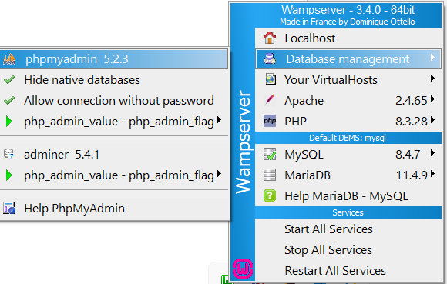
- You’ll be asked to login. “root” is the default Username and leave the password blank. After logging in:
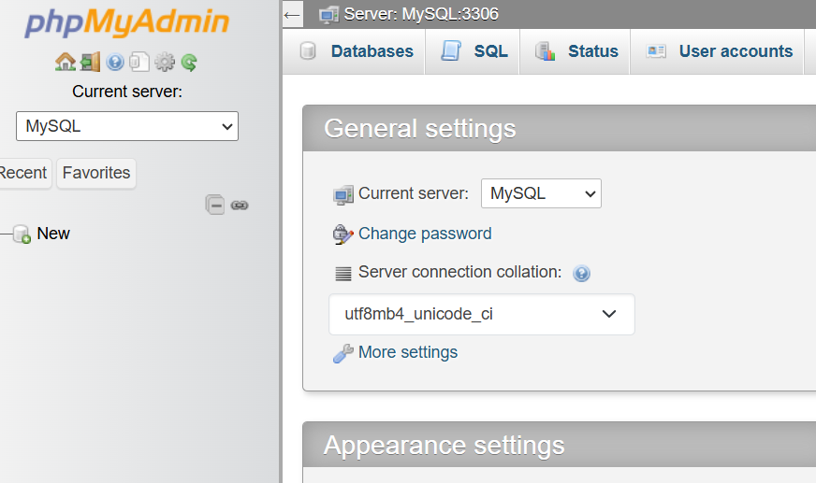

- Choose the “Databases” tab, type, “league” as the name of the database and choose: Create.
Note:
- You can also select “New” on the left and the same dialog will show.
- The result is shown in the next section.
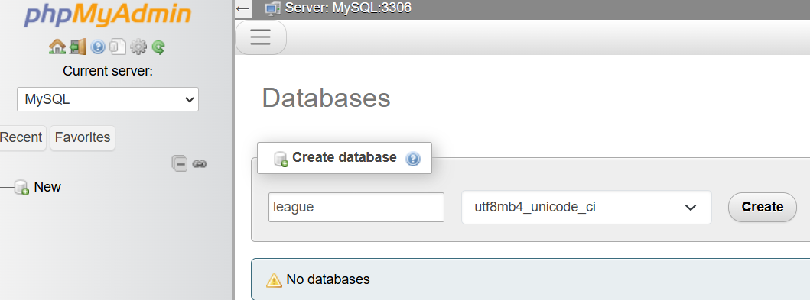

Create teams Table
- Type, “teams” for the table name and “4” for number of columns and choose: Create
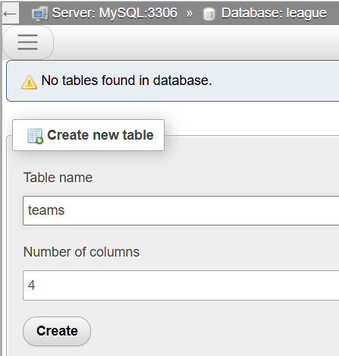
- You are going to fill the fields in the table below exactly as shown. However, we will step through this in the sub-steps below the image.
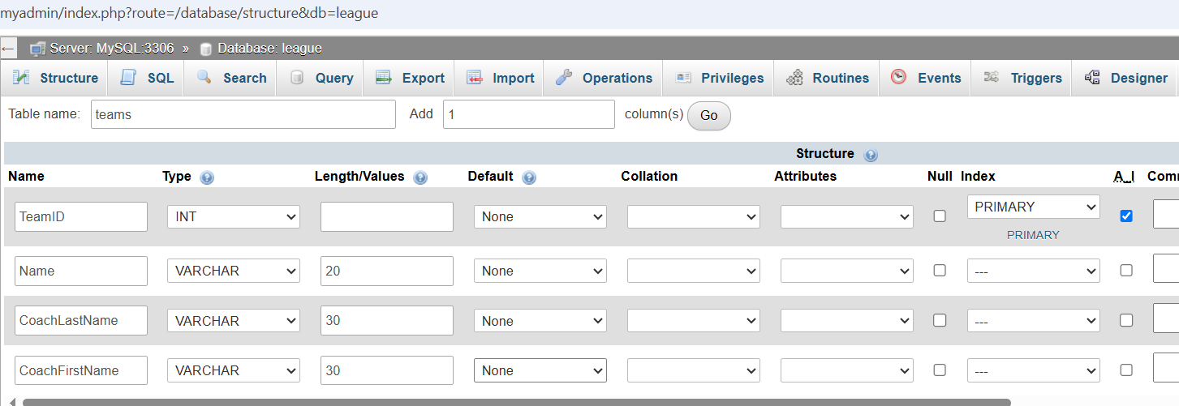
- For the first row, supply the Name (TeamID) and Type (INT).
- Still on the first row, select the Index dropdown and choose: Primary. A dialog will appear. Confirm, with no changes, by choosing: Go.
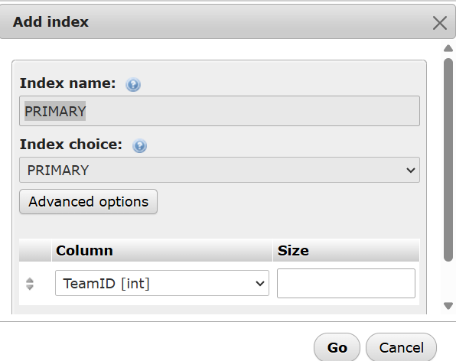
In MySQL, a table can have only one primary key, and its index is always named PRIMARY. This isn’t something you choose — it’s a built‑in convention of the database engine. phpMyAdmin simply shows you the name so you can confirm it before applying the change. [Copilot]
- Still on the first row, check the “A..I” checkbox.
In phpMyAdmin, the “A..I” checkbox stands for Auto Increment. When you check A..I, MySQL will automatically assign the next number in sequence to that field every time a new row is inserted. [Copilot] In other words, you never supply nor change this value, either when using phpMyAdmin to add records to a table, nor with code.
- Complete the next three rows by supplying the Name, Type, and Length/Values
- Scroll down in the page if necessary and choose: Save (not shown in image above)
- The result will look like as shown below. Note that the “Structure” tab is selected.
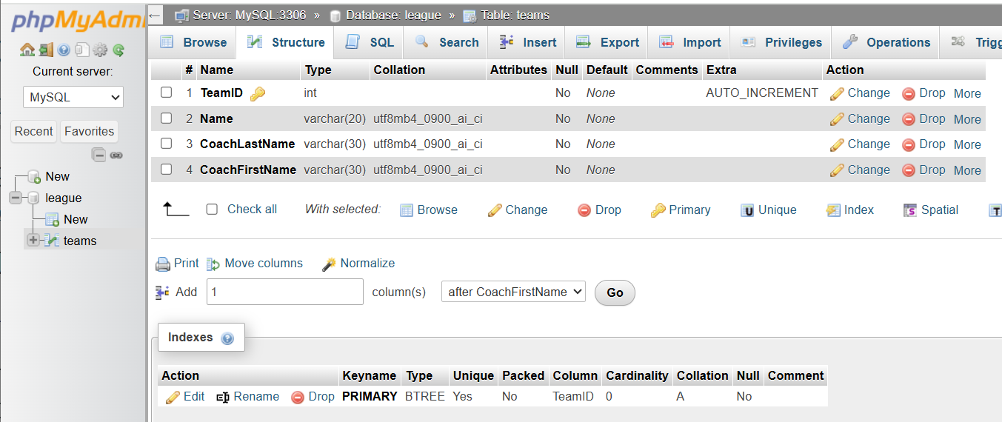

- Select the “Insert” tab and type some data in (anything you want), as shown below. DO NOT supply a TeamID. Then,choose: Go.
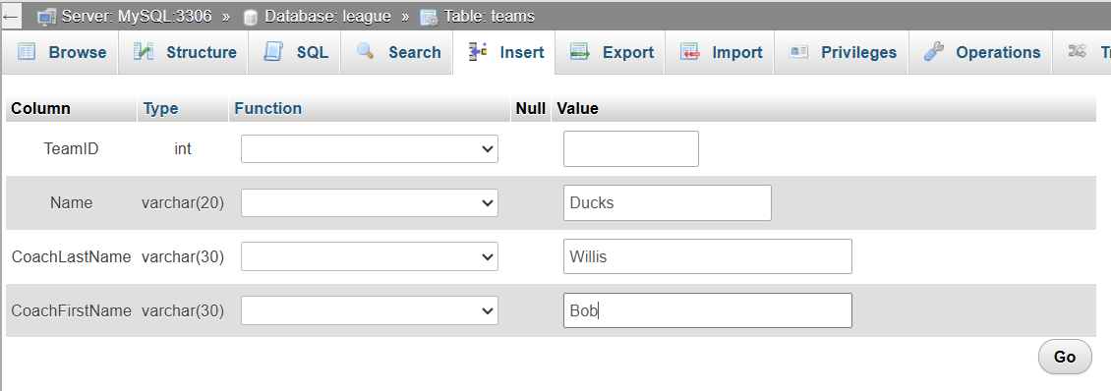
- This shows that the insertion was successful and displays the Insert SQL statement that was used:
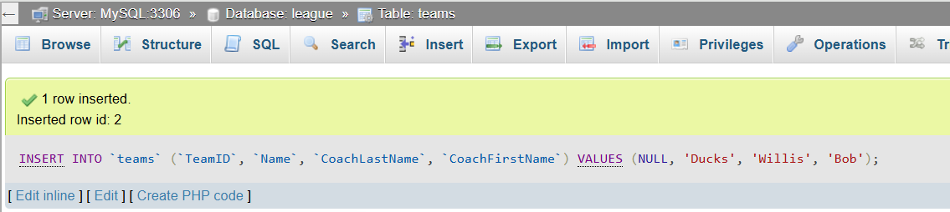
- Select the “Insert” tab and add another team. Do this until you have at least 4 teams.
- Select the “Browse” tab and you will see your records. Note the TeamID’s. You’ll need them shortly. In my case, they are: 2,3,4,5. Yours will probably be: 1,2,3,4.
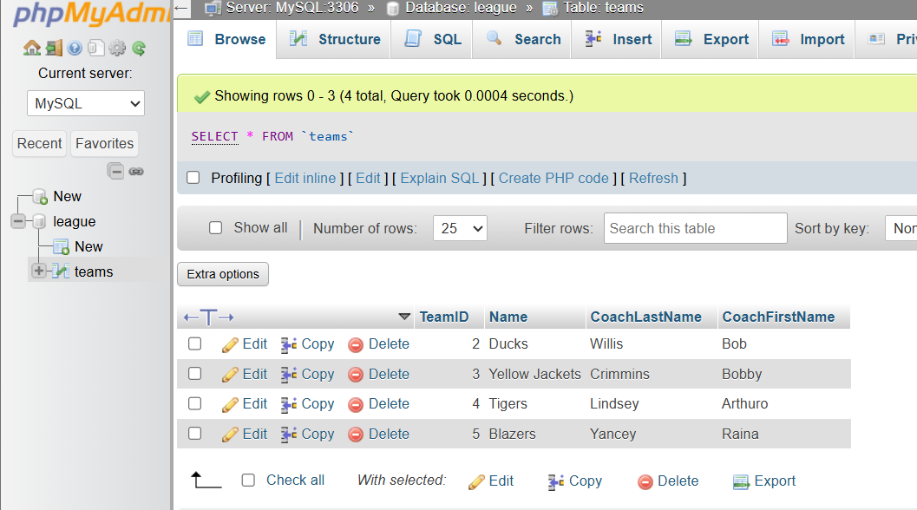

Create players Database
- Next, we’ll create another table. On the left in the figure below, choose the “New” that is below “league” and above “team”.
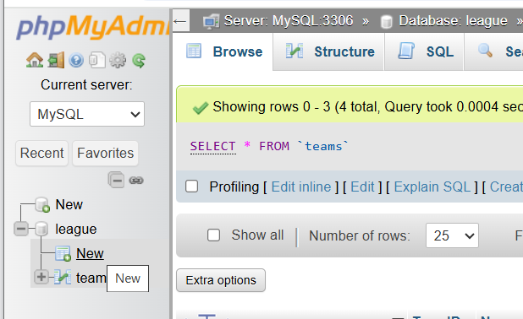
- Do the following as shown in the image below
- Type the name of the table, “players”.
- There will probably be 4 rows (fields) in your dialog. We need 6 fields in this table. So, supply the value “2” (or whatever value you need to sum to 6) in the textbox that is labelled: “Add” and then choose: Go.
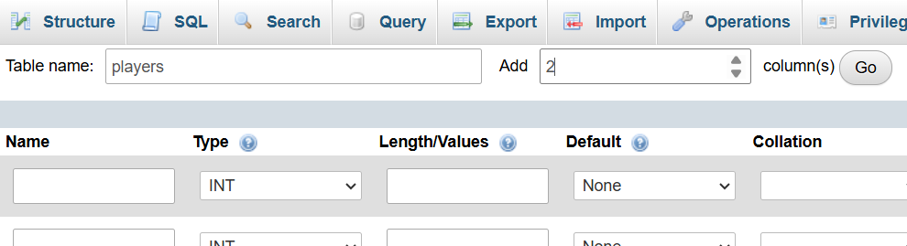
- Next, we will add the 6 fields as shown in the table below. However, we will step through it in the steps below the table.
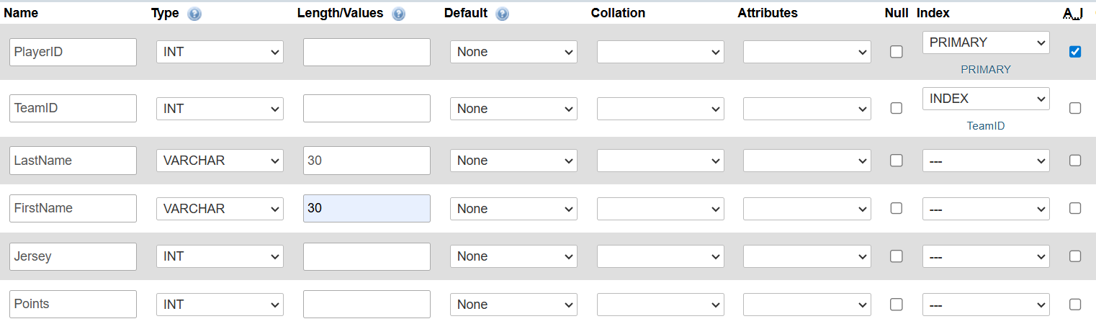
- For the first row, supply the Name (PlayerID) and Type (INT).
- Still on the first row, select the Index dropdown and choose: Primary. A dialog will appear. Confirm, with no changes, by choosing: Go.
- Still on the first row, check the “A..I” checkbox.
- On the second-row supply (as shown in figure): TeamID, INT,
- Still on the second row, choose: INDEX from the dropdown. A dialog will appear, type the value, “TeamID” for the Index name and choose: Go.
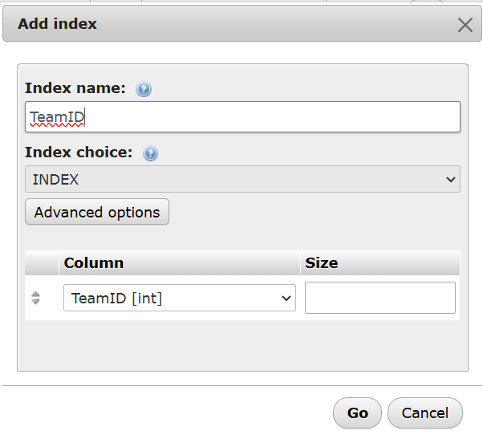
- Supply values for the next 4 rows (Name, Type, and Length/Values)
- Scroll down in the page if necessary and choose: Save (not shown in image above)

- The result will look like as shown below. Note that the “Structure” tab is selected at the top and the players table is selected from left (not shown in figure). Note the indexes at the bottom. “Indexing is a way of sorting a number of records on multiple fields. Creating an index on a field in a table creates another data structure which holds the field value, and a pointer to the record it relates to.”
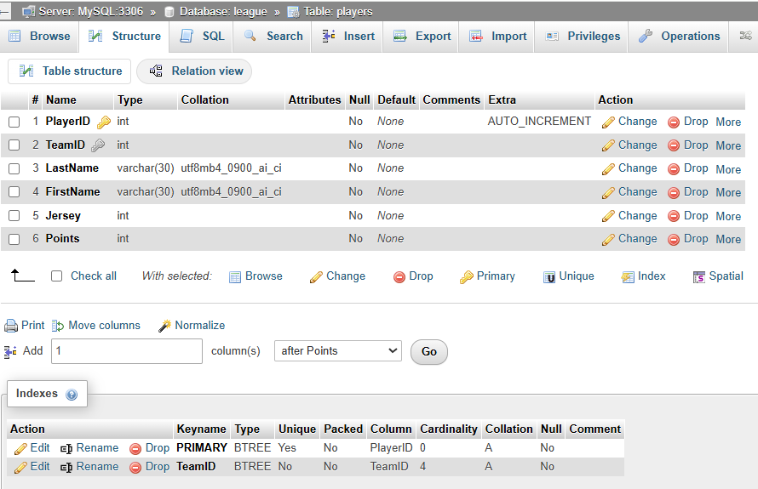
- Make sure the “players” table is selected on the left and then choose: SQL tab and then INSERT (towards bottom). Type or paste this statement in and choose: GO in the lower-ish right. Note that the “2” below is the TeamID. That is the first team in my table, yours will probably be 1. Make the change if necessary.
An
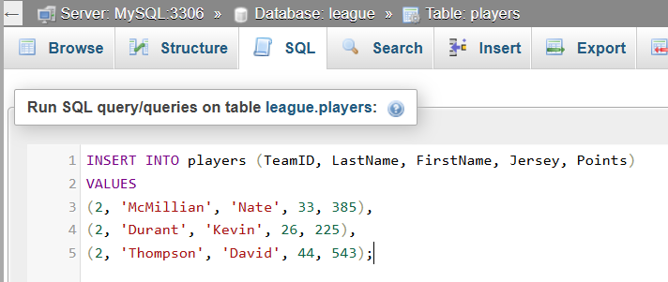

- Choose: Browse to see the records.
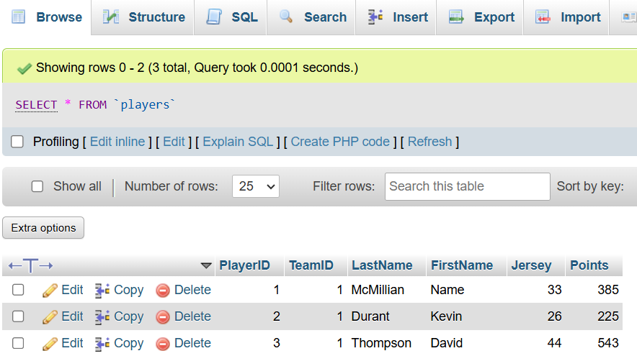
- Choose the SQL tab, and then Insert. Repeat the step above to insert more players. Make sure that you have at least 3 players on each team. You can add them all with one insert. At the end, you should have 12 or more. This script will work:
INSERT INTO players (TeamID, LastName, FirstName, Jersey, Points)
VALUES
(2, 'Anthony', 'Cole', 50, 227),
(2, 'Beal', 'Bradley', 3, 442),
(2, 'Garza', 'Luka', 55, 86),
(3, 'Mann', 'Tre', 76, 346),
(3, 'Davis', 'Anthony', 88, 116),
(3, 'Nance', 'Larry', 7, 98),
(4, 'Payton', 'Gary', 2, 64),
(4, 'Hardaway', 'Tim', 17, 221),
(4, 'Carter', 'Devin', 8, 664);
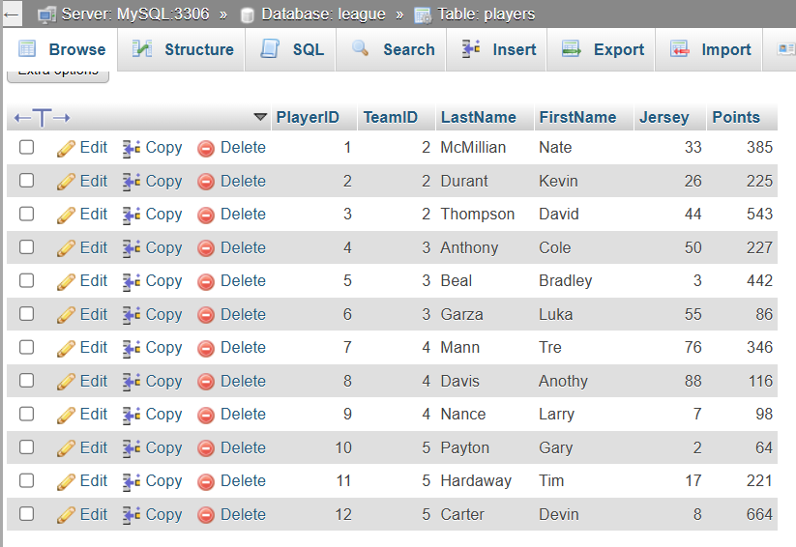

Define Primary Key – Foreign Key Relationship
- Next, we need to explicitly define the primary key – foreign key relationship between the teams and players tables. To do this, we will use the Designer tool and to use the Designer tool, we must first change the “Storage Engine”! Follow the steps below to do this. The source for this is below. However, there, the source is enabling the Relation view. The Relation view is another way you can define the PK-FK relationship.
Source: https://manage.accuwebhosting.com/knowledgebase/2567/How-to-Enable-Relation-View-in-phpMyAdmin.html
  - Select the players table and choose the Operations tab.
  - Under “Table options”, set the “Storage engine” to: “innoDB” and then choose: Go.
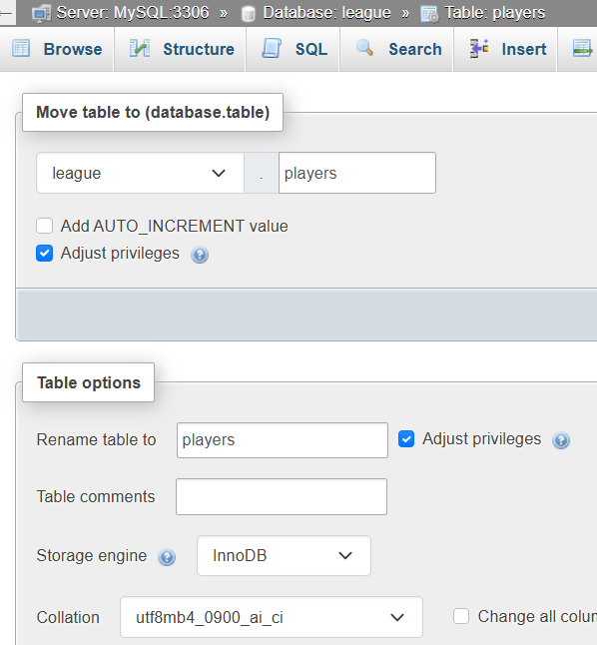
  - Do the same thing for the teams table.
- Now, we can set the foreign key constraint on the PlayerID column in the players table.
Source: https://www.youtube.com/watch?v=7HTAX0dfJqg. One technique is shown at 1:10 mark. However, I couldn’t get that to work. At end of video it shows the technique we use below.
  - Select the league database and choose: More (far right top), Designer. The result is shown below.
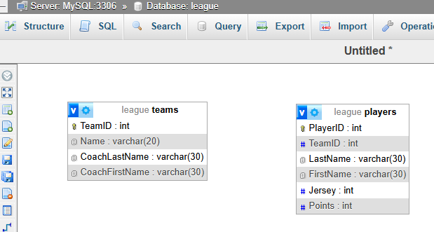

  - From the left menu, choose: Create relationship
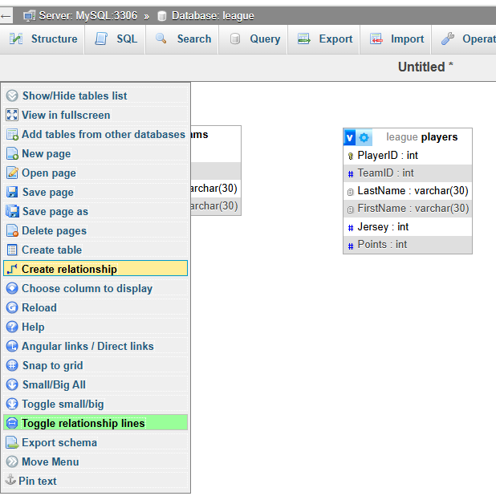
  - As the prompt leads you, click TeamID in the teams table, then click TeamID in the players table. On the pop-up, choose: Restrict for each of the options, then choose: OK.
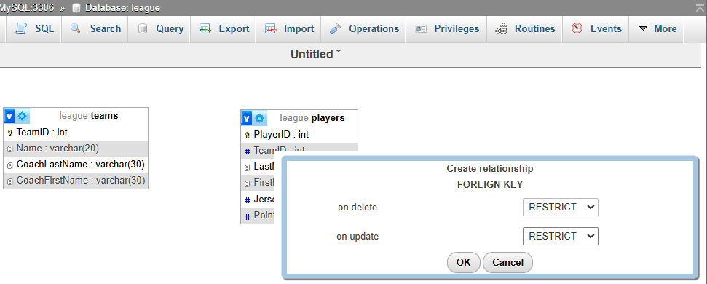
  - The result will look like this. If the line showing the association is not showing. Select the database, then More, Designer to redisplay.
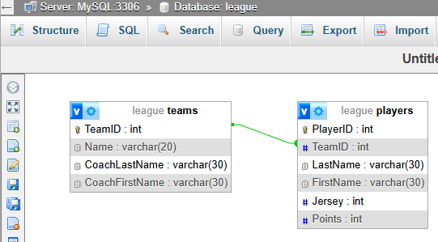

  - Select the players table and then choose: Structure. You will see that TeamID has a grey key beside it indicating that it is a foreign key.
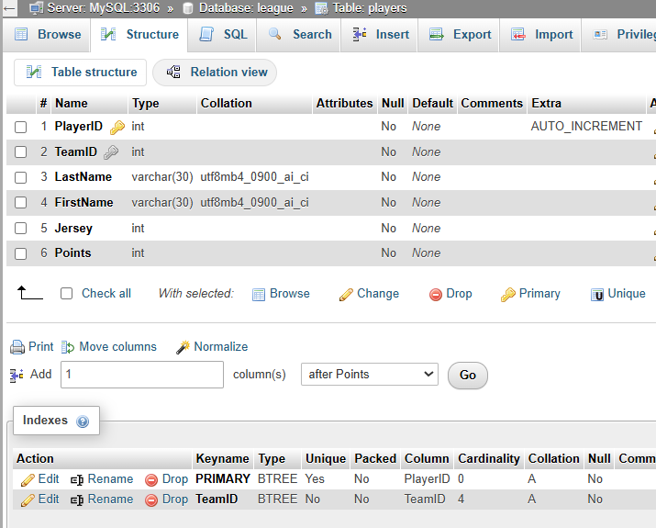

Create Backup Script & Copy Database
This is only for your information. However, it is useful to do as in later assignments you will be deleting database rows and it is convenient to be able to restore your database.
- Type this prompt into Copilot and follow the steps there to create a script (.sql) to recreate your league database. Then use the script to create a copy of your database named: league_copy
“Using phpmyadmin, how would I create and use a script to exactly recreate an existing database with all tables, relationships, data, etc?”

The End…

Appendix
- n/a

https://stackoverflow.com/questions/1108/how-does-database-indexing-work/1130#1130

