PHP Web Development, Lesson 2
Contents
1 Example 1 – Postback to Self 1
2 Example 2 – Postback to Self, more Secure 6
3 Example 3 – Postback to Self & Redirect 6
4 Example 4 – Creating an Order with Products (Classes) 11
5 Example 5 – Postback to Self via Radiobutton Selection 14
Appendix 1 Resources 15
Appendix 1.1 Detecting First Time on Page 15
Appendix 1.2 Session 15
Appendix 1.3 Single-Page Apps (SPA) 15
Appendix 1.4 Misc 16
Appendix 1.5 Redirect to another Page 16
Appendix 2 Frameworks 16

The code for the examples below is on the Schedule. The outline.php page is a link to all the examples.

Example 1 – Postback to Self
Code: ex1-postself.php, ex1-code.php
Features: (a) including code, (b) postback to self, (c) first time on page vs. post back, (d) multi-select listbox, (e) implode function (f) XSS examples.
- A single-page app (SPA), is a web app that posts back to itself. For example, you may have a page that lets a user enter data for a new product, submit and then the same page allows the user to enter the data for another new product. That is what we will create here. Modern approaches to SPAs use JavaScript frameworks to do partial page updates that refresh just a portion of the web page as opposed to the whole page. Popular frameworks are: Reach, Angular, Vue, and many others.
- Consider this example:
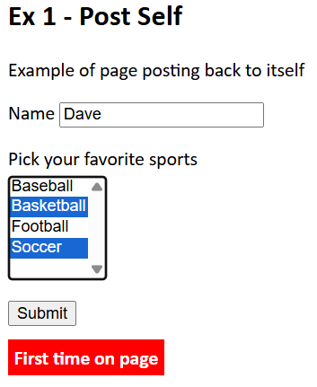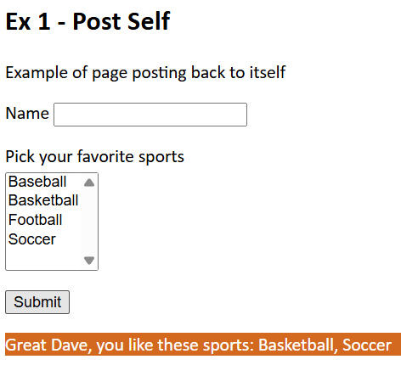
- Including code – You can place functions to build the user interface and/or to process posted data and display output in a separate file to improve readability in the .php file and to support resuse. See ex1-code.php. Place code like this in the head (or anywhere before it is needed):
<?php
include "ex1-code.php";
?>
- Post to self, either of these:
<form action="<?php echo $_SERVER['PHP_SELF']; ?>" method="POST">
<form action="" method="POST">
- Detecting postback
- This checks whether the request was made using the POST method and returns true for any POST request and false for GET, PUT, etc:
if ($_SERVER['REQUEST_METHOD'] === 'POST') {
Can also check that the required data is posted:
if ($_SERVER['REQUEST_METHOD'] === 'POST' &&
isset($_POST['username'], $_POST['email'])) {
The isset(var) function returns true if a variable exists and is not null, and false otherwise:
- This checks whether $_POST is non-empty and returns true if the form submitted at least one POST field with data
false if $_POST is empty.
if($_POST) {
- Processing a listbox
<select name="sports[]" size="5" id="sports" multiple>
<option value="Baseball">Baseball</option>
<option value="Basketball">Basketball</option>
<option value="Football">Football</option>
<option value="Soccer">Soccer</option>
</select>

$sports = $_POST['sports'];
$msg = "<p>Great " ...;
$msg .= implode(', ', $sports);
The implode function turns the array into a string separating each value by: ", ". Or, you could use a loop:
$n = count($sports);
for ($i = 0; $i < $n; $i++) {
$msg .= $sports[$i] . ", ";
}
$msg = substr($msg, 0, -2);

- Code
ex1-postself.php
<head>
<title>Ex 1-Post Self</title>
<link rel="stylesheet" href="site.css">
<?php
include "ex1-code.php";
?>
</head>
<body>
<a href="outline.php">Back to menu</a>
<h2>Ex 1 - Post Self</h2>
<p>Example of page posting back to itself</p>
<form action="<?php echo $_SERVER['PHP_SELF']; ?>" method="POST">
<?php
display_sports_choices();
?>
<input type="submit" name="btn_submit">
<?php
//if($_POST) {
if ($_SERVER['REQUEST_METHOD'] === 'POST') {
display_sports_selections();
}
else {
echo "<p><span class='error'>First time on page</span></p>";
}
?>
</form>
</body>

ex1-code.php
<?php
// Displays the name input and sports listbox.
function display_sports_choices() {
echo
'<p>
<label for="name" >Name</label>
<input type="text" name="name" id="name">
</p>
<p>
<label for="sports" id="labelListBox">Pick your favorite sports</label>
<select name="sports[]" size="5" id="sports" multiple>
<option value="Baseball">Baseball</option>
<option value="Basketball">Basketball</option>
<option value="Football">Football</option>
<option value="Soccer">Soccer</option>
</select>
</p>';
}

// Displays name entered and the selected sports.
function display_sports_selections() {
$msg = "";
if (isset($_POST['sports'])) {
$sports = $_POST['sports'];
$n = count($sports);
$msg = "<p class='selections'>Great " . $_POST['name'] . ", ";
if ($n == 1) {
$msg .= "you like this sport: ";
} else {
$msg .= "you like these sports: ";
}
$msg .= implode(', ', $sports);
$msg .= "</p>";
}
else {
$msg = "<p class='error'>You didn't select any sports</p>";
}
echo $msg;
}
?>

- Code is subject to XSS (cross-site scripting).
“Cross-site scripting (XSS) is a type of security vulnerability that can be found in some web applications. XSS attacks enable attackers to inject client-side scripts into web pages viewed by other users.”
Run the app and paste the code below either: (a) at the end of the URL and press enter, or (b) in the textbox, select a sport, and press enter:
/"><script>document.body.style.backgroundColor = "red";alert("XSS Attack")</script><p "
It displays a popup and then:
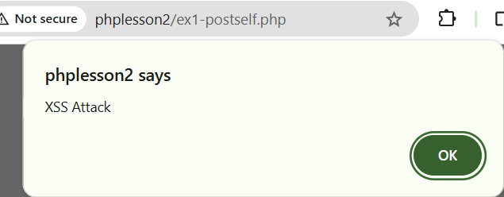 | 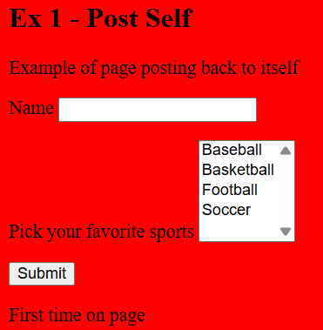
Repeat with:
/"><p style="background:yellow">XSS Example</p><p "
It displays a popup and then:
Placed in URL | Placed in textbox
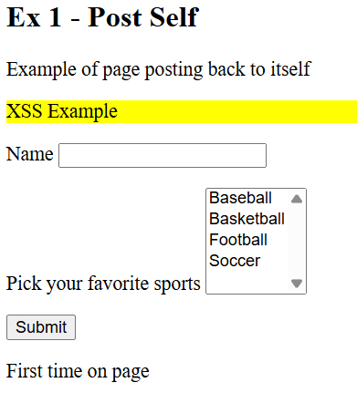 | 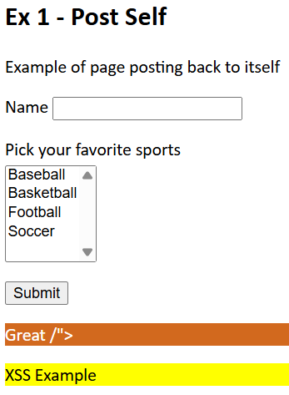

Example 2 – Postback to Self, more Secure
Code: lesson2/ex2-postself-validated.php, ex2-code-validated.php
One technique to prevent XSS is the use of the: htmlspecialchars() function. This function converts some predefined characters into HTML entities. The predefined characters are:
Character | Description | HTML Entity
& | Ampersand | &amp;
" | Double quote | &quot;
' | Single quote | &#039;
< | Less than | &lt;
> | Greater than | &gt;
The htmlspecialchars() function should be used in the form’s action attribute. For example:
<form action="<?php echo htmlspecialchars($_SERVER['PHP_SELF']); ?>" method="POST">
It should also be used anywhere you display user input via POST or GET. For example:
$msg = "<p>Great " . htmlspecialchars($_POST['name']) . ", ";

Example 3 – Postback to Self & Redirect
Code: lesson2/ex3-session.php, ex3-results.php
Features: (a) postback to enter data (number), redirect to results page, (b) session: start, checking if exists, updating, (c) array of numbers, (d) destroy session, (e) var_dump
- Consider this example:
ex3-session3.php | ex3-results3.php
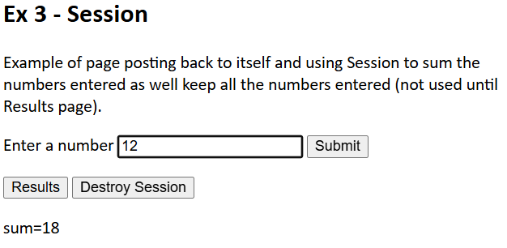 | 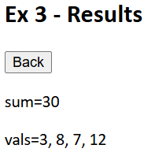
Next, we will step through how each page works.
ex3-session3.php
- We introduce a function to do the HTML encoding
function h($value) {
return htmlspecialchars($value, ENT_QUOTES, 'UTF-8');
}

- All three buttons postback to the page itself
<form action="<?php h($_SERVER['PHP_SELF']); ?>" method="POST">
- We utilize Session to maintain state. Thus, we place this at the top of the file. We also initialize the session variables if needed. We explain the Boolean variable later.
<?php
session_start();
$shouldDisplaySum = false;
if (!isset($_SESSION['sum'])) {
$_SESSION['sum'] = 0.0;
}
if (!isset($_SESSION['vals'])) {
$_SESSION['vals'] = array();
}
%>
session_start must execute anytime Session is being used, even on postback.
- We need to be able to distinguish between when the Submit, Results, & Destroy Session buttons are pressed. So, we add a name attribute to buttons so that they will be posted back when pressed.
<input type="submit" name="btn_submit" value="Submit">
<input type="submit" name="btn_results" value="Results">
<input type="submit" name="btn_destroy" value="Destroy Session">

- When Results is pressed, we redirect to ex3-results3.php. Thus, we place this at the top of the file:
if (isset($_POST['btn_results'])) {
header("Location: ex3-results3.php");
exit();
}
Notes:
- The header function essentially redirects to the Location.
- The exit function immediately stops the page’s execution. The die function is equivalent to the exit function.
- When Destroy Session is pressed, we destroy the session and reload the page:
if (isset($_POST['btn_destroy'])) {
session_unset();
session_destroy();
header("Location: ex3-session3.php");
exit();
}

- When the Submit button is pressed and a value has been posted, we add the value to the sum in session, and add the value to the array in session.
if (isset($_POST['btn_submit']) && isset($_POST['val'])) {
$shouldDisplaySum = true;
$val = trim($_POST['val']);
if ($val !== '' && is_numeric($val)) {
$_SESSION['sum'] += (float)$val;
$_SESSION['vals'][] = $val;
//array_push($_SESSION['vals'], $val);
}
}
- When the page is loaded via a redirect from the Results page (i.e. the Back button is pressed on ex3-results3.php), we set the shouldDisplaySum variable to true to make sure the sum is displayed:
if (isset($_POST['btn_back'])) {
$shouldDisplaySum = true;
}
- The complete Form is shown below. Note, that we only display the sum when a value has been posted back or we are returning to the page from the Results page.
<form action="<?php h($_SERVER['PHP_SELF']); ?>" method="POST">
<p>
<label for="val">Enter a number</label>
<input type="text" id="val" name="val">
<input type="submit" name="btn_submit" value="Submit">
</p>
<p>
<input type="submit" name="btn_results" value="Results">
<input type="submit" name="btn_destroy" value="Destroy Session">
</p>
<?php
if ($shouldDisplaySum) {
echo '<p>sum=' . h($_SESSION['sum']) . '</p>';
}
?>
</form>

- The complete initial script is:
<?php
session_start();
$shouldDisplaySum = false;
if (!isset($_SESSION['sum'])) {
$_SESSION['sum'] = 0.0;
}
if (!isset($_SESSION['vals'])) {
$_SESSION['vals'] = array();
}
if (isset($_POST['btn_results'])) {
header("Location: ex3-results3.php");
exit();
}
if (isset($_POST['btn_destroy'])) {
session_unset();
session_destroy();
header("Location: ex3-session3.php");
exit();
}
if (isset($_POST['btn_submit']) && isset($_POST['val'])) {
$shouldDisplaySum = true;
$val = trim($_POST['val']);
if ($val !== '' && is_numeric($val)) {
$_SESSION['sum'] += (float)$val;
$_SESSION['vals'][] = $val;
//array_push($_SESSION['vals'], $val);
}
}
if (isset($_POST['btn_back'])) {
$shouldDisplaySum = true;
}
function h($value) {
return htmlspecialchars($value, ENT_QUOTES, 'UTF-8');
}
?>

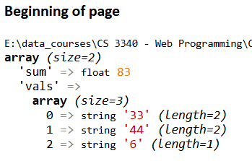
- I wrote a function to display the value of Session,
function vardump_message($msg) {
echo '<p><b>' . $msg . '</b><br>';
var_dump($_SESSION);
echo '</p>';
}
<?php
vardump_message("Beginning of page");
?>
The problem with this is that you can only use it in the body of the page (because it displays HTML). In other words, you can’t use it in the script that runs before the HTML. There is a way to pipe the equivalent of var_dump to a string and this could be a solution (e.g. make it a variable that the code could access later(?)).
ex3-results.php
<?php
session_start();
if (!isset($_SESSION['sum']) || !isset($_SESSION['vals'])) {
header("Location: ex3-session3.php");
exit();
}
function h($value) {
return htmlspecialchars($value, ENT_QUOTES, 'UTF-8');
}
$sum = $_SESSION['sum'];
$vals = $_SESSION['vals'];
$valsText = implode(', ', $vals);
// or....
//foreach($vals as $val){
// $valsText .= $val.", ";
//}
//$valsText = substr($valsText, 0, -2);
?>
<!DOCTYPE html>
<html lang="en">
<head>
<title>Ex 3-Results</title>
<link rel="stylesheet" href="site.css">
</head>
<body>
<a href="outline.php">Back to menu</a>
<h2>Ex 3 - Results</h2>
<form action="<?php echo htmlspecialchars('ex3-session3.php'); ?>" method="POST">
<input type="submit" name="btn_back" value="Back">
<p>sum=<?php echo h($sum); ?></p>
<p>vals=<?php echo h($valsText); ?></p>
</form>
</body>
</html>

Example 4 – Creating an Order with Products (Classes)
Code: lesson2/ex4-session-v1/add_order.php, add_products.php, Order.php, Product.php
Features: (a) scenario: create order, then create products, one at a time. Product page shows order, (b) custom classes, Order*Product, (c) objects in session: serialize, deserialize, (d) session: start, checking if exists, updating.
- Consider this example:
Create Order – add_order.php | Add a Product – add_product.php
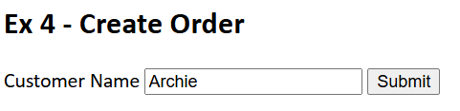 | 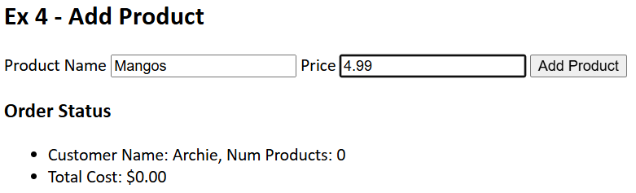
Add another Product | Add another Product
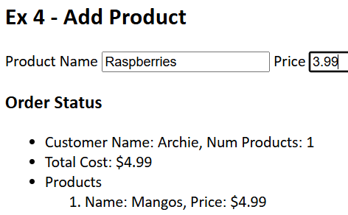 | 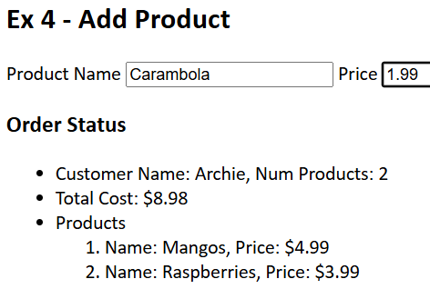
- Class References
- PHP OOP - Classes and Objects
- Classes & Objects – The Basics
- Classes
Order.php
<?php
class Order {
private $customer_name;
private $products = array();
function __construct($customer_name) {
$this->customer_name = $customer_name;
}
function getCustomerName() {
return $this->customer_name;
}
function addProduct(Product $product) {
array_push($this->products, $product);
}
function getProduct($index) {
return $this->products[$index];
}

function totalCost() {
$sum = 0;
foreach ($this->products as $product) {
$sum += $product->getPrice();
}
return $sum;
}
// Just to illustrate indexed loop
function totalCost2() {
$sum = 0;
for($i = 0; $i < count($this->products); $i++) {
$sum += $this->products[$i]->getPrice();
}
return $sum;
}
function getNumberOfProducts() {
return count($this->products);
}
}
?>
Product.php
<?php
class Product {
private $name;
private $price;
function __construct($name, $price) {
$this->name = $name;
$this->price = $price;
}
function getName() {
return $this->name;
}
function getPrice() {
return $this->price;
}
// I believe there is a real toString, __toString, but didn't figure it out.
function toString() {
$msg = sprintf("Product name: %s, Price: $%.2f", $this->name, $this->price);
return $msg;
}
}
?>

- The add_order.php contains no PHP code. It simply posts to add_product.php. The initial page processing on add_product.php.
<?php
if(isset($_POST['btn_submit_order'])){ // Post from add_order.php
$name = sanatize_input($_POST['name']); // Clean data
$order = new Order($name); // Create order
$_SESSION['order'] = serialize($order); // Put order into session
}
if(isset($_POST['btn_add_products'])){ // Post from this page, add_products.php
//var_dump($_POST['name']);
$name = sanatize_input($_POST['name']); // Clean data
if(strlen($name)>0) {
$price = sanatize_input($_POST['price']); // Clean data
$product = new Product($name, $price); // Create Product
$order = unserialize($_SESSION['order']); // Get order from session
$order->addProduct($product); // Add product to order
$_SESSION['order'] = serialize($order); // Put order back into session
}
}
?>
- The display of the current order:
<?php
echo "<h3>Order Status</h3>";
echo "<ul>";
echo "<li>Customer Name: " . $order->getCustomerName() .
", Num Products: " . $order->getNumberOfProducts() . "</li>";
echo "<li>Total Cost: " . sprintf("$%.2f", $order->totalCost()) . "</li>";
// If a postback to this page, show products
if(isset($_POST['btn_add_products'])) {
echo "<li> Products";
echo "<ol>";
for ($i = 0; $i < $order->getNumberOfProducts(); $i++) {
$product = $order->getProduct($i);
echo "<li> Name: " . $product->getName() .
", Price: " . sprintf("$%.2f", $product->getPrice()) . "</li>";
}
echo "</ol>";
echo "</li>";
}
echo "</ul>";
?>

Example 5 – Postback to Self via Radiobutton Selection
Code: lesson2/ex5-radiopostback.php
Features: (a) scenario: select a radiobutton to submit form (b) JS submit (in helper method), (c) helper methods to build radio buttons., (d) making the radio button stay checked!, (e) checking if a key exists in Post collection.
- Consider this example: selecting a radio button causes a postback and the sport is displayed. The submit button postsback, but there is no action taken (so not needed).

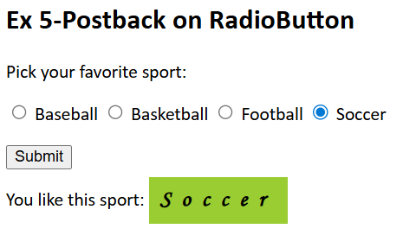
- Call a function to build radio buttons:
<p>
<?php
echo buildRadioButton('Baseball');
echo buildRadioButton('Basketball');
echo buildRadioButton('Football');
echo buildRadioButton('Soccer');
?>
</p>

- Functions:
function buildRadioButton($sport) {
$rad = "<input type='radio' name='sports[]' onclick='this.form.submit();' value='$sport' ";
$rad .= setCheckedAttribute($sport);
$rad .= "/>" . PHP_EOL;
$label = "<label>$sport</label>" . PHP_EOL;
return $rad . $label;
}
function setCheckedAttribute($sport) {
$msg = "";
if(isset($_POST['sports'])) {
$sports = $_POST['sports'];
if ($sports[0] == $sport) {
$msg = "Checked ";
}
}
return $msg;
}

Appendix
- Resources
  - Detecting First Time on Page
Don’t like article, but technique might be: if ($_SERVER['REQUEST_METHOD'] == 'POST')
https://www.sitepoint.com/community/t/send-post-values-with-header-location/38750
Show different page first time. One commenter said this is old, don’t use it.
https://stackoverflow.com/questions/8752398/show-different-page-if-first-time-visit
  - Session
Excellent description
https://www.usna.edu/Users/cs/adina/teaching/it350/fall2020/lectures/set11-sessions.html
Cookies, from same source:
https://www.usna.edu/Users/cs/adina/teaching/it350/fall2020/lectures/set10-phpCookies.html
JS Cookies
https://www.usna.edu/Users/cs/adina/teaching/it350/fall2020/lectures/set22-jscookies.html
Doc page. Simple examples
https://www.php.net/manual/en/function.session-start.php
Code is simple. Explanations seem wacky, but must be my understanding b/c w3schools is good.
https://www.w3schools.com/php/php_sessions.asp
  - Single-Page Apps (SPA)
Don’t quite understand how it works. Don’t see form/post anywhere. Some JS being used. But, very simple otherwise.
https://github.com/Posandu/php-single-page-application/tree/main
Active CSS framework. Good description of what a SPA does. I believe you just need to include a JS file.
https://activecss.org/manual/php-spa-tutorial-part-1.html
WebRocketX – all JS based
https://github.com/matthewekeller/WebRocketX
I think this has the answer I want for hw 4 (the old one, which will be same as new one). See last answer (0 points!).
https://stackoverflow.com/questions/73349425/how-can-i-make-a-single-page-application-with-php
This is excellent! All JS, raw code, not frameworks nor 3rd party JS.
https://orangeable.com/php/spa
  - Misc
Can use header(‘a.php?result=success’). From comment on question itself.
https://stackoverflow.com/questions/17333901/php-form-on-submit-stay-on-same-page
Very good explanation
https://html.form.guide/php-form/php-form-action-self/
Don’t quite understand how it works. Don’t see form/post anywhere. Some JS being used. But, very simple otherwise.
https://www.geeksforgeeks.org/how-to-call-php-function-on-the-click-of-a-button/
Other:
11 Best PHP Frameworks
Best practice in mixing html and php? and why?
Form Validation – D
  - Redirect to another Page
Didn’t like this too much
https://www.geeksforgeeks.org/how-to-make-a-redirect-in-php/
I think this is a copy of above, but written better
https://phoenixnap.com/kb/php-redirect
Supplemental resource: I don’t believe it posts the form data. This is a technique that does a full http request. Don’t recommend right now.
https://stackoverflow.com/questions/4281900/php-header-redirect-with-post-variables/4281960
- Frameworks
Laravel: wiki, | MVC | Most popular
Comparison of frameworks
Symphony | ? | Components & framework

https://en.wikipedia.org/wiki/Cross-site_scripting
https://www.geeksforgeeks.org/php/how-to-prevent-xss-with-html-php/
https://www.w3schools.com/php/func_string_htmlspecialchars.asp
https://www.geeksforgeeks.org/how-to-call-php-function-on-the-click-of-a-button/

