Lab 5 – WAMP & PhpStorm Installation
Contents
1 Answers 1
2 Introduction 1
3 WAMP Installation 2
3.1 Dowload & Install WAMP 2
3.2 Run WAMP 4
3.3 Make a Virtual Host 6
4 PhpStorm - IDE 9
4.1 Download 9
4.2 HelloWorld 9
Appendix 1 Installation References 11

Answers
You will turn this document in as evidence that you completed this lab. In this section, you will place 2 screen shots as indicated in the steps below
Webpage

helloworld.php

Introduction
- WAMP is a stack of software used to create a local web server on a Windows machine that will process and display a PHP file that may utilize a MySQL database. WAMP stands for Windows, Apache, MySQL, and PHP. There is also MAMP for Macs and LAMP for Linux.
- PhpStorm is an IDE for creating PHP web pages.
- For this lab, you will install WAMP (or the version for your operating system) and PhpStorm (you can use an alternative if you want).
- The directions below are for Windows. If you are using a Mac, you’ll follow the same steps, but you may need to prowl around a bit, or use google/AI to figure out how to accomplish a particular step/

WAMP Installation

Dowload & Install WAMP
- Downloaded WampServer, https://wampserver.aviatechno.net/ .
- For MAMP: https://sourceforge.net/projects/mamp/
- Several resources (WAMP & MAMP) are available in the Appendix.
- Choose: “Wampserver 3.4.0 64 bit…” as shown towards the bottom of image below.
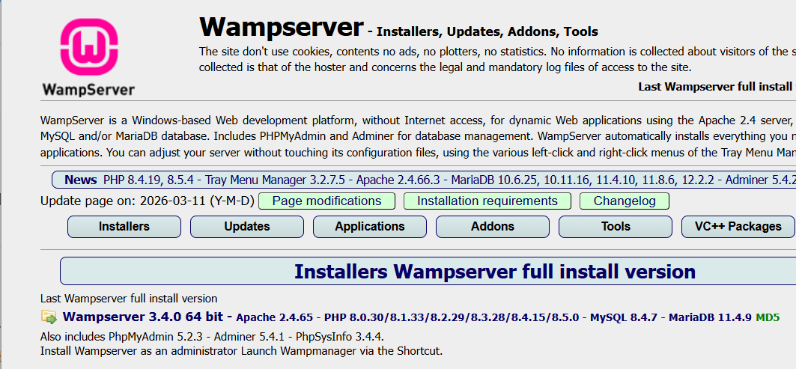
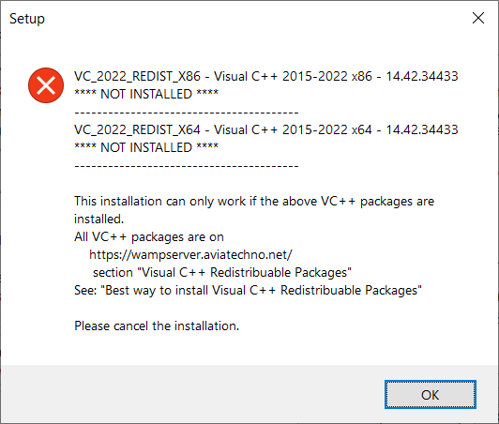
- Once it downloads, run the .exe to install, you’ll probably get this error below.
- Make a note of the exact things that are missing. Last year, on an older machine, there were only two things, as shown below, separated by the dashed lines. I just made a screen shot and placed it in a document so that I could reference it if needed. In Spring 2026, on a new computer, I had 8 missing.
- Choose: OK, and then cancel the installation. We’ll run it again shortly.

- Next, we will download and install the missing files. Go back to: https://wampserver.aviatechno.net/ and choose: “VC++ Packages” as shown in the image in step 1a above (on the far right). The result is shown below.
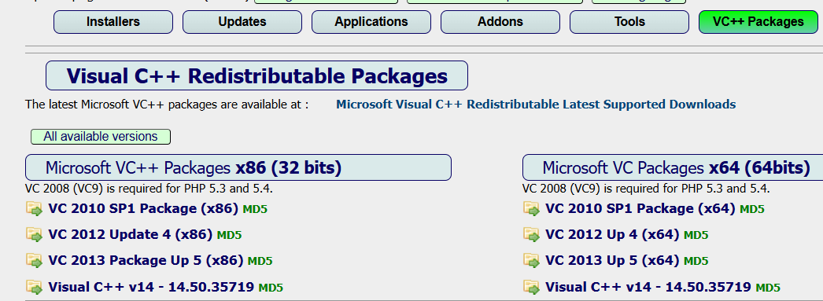
- For my case, for my older machine, I downloaded the two items circled below and ran them one-at-a-time. My new computer required them all. Some will require a restart.
- Supposedly, the “best way” to do this is to choose the “Best way to install…” button as shown at the bottom of the image below. Sometimes the server is down (no available mirror sites) which was the case for me (Spring 2026).
- Download and install the ones you need (or use the “best way”). Some may require a reboot.
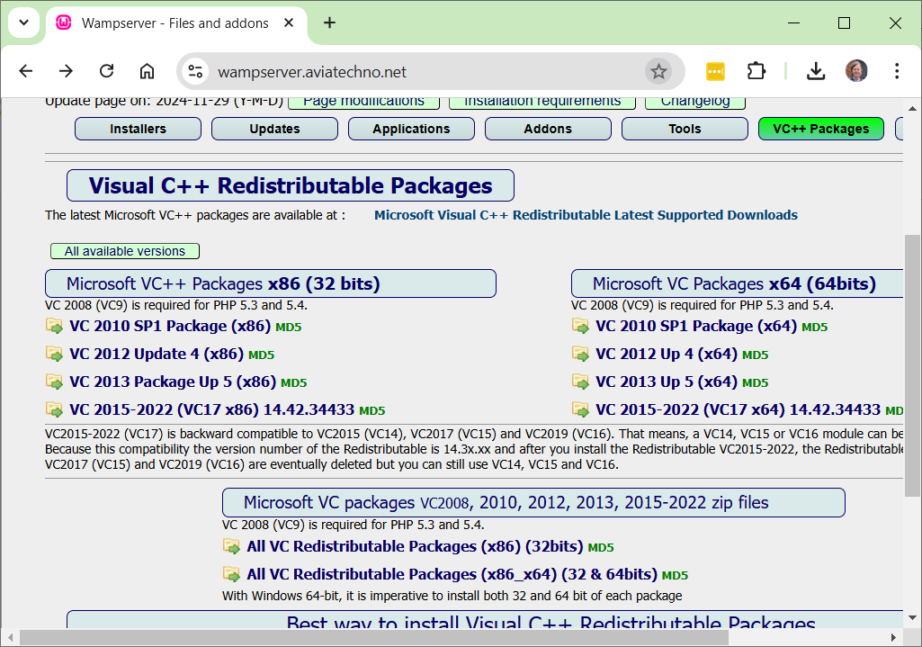

- Finish installing WAMP by restarting the installer. You’ll find it in your downloads folder. Mine was named (Spring 2026), wampserver3.4.0_x64.exe.

Run WAMP
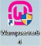
- Look for the icon on the desktop (Search for: Wampserver64, in search bar if needed). Run the program.

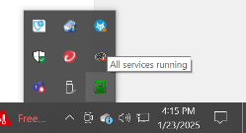
- It take a minute to load and you’ll see a progress dialog on the screen. When it complete, it puts itself in the System Tray as shown below (green icon, lower-right), it may be in the overflow area where the up arrow is.
- When the icon is green, all services are running correctly.
- Click this icon.

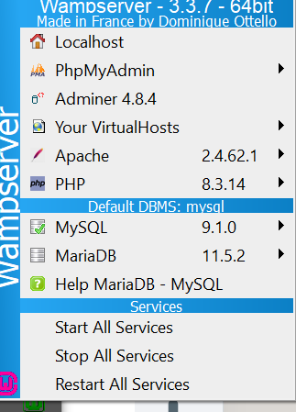
- It will display the WAMP menu as shown on the right.
- Note the Start, Stop, and Restart All Services selections at the bottom. Sometimes you will need these if things stop working correctly.
- Choose: Localhost (at the top)

- It will show this info screen. This is actually a web page on your server, index.php.
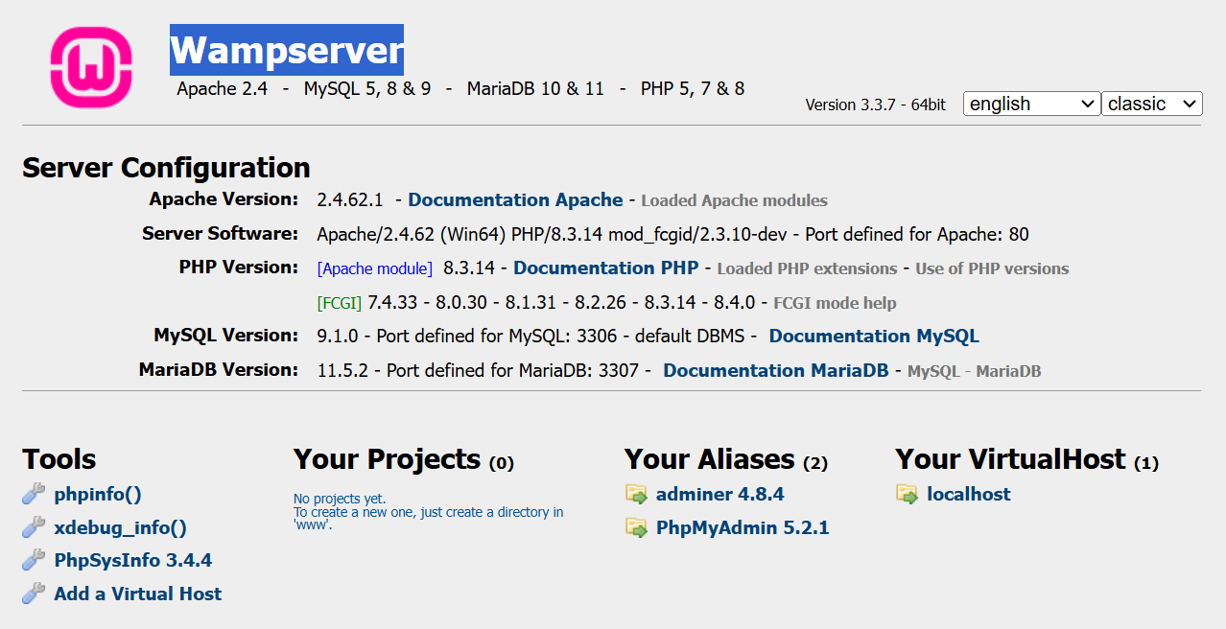
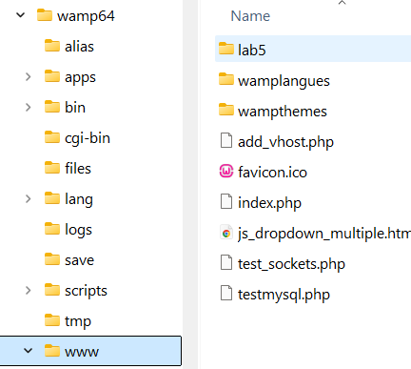
- Use Window’s File Explorer to navigate to where you installed WAMP, probably: C:\wamp64\www. This is the root of your web site (Mine show a file and a folder that I added)

- Find or create an HTML file and put it in this folder. Below, I put js_checkbox.html.
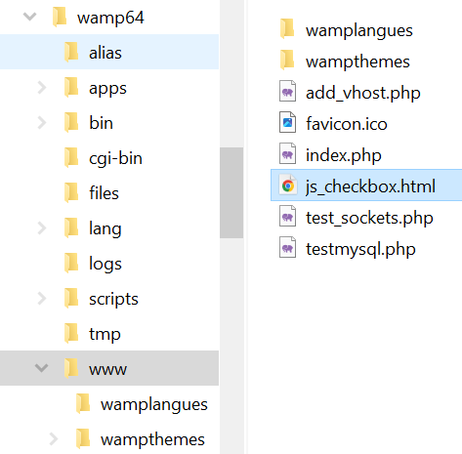
- Open a browser and type a URL similar to this one: http://localhost/js_checkbox.html (use the name of your HTML file). Your page will be displayed. In my case, the page is:
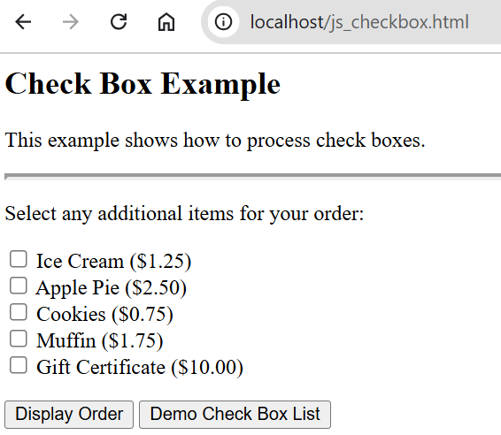
- Do the following:
- Make a screen shot similar to the one above showing your page being displayed on local host. It must show the complete URL.
- Paste the screen shot into the first box in Section 1 above, labelled: webpage.

Make a Virtual Host
MAC Users: There is not an easy way to do this, so skip this section.
As you saw, you can create websites in the localhost (wamp64/www) folder. You can also create websites anywhere on your hard drive and then map them as a virtual host. This is convenient for keeping your code organized. The directions below show how to do this for WAMP.
In this section, we will create a website (virtual host) around an existing VSCode workspace.
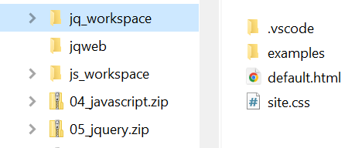
- Navigate to any folder (except wamp64/www or subfolders of it) with at least one HTML file (a previous HW, for example). In the image on the right, mine is named: jq_workspace

- Copy the path (we’ll paste it shortly). In my case it is:
E:\data_courses\CS 3340 - Web Programming\CS 3340 - Spring 2025\topics\01_ClientSide\notes_2023\jq_workspace
- Get this on your screen (Section 4, Steps 3-4). Choose: Add a Virtual Host

- Type a name for your virtual host (I used: jqweb), paste the path to folder you want to be the root of the website (Step 2 above), and choose: Start the creation…
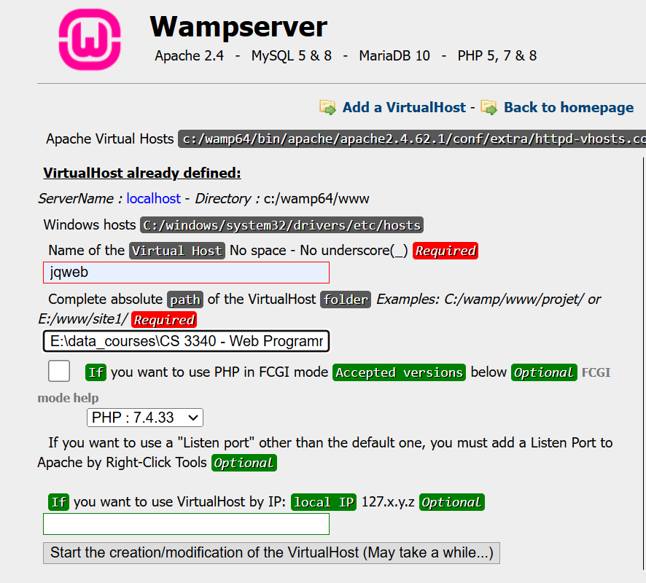

- You’ll get this message. We’ll restart DNS next.
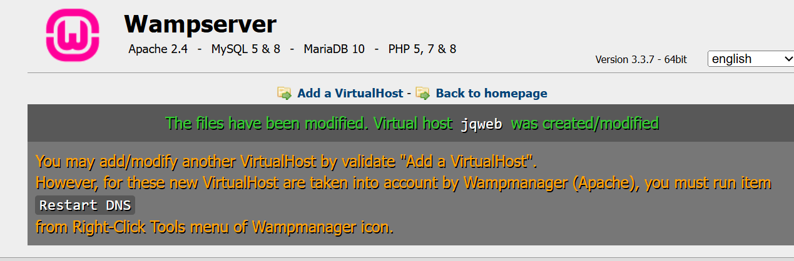
- Right-click the WAMP icon in the system tray (shown below), and choose: Tools, Restart DNS
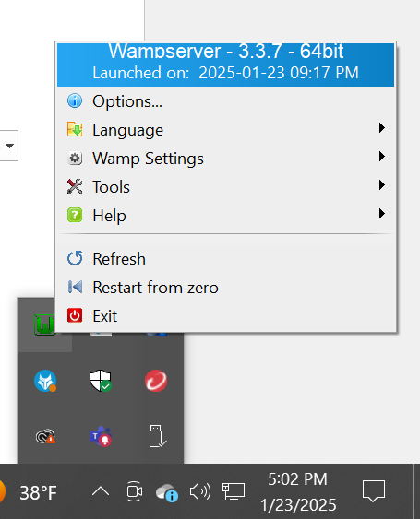

- Return to your browser and this page. Choose: Back to homepage
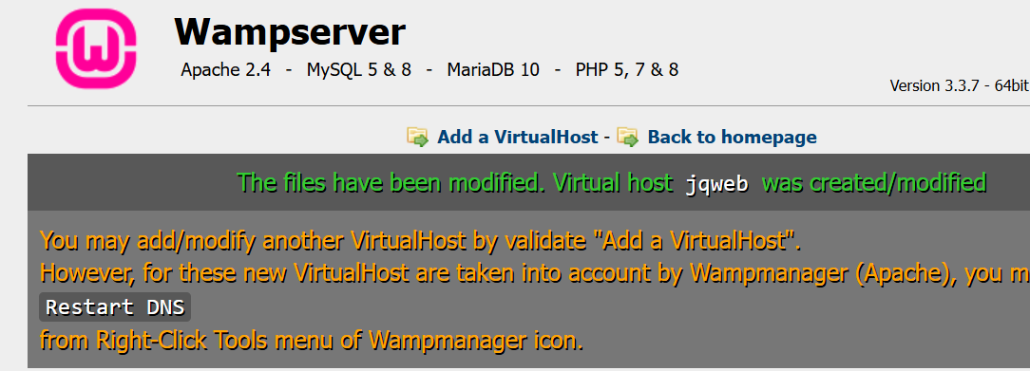

- Now, you will see your virtual host listed. Choose the link.
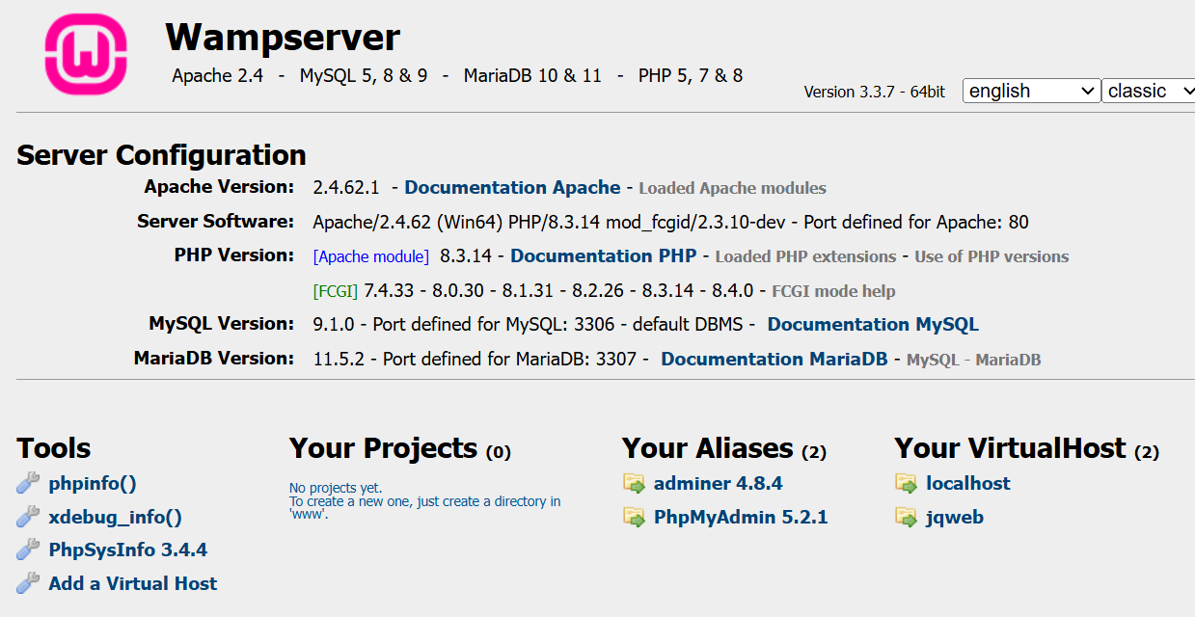

- In my case, it displays as shown on the left, below. When I choose the default.html page it is displayed as shown on the right, below.
- A WAMP server is set to automatically display, index.php if it exists in a folder. If it doesn’t exist, then it display an “Index” that lists all files and subfolders in the folder.
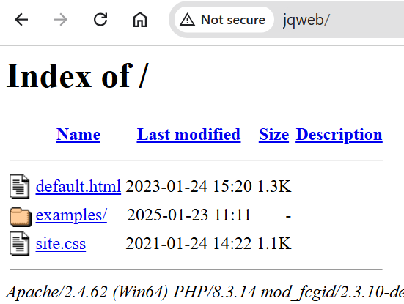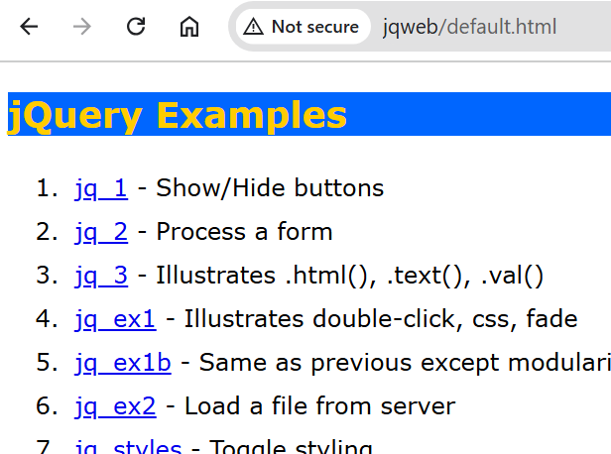

PhpStorm - IDE

Download
You can use any other editor or IDE to create PHP page, if for some reason you have a preference besides PhpStorm.
Do the following:
- Get a free educational license from JetBrains (company that makes PhpStorm):
https://www.jetbrains.com/community/education/#students
- I can’t remember what credentials it requires to prove student status. Email me the answer if you remember to, please.

- As I remember, once you submit your application, it shows you a screen with all the JetBrians products, including PhpStorm.
- Download and install PhpStorm
- When you run it, you’ll be running in Trial Mode and I think a pop appears every time you open it. Once your student status is certified, you’ll be able to “Active License” (something like that). When you do that, it will prompt you to login to the JetBrains site and then “automatically” (as I remember) change your status in the PhpStorm software so that you no longer see the popup.
- No need to run PhpStorm now, we will in a minute after we establish a workspace.

HelloWorld
This is a Hello World PHP app to show how to create a page in PhpStorm and display it on localhost.
- Create a folder in your www folder (probably located at: C:\wamp64\www) named it: lab5. Thus, the path would be: C:\wamp64\www\lab5.
- Run PhpStorm, choose the hamburger menu (upper-left), and then choose: File, New Project, PHP Empty Project
- Note: the UI seems to have changed a bit from when I first installed PhpStorm, so these directions by not be exact.
- Navigate to the folder you created above in the “Location” field and then choose: Create.
Note:
- Might see a “Free trial…” dialog in lower-right. Choose: Manage Licenses
- Choose: Extend Trial
- Choose: Activate License
- Choose: Subscription and then “Log In to JetBrains Account”
- Login to JetBrains. Then, it will say Close browser tab and return to PhpStorm
- Choose: Activate
- Select the “lab5” node, right-click and choose: New, PHP File, and give it a name, helloworld.php.

- Paste this code in (delete over what is there) and save.
<?php
date_default_timezone_set('America/New_York');
echo "<h1>Hello World!</h1>";
$date = date("D, m.d.Y, h:i:s");
echo "<p>$date</p>";
?>

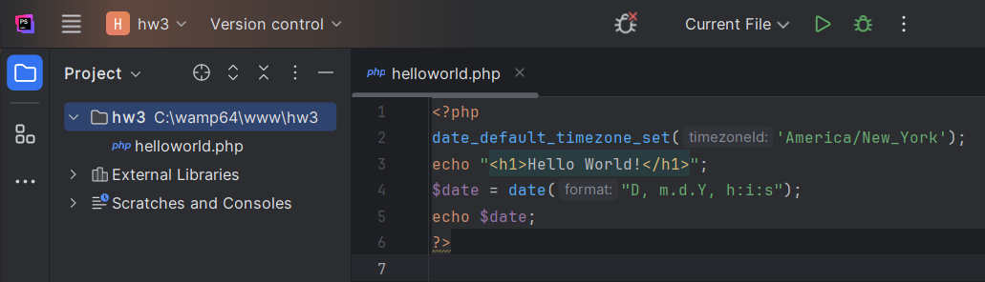

- Run WAMP (or MAMP)
- Launch localhost
- In the URL, type: localhost/lab5/ and press Enter. You’ll see the files in your lab5 folder (in the figure below, mine shows hw3 folder). Select helloworld.php and it will display.
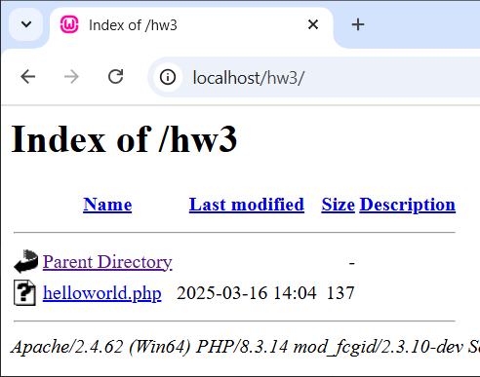 | 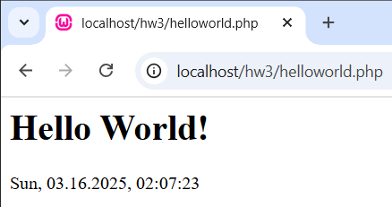

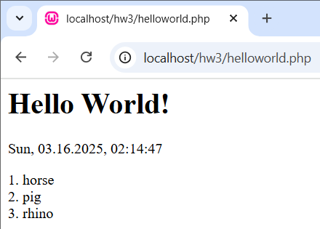
- You can make changes to the page in PhpStorm, and then simply refresh the page in the browser and the changes will show. This usually works. Sometimes it seems to use a cached version – so, if things don’t appear to be working, type the URL in again and enter. Add this code to the bottom of your file (above the “?>” closing PHP tag) and then go to localhost and refresh your page.
$s1 = "horse";
$s2 = "pig";
$s3 = "rhino";
$strs = array($s1, $s2, $s3);
$i = 1;
foreach ($strs as $str) {
echo strval($i) . ". " . $str . "<br>";
$i++;
}
Notes:
- There is a Run menu, but it doesn’t seem to work.
- The Debugger does work…sometimes. Set breakpoint, Choose: Hamburger, Run, Debug, choose the file, launch page in localhost.
- You may need to set the PHP interpreter: Hamburger, Run, Edit Configurations, PHP Script (on left), Select file, and then set Interpreter by navigating to php.exe: C:\wamp64\bin\php\php8.4.0.
- Do the following:
- Make a screen shot similar to the one above showing your helloworld.php page being displayed on local host. It must show the complete URL.
- Paste the screen shot into the second answer box in Section 1 above, labelled: helloworld.php.

- Submit your lab1_yourLastName document on Blazeview.

Appendix
- Installation References
- How to Install WAMP Server 3.3.2 on Windows 10/11 [ 2024 Update ] Step-by-Step Installation guide
https://www.youtube.com/watch?v=M2at7D-lciw.
Mostly used this one. It dealt with the missing Visual C++ Redistributable Packages.
- Step by Step Guide to Download and Install Wamp Server with MySQL
https://eecs.csuohio.edu/~sschung/CIS408/StepbyStepGuidetoDownloadInstallWampServerMySQL_2020.pdf

- MAMP (macOS) Documentation
https://documentation.mamp.info/en/MAMP-Mac/Installation/
- Using MAMP on a MAC
https://phpandmysql.com/extras/installing-mamp/
- Installing MAMP on a Mac
https://courses.cs.washington.edu/courses/cse154/19sp/resources/assets/servers/mamptutorial_mac.html

