CS 3340 - Homework 4

Stats Calculator
Contents
1 Overview 1
2 Requirements 1
3 Statistics 3
4 Test Data 3
4.1 Sample 1 3
4.2 Sample 2 4
5 Submission 4
Appendix 1 n/a 5

Overview
You will write a page that allows a user to enter numeric data and when submitted, it displays a confidence interval for the mean, based on this data.

Requirements
Write a page, data_entry.php, that looks as shown below when first loaded.
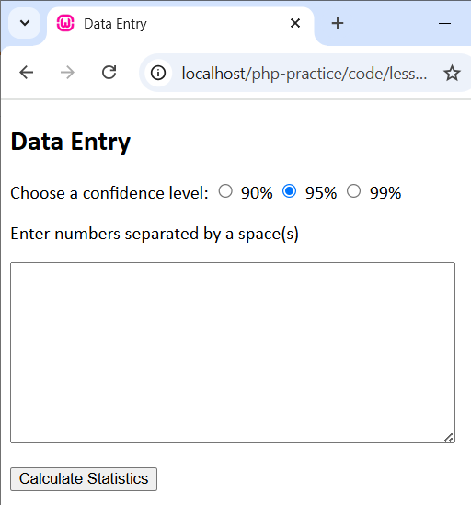 | - Requirement: The value for the three radio buttons must be: value="90% 1.645", value="95% 1.96", value="99% 2.58", respectively.  - Hint: Although this page has a .php extension, there is no PHP code in it.

The user can choose a confidence level and type (or paste) data in with a space(s) separating values
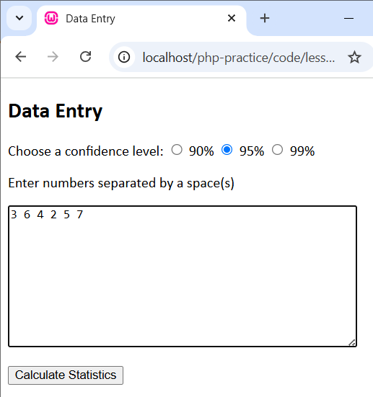
When the user presses “Calculate Statistics”, the page is posted to stats_results.php which displays the calculate results. The “Data Entry” links back to data_entry.php.
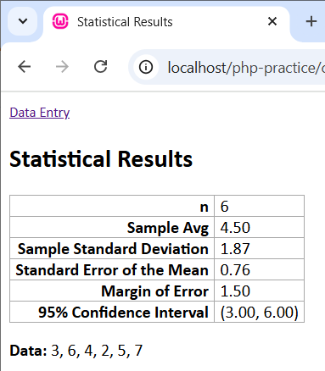 | - Requirement: No values may be hard-coded. In other words, you must access the confidence level (90%, 95%, 99%) and the corresponding z-value (1.645, 1.96, 2.58) from the value that is posted (e.g. "90% 1.645").  - Assumptions: you can assume that all data is valid and that at least 3 data values have been entered.
Hints:
- You will need the preg_split function to turn the posted string of numbers to an array of numbers.
- You might need the substr function to strip the trailing “,” of the list of data shown on the results.
- The array_sum, count, pow, and sqrt functions will be useful.
- The sprintf function is useful to format a number with a specified number of decimals and return it as a string. I do not recommend the round function.
- You do not need to build the table programmatically. You can write the HTML for it and in some of the cells use PHP to prescribe the value.
- You can define the first column in each row as “<th>” to produce the bold look.

Statistics
The tables below show the formulas you will need:
Statistic | Formula
Sample size | $n$
Sample average | $\overline{x}$
Sample standard deviation | $s=\sqrt{\frac{1}{n-1}\left(\sum_{i=1}^{n}{x_{i}^{2}-n}{\overline{x}}^{2}\right)}$
Standard error of the mean | $s_{\overline{x}}=\frac{s}{\sqrt{n}}$
Margin of error | $me=z*$ $s_{\overline{x}}$
Confidence interval | $\overline{x}±me$
The margin of error requires a z value which is determined by the confidence level chosen:
Confidence Level | Formula
90% | $z=1.645$
95% | $z=1.96$
99% | $z=2.58$

Test Data

Sample 1
Data:
3 6 4 2 5 7
Results:
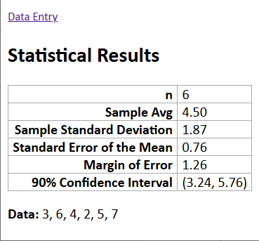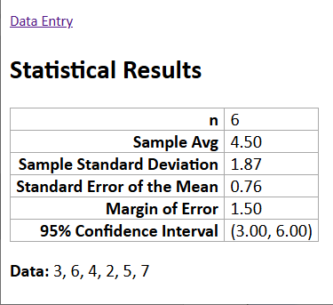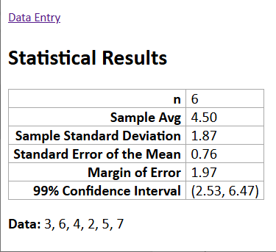

Sample 2
Data:
273.6941655 204.6942666 228.001833 188.7654414 195.7697609 145.925433 229.024209 171.4116119 209.5450617 235.2980087 175.1730019 168.5930011 200.877839 213.6301525 230.2782703 225.370277 191.6137278 206.1484107 188.9688978 181.760862 174.7263006 136.874935 224.952725 274.6410094 238.2302587 242.1363114 247.787104 261.9097598 162.8835746 201.5471842 169.4764381 221.4705113 167.9580687 209.3156865 177.9891964 230.5559489 243.9237873 193.7429731 198.8599528 229.5375848
Results:
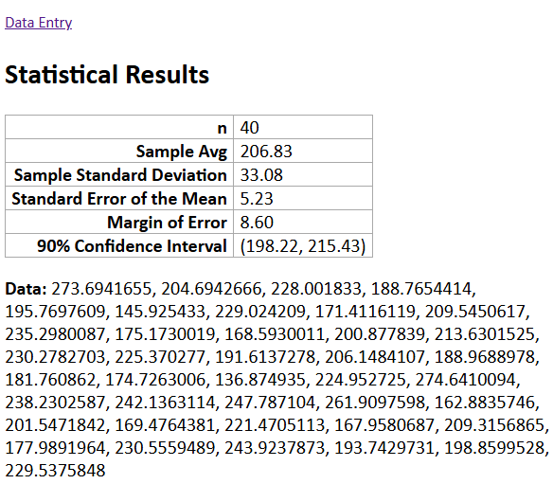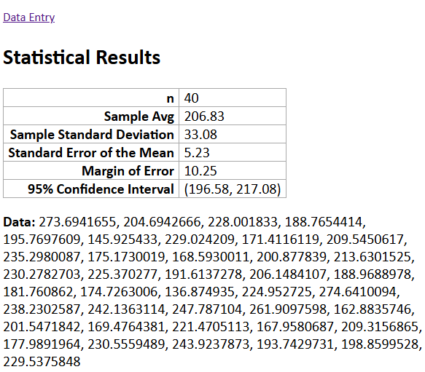
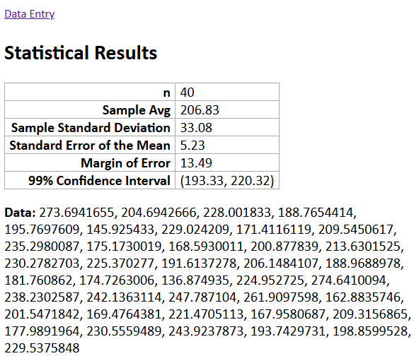

Submission
- Zip your files into a file named: hw04_lastName.zip.
- Submit on Blazeview in the HW 4 dropbox.

Appendix
- n/a

