Application, Session, & Page Lifecycles
Contents
1 Introduction 1
2 Example: Application & Session Lifecycle 1
3 Application & Session Lifecycle 2
4 ASP.NET Page Lifecycle 3
Appendix 1 n/a 4

Introduction
When a web application is loaded onto a server, the very first request for a page in this application begins the Application Lifecycle. This first request, creates an Application object which resides in memory, accessible, until at some point the application is turned off (or a power failure). When a person using a browser (client) visits a page in the app, the Application object creates a Session object which stores, among other things, the IP address of the client, beginning the Session Lifecycle (Session State Overview). Every client has their own session. Thus, when a request (HTTP Request) arrives at the server, it can route it to the correct Session object. A session stays alive as long as the corresponding client is making requests or refreshing the page. By default, in .NET, a session will timeout in 20 minutes of no requests have been made. A session can also be deleted programmatically, for example, when you log out of your banking app.
So, the very first time a page is requested from an app, the Application object is created and a Session object, that represents the client, is created and attached to the Application. Next, the Page Lifecycle begins: the Page object is created, PageLoad is called, a response (HTTP Response) is sent back to the client, and the page is destroyed.
When the client posts back, beginning another round trip, the server accepts the request, routes it to the correct application and session, starting off the page life cycle again. This process repeats.
When another client requests a page from the server, a new Session object is created and the process described in the previous paragraph repeats.

Example: Application & Session Lifecycle
This is an example of Application and Session lifecycle.
Client 1, Initial Round-trip. The very first request for a page in this application begins the Application lifecycle as well as the Session lifecycle for that particular client

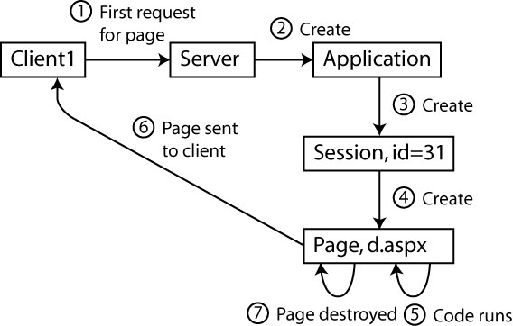
Client 1, Subsequent Round-trip (post-back). Client1 interacts with the page and postsback. The application and session objects already exist.

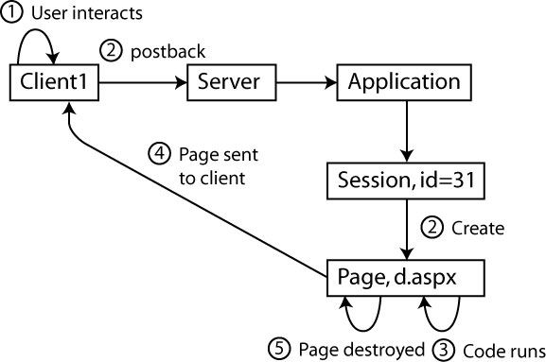

Client 2, Initial Round-trip. Client2 makes its first request for a page in the application. The application already exists. The new session object is created.

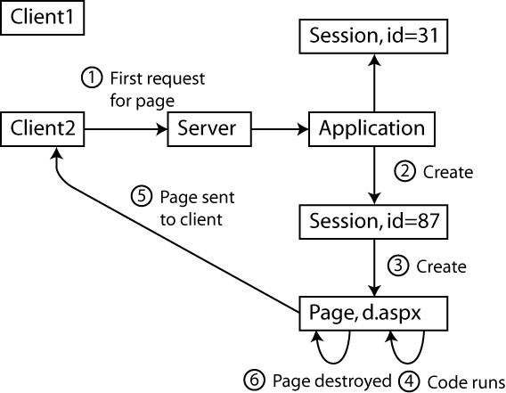

Application & Session Lifecycle
This is a rehash, plus a bit more detail than what was in the introduction.
- A web app is only alive (accessible) when it is loaded into memory by the web server. At some later point a web app may be removed from memory. Thus, we say that an application has a lifetime and goes through a series of stages, an application lifecycle.

- Suppose we put a web app in a web folder on a web server. The very first request for a page in the app creates an Application object on the server. The developer of the app can write code to store things in the Application object. For example: number of people logged in, number of guests, number of hits on main page, etc.

- This first request also creates a Session object and the Application object maintains a link to it. A Session represents a period of time that a user is using an application. For instance, as long as the client continues to interact with a page (posting-back), generally, the session will remain. When they stop interacting for some time, the session will timeout and end. Other times, the client might explicitly log-out, thus ending the session.

- Suppose another user requests a page from the web app. The Application object creates another Session, one for this particular client. Each Session has a unique Session ID which is sent to the browser and returned when posting. Thus, when requests come into the server, the server’s ApplicationManager can direct it to the correct Session. A Session stays alive until it is programmatically terminated, or it times-out.

- A Session has an HttpRequest object that handles requests from a client. When a request is received a processing pipeline is excecuted. 26 methods are called with the culmination being an HTTP Response is sent to the client. All of these methods fire events which we can handle if we want. The 15th step (method), ProcessRequest is the one we are particularly interested in. It creates the new page and executes the code. This process is called the Page Lifecycle and is described below.

ASP.NET Page Lifecycle
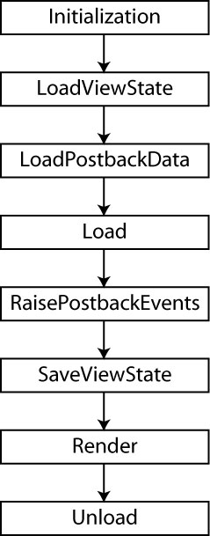
When a page is requested the server goes through a number of steps that relate to this page. This is referred to as the page lifecycle (or the page processing pipeline). The figure on the right is a summary of the page lifecycle: A description of these general steps:
- Initialization – The controls are created.
- LoadViewState – The ViewState is read and set into the server controls.
- LoadPostBackData – The data that has been posted back is loaded into the server controls.
- Load – The Page_Load method is executed. Next, recursively, all controls on the page have their Load event fired and go through a control lifecycle similar to the page lifecycle.
- RaisePostBackEvent – The control events defined by the programmer are executed.
- SaveViewState – After all the code is run, the ViewState is saved in the page as a hidden HTML field.
- Render – Next, the page is rendered. Each control has its Render method called which outputs the appropriate HTML to display itself.
- Unload – Finally, the page is unloaded. The page object is destroyed and any variables that were defined in the page are destroyed.
At each of the steps above a number of methods can be overridden : PreInit, Init, InitComplete, PreLoad, Load, LoadComplete, PreRender, PreRenderComplete, SaveStateComplete, Render, Unload.
https://msdn.microsoft.com/en-us/library/ms178472.aspx
See this on the code download:
16. Example – Shows Page events that can be overridden

Appendix
- n/a

http://msdn.microsoft.com/en-us/library/ie/bb470252.aspx
http://msdn.microsoft.com/en-us/library/ie/bb470252.aspx
http://www.4guysfromrolla.com/articles/050504-1.aspx
http://msdn.microsoft.com/en-us/library/ms178472.aspx
https://msdn.microsoft.com/en-us/library/ms178472(v=vs.100).aspx#lifecycle_events
http://www.c-sharpcorner.com/uploadfile/61b832/Asp-Net-page-life-cycle-events/

