C# Indexer

This contains some basic information about indexers in C#.

Introduction

- The ListControl class has an Items property which is a ListItemCollection. The ListItemCollection class utilizes an indexer which provides access to the ListItems using array-like notation. For example:

for(int i=0; i<lbxNames.Items.Count; i++) {
ListItem li = lbxNames.Items[i];
}

In Java, we would write the statement inside the for like this:

ListItem li = lbxNames.Items.Get(i);

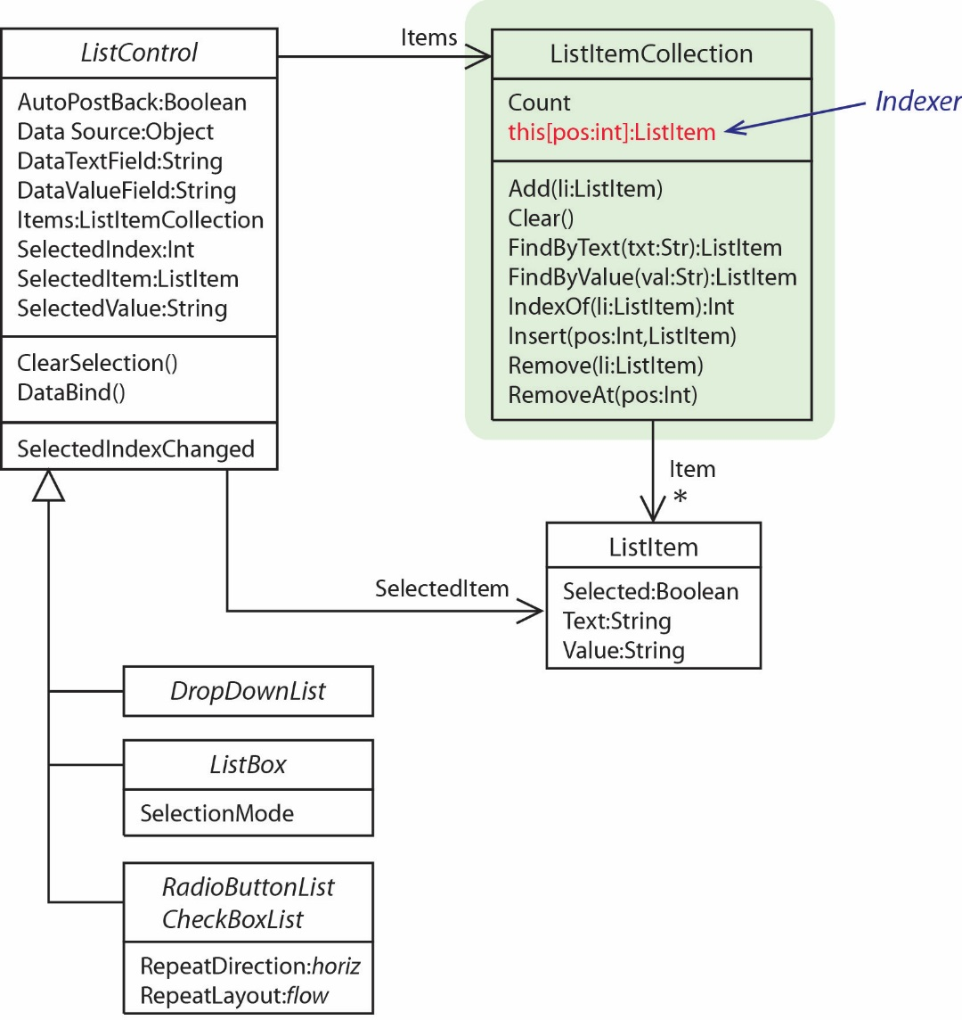

- In general, an indexer is a C# technique that allows client code access to the elements in a private collection using an array-like notation.

An indexer is a default property (in the C# sense) for a class that allows access to a private collection.
Example 1

public class Exams {
private int[] exams;

public Exams(int num) {
this.exams = new int[num]; }

// Indexer
public int this[int i] {
get { return exams[i]; }
set { exams[i] = value; }
}

public double Average() { ... }
}

- Consider the Exams class on the right which holds an array of exam scores and can calculate the average. An indexer is defined by declaring a property whose name is this.

- To use the class and indexer:

Exams exams = new Exams(3);
exams[0] = 80;
exams[1] = 90;
exams[2] = 90;

double score = exams[1];
double avg = exams.Average();

Example 2

- We can use a List to back the Indexer. In this case we will need a Count method (or property) to tell how many things are in the List.

public class Exams2 {
List<double> exams;

public Exams2() { exams = new List<double>(); }

public double this[int i] {
get {
// List has an Items field that is an Indexer(!)
return exams[i];
}
set { exams.Insert(i, value); }
}

public int Count() { return exams.Count; }

public double Average() {
double sum = 0.0;
foreach (int score in exams) sum += score;
return sum / exams.Count;
}
}

Example 3

- We can overload the indexer. In this case we overload the indexer to search for a Customer with a particular name.

public class Customers {
List<Customer> customers;

public Customers() { customers = new List<Customer>(); }

public Customer this[int i] {
get { return customers[i]; }
set { customers.Insert(i, value); }
}

public Customer this[string name] {
get {
foreach (Customer c in customers)
if (c.Name.Equals(name))
return c;
return null;
}
}

public void Add(Customer c) { customers.Add(c); }

public int Count() { return customers.Count; }

public override string ToString() { ... }
}

Which we can use like this:

Customers customers = new Customers();

Customer c = new Customer("Dave", "123 Nevins");
customers[0] = c;
c = new Customer("Tom", "555 Slater");
customers.Add(c);
c = new Customer("Linda", "77 Ridgeway");
customers.Add(c);

c = customers["Tom"];
if (c != null)
txtMsg.Text += "Customer found: " + c + Environment.NewLine;
else
txtMsg.Text += "Customer not found" + Environment.NewLine;

c = customers["Renny"];
if (c != null)
txtMsg.Text += "Customer found: " + c + Environment.NewLine;
else
txtMsg.Text += "Customer not found" + Environment.NewLine + Environment.NewLine;

