ASP.NET Basics 3

Contents
1 Lab Objectives 1
2 Stage 1 – Understanding Postback 1
3 Understanding Session Memory 3
4 Understanding Postback, Multiple Pages 5
5 Using Session Memory across Multiple Pages 9
6 Using a QueryString to Pass Information Between Pages 14
7 Stage 6 – Package Assignment for Submission 17
Appendix 1 n/a 18

Lab Objectives
- Use postback with a single page
- Use session memory works with a single page
- Use postback when you leave a page and return
- Use session memory across multiple pages.
- Use a query string to pass information between pages

Stage 1 – Understanding Postback
- (Read, no action required) There is a difference between the “first” time a page is requested and a postback.
- First time – The first time a user requests a page, the server creates a Session object using a unique Session ID so that it can differentiate between different users using the same app. The Session object can be used to store data. A Session stays alive until it times out (20 minutes by default) or you programmatically end it (e.g. when a user logs out of a page, the code typically terminates the session object).
- Postback – Next, the user interacts with the page and eventually presses a submit button (or other control) which causes the page to be posted-back to the server. This means that all the form data (e.g. value typed in a text box, item selected in a dropdown, etc) is sent back to the same page on the server. The page is processed and returned to the browser. This process continues, i.e. the page continues to postback.
In web programming, it is frequently useful to know whether it is the first time on a page (i.e. the session is created) or it is postback (i.e. the session is ongoing). We will see why as we go along.
(Optional) This is an extremely well done video, will introduce you the what goes on "under the covers" when your ASP.NET application’s browser and server interact: Submit & Postback (19 min)

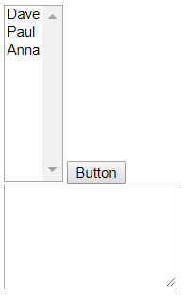
- Create your lab03 project.
- Add a web form named, postback.
- Add a ListBox and set the ID to lbxNames. Stretch it extra tall.
- Add a Button beside it and set the ID to btnDisplay
- Add a TextBox below and set: (a) ID to txtMessage, (b) TextMode to MultiLine and then stretch it larger.
- Add this code to Page_Load
lbxNames.Items.Add(new ListItem("Dave", "11"));
lbxNames.Items.Add(new ListItem("Paul", "44"));
lbxNames.Items.Add(new ListItem("Anna", "3"));
- Run (the button is not active yet) and observe that the ListBox displays the names.
- Create an event handler for the button’s click event which displays the text and value of the selected item from the ListBox in the multiline text box.
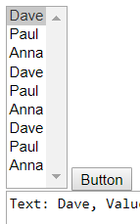
- Do the following:
- Run the page
- Select a name and press the button.
- Again, select a name and press the button. Note that every time you press the button, the list grows longer – the three names (Dave, Paul, Anna) are appended onto the existing list in the ListBox.
- (Read, no action required) Why are items added to the ListBox every time you press the button?
- Important Point: The values in a control (e.g. the Text and Values in the ListBox) persist between postbacks.
- Remember that every time the button is pressed, the page is posted-back to the server where two things occur:
- Page_Load is executed, which adds the three names to the ListBox (on top of what is already there)
- btnDisplay_Click is executed
Thus, each time Page_Load executes it adds to the listbox.
- Every time a page is requested (either the first time, or a postback), an instance of the page is created in memory on the server (i.e. an instance of the code-behind file is created). The instance of the page itself can be referenced by this (the same as Java), or with the more common alias, Page. The page class has a property, IsPostBack that returns true if a post-back occurs or false if it is the first time on the page. Thus, to detect whether it is the first time on the page or a postback we can use code like this:
protected void Page_Load(object sender, System.EventArgs e) {
if (!Page.IsPostBack) {
// First time on page
}
else {
// Postback
}
}
- We observed earlier that every time we press the button (postback), the ListBox is appended with the same 3 names. To correct this problem, we need to populate the listbox the first time we visit the page, not on postbacks.
Your turn – make the appropriate change so that we don’t append the 3 names each time postback occurs.

Understanding Session Memory
- (Read, no action required) Every time a page is requested (either the first time, or a postback):
- An instance of the page is created in memory on the server.
- The page is processed.
- HTML is sent to the browser.
- The page instance is destroyed.
Thus, we say that the web is stateless – anything that happens during a postback is lost when the HTML is sent back to the browser. In other words, if you store information in the page class during a postback, it is lost when the HTML is sent back to the browser.
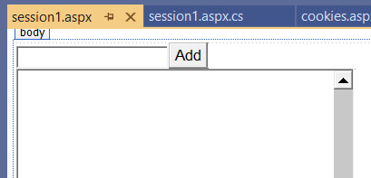
Many applications require that we remember things across postbacks. In this section, you are going to write a page that allows the user to enter a number and press an “Add” button, repeatedly. Each time the button is pressed, the current number is added to the sum of the previous numbers and then the new sum is displayed. To accomplish this, we need to “remember” the previous sum between postbacks. On solution is to use session memory.
- Add a web form named, session1.
- Add a TextBox and set the ID to txtNum.
- Add a Button beside it and set the (a) ID to btnAdd, (b) Text to “Add”
- Add a TextBox below and set: (a) ID to txtMessage, (b) TextMode to MultiLine and stretch it larger.
- Do the following:
- Add a click event-handler for the button (empty, we’ll add the code shortly).
- Add an instance variable to the page, sum which will hold the sum of the numbers entered.
- Add code to the click event to add the current number to the sum and display the new sum.
public partial class session1 : System.Web.UI.Page {

int sum;
protected void Page_Load(object sender, EventArgs e) {
}

protected void bthAdd_Click(object sender, EventArgs e) {
int curNum = Convert.ToInt32(txtNum.Text);
sum += curNum;
txtMessage.Text += "Current Num=" + curNum + ", Sum=" + sum + "\n";
txtNum.Focus();
txtNum.Attributes["onfocus"] = "this.select();";
}
}
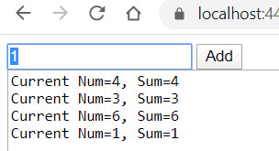
- Run, type a number in, Enter, repeat several times. Notice that it does not work correctly.

- (Read, no action required) Important Points:
- The sum is not remembered across postbacks because the value of any instance variables are lost when the page is destroyed.
- We can put the sum in session memory to preserve its value across postback. To put a variable in Session, we associate it with a key which we use to retrieve it later. For example, to put a value in Session:
Session.Add("key", value);
And to retrieve it later:
Type value = (Type)Session["key"];
or
Type value = Convert.ToType(Session["key"]);
Note that values stored in Session are stored as Objects so we must cast (or convert) them when we retrieve them.
- Next, we fix the problem above using session memory. Do the following:
- Add this code to Page_Load
if (!Page.IsPostBack) {
Session.Add("Sum", 0);
}
else {
sum = Convert.ToInt32(Session["Sum"]);
}
Note: the first time the page is accessed, we put “Sum” into session, initializing it to 0. On postbacks, we retrieve the value of “Sum” and store it in the instance variable, sum.
- Add this line to the end of the click event:
Session.Add("Sum", sum);
Important Point: When you have a variable that you want stored in Session and you change it, you should immediately store it in Session. You will forget to do this and it will haunt you!
- Run the page and verify that the cumulative sum of the numbers entered is correct.

Understanding Postback, Multiple Pages
The first time you visit a page, Page.IsPostBack=false. When you postback, and continue to postback, the value remains true. What happens you visit a page, postback, then visit another page, the return to the original page? This is not a postback and the subsequent return to the original page has Page.IsPostBack=false, i.e. first time on page. This can be a bit confusing so we will consider an example.
- Do the following:
NOTE: If something goes wrong with this step, close the page, delete it and start this step over. If you mess up the copy/paste, something will go wrong. Don’t panic, just do it over.
- Add a web form named, pback1.
- Open the page in Source mode and replace everything except the page directive (the first line) with:
<!DOCTYPE html>

<html xmlns="http://www.w3.org/1999/xhtml">
<head runat="server">
<title></title>
</head>
<body>
<form id="form1" runat="server">
<div>
<p><strong>Postback Multipage Example</strong></p>
<p>This page illustrates when it is the first time on the page or postback and what happens when you navigate to a new page and then back. You should look carefully at the code for this page and for &quot;Page 2&quot; (pback2.aspx).</p>

<p>
<asp:Button ID="btnSubmit" runat="server" onclick="btnSubmit_Click" Text="Submit/Postback" />&nbsp;
<asp:Button ID="btnLoadPage" runat="server" onclick="btnLoadPage_Click" Text="Reload" />&nbsp;
<asp:Button ID="btnPage2" runat="server" onclick="btnPage2_Click" Text="Page 2" />
</p>
<p>
<asp:TextBox ID="txtMessage" runat="server" EnableViewState="False"
Height="224px" TextMode="MultiLine" Width="384px"></asp:TextBox>
</p>

</div>
</form>
</body>
</html>

- View the page in the Designer mode to see what it is doing

- Open the code behind file, pback1.aspx.cs and replace the class (everything between the namespace line and the last “}”, i.e. leave the last “}”, otherwise, you’ll just have to add it back) with the code below. Study the code above carefully
public partial class pback1 : System.Web.UI.Page {
string newLine = Environment.NewLine;
protected void Page_Load(object sender, System.EventArgs e) {
// First time on page
if (!Page.IsPostBack) {
txtMessage.Text += newLine + "***First time on page" + newLine;
}
// Postback
else {
txtMessage.Text += newLine + "***Post-back" + newLine;
}
}
protected void btnSubmit_Click(object sender, System.EventArgs e) {
txtMessage.Text += "***Submit callled" + newLine;
}
protected void btnLoadPage_Click(object sender, EventArgs e) {
// Reload the page.
Response.Redirect(Request.RawUrl);
}
protected void btnPage2_Click(object sender, EventArgs e) {
// Go to page 2.
Response.Redirect("pback2.aspx");
}
}
- Do the following:
- Add a web form named, pback2.
- Open the page in Source mode and replace everything except the page directive (the first line) with:
<!DOCTYPE html>

<html xmlns="http://www.w3.org/1999/xhtml">
<head runat="server">
<title></title>
</head>
<body>
<form id="form1" runat="server">
<div>
<p><strong>Postback Multipage Example - Page 2</strong></p>
<p>
<asp:Button ID="btnSubmit" runat="server" onclick="btnSubmit_Click" Text="Submit/Postback" />&nbsp;
<asp:Button ID="btnPage1" runat="server" onclick="btnPage1_Click" Text="Page 1" />
&nbsp;</p>
<p>
<asp:TextBox ID="txtMessage" runat="server" Height="182px" TextMode="MultiLine"
Width="279px"></asp:TextBox>
</p>
</div>
</form>
</body>
</html>
- View the page in the Designer mode to see what it is doing

- Open the code behind file, pback2.aspx.cs and replace the class (everything between the namespace line and the last “}”) with the code below. Study the code above carefully
public partial class pback2 : System.Web.UI.Page {
string newLine = System.Environment.NewLine;
protected void Page_Load(object sender, EventArgs e) {
// First time on page
if (!Page.IsPostBack) {
txtMessage.Text += newLine + "***First time on page" + newLine;
}
// Postback.
else {
txtMessage.Text += newLine + "***Post-back" + newLine;
}
}
protected void btnSubmit_Click(object sender, EventArgs e) {
txtMessage.Text += "***Submit callled" + newLine;
}
protected void btnPage1_Click(object sender, EventArgs e) {
// Go to page 1
Response.Redirect("pback1.aspx");
}
}
- Do the following:
- Run pback1.aspx
- Note the message in the text area (“First time on page”)
- Press the “Submit/Postback” button
- Note:
- Page_Load is called and a postback is detected and a message is displayed, “Post-back”
- Then, the btnSubmit_Click event is executed which displays the message, “Submit called”
- Press the “Submit/Postback” button several more times and observe the output.
- Go back to VS and open the code behind file, pback1.aspx.cs and find the btnPage2_Click event code:
protected void btnPage2_Click(object sender, EventArgs e) {
// Go to page 2.
Response.Redirect("pback2.aspx");
}
Important Note: We use the ASP.NET Response object to load a page: Response.Redirect("pback2.aspx");
- Return to the browser where pback1.aspx is running. Press the “Page 2” button and control is transferred to pback2.aspx. Note the message in the text area (“First time on page”)
- Press the “Submit/Postback” button several times and observe the output.
- Press the “Page 1” button and control is transferred to pback1.aspx. Note the message in the text area (“First time on page”).
Thus, when you leave a page and return, it is the first time on the page, i.e. it is not a postback.
- Press the “Submit/Postback” button several times and observe the output.
- Go back to VS and open the code behind file, pback1.aspx.cs and find the btnLoadPage_Click event code:
protected void btnLoadPage_Click(object sender, EventArgs e) {
// Reload the page.
Response.Redirect(Request.RawUrl);
}

Important Note: Notice that we use the ASP.NET Request object, Request.RawUrl to obtain the page we are currently on. Thus, we are asking the server to reload the page which will, in effect, be the first time on the page.
- Return to the browser where pback1.aspx is running and press the “Reload” button and observe that it is now the “First time on the page”.
- Repeat the steps above, or simply experiment making sure you understand how postback works with multiple pages and what it means to reload a page.

Using Session Memory across Multiple Pages
In this section, we are going to see how to use session memory across multiple pages. One page will allow the user to enter a number and then increment it every time a button is pressed (postbacks), using session memory to store the value between postbacks. Another button will transfer to another page, where we retrieve the value stored in session from the first page, and allow the user to increment it on this page by pressing a button. Another button on the first page will transfer back to the first page where the new value is displayed and can be incremented further.
- Do the following:
- Add a web form named, session2a.
- Open the page in Source mode and replace everything except the page directive (the first line) with:
<!DOCTYPE html>

<html xmlns="http://www.w3.org/1999/xhtml">
<head runat="server">
<title></title>
</head>
<body>
<form id="form1" runat="server">
<div>
<p>
Name
<asp:TextBox ID="txtName" runat="server"></asp:TextBox>
</p>
<p>
Favorite Integer
<asp:TextBox ID="txtFavInt" runat="server"></asp:TextBox>
</p>
<p>
&nbsp;
<asp:Button ID="btnSave" runat="server" OnClick="btnSave_Click" Text="Save" />
&nbsp;<asp:Button ID="btnAdd1" runat="server" OnClick="btnAdd1_Click" Text="Add 1" />
&nbsp;
<asp:Button ID="btnPage2" runat="server" OnClick="btnPage2_Click" Text="Page 2" />
&nbsp;
</p>
<p>
Your current sum is: <asp:Label ID="lblSum" runat="server" ForeColor="Red" Text="n/a"></asp:Label>
<br />
</p>
</div>
</form>
</body>
</html>

- Open the code behind file, session2a.aspx.cs and replace the class (everything between the namespace line and the last “}”) with the code below. Study the code above carefully.
public partial class session2a : System.Web.UI.Page {

private int sum;
protected void Page_Load(object sender, EventArgs e) {
if (!Page.IsPostBack) {
// If first time on page, initialize sum to 0 and put in Session.
sum = 0;
Session.Add("Sum", sum);
}
else {
// If postback, pull sum from Session
sum = Convert.ToInt32(Session["Sum"]);
}
}

protected void btnSave_Click(object sender, EventArgs e) {
// Get the value entered ...
int num = Convert.ToInt32(txtFavInt.Text);
// ...which serves as the initial sum
sum = num;
// Add the sum and name to Session.
Session.Add("Sum", sum);
Session.Add("Name", txtName.Text);
// Display the sum
lblSum.Text = num.ToString();
}

protected void btnAdd1_Click(object sender, EventArgs e) {
// Add 1 to the current sum and then store in Session.
sum++;
Session.Add("Sum", sum);
lblSum.Text = sum.ToString();
}

protected void btnPage2_Click(object sender, EventArgs e) {
// Go to new page.
Response.Redirect("session2b.aspx");
}
}
- Do the following:
- Add a web form named, session2b.
- Open the page in Source mode and replace everything except the page directive (the first line) with:
<!DOCTYPE html>

<html xmlns="http://www.w3.org/1999/xhtml">
<head runat="server">
<title></title>
</head>
<body>
<form id="form1" runat="server">
<div>
<p>
Welcome,
<asp:Label ID="lblName" runat="server" ForeColor="Red" Text="Label"></asp:Label>
</p>
<p>
Your current sum is:
<asp:Label ID="lblSum" runat="server" ForeColor="Red" Text="Label"></asp:Label>
</p>
<p>
<asp:Button ID="btnAdd1" runat="server" OnClick="btnAdd1_Click" Text="Add 1" />
&nbsp;
<asp:Button ID="btnPage1" runat="server" OnClick="btnPage1_Click" Text="Page 1" />
<br />
</p>
</div>
</form>
</body>
</html>
- Open the code behind file, session2b.aspx.cs and replace the class (everything between the namespace line and the last “}”) with the code below. Study the code above carefully.
public partial class session2b : System.Web.UI.Page {

private int sum;
private string name;
protected void Page_Load(object sender, EventArgs e) {
// Always get the sum from Session. However, note that if the
// user starts on this page (e.g. has it bookmarked), the sum
// may not be in session, which could cause a problem.
sum = Convert.ToInt32(Session["Sum"]);
lblSum.Text = sum.ToString();

if (!Page.IsPostBack) {
// Get the name out of Session and put in label
name = Convert.ToString(Session["Name"]);
lblName.Text = name;
}
}

protected void btnAdd1_Click(object sender, EventArgs e) {
// Increase the sum by 1, put in Session, and display.
sum++;
Session.Add("Sum", sum);
lblSum.Text = sum.ToString();
}

protected void btnPage1_Click(object sender, EventArgs e) {
// Go back to first page.
Response.Redirect("session2a.aspx");
}
}
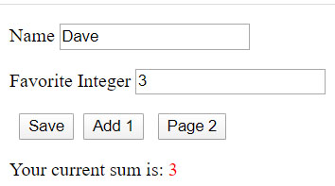
- Do the following:
- Run session2a.aspx, type in a name and an integer, and then press, “Save”.

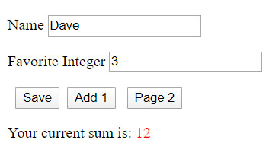
- Press, “Add 1” a handful of time and observe the sum increase.

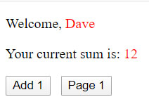
- Press, “Page 2”, and session2b.aspx will be displayed. Note that the name and sum are displayed.

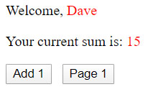
- Press, “Add 1” several times and observe the sum being updated.

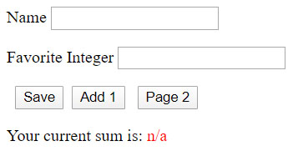
- Press, “Page 1” and session2a.aspx will be displayed. Note that the sum is no longer correct.

- (Read, no action required) Look carefully at Page_Load in session2a.apx.
protected void Page_Load(object sender, EventArgs e) {
if (!Page.IsPostBack) {
// If first time on page, initialize sum to 0 and put in Session.
sum = 0;
Session.Add("Sum", sum);
}
else {
// If postback, pull sum from Session
sum = Convert.ToInt32(Session["Sum"]);
}
}
Remember that when we leave a page and then return later, it is the “first time” on the page, i.e. it is not a postback. Thus, when we return to this page we are setting sum to 0.
- To fix this, we need to detect not only if it is the first time on the page, but also if “Sum” exists in Session. Replace the code in Page_Load with:
if (!Page.IsPostBack) {
// If first time on page, and sum is not in Session,
// initialize sum to 0 and put in Session.
if (Session["Sum"] == null) {
sum = 0;
Session.Add("Sum", sum);
}
// If first time on page and sum is in Session, get it
// and display it.
else {
int sum = Convert.ToInt32(Session["Sum"]);
lblSum.Text = sum.ToString();
}
}
else {
// If postback, pull sum from Session
sum = Convert.ToInt32(Session["Sum"]);
}
- Run the page and verify that it is working correctly now.

Using a QueryString to Pass Information Between Pages
Next, we are going to use a QueryString to pass information between pages.
- (Read, no action required) Using a QueryString is a technique where you put the information you want to pass to another page in the URL in key/value pairs. For example, to send 2 key/value pairs to the page, newPage.aspx, we would write code like this:
Response.Redirect( “newPage.aspx?key1=value1&key2=value2” );
Note that the query string:
- Begins with a “?”
- Has any number of, “key=value” separated by “&”
The receiving page writes code like this to retrieve the values:
value1 = Request.QueryString[“key1”];
value2 = Request.QueryString[“key2”];
Note that the value is a string, so it will need to be converted if a number is sent.
- Do the following:
- Add a web form named, qString1a.
- Open the page in Source mode and replace everything except the page directive (the first line) with:
<!DOCTYPE html>

<html xmlns="http://www.w3.org/1999/xhtml">
<head runat="server">
<title></title>
</head>
<body>
<form id="form1" runat="server">
<div>
<table>
<tr>
<td>
<asp:Label ID="Label1" runat="server" Text="First Name"></asp:Label>
</td>
<td>
<asp:TextBox ID="txtFName" runat="server"></asp:TextBox>
</td>
</tr>
<tr>
<td>
<asp:Label ID="Label2" runat="server" Text="Last Name"></asp:Label>
</td>
<td>
<asp:TextBox ID="txtLName" runat="server"></asp:TextBox>
</td>
</tr>
</table>

<asp:Button ID="btnLogin" runat="server" Text="Login" OnClick="btnLogin_Click" />
<br />
<asp:TextBox ID="txtMessage" runat="server" Height="189px" TextMode="MultiLine" Width="304px"></asp:TextBox>

</div>
</form>
</body>
</html>
- Open the code behind file, qString1a.aspx.cs and replace the class (everything between the namespace line and the last “}”) with:
public partial class qString1a : System.Web.UI.Page {
protected void Page_Load(object sender, EventArgs e) {

}

protected void btnLogin_Click(object sender, EventArgs e) {
string fName = txtFName.Text;
string lName = txtLName.Text;
string url = "qString1b.aspx?fName=" + fName + "&lName=" + lName;
Response.Redirect(url);
}
}
- Study the code above carefully.
- Do the following:
- Add a web form named, qString1b.
- Open the page in Source mode and replace everything except the page directive (the first line) with:
<!DOCTYPE html>

<html xmlns="http://www.w3.org/1999/xhtml">
<head runat="server">
<title></title>
</head>
<body>
<form id="form1" runat="server">
<div>
<asp:Button ID="btnLogOut" runat="server" OnClick="btnLogOut_Click" Text="Log Out" />
<br />
<asp:TextBox ID="txtMessage" runat="server" Height="172px" TextMode="MultiLine" Width="281px"></asp:TextBox>
</div>
</form>
</body>
</html>
- Open the code behind file, qString1b.aspx.cs and replace the class (everything between the namespace line and the last “}”) with:
public partial class qString1b : System.Web.UI.Page {
protected void Page_Load(object sender, EventArgs e) {
if (Request.QueryString.AllKeys.Contains("fName")) {
string fName = Request.QueryString["fName"];
string lName = Request.QueryString["lName"];
string msg = "Successful Login\n";
msg += "First Name=" + fName + ", Last Name:" + lName;
txtMessage.Text = msg;
}
}

protected void btnLogOut_Click(object sender, EventArgs e) {

}
}
- Study the code above carefully. We will program btnLogOut_Click shortly.
- Run the qString1a.aspx page. Type in names and press Login:
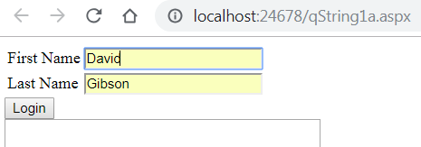
Then, qString1b.aspx is displayed. Note the names contained in the query string for the URL:
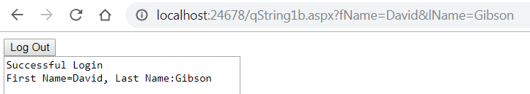
- Next, we program the “Log Out” event handler. When the Log Out button is pressed on the qString1b.aspx page we will redirect to the login page (qString1a.aspx) passing a “status” in the query string indicating that the user has logged out. Then, in Page_Load for qString1a.aspx, we will detect this status and display a message that the user has logged out. Do the following:
- Open qString1b.aspx.cs and add this code to btnLogOut_Click:
string url = "qString1a.aspx?status=logout";
Response.Redirect(url);
- Open qString1a.aspx.cs and add this code in Page_Load:
if (Request.QueryString.AllKeys.Contains("status")) {
string status = Request.QueryString["status"];
if (status.Equals("logout")) {
txtMessage.Text = "You are logged out";
}
}

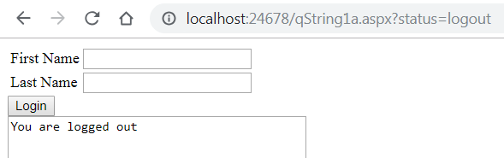
- Do the following:
- Run the qString1a.aspx page.
- Type in names and press Login.
- Once qString1b.aspx is displayed, press Log Out. You will be returned to qString1a.aspx. Note the “status” in the query string and the message that is displayed
- (Read, no action required) Suppose a user tries to load qString1b.aspx without logging in. In this case we want to direct them back to the login page (qString1a.aspx). Note the first line of Page_Load in qString1b.aspx:
if (Request.QueryString.AllKeys.Contains("fName")) {

If the URL does not contain a “fName” key, then we will view this as an illegal attempt. Thus, we will add an else block to this code to build a URL with a query string, “status=illegalAccess” and redirect back to the login page. Finally, we will detect this in the login page and display a message.

- Do the following:
  - Paste this code immediately after the if block in Page_Load for qString1b.aspx:
else {
string url = "qString1a.aspx?status=illegalAccess";
Response.Redirect(url);
}
  - Paste this code immediately after the inner if block in Page_Load for qString1a.aspx:
else if (status.Equals("illegalAccess")) {
txtMessage.Text = "You must login";
}
When done, Page_Load in qString1a.aspx.cs is:
protected void Page_Load(object sender, EventArgs e) {
if (Request.QueryString.AllKeys.Contains("status")) {
string status = Request.QueryString["status"];
if (status.Equals("logout")) {
txtMessage.Text = "You are logged out";
}
else if (status.Equals("illegalAccess")) {
txtMessage.Text = "You must login";
}
}
}

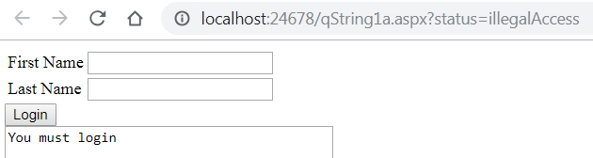
- Do the following:
- Run the qString1b.aspx page.
- This page will not be displayed, you will be redirected to qString1a.aspx. Note the message and the query string in the URL.

Stage 6 – Package Assignment for Submission
- Do the following:
- Close VS.
- Select your project folder (lab03_lastName) in File Explorer
- Right-click and choose: Send to, Compressed (zipped) folder. It should be named: lab02_lastName.zip (which probably is the default name).
- Test your zip file before submission. There is a penalty if you have not zipped the correct files/folders. Do the following:
- Copy the zip file to some other location,
- Unzip
- Launch the solution file (lab01_lastName.sln) and make sure everything works.
- Submit the zip file on Blazeview by the due date.

Appendix
- n/a

