Lab 2 – ASP.NET Basics 2

Contents
1 Lab Objectives 1
2 Notes about VS 2022 2
3 Create Lab 4 Home Page 2
4 Hide/Show Elements & Panels 3
5 Accessing Items in a DropDownList 5
6 Illustrate why the Value needs to be Unique 8
7 Add Items to a DropDownList 9
8 Remove an Item from a DropDownList 9
9 Defining an Event Handler for a DropDownList, Order of Events, AutoPostBack 10
10 Using a ListBox 11
11 Using a CheckBoxList 14
12 Using a RadioButtonList 15
13 Using a Calendar 16
14 Package Assignment for Submission 17

Lab Objectives
- Learn to use these web controls: Panel, DropDownList, ListBox, CheckBoxList, RadioButtonList
- Learn what the AutoPostBack property does and when to set it to true.
- Learn the order of how events are executed on the server.
- Learn to hide and show controls.
To make this document easier to read, it is recommended that you turn off spell checking and grammar checking in Word:
- Choose: File, Option, Proofing
- At the very bottom, check: “Hide spelling errors…” and “Hide grammar errors…”

Notes about VS 2022
These are some suggestions about doing these labs with VS 2022. Some steps below, written for VS 2019 will require these steps. Read through them quickly. You may need to refer back to them.
- In some ways, easier to add controls in Source mode (the .aspx shown in the code window, displaying the HTML and ASP.NET markup).
- You have to save things regularly or things will go wrong. You will usually have 3 pages open: (1) Source, i.e. .aspx , (2) Design, (3) code, e.g. .aspx.cs. Sometimes one is not recognizing changes from another. Usually, you can resolve be save all the files.
- Design mode is fragile. I try to keep it closed.
- Activating the Properties Window correctly can take some work. For example, consider the DropDownList that is selected in the code below. The Property Window is showing that it is a DROPDOWNLIST. I don’t know what that is, but it is incorrect.
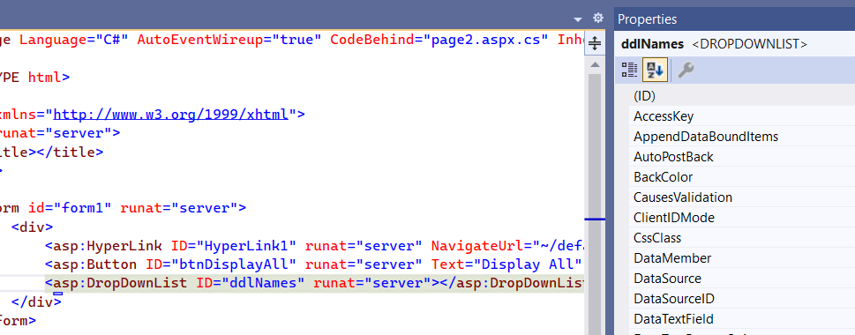
Next, I double-click the tag in the code, no change. Change to Design mode, select the dropdown, no change. Go back to Source, double click and it shows the correct class name in the Properties Window, DropDownList.
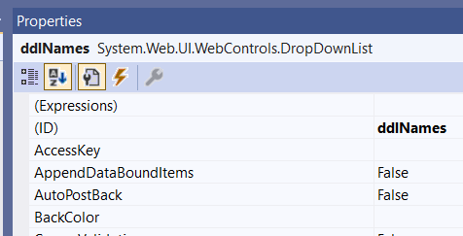

Create Lab 4 Home Page
- Create your lab04 project (solution folder must be named lab04_lastName).
- Add a web form named, default.
- Add the HTML title: “Lab 4 – FirstName LastName”, substituting your name.
- Write a level 2 header, inside the <div> tags, that reads: “Lab 4 – FirstName LastName”
- Verify that your page displays correctly

Hide/Show Elements & Panels
- Do the following:
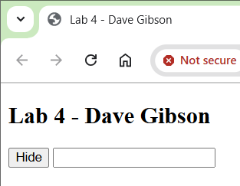
- Add a button to your page, give it the name (ID): btnHideShow and set the Text property to “Hide”.
- Add a textbox to your page, give it the name: txtInput.
- Create an event-handler for the button (double-click it in Design mode). Then close Design mode. I find it works better with it closed.
- Write the code to hide and show the textbox and change the text on the button. Your event handler will look like this:
protected void btnHideShow_Click(object sender, EventArgs e) {
if (txtInput.Visible) {
txtInput.Visible = false;
btnHideShow.Text = "Show";
}
else {
txtInput.Visible = true;
btnHideShow.Text = "Hide";
}

}
- Run your page and verify that it works correctly. Note: Right-click, View in Browser only works on as .aspx page, not on the code-behind file.
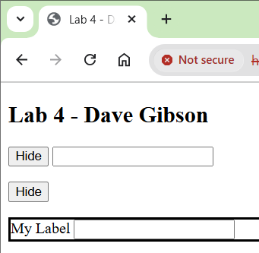
- Do the following:
- Add another button to your page below the first button (do not copy/paste the earlier one), give it the name (ID): btnHideShow2 and set the Text property to “Hide”.
- Add a Panel to your page below the button. We will just use the default name, Panel1. Set the BorderSyle property to “Solid”.
- Add a label and textbox inside the panel. No need to set any properties. Make sure the label and textbox are inside the panel. You can see this in Design mode, but you can also verify in Source mode definitively. No need to change the Text or any other property.
- Create an event-handler for the new button (double-click it in Design view).
- Write the code to hide and show the panel changing the text on the button. Your event handler will look like this:
protected void btmHideShow2_Click(object sender, EventArgs e) {
if (Panel1.Visible) {
Panel1.Visible = false;
btnHideShow2.Text = "Show";
}
else {
Panel1.Visible = true;
btnHideShow2.Text = "Hide";
}
}
Note that this code will hide and show the panel (and anything in it).
- Run your page and verify that it works correctly.

- The panel is a bit “severe”, spans the width of the page, and hugs the components inside tightly. You can improve that with a bit of jQuery. Add this to the head section:
<script src="https://ajax.googleapis.com/ajax/libs/jquery/3.3.1/jquery.min.js"></script>
<script>
$(document).ready(function () {
// Get width of label and textbox
var lblWidth = $('#Label1').width();
var txtWidth = $('#TextBox1').width();
// Set width of panel to 20% larger than the sum of components width
$('#Panel1').width(lblWidth + txtWidth * 1.20);
// Set padding around panel
$('#Panel1').css({ 'padding': '10px' });
});
</script>
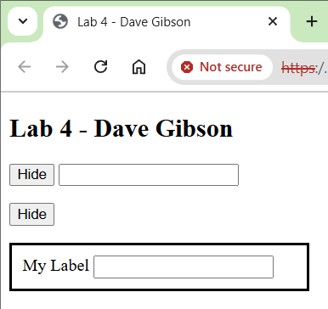
- Run your page and observe the difference in formatting.

Note: I will not be requiring you to do formatting like this on your assignments.

Accessing Items in a DropDownList
- Add a web form named, page2.
- Link default to page2. Do the following:
- Open default (not page2) in Source view. Drag a HyperLink control from the ToolBox to just below (or after) the <h2> tag.
- Set the text between the open and closing tags to: “Page 2”.
<asp:HyperLink ID="HyperLink1" runat="server">Page 2</asp:HyperLink>
- Select anywhere in the hyperlink tag and verify that it shows in the Property Window.
- Set the NavigateUrl property (in Property Window) to: “page2.aspx”
Note: if you use the “…” button to navigate to the page instead of typing it in, it will show this property as: “~/page2.aspx”. The tilde means the “home directory”, which is the folder we are in. Thus, the tilde is not necessary.
- Link page2 to default. Do the following:
- Open page2 in Source view and drag a HyperLink control to between the <div> tags.
- Set the text between the open and closing tags to: “Page 2”.
<asp:HyperLink ID="HyperLink1" runat="server">Back</asp:HyperLink>
- Set the NaviageUrl property (in Property Window) to: “default.aspx”
- Run either page and verify that you can navigate back and forth between the two pages.
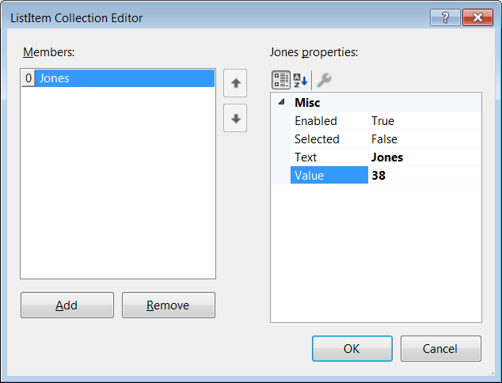
- Do the following on page2:
- Drag a Button, just after the hyperlink. Set the ID to btnDisplayAll, and set Text to: “Display All”.
- Drag a DropDownList to below the button, set the ID to ddlNames.
VS 2022 Note: These steps below (boxed) did not work for me! See below for fix if needed.

- Find the Items property in the Properties window and expand the ellipsis.
- The ListItem Collection Editor is displayed. Press, Add in the lower-left and type in the Text: “Jones” and the Value: “38”.
- Add several more entries (ListItems). Use the ones shown below so that I can refer to these later without confusion.
Text | Value
Able | 22
Mackey | 47
Benton | 11

Fix:
- View code-behind file (right-click page and choose: View Code)
- Add the code below so that PageLoad looks like as shown below. I’ll explain IsPostBack in class or another lab.
protected void Page_Load(object sender, EventArgs e) {
if (!IsPostBack) {
ListItem li;
li = new ListItem("Jones", "38");
ddlNames.Items.Add(li);
li = new ListItem("Able", "22");
ddlNames.Items.Add(li);
li = new ListItem("Mackey", "47");
ddlNames.Items.Add(li);
li = new ListItem("Benton", "11");
ddlNames.Items.Add(li);
}
}

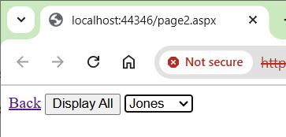
- Run your page and verify that you can choose a name from the drop down. The button doesn’t do anything yet.

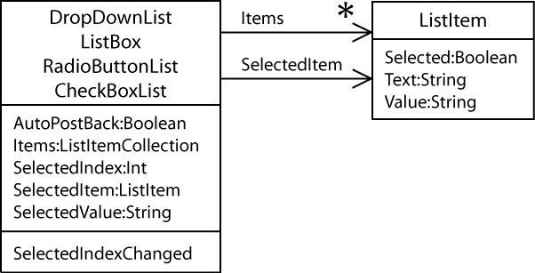
- (Read, no action required) Consider the class diagram on the right:
- A DropDownList has a list (named, Items) of ListItem.
- Each ListItem has a Text and Value (and two others) property.
- The Text property is what is displayed when the page is executed.
- The Value is what uniquely identifies the ListItem.
- The Value should be unique to ensure proper operation. The Value is almost always a key field from a database (which is always unique). The idea is that when the user selects an item from the drop down, then the code can retrieve the associated Value and then use that to look up additional information in a database. For example, we may have a drop down displaying a list of employee names (Text property) and the associated Value is the (unique) employee Id. Then, when a name is selected, we use the employee Id to look up and display their pay records. We consider the integration with a database later in the semester.
- We will consider the other properties shown for the DropDownList as we move along.
- All of the bullets above are true not only for a DropDownList, but also for a ListBox, RadioButtonList, and a CheckBoxList.
- Do the following:
- Add a <p> below the button and dropdown and then add a TextBox in the paragraph. Set the ID to, txtMessage.
- Set the TextMode property to MultiLine
- In Design mode, stretch the TextBox a bit larger. We will be outputting text there.
VS 2022 Note: This didn’t work. So, set the Height to 500px and the Width to 1000px. You may need to change these sizes.
The tag will look like this:
<asp:TextBox ID="txtMessage" runat="server" TextMode="MultiLine" Width="1000px" Height="500px"></asp:TextBox></p>

- Do the following:
- Create an event handler for the button (double-click it)
- Type or add this code to the event handler
protected void btnDisplayAll_Click(object sender, EventArgs e) {
string msg = string.Empty;
foreach (ListItem li in ddlNames.Items) {
msg += "Text: " + li.Text + ", "
+ "Value: " + li.Value + ", "
+ "Selected: " + li.Selected
+ Environment.NewLine;
}
txtMessage.Text = msg;
}
Note:
- string is an alias for String. You can use either.
- C# provides a foreach loop, which in this case would be identical to this in Java:
for(ListItem li : ddlNames.Items)
- The code simply loops through all the ListItem objects in ddlNames.Items list and collects various properties in a message which is displayed in the multi-line textbox.
- A ListItem has a Selected property that tells whether it has been selected or not.
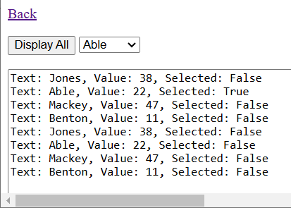
- Run your page and verify that the button works properly. Select a name from the dropdown and press the button again. Notice that the name you selected has the Selected property set to true.

- Do the following:
- Add a Button to page2 beside the other button. Set the ID to btnDisplaySelected, and set Text to: “Display Selected”.
- Create an event handler for the button (double-click it)
- Type or add this code to the event handler
protected void btnDisplaySelected_Click(object sender, EventArgs e) {
ListItem li = ddlNames.SelectedItem;
string msg = "Text: " + li.Text + ", "
+ "Value: " + li.Value + ", "
+ "Selected: " + li.Selected;
txtMessage.Text = msg;
}
Note:
- This event handler only displays the selected ListItem.
- The DropDownList has a SelectedItem property which is the ListItem object that has been selected. Thus, this is a convenience method as you could have looped through all the ListItems to find which one was selected. In other words, this code would produce identical results:
string msg = string.Empty;
foreach (ListItem li in ddlNames.Items) {
if(li.Selected) {
msg += "Text: " + li.Text + ", "
+ "Value: " + li.Value + ", "
+ "Selected: " + li.Selected
+ Environment.NewLine;
break;
}
}
txtMessage.Text = msg;

- Run your page and alternately select a name, press a button, and then press the other button; repeat. Do this to understand how the DropDownList remembers which ListItem is selected.

Illustrate why the Value needs to be Unique
- Do the following:
- Select the DropDownList and expand the Items property.
VS 2022 Note: This didn’t work. Instead, open the code-behind file (page2.aspx.cs).
- Change the last name, Benton, to have a Value of 38. Notice that the first item also has a Value of 38.
VS 2022 Note: In Page_Load, change “Benton”’s value from “11” to “38”.
- Run the page, select the last name, Benton and then press, Display Selected
- You’ll notice that Jones is displayed. The internal event (inside the drop down) that marks the item as selected finds the first item with a matching value. This illustrates that the Value property needs to be unique.
- Change the Value for Benton back to the value it was before, or something unique, say 99.

Add Items to a DropDownList
- Do the following:
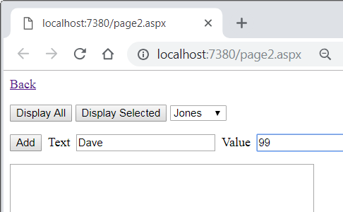
- Add a <p> below the other buttons, and above the TextBox.
- Inside the <p>, add a Button. Set the ID to btnAdd and the Text to: “Add”.
- Inside the <p>, Add a Label beside the button. Set the Text to: “Text”.
- Add a TextBox beside the label. Set the name to txtText.
- Add a Label beside the text box. Set the Text to: “Value”.
- Add a TextBox beside the label. Set the name to txtValue.
- Create an event handler for btnAdd (double-click)
- Type or add the code below to the event handler
protected void btnAdd_Click(object sender, EventArgs e) {
if(!String.IsNullOrEmpty(txtText.Text) && !String.IsNullOrEmpty(txtValue.Text)) {
string text = txtText.Text;
string value = txtValue.Text;
ListItem li = new ListItem(text, value);
ddlNames.Items.Add(li);
txtMessage.Text = "ListItem added to dropdown";
txtText.Text = String.Empty;
txtValue.Text = String.Empty;
}
else {
txtMessage.Text = "Must supply a value for Text & Value";
}

}
- Study the code above carefully. Run the page and experiment.

Remove an Item from a DropDownList
- Do the following:
- Add a Button beside the “Display Selected” button. Set the name to btnRemoveSelected and the Text to: “Remove Selected”.
- Create an event handler for the button and add or type this code:
protected void btnRemoveSelected_Click(object sender, EventArgs e) {
if(ddlNames.SelectedItem != null) {
ListItem li = ddlNames.SelectedItem;
ddlNames.Items.Remove(li);
txtMessage.Text = "ListItem removed: " + li.Text + ", " + li.Value;
}
}
- Study the code carefully. Run the page. Select a name and then choose: Remove Selected. Verify that the item was removed from the drop down. And, verify that you can add an item to the drop down and when selected it works properly.

Defining an Event Handler for a DropDownList, Order of Events, AutoPostBack
- Do the following:
- Note that we have not defined an event handler for the DropDownList itself. For many applications you do not need one. For many applications, as this one, you will have a Button that does something with the item selected. Thus, the button is the event handler.
- Next, we will create an event handler for the dropdown so that we can observe some behaviors that are not obvious.
- Create an event handler for the drop down by double clicking it. It will create this event handler:
protected void ddlNames_SelectedIndexChanged(object sender, EventArgs e) {

}
Notice that the name of the event is SelectedIndexChanged whereas the Buttons have a Click event. Thus, SelectedIndexChanged is called when an item has been selected. However, there is a catch…
- Add this code to the event handler:
ListItem li = ddlNames.SelectedItem;
string msg = Environment.NewLine + "In SelectedIndexChanged event" + Environment.NewLine
+ " Text: " + li.Text + ", "
+ "Value: " + li.Value + ", "
+ "Selected: " + li.Selected;
txtMessage.Text += msg;
Notice the “+=” in the last line.
- Replace the code in the Display Selected event handler (btnDisplaySelected_Click) with the code below.
ListItem li = ddlNames.SelectedItem;
string msg = Environment.NewLine + "In Click event" + Environment.NewLine
+ " Text: " + li.Text + ", "
+ "Value: " + li.Value + ", "
+ "Selected: " + li.Selected;
txtMessage.Text += msg;
Notice the “+=” in the last line.
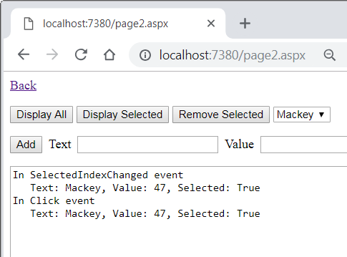
- Run the page and do the following:
- Select a name from the drop down and observe that nothing happens.
- Press Display Selected. The output should look as shown on the right. Notice that both events occurred.
- (Read, no action required)
- When you selected a name from the drop down, a SelectedIndexChanged event was registered but not executed.
- When you pressed the Display Selected button, the Click event was registered and both events were executed in the order they were registered.
- The button not only registered an event when pressed, it also caused a postback. A postback means that the page is sent back to the server, where all registered events are run, and then sent back to the browser. A Button always causes a postback.
- A DropDownList has an AutoPostBack property that is set to False by default. We will change this next. This will force the page to postback to the server whenever a name is selected.

- Do the following:
- Select the drop down and set its AutoPostBack property to True.
- Run the page and do the following:
- Select a name from the drop down and observe that the SelectedIndexChanged event is executed immediately (because the when you selected a name it caused a postback).
- Continue to select names and also press Display Selected.
- Select the drop down and set its AutoPostBack property to False.

Using a ListBox
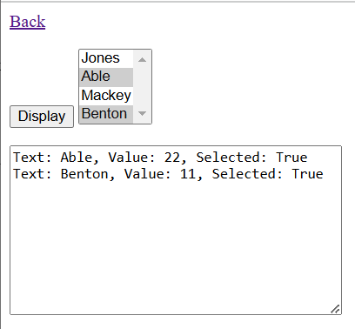
- Add a web form named, page3 and do the following:
- Make a link from default to page3 and a link from page3 to default. See directions above if necessary.
You can also do this by carefully copy/paste the code for the earlier links.
- Run either page and verify that you can navigate back and forth between the two pages.
- Add a button with ID btnDisplay and Text set to “Display”. Eventually, the page will look as shown on the right.
- Add a ListBox and
- Set the ID to lbxNames
- Set the SelectMode property to Multiple. This control allows multiple items to be selected.
- Expand the Items collection and add 5 or so names making sure the values are unique. I suggest using numbers.
VS 2022 Note: I had to use code in Page_Load. This is the same as page2.aspx except that we are putting the ListItems into the ListBox, lbxNames.
protected void Page_Load(object sender, EventArgs e) {
if (!IsPostBack) {
ListItem li;
li = new ListItem("Jones", "38");
lbxNames.Items.Add(li);
li = new ListItem("Able", "22");
lbxNames.Items.Add(li);
li = new ListItem("Mackey", "47");
lbxNames.Items.Add(li);
li = new ListItem("Benton", "11");
lbxNames.Items.Add(li);
}
}
- Notice that the AutoPostBack property is False. Leave it that way.
- Add a new <p>, and then add a TextBox in the <p>, set the ID to txtMessage, set TextMode to “MultiLine”, and stretch it larger.
VS 2022 Note: You may need to set the height and width in the property window to 150 and 300, respectively.

- Create an event handler for the button and supply this code.
protected void btnDisplay_Click(object sender, EventArgs e) {
string msg = string.Empty;
foreach (ListItem li in lbxNames.Items) {
if (li.Selected) {
msg += "Text: " + li.Text + ", "
+ "Value: " + li.Value + ", "
+ "Selected: " + li.Selected
+ Environment.NewLine;
}
}
txtMessage.Text = msg;
}
- Run your page and verify that all selected items are displayed.
- Add a button between the Display button and the ListBox. Set the name to btnRemove and Text set to “Remove Selected”.
- Create an event handler for the button and supply this code.
protected void btnRemove_Click(object sender, EventArgs e) {
string msg = "Items removed:" + Environment.NewLine;
for (int i = 0; i < lbxNames.Items.Count; i++) {
ListItem li = lbxNames.Items[i];
if (li.Selected) {
lbxNames.Items.Remove(li);
msg += "Text: " + li.Text + Environment.NewLine;
}
}
txtMessage.Text = msg;
}
Note:
- We are using an indexed loop to iterate over the Items. The reason is the same as Java, you can’t modify a collection when using a foreach loop.
- The Items property (the list of ListItems) has a Count property, which is equivalent to size() in Java
- We access the current ListItem with a new syntax:
ListItem li = lbxNames.Items[i];
The notation looks like Java’s array notation and in some respects it is. However, Items is actually a structure called an indexer (Java does not have this). An indexer is essentially a structure somewhere between an array and a list. We will consider this further in class.
- The code above compiles, but is not correct! We see this next.

- Do the following:
- Run your page.
- Select the first two names.
- Press the Remove Selected button.
- Verify that only the first item was removed.
- Close your page and run again (or choose: Back and then Page 3)
- Select the first and third names.
- Press the Remove Selected button.
- Verify that both names were removed.
Can you figure out why this code performed incorrectly when the first two items were selected? If you took CS 1302 from me, we illustrated this when we considered removing items from an ArrayList using an indexed loop.
Here’s the problem: all the ListItems have an index: 0, 1, …. So, when the loop is on i=0, that item is selected and so it is removed properly. However, once it is removed, all the other items are re-indexed. Thus, the second item, which had index=1, changes to index=0, etc. In the meantime, the loop increments i to 1. Thus, we skipped over the previously second item because it is now first. We fix this next, by iterating over the ListItems in reverse order.
- Replace the code in the event handler with this code:
string msg = "Items removed:" + Environment.NewLine;
for (int i = lbxNames.Items.Count-1; i>=0; i--)
{
ListItem li = lbxNames.Items[i];
if (li.Selected)
{
lbxNames.Items.Remove(li);
msg += "Text: " + li.Text + Environment.NewLine;
}
}
txtMessage.Text = msg;
By iterating in reverse order, when we remove a ListItem, the only items that are re-indexed are ones that we have previously processed in the loop. Thus, we don’t skip any selected items.
- Run your page, experiment, and verify that the code is running correctly. To experiment thoroughly, you should rerun your page from VS several times.

Using a CheckBoxList
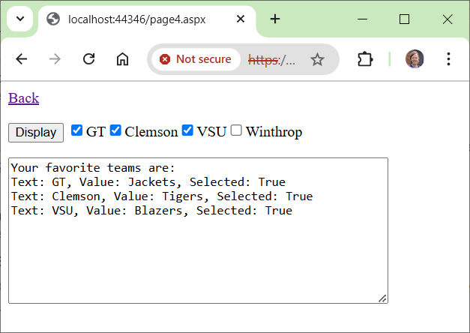
- Add a web form named, page4 and link this page to default and link default to this page.
- Add a <p> and then add a CheckBoxList inside the <p> to page4 and do the following:
- Set the ID to cblTeams
- Set the RepeatDirection property to Horizontal.
- Set the RepeatLayout property to Flow.
- Expand the Items collection and add 5 or so teams. Make the Text the school name (e.g. VSU) and the Value the sports name (e.g. Blazers).
VS 2022 Notes: Use this code in Page_Load
protected void Page_Load(object sender, EventArgs e) {
if (!IsPostBack) {
ListItem li;
li = new ListItem("GT", "Jackets");
cblTeams.Items.Add(li);
li = new ListItem("Clemson", "Tigers");
cblTeams.Items.Add(li);
li = new ListItem("VSU", "Blazers");
cblTeams.Items.Add(li);
li = new ListItem("Winthrop", "Eagles");
cblTeams.Items.Add(li);
}
}
- Notice that the AutoPostBack property is False. Leave it that way.
- Add a button, before the CheckBoxList, with name btnDisplay and Text set to “Display”.
- Start a new <p> and then add a TextBox, set the name to txtMessage, set TextMode to “MultiLine”, and stretch it larger.
VS 2022 Note: You may need to set the height and width in the property window to 150 and 400, respectively.
- Create an event handler for the button and supply this code.
protected void btnDisplay_Click(object sender, EventArgs e) {
string msg = "Your favorite teams are:" + Environment.NewLine;
foreach (ListItem li in cblTeams.Items) {
if (li.Selected) {
msg += "Text: " + li.Text + ", "
+ "Value: " + li.Value + ", "
+ "Selected: " + li.Selected
+ Environment.NewLine;
}
}
txtMessage.Text = msg;
}
- Run your page and verify.

Using a RadioButtonList
Your turn. Do the following:
- Add a web form named, page5 and link this page to default and link default to this page.
Warning: do not copy/paste page4 in the SE. It will not work correctly.
- Make an example similar to the previous stage (CheckBoxList) except use a RadioButtonList. Hint: you do not have to loop through all the radio buttons to see which one is selected. In a RadioButtonList, only one item can be selected. Thus, in your event handler, simply use the SelectedItem property of the RadioButtonList.
Note: You can copy/paste some of the HTML/ASP tags. If so, you should do that, then generate the event-handler with the usual double-click from Design mode. Easy to mess up when copying. May have to start over if you get goofed.
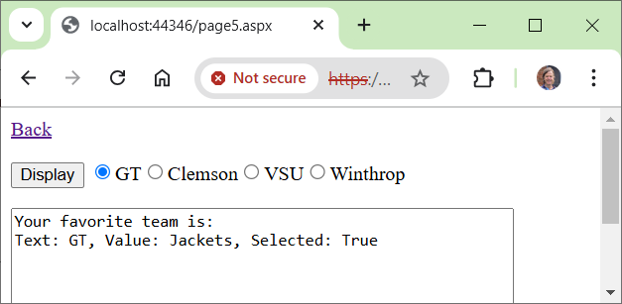

Using a Calendar
- Add a web form named, page6 and link this page to default and link default to this page.
- Add a button with name btnDisplay and Text set to “Display”.
- Add a Calendar with ID cal and verify that SelectionMode is set to “Day”.
- Add a TextBox, set the name to txtMessage, set TextMode to “MultiLine”, and stretch it larger.
- Create an event handler for the button and supply this code:
DateTime date = cal.SelectedDate;
string msg = "Date properties" + Environment.NewLine;
msg += "Short date string:" + date.ToShortDateString() + Environment.NewLine;
msg += "Day:" + date.Day;
msg += ", Month:" + date.Month;
msg += ", Year:" + date.Year + Environment.NewLine;
msg += "Day of week:" + date.DayOfWeek + Environment.NewLine;
msg += "Day of year:" + date.DayOfYear + Environment.NewLine;

// Illustrates the AddDays method
DateTime date2 = date.AddDays(3);
msg += "3 days from now:" + date2.ToShortDateString() + Environment.NewLine;

txtMessage.Text = msg;
- Run, select a date, press the button and observe the output.
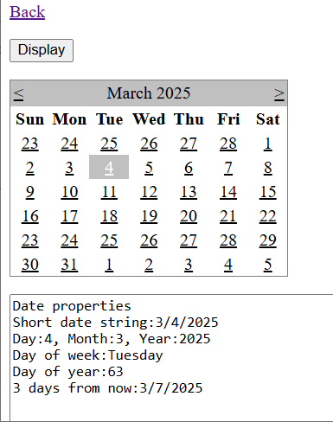

Package Assignment for Submission
- Close VS and zip your lab04_lastName project folder and submit on Blazeview in the Lab 04 dropbox.
If you need further directions, follow step 10 from Lab 1, exactly, substituting lab04 for lab01.
To avoid a deduction of points, verify the following:
- The name of your zip file is: lab04_lastName (your last name, of course).
- Inside the zip file, verify that your lab04_lastName project folder is indeed named: lab04_lastName
- Inside your lab04_lastName project folder there should be:
- A lab04_lastName.sln file
- The page(s) you developed
- Some other files & folders.

