Lab 1 – ASP.NET Basics 1

Contents
1 Lab Objectives 1
2 Notes about VS 2022 2
3 Create a Project & Solution 3
4 Build a Web Page 6
5 Explore Folder Structure 8
6 Create your Lab 1 Home Page 9
7 View the Code-Behind File 10
8 Add Some Controls 11
9 Add another Control 15
10 Add a Validator Control 16
11 Exploring the Debugger 17
12 A Question for You 21
13 Add AJAX 22
14 Package Assignment for Submission 24

- The labs I will have you do are written for VS 2019. At times, you may have to figure out how to do what I am asking you to do in the labs. So far, I’ve gone through them and put notes where things are different from VS 2019.

Lab Objectives
- Understand how the project and solution are stored on disk.
- Build a simple web app that utilizes server-side processing.
- Learn the architecture of an ASP.NET web app.
- Know what a code-behind file is and how to utilize event-handlers.
- Layout an app with basic server controls and validators
- Become familiar with the page lifecycle.
- Write simple event handlers.
- Utilize AJAX in an app.
- Use the debugger in VS
To make this document easier to read, it is recommended that you turn off spell checking and grammar checking in Word:

- Choose: File, Option, Proofing
- At the very bottom, check: “Hide spelling errors…” and “Hide grammar errors…”

Notes about VS 2022
These are some suggestions about doing these labs with VS 2022. Some steps below, written for VS 2019 will require these steps. Read through them quickly. You may need to refer back to them.
- In some ways, easier to add controls in Source mode (the .aspx shown in the code window, displaying the HTML and ASP.NET markup).
- You have to save things regularly or things will go wrong. You will usually have 3 pages open: (1) Source, i.e. .aspx , (2) Design, (3) code, e.g. .aspx.cs. Sometimes one is not recognizing changes from another. Usually, you can resolve by saving all the files.
- Design mode is fragile. I try to keep it closed.
- Activating the Properties Window correctly can take some work. For example, consider the DropDownList that is selected in the code below. The Property Window is showing that it is a DROPDOWNLIST. I don’t know what that is, but it is incorrect.
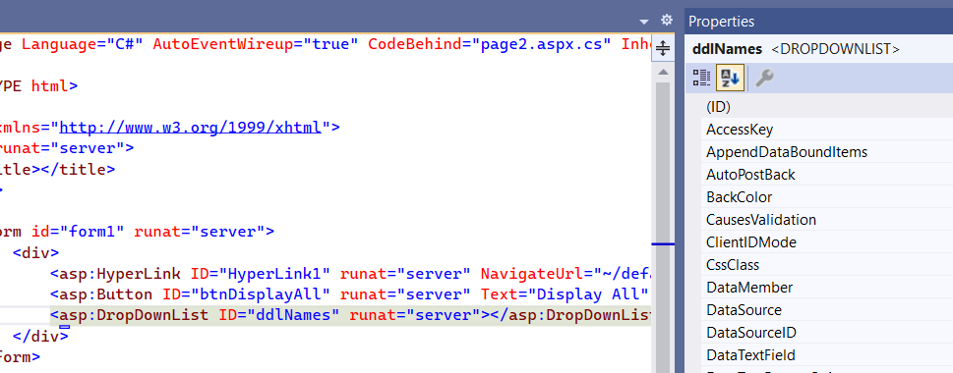
Next, I double-click the tag in the code, no change. Change to Design mode, select the dropdown, no change. Go back to Source, double click and it shows the correct class name in the Properties Window, DropDownList.
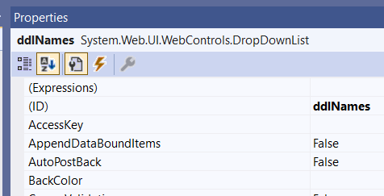

Create a Project & Solution
- Create Workspace – Create a folder on your hard drive where you will store the work for this lab and subsequent labs. This is similar to a workspace in Eclipse. It can be any folder. You might name it: cs3340_labs. Then, you can put all your labs in this folder. Whatever folder you choose, we will call this your labs folder.
- (Read, no action required). In this class we will use the Visual Studio 2022 Enterprise IDE (VS) to create projects. Note the following about how VS organizes your work:
- A VS project contains the code you write for a particular lab, or homework, etc. There are many different types of projects, but we will only create ASP.NET Web Application projects.
- A VS project is housed in a solution. A solution can contain any number of projects.
- You will use VS to create a project which you will name: lab01_lastName. Among other files and folders, there will also be a solution file named: lab01_lastName.sln. You can double-click this to launch your project in VS.
- In summary, the file structure will look like this:
workspace // any folder on your computer
lab01_lastName // project folder
lab01_lastName.sln // solution file
... // other project files & folders
lab02_lastName // project folder
lab02_lastName.sln // solution file
... // other project files & folders
- To submit your labs and homeworks, you will zip the project folder into file named: lab01_lastName.zip. You will do this in the last section of this lab.
- Every lab and homework will have this same structure: lab02_lastName, lab03_lastName, …, hw01_lastName, hw02_lastName, …
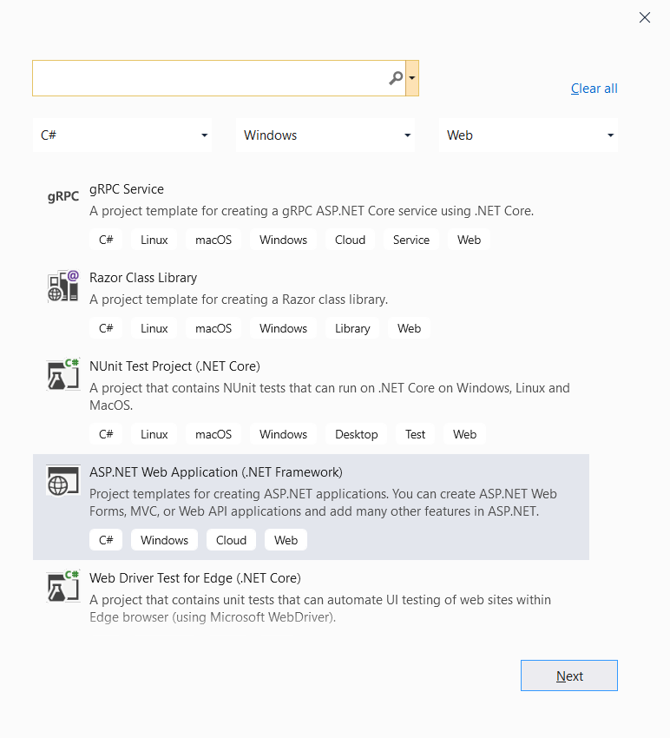
- Create Your Project
- Launch VS 2022.
- Choose: Create a new Project
- On the Create a new project dialog, select the, ASP.NET Web Application (.NET Framework) template (language should be C#) and choose: Next.
This is easy to mess up because there are a lot of similarly named project templates and languages. The easiest way to do this is to set the filters at the top: (a) C# in the first, (b) Windows in the second, (c) Web in the third.

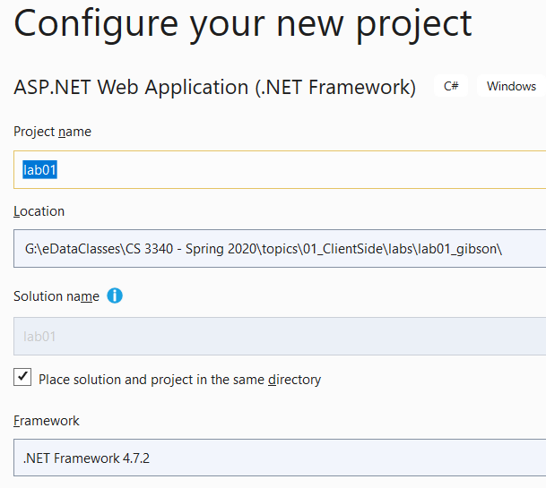
- Do the following on the Configure your new project dialog:
- Type the Project name: “lab02_lastName” (use your last name!)
- Choose the Location by navigating to your labs folder created above.
Warning: if your path is too long, you get a cryptic error and the project is not created. I’ve tried a path of 113 characters, 7 folders deep, and it failed.
- Check the box that says, “Place solution and project in the same directory”
- Choose: Create.

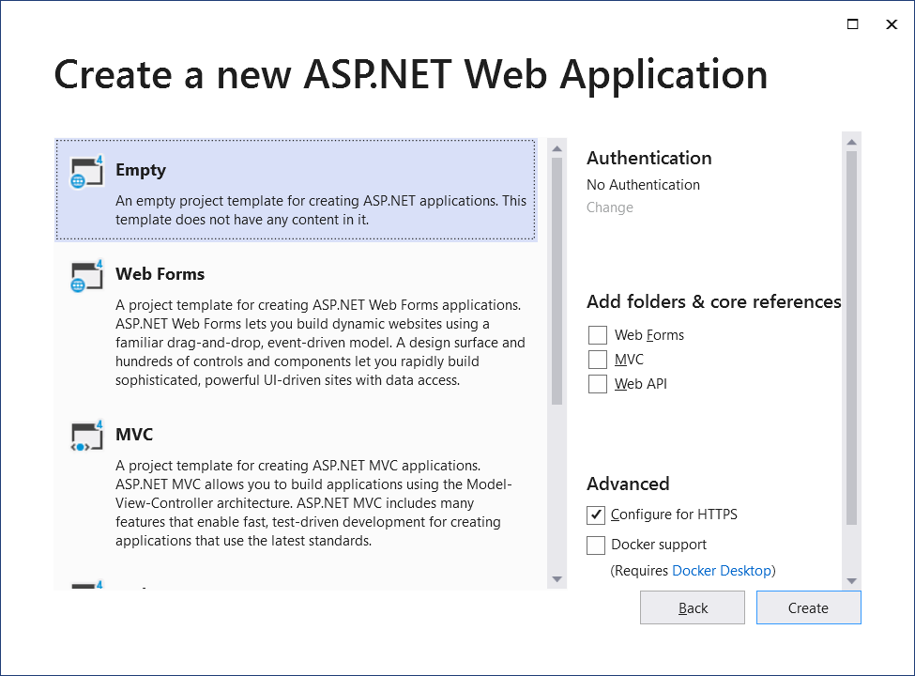
- Do the following on the Create a new ASP.NET Web Application dialog:
- Choose: Empty
- Choose: Create (this takes a few seconds)

- (Read, no action required). Your window will look similar to what is shown below. Note the following:
- The Solution Explorer (SE) lists all the projects in your solution. When a project is selected, it lists the files in that project. We will generally only have one project in a solution; however, it can be useful to create another project inside a solution to test something out, etc.
- If the SE is not displayed, choose: View, Solution Explorer
- In the diagram below, in the SE, the solution is named: lab01 (yours will be named: lab01_lastName, same as the project name). And, the project is named: lab01 (yours will be named: lab01_lastName).
- If you select the project, the Properties Window displays properties for the project. We won’t change any project properties. However, any item selected has properties and we will use this pane heavily throughout the course.
- If the Properties pane is not displayed, choose: View, Properties Window

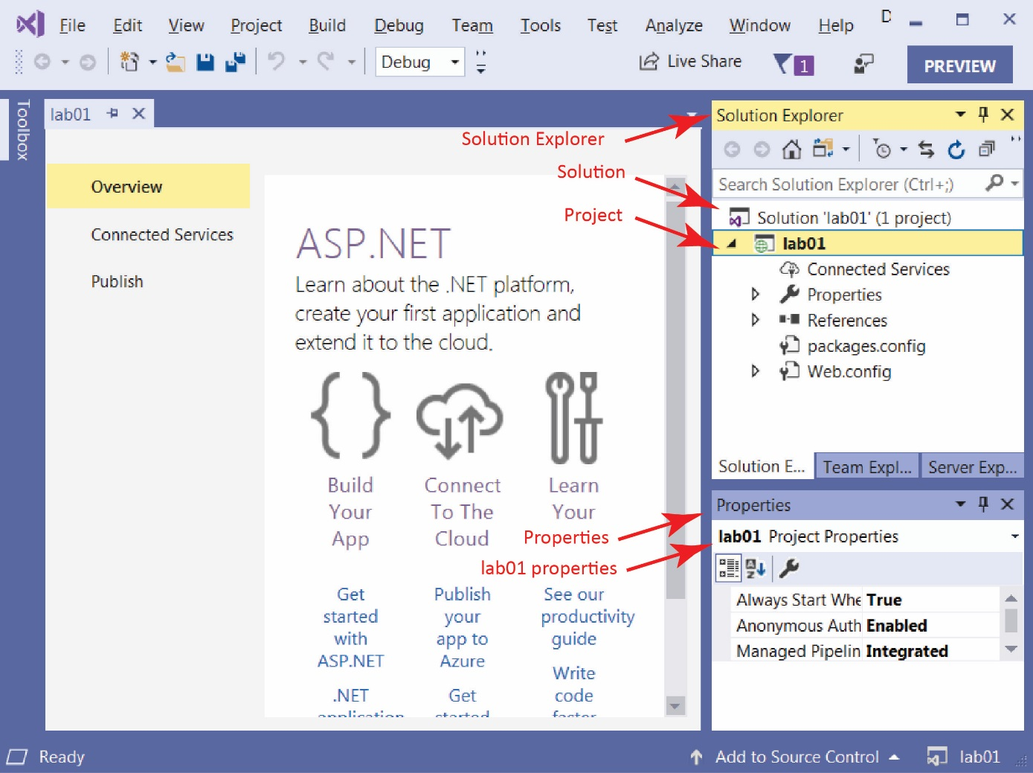

Build a Web Page
- Build a Web Page
- Select the lab02_lastName project in the Solution Explorer (SE), right-click and choose: Add, HTML Page. Supply the name, default and choose, OK.
- If you do not see HTML Page, then choose: Add, New Item, Visual C#, Web, HTML Page.
- Notice the web page is open in the code window and the file is displayed in the SE. VS 2022 only displays the page in Source mode (e.g. the HTML). You can also view the page in Design view where you can type text into the page as well as use tools to, for instance, create a table.
However, you must do the hack in the next step so that you see Design, Split and Source buttons in lower left to change the view.
- HACK: Close default.html and then do the following:
  - Right-click default.html in the SE and choose: Open With
  - Select: “HTML (Web Forms) Editor and choose: OK
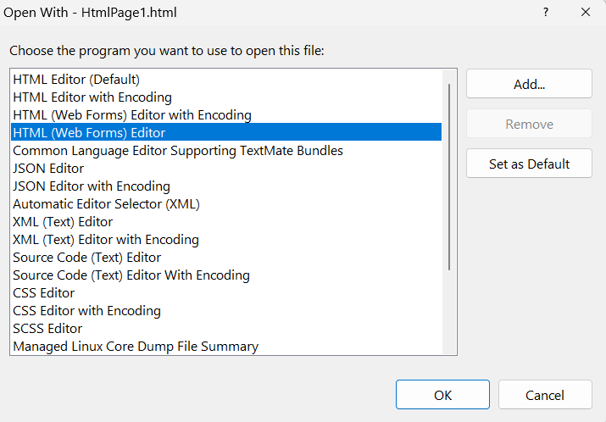
- Now, you will see Design, Split and Source buttons in lower left to change the view. Swap back and forth to get a feel for it.
- Change to Source mode by selecting the Source button in the lower-left. Type the values shown in the image below, substituting your name. Save. Choose the Design view button in lower-left to see what it looks like.
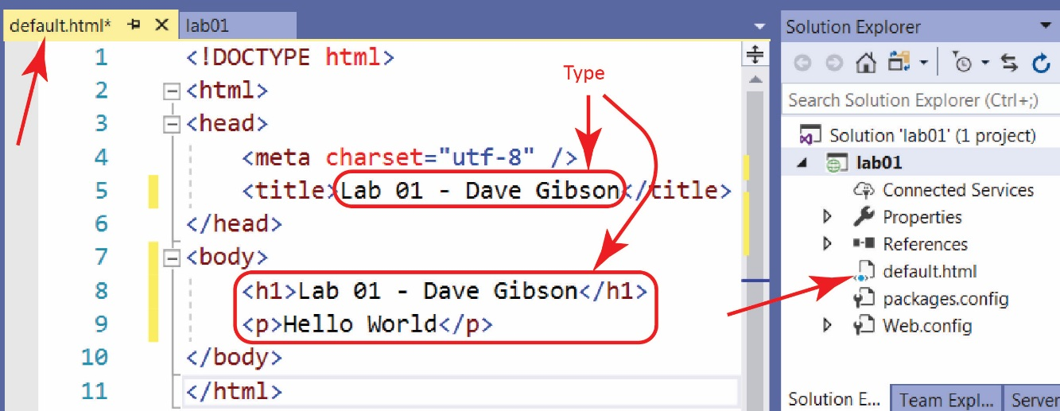
- (Read, no action required) Window’s computers have a webserver to serve pages locally, to the machine you are working on. The webserver’s name is localhost. This is where we will test pages.
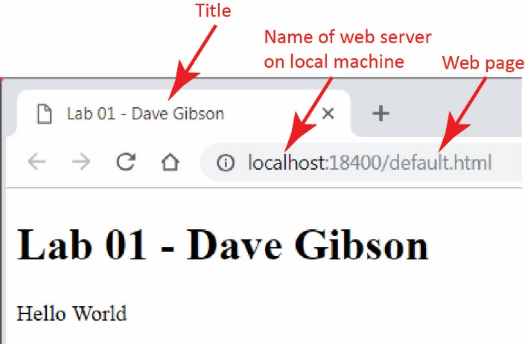
- Display your page. When you are done, return to VS.
There are 3 ways to display your page on localhost:

- Right-click in page and choose View in Browser
- Choose: File, View in Browser
- Press: Ctrl+Shift+W

Warning

Sometimes View in Browser gives this error:
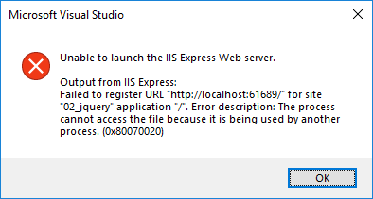
One solution is to use the drop down at top that says “IIS Express (Google Chrome)” and choose another browser. E.g. Edge.
I’m not sure, but I think the problem results when you continually run your page, and then a page has a fatal error, but the process displaying the page doesn’t get destroyed. I also think I have “fixed” this error by rebooting my computer.

- Edit page in Design View
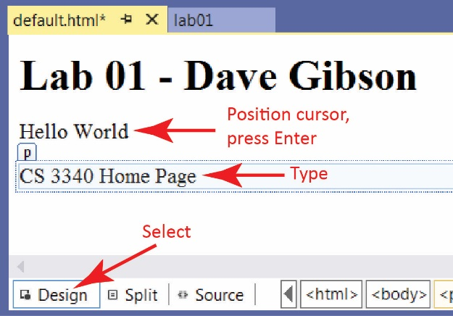
- Do the following:
- Open the page in VS and select the Design button in the lower-left.
- Place the cursor and the end of the text, “Hello World,” and press Enter
- Type the text as shown in the image on the right.
- Display the Source (choose the Source tab) and verify that HTML has been added to your page.
- Save
- Display your page.

Explore Folder Structure
- Explore Folder Structure
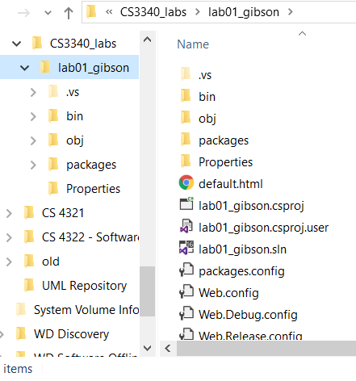
- Navigate to your labs folder (in the example on the right the folder is: CS3340_labs) in File Explorer and select the project folder (lab01_lastName). Note the contents of the folder, specifically, these will be of interest as we go along:
default.html
lab01.sln
web.config
- Double-click the solution file (lab01_lastName.sln) and VS will open the lab01_lastName project.
- (Read, no action required) Three ways you can open your solution:
- Launch VS and your solution may be listed under Open recent
- Launch VS and choose Open a project or solution and then navigate to your .sln file.
- Double-click the .sln file in the File Explorer (Windows 10) or Windows Explorer (Windows 7)
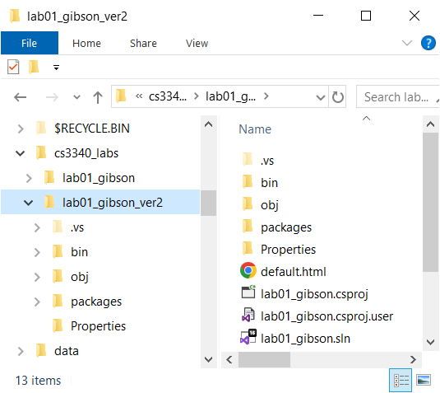
- (Read, no action required) If you want to make a copy of your project, the best way is to use File Explorer and copy the project folder. For example:
- You could copy: lab01_lastName and paste it in the same parent folder (your labs folder) (or elsewhere).
- Rename it, say: lab01_gibson_ver2
- The solution file will still be: lab01_gibson.sln and will work fine.
Notes: VS does not have a “Save as” to save a solution (or project) to another location. Also, there does not appear to be a way to copy/paste the project in the SE.
- Close VS. Sometimes you will be prompted to save your solution file. If you say yes, sometimes it wants a location. At that point I just back out and tell it not to save.

Create your Lab 1 Home Page
- Delete your default.aspx file from the Solution Explorer. Yes, delete it!
- Add a Web Form. A web form contains HTML and it contains ASP.NET web controls.
- Right-click lab01 in the SE, right-click and
- Choose: Add, Web Form. If you don’t see, choose: Add, New Item, Web Form.
- Supply the name: default
- Press, OK. This is your Lab 1 home page.
- The page is displayed in Source view. It will look similar to the figure on the below.
Note: a web form displays the Design, Split, Source view buttons automatically. You do not need to do the HACK we did with an HTML page.
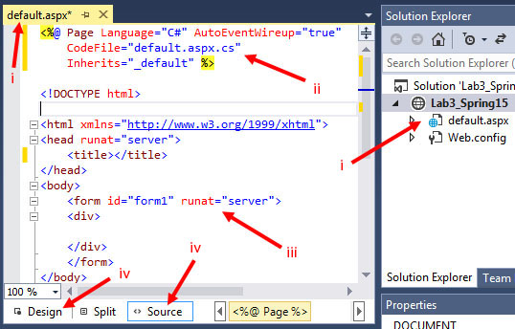
Note:
- A web form has the file extension .aspx
- The first line of a web form has is a page directive. A page directive specifies various properties for use by the compiler.
<%@ Page Language="C#" AutoEventWireup="true" CodeBehind="default.aspx.cs" Inherits="lab03_gibson._default" %>
The four properties shown:
- Language – Specifies the C# language.
- AutoEventWireup – When true, automatically registers event handlers with events.
- CodeBehind Specifies the name of the code-behind file that contains the code that accompanies this web form. By convention, the name is the name of the web form followed by the language, in this case “.cs” for the C# language. The code-behind file contains the server-side code to process this form.
- Inherits – The Page class instance inherits the members of the (somewhat awkwardly named) _default class. We will see this class and code-behind file shortly. We will also see why the class name is _default when the file name is default. In other words, what is the deal with that underscore?

- The body always contains a single form with an important attribute and value, runat=”server”. This informs the ASP.NET engine to process this element on the server. We will consider this in subsequent labs and lecture.
- Add the HTML title: “Lab 1 – FirstName LastName”, substituting your name. For example:
<title>Lab 1 - Dave Gibson</title>
- Write a level 2 header, inside the <div> tags, that reads: “Lab 3 – FirstName LastName”
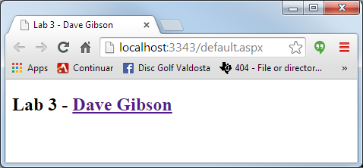
- View your page on local host: right-click in page, and choose: View in Browser. Note: your page will not show a hyperlink as is shown on the right.

View the Code-Behind File
Notes:
- I will frequently refer to a web form as a page as it is simpler to say and write. If I need to be more specific, I will refer to a web form (.aspx) or an HTML page (.html).
- A user agent is the computer program being used to communicate with the server, to be able to request and receive information from the server. Thus, a user agent maybe a browser, a mobile phone, etc.
- A web form (.aspx) is different from a web page (.html). When a user requests a web page, the web server sends it directly to the browser with no processing on the server. When a user requests a web form, the server “runs” the form, outputting HTML, and sends it to the browser. We will see what “run” means as we go along.
- Inspect the Page.
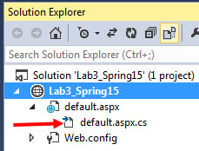
- In the SE, expand default.aspx and you will see there is another file named default.aspx.cs. This is the code-behind file. (You will also see another file, default.aspx.designer.cs which is not shown in the figure on the right. This file is auto-generated and generally, should not be modified directly. If you want to, open this file and inspect it.)
- Open the code-behind file by double clicking on it (or right-click on the page and choose: View Code).
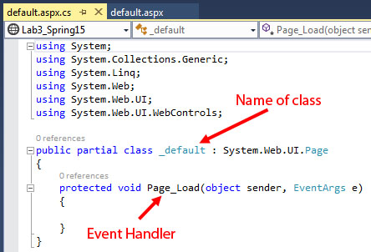
Note the following (read each item and scroll up to the figure to verify/coordinate the comment):
- The name of the class is _default. The “_” is automatically added for a page named default or Default because the former is a reserved word in C#, and the latter is a reserved word in VB.NET (the two languages can be used together in the same page.). Any other page name that is not a reserved word is simply the name of the class. For instance, a BookSearch.aspx page would have an associated class named BookSearch as well.
- A Page_Load (empty) method is shown. We call this an event handler. When a client requests this page, the server always calls this method. Later in this lab we will place a line of code there and see how it works. In another lab we will explore in more detail how to use Page_Load.
- The using statements provide the same role as import in Java: access to the API classes.
- The “:” in the class definition is the same as extends in Java. Thus, the superclass of _default is Page.
- The “partial” keyword in the definition of the class indicates that this is a partial class. The other part is in the default.aspx.designer.cs file. We have no real need to consider this; however, my notes talk a bit more about what a partial class is.
Note: VS uses the “next line” brace style. To change it to the more usual, same line, do the following:
- Go to Tools -> Options -> Text Editor -> C# -> Code Style -> Formatting-> New Lines
- In the first section, “New line options for braces”, uncheck everything.

Add Some Controls
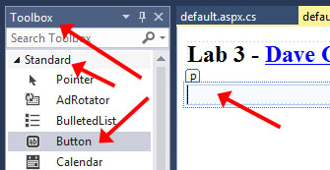
- Add a button and a Label
- Open your page (default.aspx) in Design view
- Put your cursor at the end of your name and press Enter. This makes sure that subsequent additions to the page will occur inside the form tag. We will verify this later.
VS 2022 Note: As mentioned, Design mode is fragile. I recommend using Source mode and dragging the controls into the HTML at the proper location.
- Find the Toolbox on the left of your window. Make sure the Standard tab is selected.
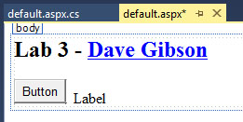
- Drag a Button onto the page.
VS 2022 Note: Drag into the HTML in Source mode.
- Drag a Label onto the design. Add a few spaces between the Button and Label. The result is shown on the right.
- (For the last time) Your page will not show a link as the one on the right does.

- Change some Button properties
- Select the button and inspect the Properties window below the SE (If you don’t see it, right-click the Button and choose: Properties). In the figure on the right, I have hidden the SE to make the figure more compact. Note the items indicated. The ID shown for yours will probably be something like: ctl00.
VS 2022 Note:
- Select the ASP button tag in Source mode to show it in Properties Window.
- Make sure the “Class” shown in the figure is exactly the same as shown, Button. If it shows BUTTON, see the notes in Section 2.
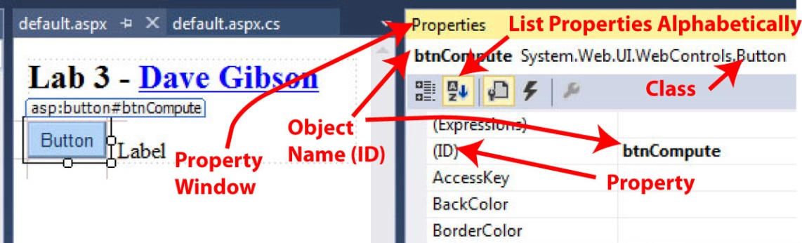

- Change the “ID” property to: btnCompute. The button’s name is btnCompute, which is an object created from the Button class.
VS 2022 Note: I sometimes find it easier to simply edit the HTML in Source mode.
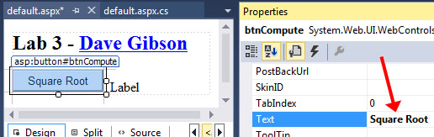
- Change the “Text” property to: Square Root. This will change the text that is displayed on the face of the button.

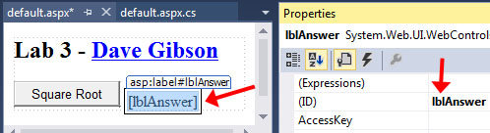
- Change the Label properties –
- Select the Label and make sure the Properties window is displayed.
- Change the “ID” property to: lblAnswer.
- Scroll down and see that the “Text” property is set to, “Label”, which is what is displayed when the page is viewed. Delete this text (empty). Later, we will write code that changes the “Text” property to a message when the button is pressed.
- View the page in Source view. As shown below, you will see two ASP.NET web controls (controls) that represent the button and label. These tags have a runat=”server” attribute which means they are “run” on the server, and output as pure HTML and sent to the browser. We illustrate this later.
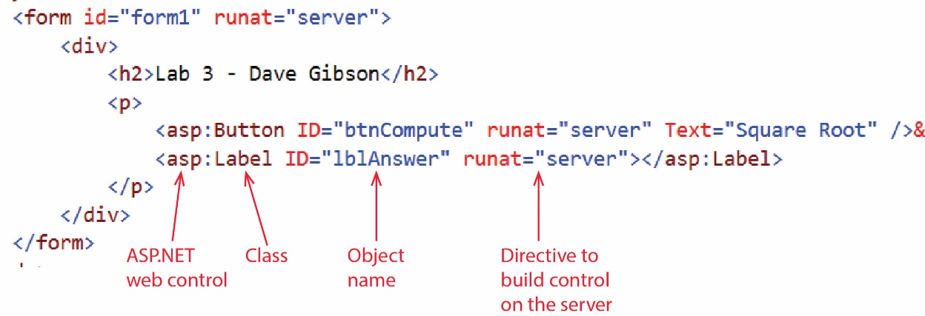
- Build and run your application
- Choose: Build, Build Solution (or Ctrl+Shift+B). When complete, the message “Build succeeded” will appear in Output pane below the Code pane.
Note, When you right-click in page and choose: View in Browser, it automatically builds your page. However, if things start to act up, don’t hesitate to Build or Rebuild your page explicitly.
- Display your page on localhost. There are 3 ways:
- Right-click in page and choose: View in Browser.
- Choose: Debug, Start without Debugging. This will display your page on localhost.
- Press: Ctrl+F5.
- Note: you can press the button but nothing happens. And, the label is not shown (because the Text property is empty).

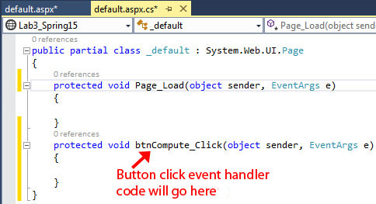
- Add functionality to the Button
- Display the page in Design view.
- Double-click the button. This will display the code-behind file and it will create a method named: btnCompute_Click as shown in the figure on the right. This is an event-handler (for the button) and is called when the Button is pressed when the page is viewed.

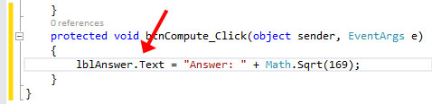
- Write code in the event-handler that will display the square root of 169 in the Label. As you type, you will notice that auto-complete will help you.

lblAnswer.Text = "Answer = " + Math.Sqrt(169);
Note the following:
- Microsoft’s convention is for the name of all public members of a class is to use camel-case, except with the first letter capitalized.
- Later in the course we will consider the parameters for this event handler. Most (or all) event handlers we consider in this class have the same two parameters.
- The .Text property is being used as if it were an instance variable. In other words, we are not calling a setText method. Behind the scenes, there actually is a setter. Later, we will see that C# defines getters and setters in a really clever way: so that we don’t have to write getText and setText; we just use Text:
lblAnswer.Text = "..."; // Text used as a setter
String msg = lblAnswer.Text; // Text used as a getter
- Return to your page (default.aspx) and view it in the browser (right-click and choose: View in Browser). If you try to run your code-behind file, a common mistake, nothing will happen. Also, you can’t just refresh a previous version of the page in the browser, the page must be run first.
Before data entry | After data entry
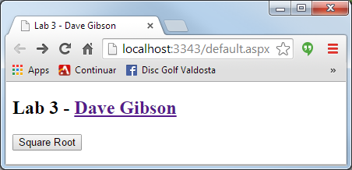 | 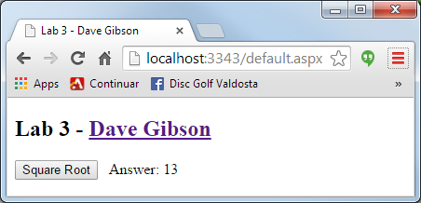

Add another Control
- Add a TextBox. We will have the user enter a number to take the square root of.
- Open your page in Design view.
- Use the Toolbox to add (drag) a TextBox to the page. Reposition it so that it is between the Button and the Label.
- Use the Properties window to set the “ID” property for the TextBox to: txtInput
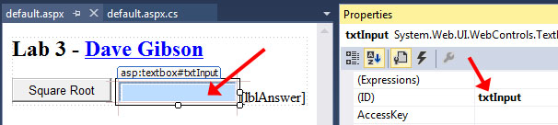
- Change the Button event handler. We will change the button’s event-handler code to obtain the number the user typed in and compute the square root of that number.
- Display the code-behind page (default.aspx.cs).
- Type this code in the event handler (btnCompute_Click):
String strInput = txtInput.Text;
double dblInput = Convert.ToDouble(strInput);
lblAnswer.Text = "Square Root = " + Math.Sqrt(dblInput);
Study this code to understand what it is doing. Note that the Convert class contains static methods to convert almost anything into some other type.
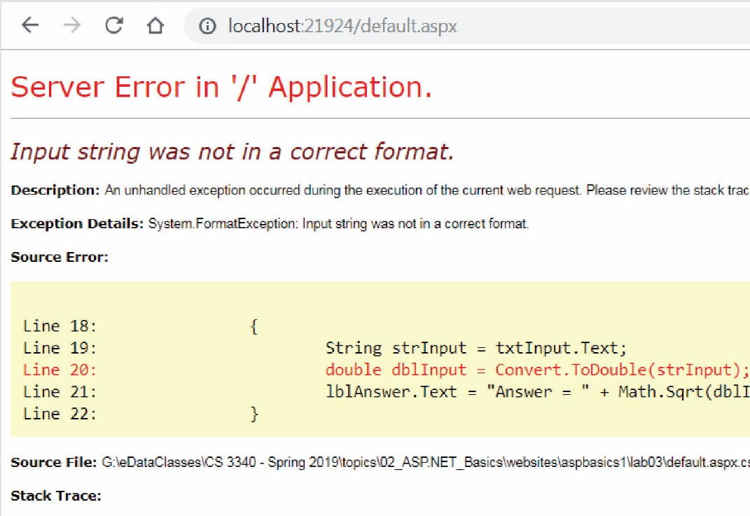
- View your page in the browser.
- Test by supplying a number. The page should work as expected.
- Test by supplying a string of characters. An exception is thrown when the run-time tries to convert these characters to a double. The output is shown on the right and is very similar to the output you receive when an exception is thrown in Java.

Add a Validator Control
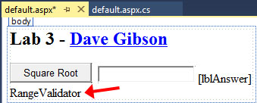
- Add input validation
- Open your page in Design view.
VS 2022 Note: I’m repeatedly having to close the page and reopen, then choose Design, to see the Design properly.
- Open the Toolbox, open the Validation tab. Drag a RangeValidator onto the page.
VS 2022 Note: I had a hard time doing this from the Design page. One attempt I dragged it to a bad location and it didn’t show at all. The problem was that it was above the page directive at the top of the file. I deleted it. When in doubt using the Design page, always check the .aspx page. I finally had better luck simply dragging the validator into the .aspx page itself.
- Select the RangeValidator in Design view and then change the properties below in the Properties Window:
VS 2022 Note:
- If you have problems viewing the properties, use the dropdown to select the actual element. In my case, it would only show “<HTML ELEMENT>”. From the dropdown I could choose: “RangeValidator1”.
- I had problems setting the properties. I’d type them and then they would immediately disappear. I had luck by selecting the validator in the .aspx page and then setting the properties.
- I had to save the page to see the property values added to the validator in the .aspx page.
- I could not get the ForeColor to “stick”, so I added ForeColor to the label, then removed it form the code and added it to the validator code.
Property | Value
ControlToValidate | txtInput
ErrorMessage | Input must be positive
ForeColor | Red
MaximumValue | 999999
MinimumValue | 0
Type | Double
- Modify web.config.
- Run your page and type in a value. It will immediately throw an exception. To fix this, we have to add a node to Web.config to tell it to use jQuery. The Web.config file contains global information about your site (your project, lab03 in this case).
- In the SE, open your Web.config file. Copy the appSettings node below:
<appSettings>
<add key="ValidationSettings:UnobtrusiveValidationMode" value="None" />
</appSettings>
And paste it above (or below) the system.web node. Your (partial) web.config will look like this:
<configuration>
<appSettings>
<add key="ValidationSettings:UnobtrusiveValidationMode" value="None" />
</appSettings>
<system.web>
<compilation debug="true" targetFramework="4.5" />
<httpRuntime targetFramework="4.5" />
</system.web>
</configuration>
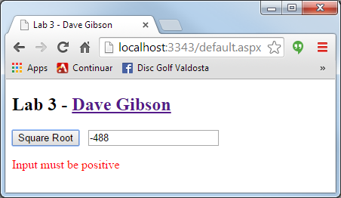
- View your page. Test with a negative number (or a string).

Exploring the Debugger
The Debugger is used to step through your code, line-by-line. You start by specifying a breakpoint(s). Then, you run the program in debug mode and the code executes until it gets to the breakpoint where it stops execution and waits input from you as to how to proceed. At that point, you can: (a) inspect the value of variables and controls, (b) step line-by-line through the code, (c) advance to the next breakpoint, (d) step into or over method calls, etc. LEARN TO USE THE DEBUGGER!
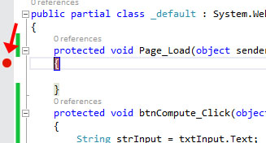
- Add a Breakpoint
- Open the code-behind page (default.aspx.cs).
- Find the Page_Load event handler. There is no code in the method; however, we could place code here.
- Click in the far-left margin of the opening brace ({). A red circle will appear. This is a Breakpoint. When we run the program in Debug mode, execution will stop here. Then, we can step through the program.
- Run program in Debug mode. If something goes wrong with the steps below, or you want to redo them, you need to stop the debugger, and then start the step(s) again. To stop the debugger, choose: Debug, Stop Debugging
- Choose: Debug, Start Debugging (or press F5). It may take a few seconds. The browser will be displayed but there will be nothing on the page. You may be automatically directed back to VS as shown on the right below. If you aren’t, just switch back there. The yellow highlight means the program execution has been halted just before this line is executed.
Browser | Visual Studio
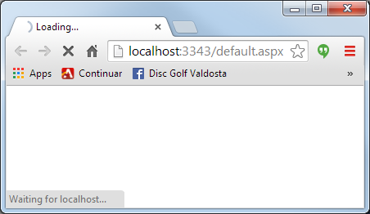 | 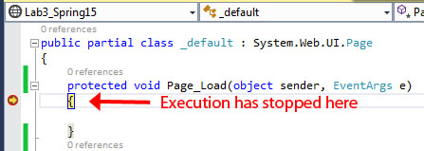

- Execute the Page_Load event.
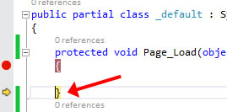
- Choose: Debug, Step Over (or press F10). Notice the yellow highlight has moved indicating that the previous line of code has been executed (the brace!). Had there been code in Page_Load, we would have stepped through it by continuing to press F10. The purpose was to show you that the very first thing that happens on the server is that the Page_Load event code is run.

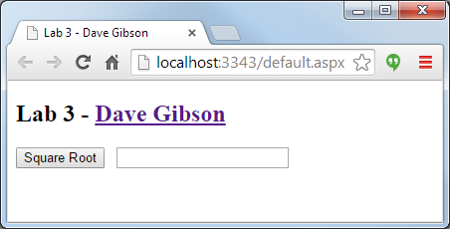
- Step over again (e.g. press F10). Now, the page is loaded and the browser shows the full page.

- Type a number in.
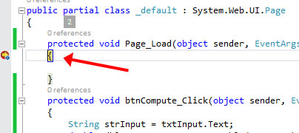
- Type in a number and press the Button. The code executes and again stops at the Page_Load event. When you pressed the button, the page did a “post-back” to the server. Notice that the Page_Load event runs every time a post-back occurs.

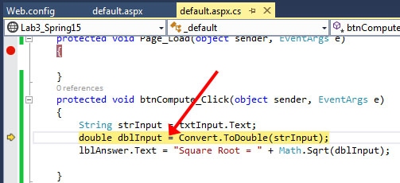
- Press F10 four (4) times. Notice that code finished Page_Load and then entered btnCompute_Click.

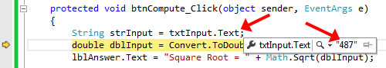
- Hover your mouse over “Text” in the line with “txtInput.Text” (the line above the yellow highlighted line). Notice that the value you typed in is displayed (e.g. 487 from the example above).
- Hover your mouse over “strInput” and you will see a similar result.

- Use the Locals Window
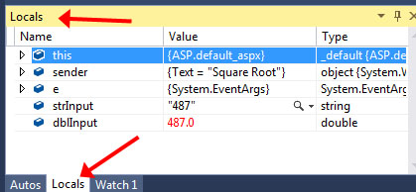
- Find the Locals window (look for a Locals tab along the bottom left of your screen). The Locals window shows variables defined in the local scope. If you don’t see it, choose: Debug, Windows, Locals. This is only available when you are actively debugging a program. It should look similar to the figure on the right. (I don’t remember what the difference is in the Autos and Locals windows is exactly, but sometimes you need one, and sometimes the other!)
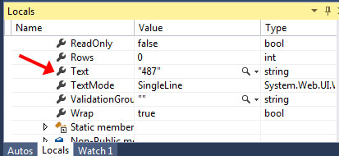
- Expand the “this” reference. “this” is the instance (object) of your Page. Thus, “this” is an object which contains references to all the variables and controls we have defined in the page (class).
- Scroll down to “txtInput” (almost to the end of the long list) and expand.
- Then, scroll down to the “Text” property of txtInput and see the value you typed in.
- Now display the Autos window and there you will see txtInput without having to drill down into this.

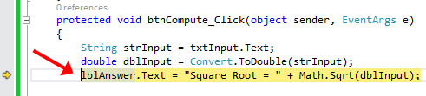
- Redisplay the code-behind file. Press F10 once.

- Use the Immediate Window
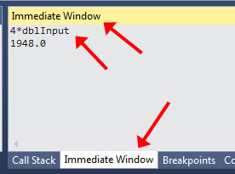
- Find the Immediate Window (look for an Immediate Window tab along the bottom left of your screen). The Immediate Window allows you to write lines of code and execute them. This is occasionally useful. If you don’t see it, choose: Debug, Windows, Immediate Window.
- Type:
4 * dblInput
Then, press Enter. Notice that dblInput is a local variable defined in the event-handler. The immediate window allows you to compute with variables that are in scope. You could also see the value in an array (or any variable), e.g. myArray[3] and Enter. It is probably hard to see why this is useful, but it is from time-to-time, as a debugging technique. Note: in previous versions you had to type a “?” in front of the expression. It does still work when you do this, and the documentation says to do it, but it works without (at least in this example).

- Finish the debugging session
- Press F10 two more times and the result is shown in the browser. If you press the Button again, the debugging continues.
- End the debugging session. Do one of the following:
- Choose: Debug, Stop Debugging
- Press Shift + F5
- Press the red (maroon?) square icon on the toolbar.
- Summary of Debugging Commands – Read, no action required.
Description | Keyboard | Menu
Start debugging | F5 | Debug, Start Debugging
Continue, advance to next breakpoint | F5 | Debug, Continue
Step over a method call | F10 | Debug, Step Over
Step into a method | F11 | Debug, Step Into
Step out of a method | Shift+F11 | Debug, Step Out
Stop debugging | Shift+F5 | Debug, Stop Debugging
- Other Debugging Techniques – Read, no action required. You will need to display debug information as you work on your assignments. Here are several approaches:
- Put a TextBox (with TextMode property set to MultilLine) at the bottom of each page you develop (so it is out of the way of the page you are developing). Then, you can display debug output there, e.g. txtDebug.Text +=“price=” + price + “\n”;. I recommend this approach for every page you develop for this class. It will be fine to leave this on homework you submit, just make sure it is clearly below everything else.
- (Skip this point – Not working as described, VS 2019 nor 2022) You can use: System.Diagnostics.Debug.WriteLine(…) to write to the Output window in VS. If you choose this approach: (a) include a using System.Diagnostics; so that you can just write: Debug.WriteLine(…) (b) Go to Tools, Options, Debugging, OutputWindow and turn off: Module Load Messages, Module Unload Messages, Process Exit Messages, Thread Exit Messages. Otherwise, the output you write will have other messages interspersed.
- Conditional compilation is useful for debugging and testing and custom builds. I couldn’t find a good link to reference to, though.

A Question for You
- Figure out what is going on!
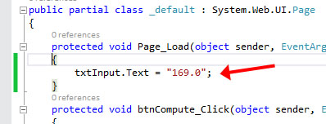
- Make sure the debugger is stopped!
- Add this line to the Page_Load event:
txtInput.Text = "169.0";

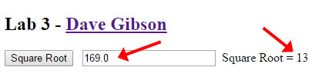
- Run the program and simply press Enter. You should see the result: 13.

- Next (the page should still be running), change the input value (to 4, say) and press Enter. The answer is still 13.
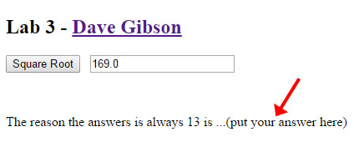
- Use the debugger (and your brain) to figure out why the answer is always 13. When you find the answer, type it at the bottom of your page.

- Comment out the line you added to Page_Load. Thus, the page should properly calculate the square root of the input now.

Add AJAX
- An AJAX Example
The page we have built so far communicates with the server in a synchronous manner. The user presses the button and waits for the server to respond. You can tell a page is using synchronous communication when the browser tab flashes after an action is taken.
- Run your page and interact with it. Each time you press the button, you will see the tab flicker.
AJAX is a technique for communicating with the server asynchronously. When the user makes an action, the page sends a message to the server in the background, but continues to run normally in the browser. An example is Google Maps and thousands (millions?) of other sites.
- Move or zoom the map and observe how smooth the interaction is and notice that the tab doesn’t flicker: http://goo.gl/maps/ih2wZ
- AJAXify your page
We will add code to make your button communicate asynchronously with the server.
VS 2022 Note: Ignore the Design mode view shown in the right of the next 3 images. We will work in Source mode.
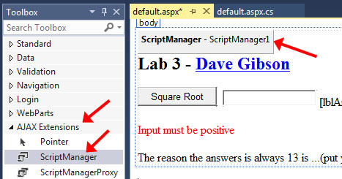
- Display your page (not Design mode). Open the Toolbox and expand the AJAX Extensions heading
- Drag a ScriptManager to end of the opening form tag. (make sure it is inside the form tag). Note: ScriptManager is a web control that has no visual presence when the page is run. It’s job is in the background, enabling asynchronous communication. However, in Design mode, you can see it as shown in the figure on the right.

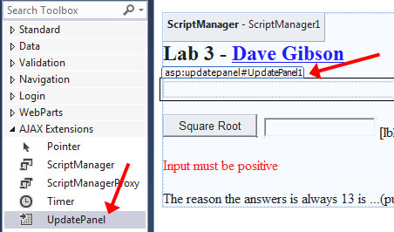
- Drag an UpdatePanel to just before the “Square Root” button.

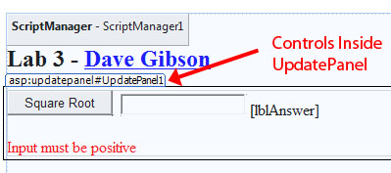
- Cut/Paste or drag each of the components (button, textbox, label, validator) into the UpdatePanel.
VS 2022 Note: Skip the steps above. Move to the next step.

- View the page (Source mode) and the markup should look like this (I’ve formatted the code so yours will look different):
VS 2022 Note: You will need to manually add the <ContentTemplate> node and put the controls inside it.
<form id="form1" runat="server">
<asp:ScriptManager ID="ScriptManager1" runat="server"></asp:ScriptManager>
<div>
<h2>Lab 3 - Dave Gibson</h2>
<p>
<asp:UpdatePanel runat="server">
<ContentTemplate>
<asp:Button runat="server" Text="Square Root" ID="btnCompute"
OnClick="btnCompute_Click"></asp:Button>
<asp:TextBox runat="server" ID="txtInput"></asp:TextBox>
<asp:Label runat="server" ID="lblAnswer" ></asp:Label><br />
<asp:RangeValidator ID="RangeValidator1" runat="server" ForeColor="Red"
ErrorMessage="Input must be positive" ControlToValidate="txtInput"
MaximumValue="999999" MinimumValue="0" Type="Double"></asp:RangeValidator>
</ContentTemplate>
</asp:UpdatePanel>
</div>
</form>
- View your page in a browser. Make sure the tab doesn’t flicker. If it does, then check to see that the markup is correct (as shown above). Make sure the <ContentTemplate> is present. If you cut/paste in Source mode, it will not put this required tag.

Package Assignment for Submission
- Do the following:
- Close VS.
- Select your project folder (lab02_lastName) in File Explorer
- Right-click and choose: Send to, Compressed (zipped) folder. It should be named: lab02_lastName.zip (which probably is the default name).
- Test your zip file before submission. There is a penalty if you have not zipped the correct files/folders. Do the following:
- Copy the zip file to some other location,
- Unzip
- Launch the solution file (lab01_lastName.sln) and make sure everything works.
- Submit the zip file on Blazeview by the due date.

https://www.c-sharpcorner.com/UploadFile/puranindia/what-is-the-autoeventwireup-attribute-in-Asp-Net/

