Lab 0 – Installing VS Enterprise 2022
Contents
1 Overview 1
2 Download & Install VS 2022 1

Overview
- VS Enterprise 2022 is available in the CS Open Lab (2111 Nevins) and our classroom. If you choose to work in the lab, then you (obviously!) don’t need to download the software on a personal device.
- These directions guide you to download VS Enterprise 2022. This product runs on Windows 10 or 11. There is a version that runs on Mac; however, it is different than the Windows version and
- There is a “Visual Studio for Mac”; however, (a) it is a much lighter weight version that is completely different than VS 2022 (b) it has been phased out and there will not be any more releases. The few students who have tried this have not had luck completing the labs and assignments. If you have the time, you can try. If it doesn’t work, you can use the CS Open Lab.

Download & Install VS 2022
- Verify that your computer meets the minimum requirements for Visual Studio Enterprise 2022.
https://learn.microsoft.com/en-us/visualstudio/releases/2022/system-requirements#visual-studio-2022-system-requirements
TLDR: Need Win 10 or 11, 4 GB RAM (recommend 16 GB)
- Visit this page: https://learn.microsoft.com/en-us/azure/education-hub/
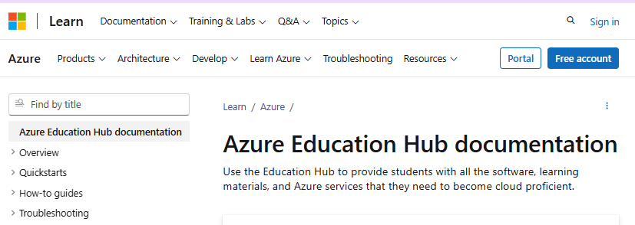

- Do the following:
  - Choose: Sign In (upper-right)
  - Choose: Work or school account
  - Sign in to VSU as prompted
  - Complete the 2-factor (MS Authenticator)
More than likely, you’ll get this error below. If so, try signing up with another email address. One student has already done this and succeeded in the next steps of these instructions obtaining a trial version that lasts for 3 months. I believe this is a “student” trial. I believe the regular trial period is 30 days. Either way, that should be enough to complete the assignment for this course.
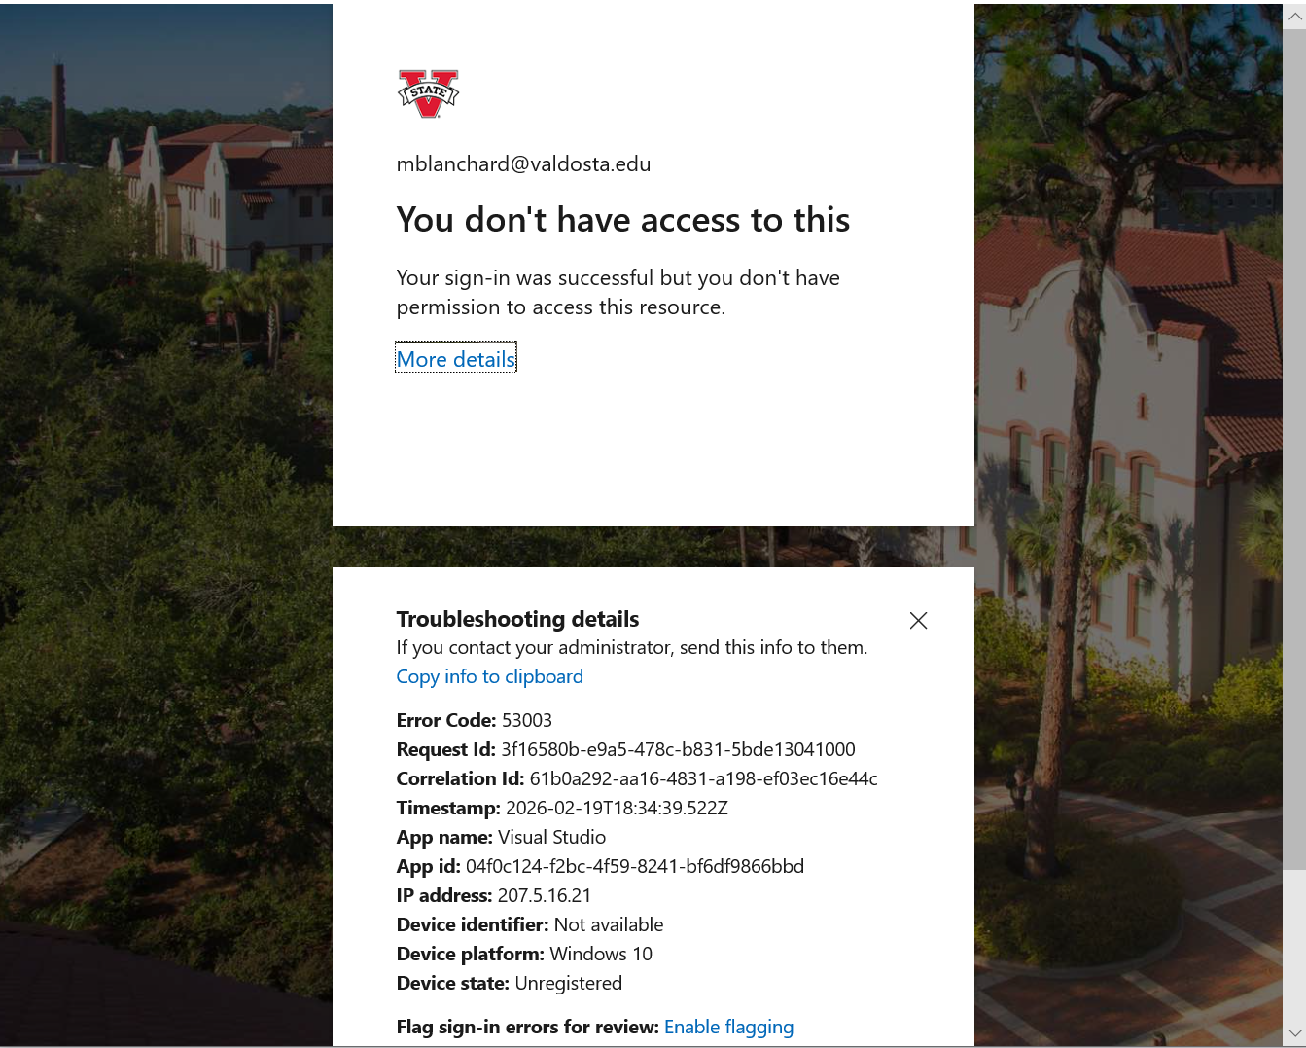
- Next, it recommended that I set up a personal account (something like that), it forced me to do it but was simple.

- Eventually, ended on this page:
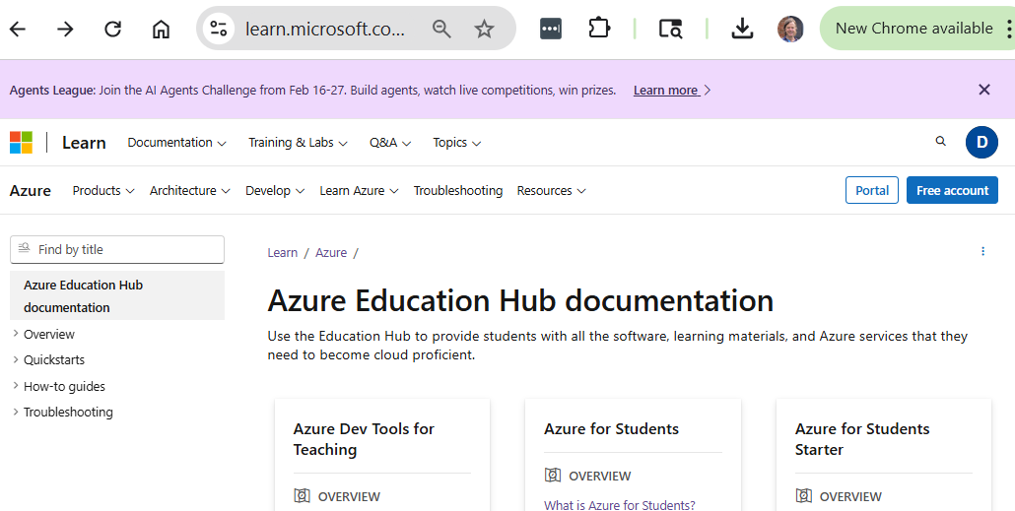
- Choose from upper-left: Products, View all products. Result:
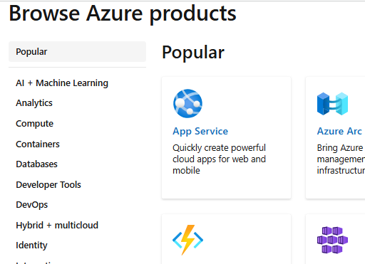

- Choose from the left: Developer Tools. Result:
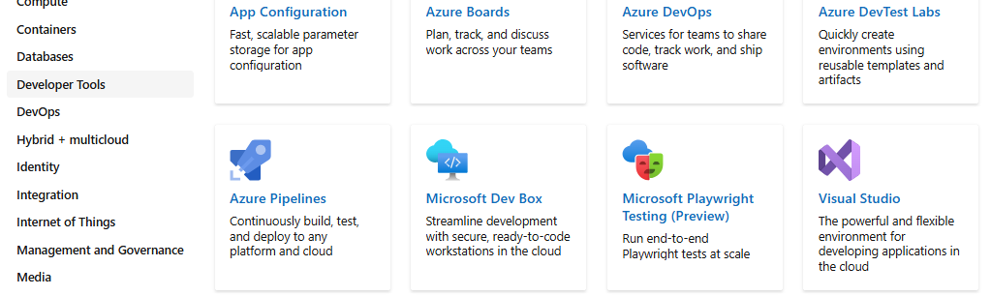
- Choose: Visual Studio. Result:
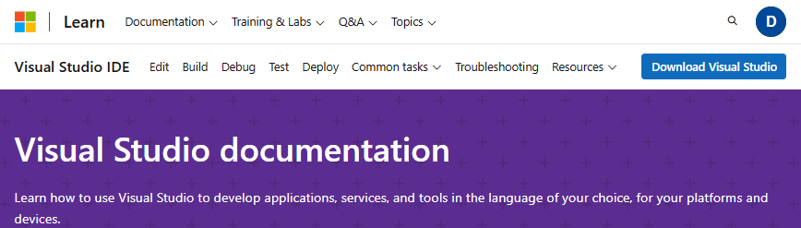
- Choose: Download Visual Studio. Result:
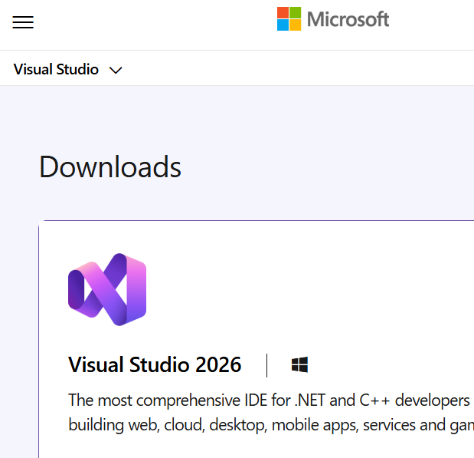

- Scroll down so the result looks like:
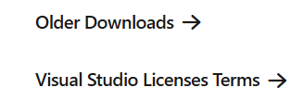
- Choose: Older Downloads. Result:
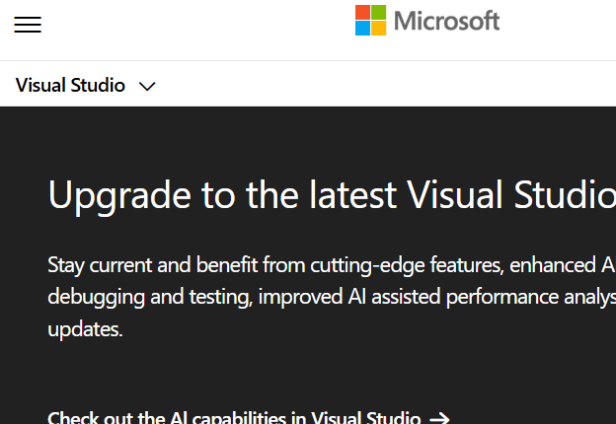
- Scroll down so it looks like:
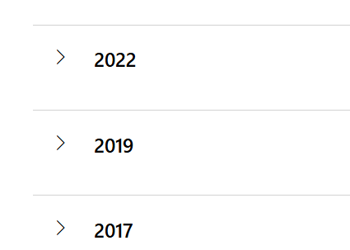

- Open the 2022 Accordion. Result:
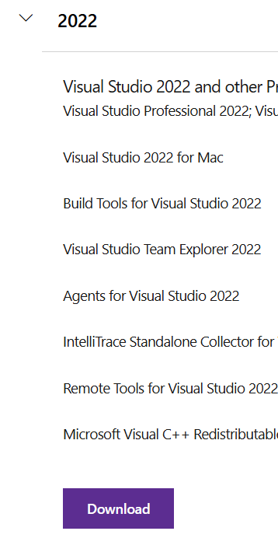

- Choose: Download. Result
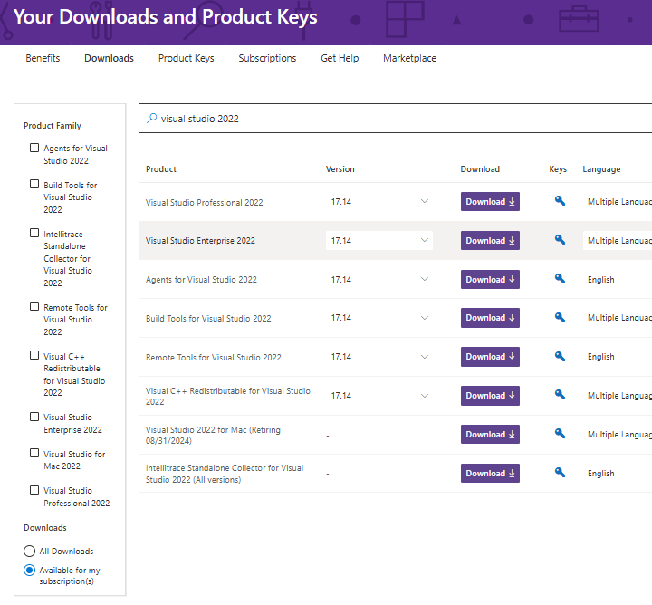
- Notice in the figure above: (a) lower-left, radio button is selected for “Available for my subscription(s)”, (b) Visual Studio Enterprise 2022, (c) note the “Key”. I’m not sure if you will need that, in the past you have needed that, but not much there Spring 2026. Do the following:
  - Choose: Download (on the Visual Studio Enterprise 2022 row)
  - Run the installer (in downloads folder). In the past, this has taken 20+ minutes, as I remember.
- Run VS Enterprise. When you first run it, it asks you how you want to set it up. You’ll want to choose something like “web development” and “C#” for language.

