Responsive Design – Grid & Flexbox
Contents
1 CSS Layout: Grid & Flexbox 1
2 CSS Grid 2
3 CSS Flexbox 2
4 Media Queries 3
Appendix 1 n/a 3

CSS Layout: Grid & Flexbox
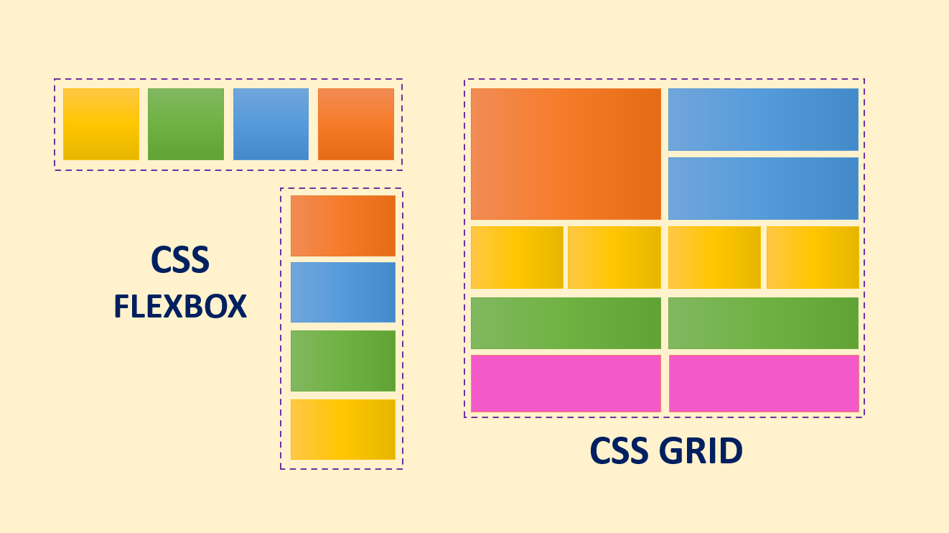
A brief history of HTML/CSS layouting – nice history starting with tables all the way to CSS Grid. CSS Flexible Box Layout Module (Flexbox) gained widespread browser support around 2013 while CSS Grid Layout Module (Grid) gained support around 2017.
High-level overview of CSS Grid & Flexbox:
CSS Grid:
- Uses: display: grid in the container.
- Two-dimensional. Defined with rows and columns, which can be merged.
- Useful for creating more complex and organized layouts.

CSS Flexbox:
- Uses: display: flex in the container.
- One-dimensional, useful in allocating space among the flex items in the flex container.
- Can model a row or column (grids work with both).
“Another major difference between the two is that Flexbox takes a basis in the content while Grid takes a basis in the layout.”
Source for text above: https://www.simplilearn.com/tutorials/css-tutorial/css-grid-vs-flexbox
Source for images: https://medium.com/@g.r.tanny/why-designers-should-learn-flexbox-and-css-grid-d3a48f00aa31

CSS Grid
CSS Grid layout is used to create a grid of elements. A grid container is container (e.g. a <div>) that utilizes the: display: grid or inline-grid property. Direct children of the container become grid items.
Common grid properties:
- Grid Container: grid-template-columns, grid-template-rows, column-gap, row-gap, align-content, align-items, justify-content
- Grid Item: grid-column-start, grid-column-end, grid-row-start, grid-row-end, justify-self, align-self, text-align .
- Go through these in class:
W3Schools – CSS Grid | Comment
Grid Intro | Look at carefully.
Grid Container | Grid Container (see list of properties at bottom), Grid Tracks, Grid Gaps, Grid Align (Look at most, except: Place Items).
Grid Items | See first bit. Scan: grid-area, naming grids, order and the rest. See list of properties at bottom. Some references use the term Grid Cell instead of Grid Item.
- See examples in code download
- Additional references:
Reference | Comment
CSS grid layout | There are many “Guides” towards the bottom of the page. [developer.mozilla]
Basic concepts of grid layout | [developer.mozilla]
CSS Grid Layout | [simplilearn]
CSS Grid Crash Course | Excellent video (54 min) [Traversy Media]

CSS Flexbox
CSS Flexbox is used to arrange elements either horizontally or vertically in a container. A flex container (e.g. a <div>) utilizes the: display: flex or inline-flex property. Direct children of the container become flex items.
Common Flex properties:
- Flex Container: flex-direction, flex-wrap, align-content, align-items, justify-content
- Grid Item: flex-grow, flex-shrink, align-self.
- Go through these in class :
W3Schools – CSS Grid | Comment
Flexbox Intro
Flex Container
Flex Items
- See examples in code download
- Additional references:
Reference | Comments
CSS Flexbox | [W3schools]
Basic concepts of flexbox | Other related topics in left menu. [developer.mozilla]
CSS Flexbox: the Best Guide | [simplilearn]
CSS Grid Vs. Flexbox: A Tutorial | [simplilearn]
Flexbox Crash Course 2022 | Excellent video (47 min) [Traversy Media]
CSS Flexbox
CSS Grid vs. Flexbox

Media Queries
- CSS Flexbox is used to arrange elements. It utilizes the: display: flex, justify-content (center, flex-start, flex-end), and Media Queries are a way to conditionally apply a CSS rule, depending on the screen size. Also see Examples.
Reference | Comments
Intro | [W3schools]
Beginner’s guide to media queries | Other related topics in left menu. [developer.mozilla]
Using media queries | More detailed [developer.mozilla]
Printing | [developer.mozilla]

Appendix
- n/a

