Responsive Design – CSS
Contents
1 Responsive & Adaptive Design 1
2 Implementing Responsive & Adaptive Design 3
2.1 Responsive Design 3
2.2 Semantic Layout Elements 3
2.3 Responsive CSS Properties 4
3 Video – Responsive Web Development Tips 5
4 Responsive Design Tutorials 5
4.1 W3Schools 5
4.2 freeCodeCamp 5
Appendix 1 Responsive Design Resources 6
Appendix 2 Firefox Tools 8
Appendix 2.1 Responsive Design Mode 8
Appendix 2.2 Developer Tools 9
Appendix 3 Viewport 10

Responsive & Adaptive Design
One part of User Experience (UX) Design is specifying the visual design: what components are on the page and how they are arranged. Responsive Design refers to a design that changes to fit the browser window. Do the following:
- Open Firefox browser and open this page: https://www.bostonglobe.com/, in Firefox
- Put in Responsive Design Mode (Ctrl+Shift+M)
- Display Developer Tools (Ctrl+Shift+I). Reduce page to 50x50px and then enlarge.
An Adaptive Design has multiple fixed-size designs and the appropriate one is chosen depending on the screen size. Inside adaptive design, there are often responsive components. See:
- https://www.amazon.com/, look like one design for large down to mobile, and then changes at mobile.
- https://www.usatoday.com/ , appears to be just one size
- https://www.homedepot.com/, The icons on the right (Shop All, Services, …) fall off at 1023px width
- https://www.apple.com/, The font size on the “Store” text decreases at 736px width.
This is a good visual of the difference between responsive and adaptive design.
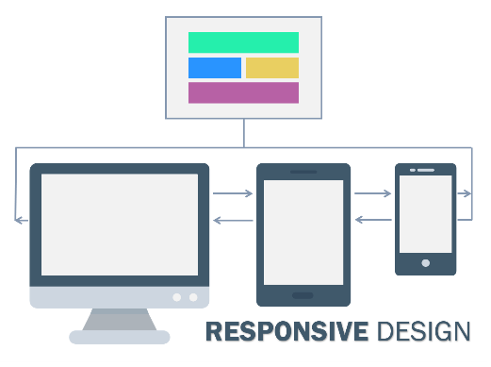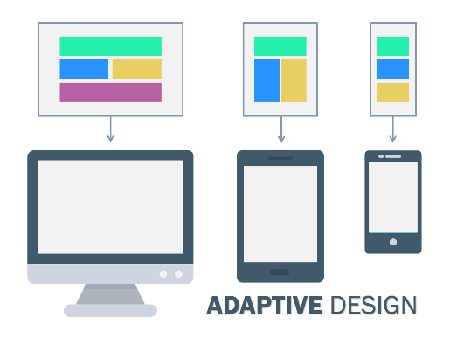
Responsive Design:
A responsive website shows content based on the available browser space. If you open a responsive site on the desktop and then change the size of the browser window, the content will move dynamically to arrange itself (at least in theory) optimally for the browser window. On mobile phones, this process is automatic; the site checks for the available space and then presents itself in the ideal arrangement.
Responsive design is straightforward. Because it is fluid, it means that users can access your online world and enjoy as much of it on their handheld device as they would on a massive monitor. For this to be true, responsive design requires a very good conceptualization of the site and a deep knowledge of the needs and wants of the end users!
Adaptive Design:
Where responsive design relies on changing the design pattern to fit the real estate available to it, adaptive design has multiple fixed layout sizes. When the site detects the available space, it selects the layout most appropriate for the screen. So, when you open a browser on the desktop, the site chooses the best layout for that desktop screen; resizing the browser has no impact on the design.
Some sites have been quick to embrace adaptive design. Amazon, USA Today, Apple, and About.com configured themselves to be mobile-optimized websites. The layout displayed on a mobile website using adaptive design may be different from the desktop’s version. However, this is because the designers have picked a different layout for the phone’s screen rather than leaving the design to try to rearrange itself.
In adaptive design, it’s normal to develop six designs for the six most common screen widths; 320, 480, 760, 960, 1200, and 1600 pixels.
Comparison:
Responsive Design is easier and takes less work to implement. … Responsive designers create a single design to be used on all screens and will generally start in the middle of the resolution and use media queries to determine what adjustments will be made for the lower and higher end of the resolution scale.
Adaptive design will (theoretically) ensure the best user experience according to whichever device the user is using to interface. Unlike responsive design, where a screen “flows” from desktop design into a smaller device’s, adaptive design offers tailor-made solutions…. Another advantage — research shows that a company with an adaptive website will often outperform, on speed tests, a company with a responsive website. This isn’t a small difference either; adaptive sites are often 2-3 times faster than responsive ones and give rather less data to the user in order to deliver the user experience
Responsive Design is the most popular, currently.
Source: https://www.interaction-design.org/literature/article/adaptive-vs-responsive-design
Other references:
- https://www.interaction-design.org/literature/topics/responsive-design
- https://www.interaction-design.org/literature/topics/adaptive-design
- https://www.interaction-design.org/literature/topics/ui-design-patterns
- https://www.uxpin.com/studio/blog/responsive-vs-adaptive-design-whats-best-choice-designers/

Implementing Responsive & Adaptive Design
This section discusses some of the techniques needed for designing responsive and adaptive sites.

Responsive Design
We will consider three approaches to building responsive or adaptive sites:
- Manually – Apply CSS to HTML in such a way that the site is responsive. This involves techniques we consider next: semantic HTML elements (Section 2.2) and/or divs; and styling them properly using CSS display, float, clear, box-sizing, and others; Media Queries (Section 2.3);
- Manually using CSS Grid; and CSS Flexbox. These techniques offer a powerful way to organize a page using display: grid and display: flex, respectively. These are considered in a different document, 09_responsive_grid_flex_notes.docx.
- Framework - Use a CSS framework such as W3.CSS, Bootstrap , or Tailwind to build responsive designs. These are styles built on top of the CSS concepts mentioned above. They usually also rely on JavaScript. We will only consider Bootstrap and that is in the document: 10_responsive_bootstrap_notes.docx.
“In essence, a CSS framework comprises several CSS stylesheets ready for use by web developers and designers. The stylesheets are prepped for standard web design functions: setting colors, layout, fonts, navbars, etc. Generally, stylesheets are supported and expanded by other scripting technologies like SASS and JavaScript.”
“With a CSS framework, the user has a completed CSS stylesheet, and they only have to code the HTML with accurate classes, structure, and IDs to set up a web page. The framework already has classes built-in for common website elements – footer, slider, navigation bar, hamburger menu, column-based layouts, etc.”
Source: https://www.browserstack.com/guide/top-css-frameworks

Semantic Layout Elements
HTML has several semantic elements that define the different parts of a web page:
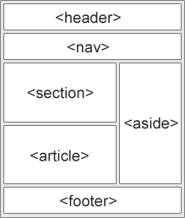 | - <header> - Defines a header for a document or a section  - <nav> - Defines a set of navigation links  - <section> - Defines a section in a document  - <article> - Defines an independent, self-contained content  - <aside> - Defines content aside from the content (like a sidebar)  - <footer> - Defines a footer for a document or a section  - <details> - Defines additional details that the user can open and close on demand  - <summary> - Defines a heading for the <details> element
Source: https://www.w3schools.com/html/html_layout.asp
There are a number of acceptable scenarios with section and article tags including: articles nested inside a section, sections nested inside an article, sections inside an article which is inside a section, and articles within articles, etc. S->*A, A->*S, S<->*A, A->*A
For more detail, see HTML Semantics.
Using semantic elements provides more information for screen readers and makes the HTML more understandable. They do render a bit different from a div tag. Every browser uses a default style sheet that defines how all HTML elements are rendered.
Why use an HTML5 semantic tag instead of div? – See the excellent first answer.

Responsive CSS Properties
This section has a few more CSS topics that are useful for responsive design.
- The display property is the most important CSS property for controlling layout.
- CSS display Property – Study this completely.
- CSS display, CSS ref – Scan, see, “Show demo” at beginning
Reference | Comments
CSS display Property | [W3schools]
CSS display, CSS ref | In second section, Definition & Usage, choose the “Show demo” button. [W3schools]
display | [developer.mozilla]
CSS Display: One-Stop Tutorial | [simplilearn]
- The CSS overflow property controls what happens to content that is too big to fit into an area.
- CSS Layout - Overflow – Scan
Reference | Comments
CSS Layout - Overflow | [W3schools]
overflow | [developer.mozilla]
Flow layout and overflow | [developer.mozilla]
- The CSS float property specifies how an element should float (left, right, none, inherit). Examples: float an image to the left or right around text.
- CSS Layout - float and clear – Scan
Reference | Comments
CSS Layout - float and clear | [W3schools]
float | [developer.mozilla]
- The CSS clear property specifies what should happen to an element when it is next to a floating element. In other words, if you have some floated elements and you want the next element to be below, you use the clear property. The authors recommend: clearfix::after to handle an element (e.g. an image) that overflows its container.
- CSS Layout - clear and clearfix – Scan
Reference | Comments
CSS Layout - clear and clearfix | [W3schools]
clear | [developer.mozilla]

- The CSS box-sizing property allows us to include the padding and border in an element’s total width and height. By default, the actual width of an element is: width + padding + border. In other words, if you have a div with a width of 100 and add 10-pixel padding, then the div will appear bigger than you have set. In this case, the width of the div would be 120 pixels. By applying: box-sizing: border-box, to an element, this will force the element’s actual width to include the padding and border. A common rule defines that all elements on the page (“*” is the universal selector, it selects everything on the page) will have this feature applied to them.
* {
box-sizing: border-box;
}
Reference | Comments
CSS Box Sizing | [W3schools]
box-sizing | [developer.mozilla]

Video – Responsive Web Development Tips
Responsive Web Development Tips That Everyone Should Know (len: 9:40)
Time | Description
0:00 | Responsive Design
7:02 | SASS Preprocessor
7:40 | BEM (Block, Element, Modifier) is a component-based approach to web development
8:36 | What is next for CSS

Responsive Design Tutorials

W3Schools
Go through this in class: https://www.w3schools.com/html/html_responsive.asp
- What is responsive design?
- Setting the viewport (another source: Viewport meta tag). Explanation of viewport.
- Responsive images – max-width property, picture property (scan/ignore)
- Responsive text size – use the “vw” unit for text sizes (viewport width)
- Media queries – Different styles for different browser sizes.
  - Media query fundamentals
  - Using media queries
  - Responsive Web Design - Media Queries
- Full Example – Does not use Grid nor FlexBox. Structure is responsive, text is not.
- Shows example using frameworks:
  - w3.css – smaller, alternative to bootstrap, independent of jQuery and any other JS library. Shows example with no explanation, and provides link to tutorial: https://www.w3schools.com/w3css/default.asp. We will NOT cover this
  - Bootstrap - uses jQuery, most popular of frameworks. Shows example with no explanation, and provides link to tutorial: https://www.w3schools.com/bootstrap/default.asp. We will cover this later.

freeCodeCamp
Go through this in class: https://www.freecodecamp.org/news/learn-responsive-web-design-in-5-minutes/

Appendix
- Responsive Design Resources
Responsive Design, UI Design, RD-Let Device to the Work. More detail than w3schools. High-level. Useful.
- https://www.interaction-design.org/literature/topics/responsive-design
- https://www.interaction-design.org/literature/topics/ui-design-patterns
- https://www.interaction-design.org/literature/article/responsive-design-let-the-device-do-the-work
- https://developer.mozilla.org/en-US/docs/Learn/CSS/CSS_layout/Responsive_Design - First bit is useful, detailed later
The Encyclopedia of Human-Computer Interaction, 2nd Ed. 4000 pages, 53 chapters.
- https://www.interaction-design.org/literature
HTML 5
- https://www.tutorialspoint.com/html5/html5_new_tags.htm – New tags in HTML 5 (2014)
- https://www.techonthenet.com/html/index.php – Index on right of all tags, simple example of each
- Header sizes in em: https://html.spec.whatwg.org/multipage/rendering.html#sections-and-headings
- HTML spec: https://html.spec.whatwg.org/multipage/rendering.html
CSS
The is the W3School tutorial on CSS. The items in blue were (mostly) not considered in class

CSS Tutorial  - CSS HOME – Already covered  - CSS Introduction – Already covered  - CSS Syntax – Already covered  - CSS Selectors – Already covered  - CSS How To – Already covered  - CSS Colors – Already covered  - CSS Backgrounds – Already covered  - CSS Borders – Already covered  - CSS Margins – Already covered  - CSS Padding – Already covered  - CSS Height/Width – Already covered  - CSS Box Model – Already covered  - CSS Outline – Already covered  - CSS Text – Already covered  - CSS Fonts – Already covered  - CSS Icons - Omit  - CSS Links – Scan quickly  - CSS Lists – Already covered  - CSS Tables – Already covered | - CSS Display – Scan  - CSS Max-width - Scan  - CSS Position – Read carefully  - CSS Overflow - Scan  - CSS Float – Read carefully  - CSS Inline-block - Read carefully  - CSS Align – Read carefully  - CSS Combinators – Already covered  - CSS Pseudo-class – Read carefully  - CSS Pseudo-element – Scan  - CSS Opacity – Omit  - CSS Navigation Bar – Scan  - CSS Dropdowns – Scan  - CSS Image Gallery – Omit  - CSS Image Sprites – Omit  - CSS Attr Selectors – Scan Quickly  - CSS Forms – Read carefully  - CSS Counters – Scan Quickly  - CSS Website Layout – Read very carefully  - CSS Units – Scan quickly  - CSS Specificity – Scan quickly

The “Advanced” section at the bottom of the tutorial also has some useful topics:
CSS Advanced Tutorial  - CSS Rounded Corners – Scan quickly  - CSS Border Images – Omit  - CSS Backgrounds – Omit  - CSS Colors – Scan quickly, only first section: RGBA Colors  - CSS Gradients – Omit  - CSS Shadows – Omit  - CSS Text Effects – Scan quickly, only first section: CSS Word Wrapping  - CSS Web Fonts – Omit  - CSS 2D Transforms – Omit  - CSS 3D Transforms – Omit  - CSS Transitions – Omit  - CSS Animations – Omit | - CSS Tooltips – Scan quickly  - CSS Style Images – Omit  - CSS object-fit – Omit  - CSS Buttons – Scan  - CSS Pagination – Scan quickly  - CSS Multiple Columns – Scan quickly  - CSS User Interface – Scan quickly, only the second section: CSS Resizing  - CSS Variables – Scan quickly  - CSS Box Sizing – Read carefully  - CSS Media Queries – Read carefully  - CSS MQ Examples – Scan quickly, just the first 3 examples.  - CSS Flexbox  - CSS Flexbox – Read carefully  - CSS Flex Container – Scan  - CSS Flex Items – Scan quickly, just the first 2 sections: Child Elements & The order Property  - CSS Flex Responsive – Scan

- Firefox Tools
  - Responsive Design Mode
Firefox has a tool to allow you to see what you page looks like with different screen sizes, without having to resize the browser. It allows you to resize the web page, inside the browser, without changing the size of the browser itself.
Choose: Application Menu (Hamburger menu), More Tools, Responsive Design Mode.
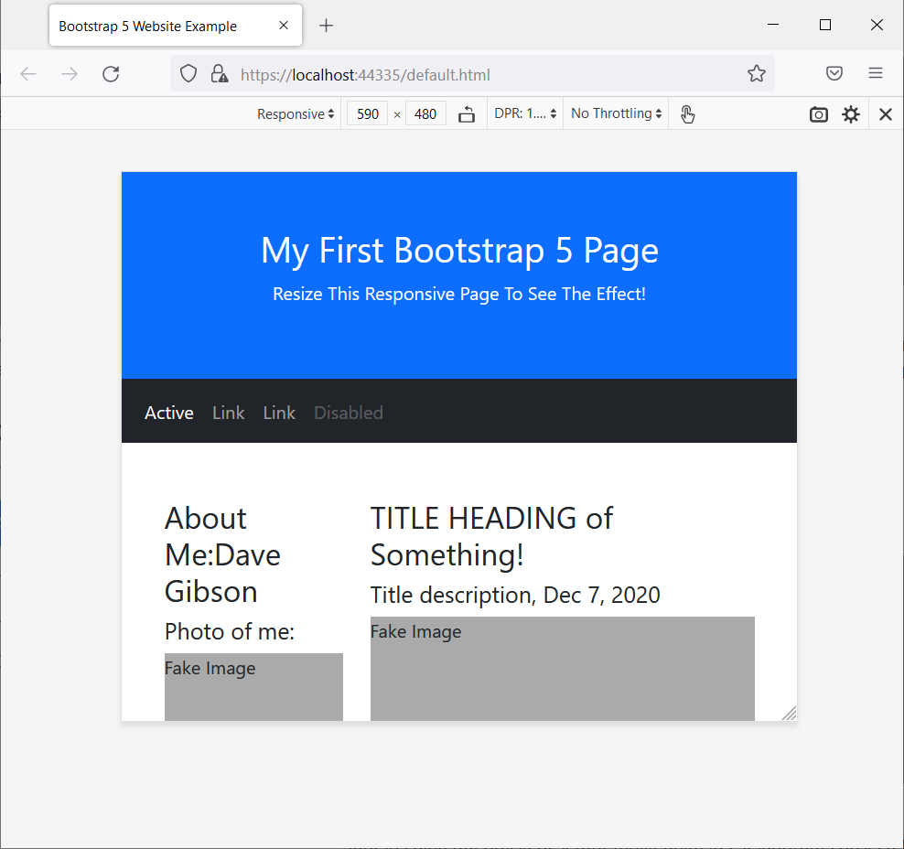

  - Developer Tools
You can also add the Developer Tools. Under Inspector, can select a tag and see what CSS is used and the size of the element including borders, padding, margins.
Choose: Application Menu (Hamburger menu), More Tools, Responsive Design Mode.
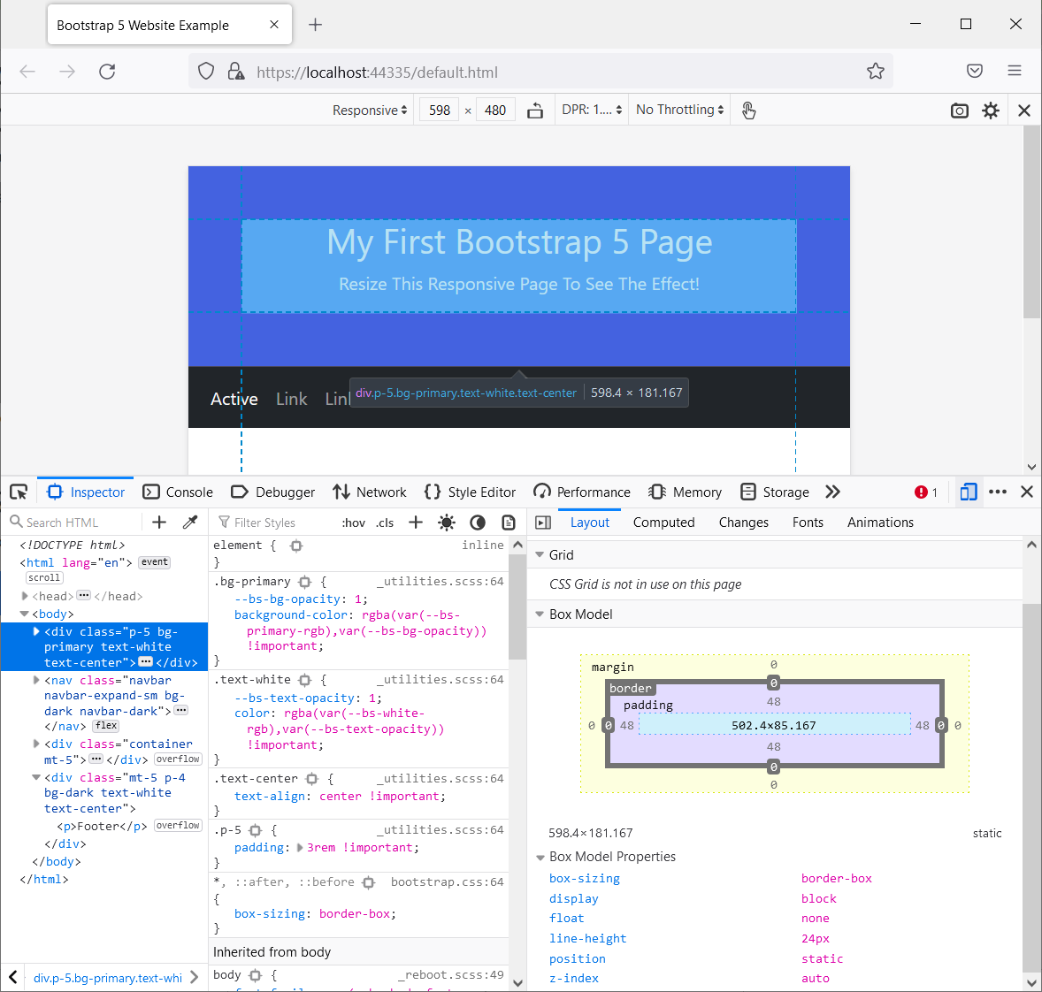

- Viewport
Response from Copilot:
Here’s a moderately detailed explanation of what this line of HTML does:
<meta name="viewport" content="width=device-width, initial-scale=1.0">
What It Is
This is a viewport meta tag, commonly placed inside the <head> section of an HTML document. It tells mobile browsers how to control the page’s dimensions and scaling.
Without it, mobile devices often assume a webpage is designed for desktop screens and automatically zoom out, making the whole layout tiny.
What Each Part Means
- name="viewport"
This tells the browser that the tag provides instructions for the viewport—the visible area of a web page on a device.
- content="width=device-width"
- Sets the layout width of the page to match the actual width of the device’s screen.
- On a phone with a 390-pixel screen, the CSS layout width becomes 390px.
- Without this, browsers often use a virtual desktop width (e.g., ~980px), which breaks responsive layouts.
- initial-scale=1.0
- Sets the initial zoom level to 1:1 when the page loads.
- “1.0” means the page appears at its natural size, not zoomed in or out.
- Helps ensure consistent layout and readable text on load.
Why It Matters
This tag is essential for responsive web design because it allows CSS media queries and flexible layouts to behave correctly on mobile devices. Without it:
- A page may shrink to fit a desktop-sized layout.
- Buttons and text may appear too small.
- Media queries (like @media (max-width: 600px)) may not trigger as expected.
Summary
In short, the tag tells the browser:
“Render this page at the device’s real width and start at a normal zoom level, so that responsive design works.”
If you want, I can also explain the other optional parameters (like maximum-scale, user-scalable, etc.) and when to use them.

https://medium.muz.li/what-is-awd-5-great-adaptive-web-design-examples-for-inspiration-3218e9f624ea

