JSON Notes

Contents
1 JSON Introducion 2
2 JSON Syntax 3
3 JavaScript Objects 6
3.1 for…in Loop 6
3.2 Convert Object into an Array 6
3.3 Iterate over Array with for…of Loop 6
3.4 Iterate over Array with Indexed Loop 7
3.5 Quoted Property Names 7
4 JS Support for JSON 7
4.1 Load JSON with jQuery 8
4.2 Load JSON with JavaScript fetch 8
4.3 Load JSON with JavaScript XMLHTTPRequest 9
5 Creating HTML with jQuery 9
6 JSON Example 13
6.1 Retrieving the Data 14
6.2 Page Structure 14
6.3 showHeaders Function 14
6.4 showMembers Function 15
7 Expectations 16
Appendix 1 Additional Information about JavaScript Objects 16
Appendix 2 JavaScript Objects – “Classes” 17
Appendix 3 ECMAScript vs. JavaScript 17
Appendix 4 JSON Example 18
Appendix 4.1 Retrieving the Data 19
Appendix 4.2 Page Structure 20
Appendix 4.3 populateHeader Function 20
Appendix 4.4 showHeroes Function 21

JSON Introducion
JSON (JavaScript Object Notation) – Similar to XML, is an open format, text-based data-exchange format that is easy for humans and machines to read. The examples below show the same data represented in JSON and XML.
JSON
- {"employees":[
- {"name":"Shyam", "email":"shyamjaiswal@gmail.com"},
- {"name":"Bob", "email":"bob32@gmail.com"},
- {"name":"Jai", "email":"jai87@gmail.com"}
- ]}

- XML
<employees>
<employee>
<name>Shyam</name>
<email>shyamjaiswal@gmail.com</email>
</employee>
<employee>
<name>Bob</name>
<email>bob32@gmail.com</email>
</employee>
<employee>
<name>Jai</name>
<email>jai87@gmail.com</email>
</employee>
</employees>
JSON vs XML: https://www.w3schools.com/js/js_json_xml.asp
JSON is used by many web services and API’s for providing data to clients. For example, AWS provides support for jSON document databases, that are nonrelational databases designed to store and query data. Other API’s that use JSON: Wikipedia, Facebook, Google Maps, Home Depot, etc. Some that are suitable for small projects: Rick and Morty, WeatherXU, SportsDB, MealDB, Placeholder, etc.
A short, excellent description of JSON: https://aws.amazon.com/documentdb/what-is-json/.

JSON Syntax
JSON syntax is derived from JavaScript object notation syntax:
- Data is in key/value pairs
- The key must be double quoted
- Data is separated by commas
- Curly braces hold objects
- Square brackets hold arrays
- A JSON file has either one object or one array. And, either can be nested in the other at any depth.
References
- Syntax: https://www.w3schools.com/js/js_json_syntax.asp (stop at JavaScript Objects)
- Data Types: https://www.w3schools.com/js/js_json_datatypes.asp
- Arrays: https://www.w3schools.com/js/js_json_arrays.asp
Some examples are shown below. All have been parsed from my GitHub (drgap) in test1.json – test5.json. Later, we will see how a JSON String is parsed to turn it into either a JavaScript object or array. In the examples below, the JSON string is shown, and the corresponding image shows how it is received. response is the variable that references the object or array.
- JSON String representing an Object:
{"name": "Lorenzo", "salary": 76000, "married": true }
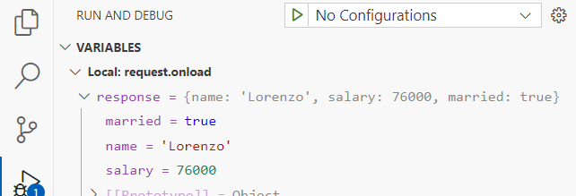
Sample code:
// Imagine that a page has read the JSON string, above into a variable named: response.
const sal = response.salary
- JSON String representing an Array:
["Sunday", "Monday", "Tuesday", "Wednesday", "Thursday", "Friday", "Saturday"]
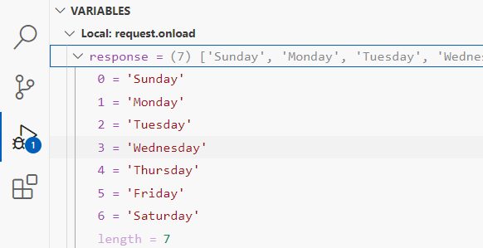
Sample code:
const day = response[5]

- JSON String representing an Array of Objects:
[ {"name":"Ram", "email":"Ram@gmail.com"},
{"name":"Bob", "email":"bob32@gmail.com"} ]
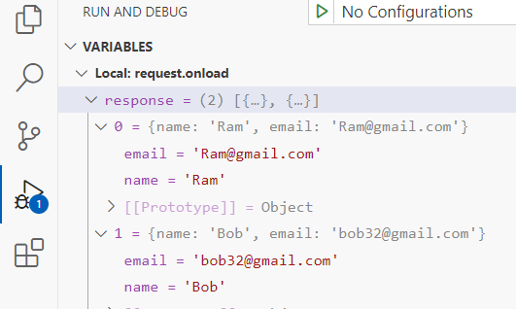
Sample code:
const person = response[0];
const name = person.name;
const name2 = response[0].name;
// Give more meaningful name
const persons = response;
// Loop with for-of
for(person2 of persons) {
msg += person2.email + ", ";
}
// Loop with indexed for
for(i=0; i<persons.length; i++) {
var p = persons[i];
msg += p.email + ", ";
}

- JSON String representing an Object with an Array Property:
{"name":"John", "age":30, "cars":["Ford", "BMW", "Fiat"] }
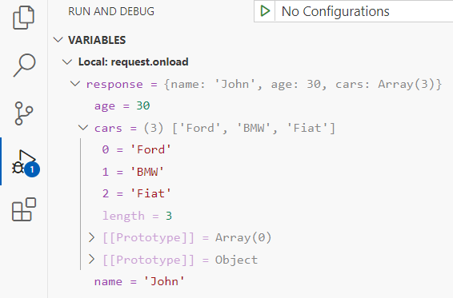
Sample code:
const secondFavCar = response.cars[1]

- JSON String representing an object with a single property, employee, which is an object.:
{"employee": {"name": "Lorenzo", "salary": 76000, "married": true } }
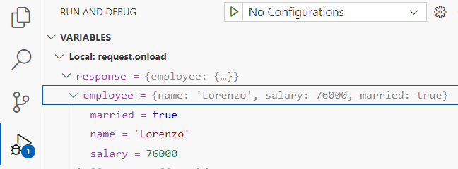
Sample code:
const salary = response.employee.salary
- JSON String representing an array with 3 elements, each element is an object with 2 properties: employee and job, which are themselves objects.
[
{
"employee": {"name": "Lorenzo", "salary": 76000, "married": false},
"job" : {"location": "NYC", "title": "Software Engineer"}
},
{
"employee": {"name": "Sandra", "salary": 89000, "married": true},
"job" : {"location": "SF", "title": "Full-Stack Engineer"}
},
{
"employee": {"name": "Lena", "salary": 67000, "married": false},
"job" : {"location": "ATL", "title": "UX Engineer"}
}
]
Sample code (below, I’ve changed from using response to data):
const firstSal = data[0].employee.salary;
// Give more meaningful name
const employees = data;
// Loop with for-of
for(obj of employees) {
msg += "obj.employee.name:" + obj.employee.name + ", ";
msg += "obj.job.title:" + obj.job.title + "<br>";
}
// Loop with indexed for
for(i=0; i<employees.length; i++) {
var obj = employees[i];
msg += "obj.employee.name:" + obj.employee.name + ", ";
msg += "obj.job.title:" + obj.job.title + "<br>";
}
For many situations, we are interested in representing 1-many data. For example, a Person has many Dog objects. There are two scenarios (A has many B objects) for representing as JSON:
- Represent an A object that inside it has a property that is an array of B objects.
- Represent an array of B objects.
Next, we discuss JavaScript Objects.

JavaScript Objects
JavaScript does not have classes, it only has objects. However, you can encapsulate data and methods into objects. A JavaScript object is a list of name:value pairs. An example of a JS literal is:
var person = {firstName:"John", lastName:"Doe", age:50, eyeColor:"blue"};
Note that a JS object is very similar to a JSON string. One difference is the name of the data fields (e.g. firstName, lastName, age, eyeColor) do not have to be quoted as they do with JSON. As we see later, they can be quoted. A JS object can also be created as shown below. However, the preceding technique is preferred because it is simpler, more readable, and faster:
var person = new Object();
person.firstName = "John";
person.lastName = "Doe";
person.age = 50;
person.eyeColor = "blue";
JS objects are addressed by reference, just the same as Java. Thus, the statement below defines another reference to the same object:
var x = person;
You can use several syntaxes for accessing the property of an object. For example:
- person.age
- person[“age”]
- objectName[expression] – where the expression evaluates to a property name. For example:
x=“age”;
person[x]

for…in Loop
JS provides a for…in loop for iterating over the properties of an object. Note in the code below, that the loop is actually looping over the property names, which are then used to access the property values. For example:
const person = { name: "John", age: 50, city: "New York" };
let msg = "";
for (x in person) {
msg += x + "=" + person[x] + ", ";
}
alert(msg); // name=John, age=50, city=New York

Convert Object into an Array
The values in a JS object can be converted to an array using: Object.values(). For example:
const person = { name: "John", age: 50, city: "New York" };
const myArray = Object.values(person);
You can display an array: alert(myArray); // John,50,New York

Iterate over Array with for…of Loop
JS provides a for…of loop for iterating over the values in an array.
for (val of myArray) {
msg += val + ", ";
}
alert(msg); // John, 50, New York,

Iterate over Array with Indexed Loop
You can also iterate over an array with an indexed loop:
for (i = 0; i < myArray.length; i++) {
msg += myArray[i] + ", ";
}
alert(msg); // John, 50, New York,

Quoted Property Names
JS also allows you to use quoted property names when defining an object. For example:
const person = { "first name": "John", "age": 31, "city": "New York" };
Using this notation, the only thing you can’t do (from the examples above) is use the “dot” notation to access properties. They must be quoted. For example: person["first name"].
Note that this style of object is very similar to JSON. The difference is that JSON is a string, not an object.

JS Support for JSON
JavaScript has a method, JSON.parse, to convert a JSON string into a JavaScript object. For example:
const jSONString = '{ "name": "John", "age": 31, "city": "New York" }';
const jsObjectPerson = JSON.parse(jSONString);
myDiv.innerHTML = jsObjectPerson.name;
JavaScript has a method, JSON.stringify, to convert a JavaScript object into a JSON string. For example:
const jsObjectPerson = { name: "John", age: 50, city: "New York" };
const jSONString = JSON.stringify(jsObjectPerson);
myDiv.innerHTML = jSONString;
alert(jSONString); // {"name":"John","age":50,"city":"New York"}
Tip – If you change your JSON data and your page is not reflecting that change, then there is typically a caching issue. Do this: (1) hard refresh in browser: (Win) Ctrl+Shift+R (Mac) Cmd+Shift+R, (2) Disable cache in Developer Tools: (a) Open Developer Tools: Ctrl+Shift+I, (b) choose the Network tab, (c) at the top, check, “Disable cache”.

Load JSON with jQuery
function loadJSON() {
var url = 'https://raw.githubusercontent.com/drgap/json_example/refs/heads/main/test1.json';
$('#error').text('');
$('#output').text('');
$.getJSON(url, function(data) {
try {
// Do something with the data and build msg output
var msg = 'Successfully loaded ';
$('#output').text(msg);
} catch (e) {
$('#error').text('Failed to process JSON: ' + e.message);
}
}).fail(function(jqxhr, textStatus, error) {
var msg = 'Request failed: ' + (error || textStatus);
$('#error').text(msg);
});
}

Load JSON with JavaScript fetch
function loadJSON(file) {
var url = 'https://raw.githubusercontent.com/drgap/json_example/refs/heads/main/test1/json';
$('#error').text('');
$('#output').text('');
fetch(url)
.then(function(response) {
if (!response.ok) {
throw new Error('Request failed: ' + response.status);
}
return response.json();
})
.then(function(data) {
try {
// Do something with the data and build msg output
var msg = 'Successfully loaded ';
document.getElementById('output').textContent = msg;
} catch (e) {
document.getElementById('error').textContent = 'Failed to process JSON: '
+ e.message;
}
})
.catch(function(error) {
document.getElementById('error').textContent = 'Request failed: ' +
error.message;
});
}

Load JSON with JavaScript XMLHTTPRequest
function loadJSON() {
var url = 'https://raw.githubusercontent.com/drgap/json_example/refs/heads/main/test1.json';
$('#error').text('');
$('#output').text('');
var xhr = new XMLHttpRequest();s
xhr.open('GET', url, true);
xhr.responseType = 'json';
xhr.onload = function() {
if (xhr.status === 200) {
try {
// Do something with the data and build msg output
var msg = 'Successfully loaded ';
document.getElementById('output').textContent = msg;
} catch (e) {
document.getElementById('error').textContent = 'Failed to process JSON: ' +
e.message;
}
} else {
document.getElementById('error').textContent = 'Request failed: ' + xhr.status;
}
};

Creating HTML with jQuery
Here, we show how to use jQuery to create and manipulate HTML tags. There are four ways of creating HTML elements using jQuery:
var newEle = $(document.createElement('div'));
var newEle = $('<div>');
var newEle = $('<div></div>');
var newEle = $('<div/>');
Some common methods you can call on an HTML tag:
- html(): Get or set the HTML contents of an element.
- text(): Get or set the text content, with HTML stripped out.
- append(): Insert content at the end of the element(s).
- attr(): Get or set the value of a specified attribute (e.g., src, href, class).
- css(): Get or set one or more CSS style properties.
- addClass(): Add one or more class names.
- val(): Get or set the value of form elements (like inputs, selects, textareas).

The data in the example below is all hard so that we can focus on the process of creating a page programmatically. The page has three methods, one to build the header and sub-header, one to build the table, and one to build the unordered list. This is the page:
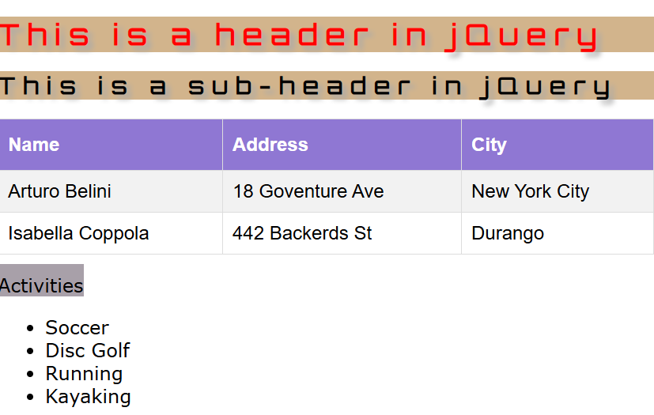
The HTML body is shown below. We are using semantic tags: header and section. We’ll look at these in more detail in a subsequent topic, Responsive Design.
<body>
<header id="header">
</header>
<section id="main_section">
</section>
<script>
buildHeaderAndDisplayJQ();
buildTableAndDisplayJQ();
buildListAndDisplayJQ();
</script>
</body>
This method uses jQuery to build an h1 and an h2, and attach them to the header.
function buildHeaderAndDisplayJQ() {
const $header = $("#header");

var $h1 = $("<h1></h1>"); // Create h1 and attach to header
$h1.text("This is a header in jQuery")
.css('background-color', 'tan');
$header.append($h1);

var $h2 = $("<h2></h2>"); // Create h2 and attach to header
$h2.text("This is a sub-header in jQuery")
.css('background-color', 'tan');
$header.append($h2);
}

This method uses jQuery to build a table with 3 rows. A helper method is used to build an individual row. This code could be easily adapted to the case where you have a data source (array, or object with an array in it) with an unknow number of items by using a loop over the data source.
function buildTableAndDisplayJQ() {
const tableHeader = "<th></th>"; // Passed to buildTableRowJQ to specify to build a row of table headers
const tableData = "<td></td>"; // Passed to buildTableRowJQ to specify to build a row of table data cells
const $table = $("<table id='employees'></table>"); // Create table

var vals = ["Name", "Address", "City"]; // Sample data
var $row = buildTableRowJQ(tableHeader, vals); // Build a <th> row with data
$table.append($row); // Put row in table

vals = ["Arturo Belini", "18 Goventure Ave", "New York City"]; // Sample data
$row = buildTableRowJQ(tableData, vals); // Build a <td> row with data
$table.append($row); // Put row in table

vals = ["Isabella Coppola", "442 Backerds St", "Durango"]; // Sample data
$row = buildTableRowJQ(tableData, vals); // Build a <td> row with data
$table.append($row); // Put row in table

const $section = $("#main_section"); // Get section
$section.append($table); // Put table in section
}
This helper method builds a single row.
function buildTableRowJQ(cellType, vals) {
const $row = $("<tr></tr>");
for(val of vals) {
const $cell = $(cellType);
$cell.text(val);
$row.append($cell);
}
return $row;
}

This method uses jQuery to build an unordered list. It puts the list inside a paragraph.
function buildListAndDisplayJQ() {
const $section = $("#main_section");
const $para = $("<p></p>"); // Put list in a paragraph. Div would work for more flexibility.
const $label = $("<label for='listActivities' class='padTop'>Activities</label>"); // Label for list
$para.append($label); // Put label in paragraph.

const $list = $("<ul id='listActivities'></ul>"); // Create unordered list;
var list_items = ["Soccer", "Disc Golf", "Running", "Kayaking"]; // list items

for(list_item of list_items) {
var $list_item = $("<li></li>"); // Create <li>
$list_item.text(list_item); // Set text
$list.append($list_item); // Add to list
}
$para.append($list); // Put list in paragraph.

$section.append($para); // Put paragraph in section
}

JSON Example
Consider this jSON data that represents a squad of super heroes. The data is shown below on the left and on the right is a class diagram that summarizes the data.
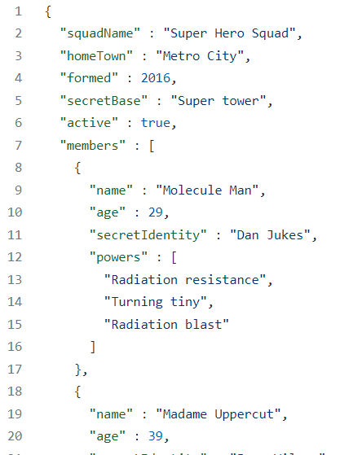 | 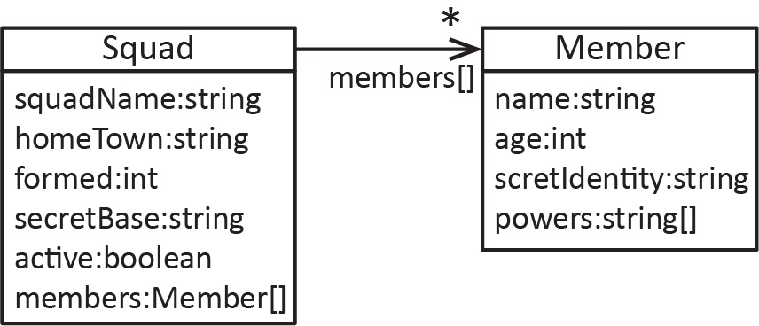
We will write a web page to read and display this data as shown below:
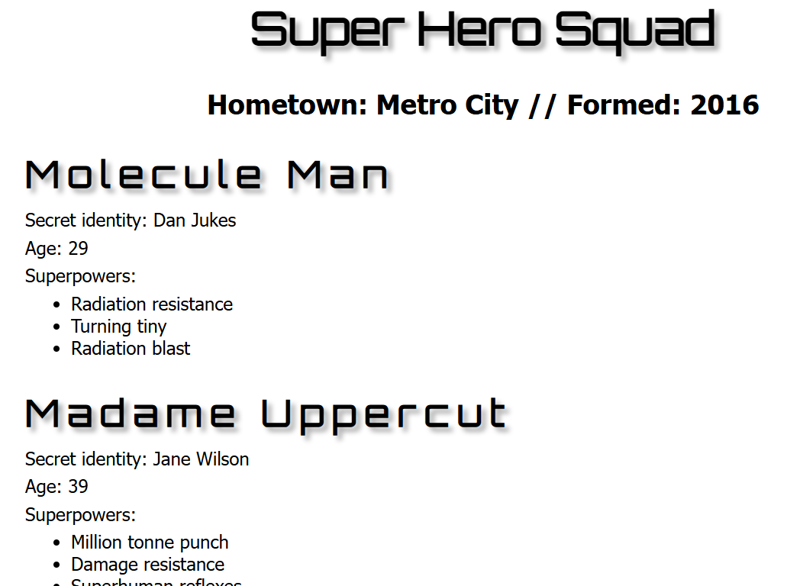

Retrieving the Data
The code for this example is in the download (heroes-new.html). In what follows, we step through the code. The JSON data is automatically parsed into a squad object which is passed to two functions (showHeader & showMemberss) to build the page and display the data.
$(function() {
$.getJSON("https://raw.githubusercontent.com/drgap/json_example/main/superheroes.json",
function(squad) {
showHeaders(squad); // Build page header
showMembers(squad); // Build main section of page
});
});

Page Structure
The HTML is shown below.
<body>
<header id="header">
</header>

<section id="section">
</section>
</body>
Note the following:
- We use the semantic tags: header and section – these tags are layout elements. We study this in more detail later when we consider responsive design.
- Inside the section, we will create an article for each member of the squad.

showHeaders Function
The code is below. Some programmers use “$” in front of any variable that is a jQuery object.
function showHeaders(squad) {
const $header = $("#header");

// Create h1 and attach to header
var $h1 = $("<h1></h1>");
$h1.text(squad['squadName']);
$header.append($h1);

const $p = $("<p></p>"); // Create p and attach to header
const msg = 'Hometown: ' + squad['homeTown'] +
' // Formed: ' + squad['formed'];
$p.text(msg);
$header.append($p);
}

showMembers Function
The code is below. Note that section is the global variable representing the section tag in the page.
function showMembers(squad) {
const $section = $("#section");
// members is an array of Member objects
const members = squad['members'];

for (let i = 0; i < members.length; i++) {
// Put each member in an article
const $article = $("<article></article>");
const $h2 = $("<h2></h2>");
const $p1 = $("<p></p>");
const $p2 = $("<p></p>");
const $p3 = $("<p></p>");
const $ul = $("<ul></ul>");
$h2.text(members[i].name)
$p1.text('Secret identity: ' + members[i].secretIdentity);
$p2.text('Age: ' + members[i].age);
$p3.text('Superpowers:');
// powers variable represents the powers array this member object has
const powers = members[i].powers;
for (let j = 0; j < powers.length; j++) {
const $li = $("<li></li>");
$li.text(powers[j]);
$ul.append($li);
}
$p3.append($ul);

$article.append($h2);
$article.append($p1);
$article.append($p2);
$article.append($p3);
$article.append($ul);
$section.append($article);
}
}

Expectations
- Given the description of a situation, write a JSON string.

Appendix
- Additional Information about JavaScript Objects
- JS properties can be added and deleted. For example:
var person = {fname:"John", lname:"Doe", age:25};

person.nationality = "English"; // Add property

document.getElementById("demo").innerHTML =
person.fname + " is " + person.nationality + ".";

delete person.age;
- Example of a JS method:
var person = {
firstName: "John",
lastName : "Doe",
id : 5566,
fullName : function() {
return this.firstName + " " + this.lastName;
}
};

// Display data from the object:
document.getElementById("demo").innerHTML = person.fullName();
- JS methods are functions stored as object properties. Thus, if you loop over the object properties, the fullName property in the example below will display the method itself
var person = {
firstName: "John",
lastName : "Doe",
id : 5566,
fullName : function() {
return this.firstName + " " + this.lastName;
}
};

for (x in person) {
txt += person[x] + " ";
};
Output:
John Doe 5566 function() { return this.firstName + " " + this.lastName; }

- JavaScript Objects – “Classes”

- A JS “class”:

// Constructor
function Person(first, last, age, eye) {
this.firstName = first;
this.lastName = last;
this.age = age;
this.eyeColor = eye;
}

// Add a method:
Person.prototype.name = function() {
return this.firstName + " " + this.lastName
};

// Create an object
var myFather = new Person("John", "Doe", 50, "blue");
var myMother = new Person("Mary", "Doe", 51, "brown");

document.getElementById("demo").innerHTML = "My father is " + myFather.name();

- ECMAScript vs. JavaScript
- ECMAScript vs. JavaScript
The ECMAScript specification is a standardized specification of a scripting language. ECMAScript is a programming language. JavaScript, on the other hand, can be viewed as a "dialect" of ECMAScript. It conforms to the ECMAScript specification while also providing additional features not described in the specification. However, JS does not provide all the features of ECMAScript.

https://en.wikipedia.org/wiki/ECMAScript

- JSON Example
Older, uses JS approach. Consider this jSON data that represents a squad of super heroes. The data is shown below on the left and on the right is a class diagram that summarizes the data.
We will write a web page to read and display this data as shown below:
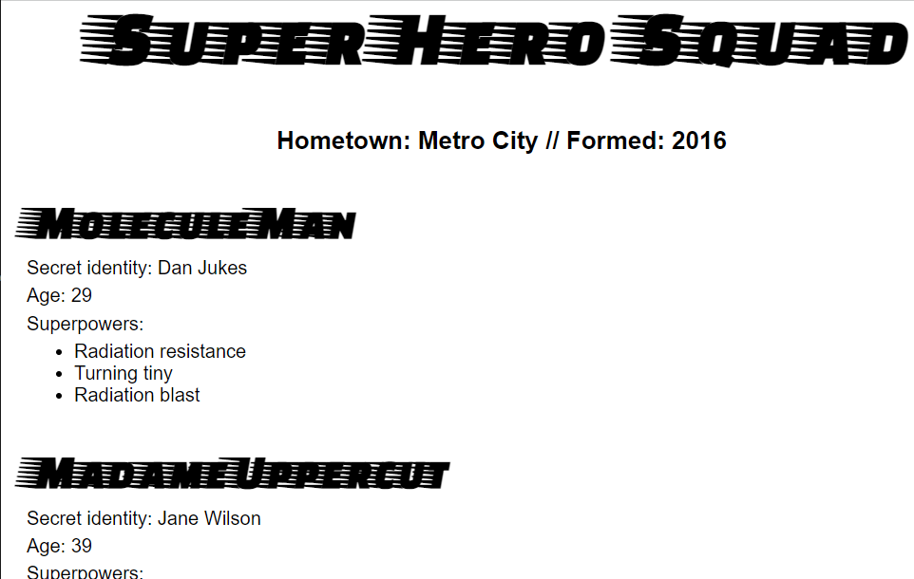
  - Retrieving the Data
The code for this example is in the download (heroes.html). In what follows, we step through the code. First, the code uses AJAX to make an asynchronous call to retrieve the data from my GitHub account. When the data is received (request.response) it is converted into a JS object (superHeroes), which is passed to two functions (populateHeader & showHeroes) to build the page and display the data.
let requestURL = 'https://raw.githubusercontent.com/drgap/json_example/main/superheroes.json';
// AJAX - make asynchronous call to get data.
let request = new XMLHttpRequest();
request.open('GET', requestURL);
request.responseType = 'json'; // type of data being returned
request.send();

// When server responds, call this function
request.onload = function () {
const superHeroes = request.response; // Converts the jSON to a single object.
populateHeader(superHeroes); // Build page header
showHeroes(superHeroes); // Build main section of page
}
Note in the code above, by setting:
request.responseType = 'json';
when the response is received:
const superHeroes = request.response;
the data has been automatically converted to a JS object. However, if we had set:
request.responseType = 'text';
when the response is received we would have need to parse it to create a JS object:
const superHeroes = JSON.parse(request.response);

  - Page Structure
The HTML is shown below. Note the following:
- We use the semantic tags: header and section – these tags are layout elements. We study this in more detail later when we consider responsive design.
- The main script is in the body of the page because we need it to execute and build the page. The helper functions, populateHeader & showHeroes are in the head section (not shown here).
- The header and section variables are global variables because they are declared outside any functions. Thus, they will be available in the helper functions.
- The querySelector method returns the first occurrence of the argument. Alternately, header could have been accessed with: const header = document.getElementById('hdr');
<body>
<header id="hdr">
</header>

<section>
</section>

<script>
const header = document.querySelector('header');
const section = document.querySelector('section');

let requestURL = 'https://raw.githubusercontent.com/...superheroes.json';
let request = new XMLHttpRequest();
request.open('GET', requestURL);
...
populateHeader(superHeroes); // Build page header
showHeroes(superHeroes); // Build main section of page
}
</script>
</body>

  - populateHeader Function
The code is below. Note that header is the global variable representing the header section in the page.
function populateHeader(superHeroes) {
const myH1 = document.createElement('h1');
myH1.textContent = superHeroes['squadName'];
header.appendChild(myH1);

const myPara = document.createElement('p');
myPara.textContent = 'Hometown: ' + superHeroes['homeTown'] +
' // Formed: ' + superHeroes['formed'];
header.appendChild(myPara);
}

  - showHeroes Function
The code is below. Note that section is the global variable representing the section tag in the page.
function showHeroes(superHeroes) {
// members is an array of objects
const heroes = superHeroes['members'];

for (let i = 0; i < heroes.length; i++) {
const myArticle = document.createElement('article');
const myH2 = document.createElement('h2');
const myPara1 = document.createElement('p');
const myPara2 = document.createElement('p');
const myPara3 = document.createElement('p');
const myList = document.createElement('ul');

myH2.textContent = heroes[i].name;
myPara1.textContent = 'Secret identity: ' + heroes[i].secretIdentity;
myPara2.textContent = 'Age: ' + heroes[i].age;
myPara3.textContent = 'Superpowers:';

const superPowers = heroes[i].powers; // heros[i].powers is an array of objects
for (let j = 0; j < superPowers.length; j++) {
const listItem = document.createElement('li');
listItem.textContent = superPowers[j];
myList.appendChild(listItem);
}

myArticle.appendChild(myH2);
myArticle.appendChild(myPara1);
myArticle.appendChild(myPara2);
myArticle.appendChild(myPara3);
myArticle.appendChild(myList);

section.appendChild(myArticle);
}
}

