jQuery

Contents
1 Introduction 2
2 How to use jQuery 3
3 .ready(handler) Method 4
4 Example – HelloWorld and Hide/Show 5
5 Example – TextField & TextArea 7
6 Example – Checkboxes 7
7 Example – RadioButtons 8
8 Example – Dropdown 8
9 Example – Dropdown Multi-Select 8
10 Example – Chaining 8
11 Example – Form Processing 9
12 More Examples 11
13 Expectations 11
Appendix 1 W3Schools Tutorials 12
Appendix 2 Examples of Selectors 13
Appendix 3 Events 13
Appendix 4 Effects 13
Appendix 5 Examples 13
Appendix 6 Callback Functions 14
Appendix 7 Get and Set Contents 14
Appendix 8 Add/Remove Contents 14
Appendix 9 Manipulating CSS 14
Appendix 10 References 14
Appendix 11 External Examples 14

Introduction
jQuery is a JavaScript library that simplifies using the JavaScript DOM, event handling, animation, and AJAX code. This allows developers to write simpler code to provide an enhanced user experience. jQuery is written in JavaScript. Anything you can do in jQuery, you can do in JavaScript, but in many cases, it would take much more code. An excellent high-lever overview and history of the language is found at Wikipedia.
Consider an example to hide all paragraphs:
JavaScript | jQuery
function hideParagraphs() {  var paragraphs = document.querySelectorAll("p");  for(i=0; i<paragraphs.length; i++) {  paragraphs[i].style.display = "none";  }  } | $("#btnJQHide").click(function () {  $("p").hide();  });
An important part of client-side code is the ability to manipulate HTML and as such, an important first step is the ability to select HTML elements. Consider several different ways to select elements using JavaScript and jQuery.
Select Element(s) by | JavaScript | jQuery
Id | getElementById("myId") | $("#myId")
Name attribute | getElementsByName("myName") | $("[name=’myName’]")
Class name | getElementsByClassName("myClass") | $(".myClass")
Tag | getElementsByTagName("p") | $(“p”)
However, jQuery allows many more ways to select elements, as we will see later. Some notes about jQuery:
- The “$” is an alias for “jQuery”. For example, these two statements are identical: $("h2") and jQuery("h2").
- $ (or jQuery) is simply a JavaScript function that takes different types of input.
- The argument for a call to $ (jQuery) is called a selector, which are very similar to CSS selectors.
- A jQuery selector returns a jQuery object that wraps the HTML element(s) that were selected. A jQuery object has over 300 methods (actions) for manipulating the elements. This is what makes jQuery so powerful. (The JavaScript getElement… functions return an HTML element or an array of HTML elements.)
- Most jQuery methods return a jQuery object, which means that actions (methods) can be chained together.
Example 1
$("#btnJQHideShow").click(function () {
$("p").fadeOut(2000).fadeIn(2000);
});
Example 2
$("div").click(function () {
$(this)
.find('ul') // Selects all <ul> elements
.css('border', '1px solid red') // Applies a red border to <ul>s
.end() // Reverts the selection back to the div that was clicked
.css('border', '2px solid blue'); // Applies a blue border to the div
});

- jQuery methods can also return: string, number, Boolean, JS Objects or arrays, DOM element. These methods are called terminal methods, meaning no more chaining is possible.

The basic syntax of a jQuery statement is:
$(selector).action()
Where:
- $ – Used to access jQuery
- selector – Used to find HTML element(s)
- $(selector) – Returns a jQuery object that wraps all the elements that were selected. Thus, we can call one of the 300+ jQuery methods on this object.
- action – Action to be performed on the element(s). Repeat of above: More specifically, it is a jQuery method. As stated above, the selector returns HTML objects wrapped as a jQuery object; thus, we can call jQuery methods on this object.
As an example, the text method sets or returns the text content of selected elements. For example, this statement changes the text of all level 2 headers to the value shown:
$("h2").text("Header is changed");
Some resources:
Resource | Description
jQuery API | jQuery methods documentation
Selectors API | Selectors API
learn.jQuery | A good reference for selecting and using elements
TutorialsTeacher | Selectors tutorial
freeCodeCamp | Thorough, simple jQuery tutorial

How to use jQuery
You can use jQuery in one of two ways:
- Include it from a Content Delivery Network (CDN) by adding the statement below in the head section. Google is a CDN for jQuery.
<script src="https://ajax.googleapis.com/ajax/libs/jquery/3.7.1/jquery.min.js"></script>
- Download it from: http://jquery.com/download/ and then put it in your folder where your pages are. Then, reference it by adding this in the head section:
<script src="jquery-3.7.1.min.js"></script>

.ready(handler) Method
Suppose we have a button that is to trigger an event handler when pressed. With JS, the button would have a click attribute specifying which JS function to call. For jQuery, we generally write code that runs when the page is completely loaded. This code does three things: (1) selects the button, (2) attaches a click event to the button, and (3) defines an anonymous function to be the event handler.
We first consider the:
.ready(function() {...})
jQuery method. The ready method accepts a function, which is executed when the DOM is fully loaded into memory. One common application of this is to define and attach event handlers to various controls on the page. The general syntax for this approach is:
$(document).ready(function() {
// jQuery functions go here...
});
This statement selects the entire HTML document and calls the ready method on it. Once the DOM is loaded, the function is executed.
Note: The syntax above is depreciated; however, you will find it all over the web and even in the official jQuery tutorials. These notes will continue to use the deprecated syntax. The new syntax is:
$(function() {
// jQuery functions go here...
});
For example,
Code | Interpretation
<script>  $(document).ready(function () {  $("p").click(function () {  $(this).hide();  });  });  </script> | - Assigns the click event to all paragraphs, once the DOM is loaded.  - The click event accepts a function which executes when a paragraph is clicked. In this case, the clicked paragraph would be hidden.  - This function is called an event handler and is implemented as an anonymous function.  - this is a reference to the HTML DOM element that is the source of the event (i.e. a paragraph).

Note: The syntax above is depreciated. These notes will continue to use the deprecated syntax. The new syntax is:
$("p").on(‘click’, function () {
$(this).hide();
});

The example above, could be modularized (though this doesn’t seem to be done very often in practice) as shown below See jq_modular.html on the website.
function hideParagraph() {
$("p").click(function () {
$(this).hide();
});
}

$(document).ready(hideParagraph());
If you had multiple event handlers:
$(document).ready(function() {
hideParagraph();
hideHeaders();
});

Example – HelloWorld and Hide/Show
Example – Illustrates “hello world” using jQuery. Also shows how to hide and redisplay a button. See jq_1.html on the website.
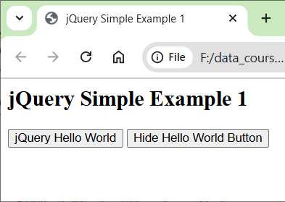 | 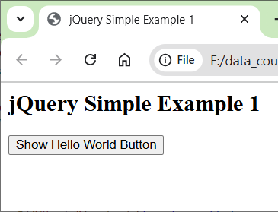

<html>
<head>
...
<script src="https://ajax.googleapis.com/ajax/libs/jquery/3.3.1/jquery.min.js"></script>
<script type="text/javascript">
$(document).ready(function () {
$("#jqButton").click(function () {
alert("jQuery Hello World");
});
$("#hide").click(function () {
if ($(this).text() === "Hide Hello World Button") {
$("#jqButton").hide();
$(this).text("Show Hello World Button");
}
else if ($(this).text() === "Show Hello World Button") {
$("#jqButton").show();
$(this).text("Hide Hello World Button");
}
});
});
</script>
</head>
<body>
<h2>jQuery Simple Example 1</h2>
<form id="hello">
<button type="button" id="jqButton">jQuery Hello World</button>
<button type="button" id="hide">Hide Hello World Button</button>
</form>
</body>
</html>

Note:
- In JavaScript, “===” returns true only when the operands are the same type and the contents are the same.

Example – TextField & TextArea
Consider this HTML which displays a button, a text box, and a text area:
<button type="button" id="process">Process</button>
<input id="name" type="text" />
<textarea id="message"></textarea>
In the jQuery code below, the element with id=”process” (the button) is selected and a click event is attached to it. As stated earlier, the click method requires a function to define the event handler, which in this case, retrieves the name from the text box, builds a message, and displays it in the text area.
$("#process").click(function () {
var name = $("#name").val();
var msg = "Hello " + name;
$("#message").val(msg);
});
Note:
- The function itself is essentially a JavaScript function, but can (and usually does) contain jQuery (the highlighted lines).
- The jQuery val method sets or returns the value of form fields. The text method does not work.
Note: The syntax for the click method above is apparently depreciated, which these notes will continue to use. The new syntax is:
$(selector).on(“click”, function() {
// code goes here.
});

Example – Checkboxes
Consider this HTML:
<p>Activities:
<input name="activities" type="checkbox" value="Soccer" />Futball
<input name="activities" type="checkbox" value="Chess" />Chess
<input name="activities" type="checkbox" value="ACM" />ACM
</p>
The each method performs an action on each element in the jQuery object. The each method requires a function to define the required action. In the jQuery below, we are selecting each selected checkboxes, and pushing the value of each one into the (JavaScript) activities array.
var activities = []; // Array to store the activities that have been checked
$("input[name='activities']:checked").each(function() {
activities.push($(this).val());
});

We could also obtain the text beside the checkbox with the statement below, using the next method. This works even if a Label is used for the checkboxes.
var chkText = $(this).next().text();
If the Label is on the left of the checkbox, which is more standard, I believe, you could use .prev, instead of .next, in order to access the previous node. However, if only text was used on the left, I’m not sure how to obtain that text. I tried, .prev which gives the previous sibling; however, it didn’t work.

Example – RadioButtons
Radiobuttons are handled similarly to checkboxes. Consider:
<p>Mood:
<input name="mood" type="radio" value="Happy" />Happy
<input name="mood" type="radio" value="Copacetic" />Copacetic
<input name="mood" type="radio" value="Sad" />Sad
</p>
Since only one radiobutton can be selected, we don’t need .each as with checkboxes:
var mood = $("input[name='mood']:checked").val();

Example – Dropdown
The HTML:
<select id="classification" class="inVals" name="D1">
<option value="1">Freshman</option>
<option value="2">Sophomore</option>
<option value="3">Junior</option>
<option value="4">Senior</option>
</select>
The jQuery:
var classificationDesc = $("#classification option:selected").text();
var classificationNum = $("#classification option:selected").val();

Example – Dropdown Multi-Select
The HTML:
<select size="5" id="classes" multiple="multiple">
<option value="3">CS 3300</option>
<option value="2">CS 3340</option>
<option value="4">CS 3410</option>
<option value="4">CS 3520</option>
<option value="3">CS 4721</option>
</select>
The jQuery:
// Get classes from multi-select dropdown
var classes = []; // Array to store class names
var credits = []; // Array to store class credits
var totalCredits = 0; // Stores total credits
$("#classes option:selected").each(function () {
classes.push($(this).text());
credits.push($(this).val());
totalCredits += parseInt($(this).val());
});

Example – Chaining
Many jQuery methods return jQuery objects which allows function calls to be chained. For example:
$("#p1").css("color", "red").slideUp(2000).slideDown(2000);

Source: https://www.w3schools.com/jquery/jquery_chaining.asp

Example – Form Processing
Illustrates processing form elements. See jq_2.html on website. Consider the page below.
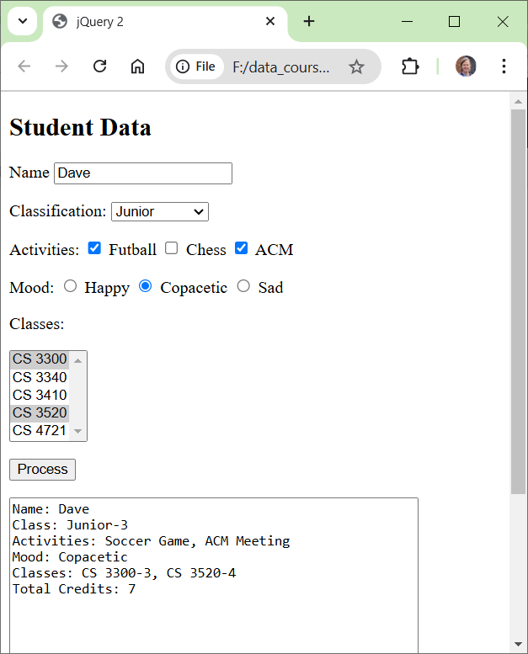
The code on the next page shows the jQuery to process this form. Interspersed with the jQuery is the HTML it is referencing. Of course, the HTML would be in the body; it is interspersed with the jQuery for ease of understanding the jQuery.
$(document).ready(function () {
$("#process").click(function () {

HTML - TextBox
<p>Name <input id="name" class="inVals" type="text" /></p>
jQuery
var name = $("#name").val();

HTML – Dropdown, Single Selection
<select id="classification" class="inVals" name="D1">
<option value="1">Freshman</option>
<option value="2">Sophomore</option>
<option value="3">Junior</option>
<option value="4">Senior</option>
</select>
jQuery
var classificationDesc = $("#classification option:selected").text();
var classificationNum = $("#classification option:selected").val();

HTML - Checkboxes
<p>Activities:
<input name="activities" class="acts" type="checkbox" value="Soccer" />Soccer
<input name="activities" class="acts" type="checkbox" value="Chess" />Chess
<input name="activities" class="acts" type="checkbox" value="ACM" />ACM
</p>
jQuery
var activities = [];
$("input[name='activities']:checked").each(function() {
activities.push($(this).val());
});

HTML - RadioButtons
<p>Mood:
<input name="mood" type="radio" value="Happy" />Happy
<input name="mood" type="radio" value="Copacetic" />Copacetic
<input name="mood" type="radio" value="Sad" />Sad
</p>
jQuery
var mood = $("input[name='mood']:checked").val();

HTML – Dropdown, Multiple Selection
<select size="5" id="classes" multiple="multiple">
<option value="3">CS 3300</option>
<option value="2">CS 3340</option>
<option value="4">CS 3410</option>
<option value="4">CS 3520</option>
<option value="3">CS 4721</option>
</select>
jQuery
var classes = [];
var credits = [];
var totalCredits = 0;
$("#classes option:selected").each(function () {
classes.push($(this).text());
credits.push($(this).val());
totalCredits += parseInt($(this).val());
});

HTML – TextArea
<p><textarea rows="10" id="message" cols="50"></textarea></p>
jQuery
var message = "Name: " + name + "\n";
message += "Class: " + classificationDesc + "-" + classificationNum + "\n";
message += "Activities: ";
for (i = 0; i < activities.length; i++)
message += activities[i] + (i<activities.length-1 ? ", " : "");
message += "\nMood: " + mood + "\n";
message += "Classes: ";
for (i = 0; i < classes.length; i++)
message += classes[i] + "-" + credits[i] + (i < classes.length - 1 ? ", " : "");
message += "\nTotal Credits: " + totalCredits;

$("#message").val(message);
});
});

More Examples
- See jq_ex1.html to illustrate double-click, css, fade
- See jq_styles.html to illustrate add css class, and toggling classes
- See jq_ex2.html to illustrate loading a file from server.

Expectations
- Given a description of a simple client-side dynamic behavior write the HTML and jQuery to implement:
- Use a jQuery selector to select a form element based on id
- Apply jQuery click event
- Use jQuery to process form elements for a simple example.

Appendix
- W3Schools Tutorials
For each tutorial, I have listed the chapters and highlighted in blue are the ones you should read.
jQuery Tutorial

- jQuery HOME – Read carefully
- jQuery Intro – Read carefully
- jQuery Getting Started – Read carefully
- jQuery Syntax – Read carefully
- jQuery Selectors – Read carefully
- jQuery Events – Read carefully though the ready and click events, scan the rest of them if interested.

jQuery Effects Tutorial

- jQuery Hide/Show – Read carefully
- jQuery Fade – Omit
- jQuery Slide – Omit
- jQuery Animate – Omit
- jQuery stop() – Omit
- jQuery Callback – Read carefully
- jQuery Chaining – Scan

jQuery HTML Tutorial

- jQuery Get – Read carefully
- jQuery Set – Read carefully
- jQuery Add – Omit
- jQuery Remove – Omit
- jQuery CSS Classes – Omit
- jQuery css() – Read carefully
- jQuery Dimensions – Omit

jQuery AJAX Tutorial

- jQuery AJAX Intro – Read carefully
- jQuery Load – Read carefully
- jQuery Get/Post – Omit

- Examples of Selectors
jQuery allows a much more flexible way to select elements. For example:
$(“*”) | Selects all elements
$(this) | Selects the current HTML element
$("p.intro") | Selects all <p> elements with class="intro"
$("p:first") | Selects the first <p> element
$("ul li:first") | Selects the first <li> element of the first <ul>
$("ul li:first-child") | Selects the first <li> element of every <ul>
$("[href]") | Selects all elements with an href attribute
$("a[target='_blank']") | Selects all <a> elements with a target attribute value equal to "_blank"
$("a[target!='_blank']") | Selects all <a> elements with a target attribute value NOT equal to "_blank"
$(":button") | Selects all <button> elements and <input> elements of type="button"
$("tr:even") | Selects all even <tr> elements
$("tr:odd") | Selects all odd <tr> elements
A good reference for selecting elements with jQuery is learn.jQuery.
- Events
When the user interacts with a page, we want to change things in response. User interactions fire events which jQuery can respond to.
- http://www.w3schools.com/jquery/jquery_events.asp
- Full list of jQuery events: http://www.w3schools.com/jquery/jquery_ref_events.asp
- Effects
How do we change the HTML?
- http://www.w3schools.com/jquery/jquery_hide_show.asp
- Full list of jQuery effects: http://www.w3schools.com/jquery/jquery_ref_effects.asp
- Examples
Effect | Description
Fading | http://www.w3schools.com/jquery/jquery_fade.asp
Sliding | http://www.w3schools.com/jquery/jquery_slide.asp
animate | http://www.w3schools.com/jquery/jquery_animate.asp
Stop | http://www.w3schools.com/jquery/jquery_stop.asp

- Callback Functions
Some functions take an optional argument which is a callback function. A callback function is executed after an effect is finished.
http://www.w3schools.com/jquery/jquery_callback.asp
- Get and Set Contents
How do we get or set the contents of elements? These methods are useful:
- text() - Sets or returns the text content of selected elements
- html() - Sets or returns the content of selected elements (including HTML markup)
- val() - Sets or returns the value of form fields
Examples:
- get: http://www.w3schools.com/jquery/jquery_dom_get.asp
- set: http://www.w3schools.com/jquery/jquery_dom_set.asp
- Add/Remove Contents
Add/Remove the contents of a tag or tags themselves:
- http://www.w3schools.com/jquery/jquery_dom_add.asp
- http://www.w3schools.com/jquery/jquery_dom_remove.asp
- Manipulating CSS
Add/Remove existing CSS classes or add CSS on the fly:
- http://www.w3schools.com/jquery/jquery_css_classes.asp
- http://www.w3schools.com/jquery/jquery_css.asp
- jQuery HTML/CSS Reference: http://www.w3schools.com/jquery/jquery_ref_html.asp
- References
- jQuery.com: How jQuery Works, jQuery Event Basics and Introduction to Effects.
- jQuery Fundamentals: jQuery Basics, Events & Event Delegation.
- External Examples
- jQuery Examples – Tons of examples
- 12 Examples - Examples of 12 jQuery functions
- jQuery.com/Learning Center - Nicely organized Chapters.

https://api.jquery.com/ready/
https://api.jquery.com/click-shorthand/
https://api.jquery.com/click-shorthand/#click-handler
http://www.w3schools.com/jquery/jquery_selectors.asp

