Java Script Notes

Contents
1 Introduction 1
2 HTML Forms 2
3 Events 3
4 Simple Java Script Example 4
5 Programming the HTML DOM 5
5.1 Browser Object Model 5
5.2 HTML DOM Objects 6
6 Accessing Elements via the DOM 8
6.1 TextBox 8
6.2 Displaying Output 8
6.3 Check Boxes 9
6.4 Radio Buttons 9
6.5 Drop-Down (Single Selection) 10
6.6 Drop-Down (Multiple Selection) 11
7 Expectations 11
Appendix 1 Prerequisite Material 12
Appendix 1.1 HTML Forms 12
Appendix 1.2 JavaScript 12
Appendix 1.3 JavaScript HTML DOM 13
Appendix 1.4 JavaScript Browser BOM 13

Introduction
Java Script (JS):
- Can be used as a procedural language or as object oriented (or both). Here, we will use it procedurally. Later, we will learn some basics about classes and objects.
- It is used on both the client-side and the server-side. We will only use it on the client-side. On the client-side, it runs in the browser. It is estimated that 97% of web pages use JS.
- With JS, you frequently write event-handlers that respond to events on the page (e.g button press). These are simply JS functions.
- It is a way to make a page interactive: update content dynamically, data validation, control multimedia, pop-up menus, etc.
Among other ways, JS can be used in these 3 ways:
- As a stand-alone feature in a web page to provide some functionality, e.g. a monthly payment calculator.
- Data validation, e.g. determining if a number a user entered is an integer between 1 and 10.
- Make a page interactive. Can manipulate HTML elements, e.g. hide or show a paragraph of text, or build a table dynamically, control multimedia, update content dynamically, etc. This is possible because of the HTML DOM (Document Object Model) which we consider a later Section.
The prerequisite material for the following sections are completing these W3School’s tutorials: HTML Forms Tutorial, Java Script Tutorial, JavaScript HTML DOM Tutorial, JavaScript Browser BOM Tutorial. The specific topics are found in the Appendix.

HTML Forms
There is a bit more to forms but below will be sufficient.
<form id="studentForm">
<p>
<label for="username">TextBox:</label>
<input id="username" class="username" type="text" />
</p>
<p>
<label for="classification">DropDown:</label>
<select id="classification" class="inVals">
<option value="1">Freshman</option>
<option value="2">Sophomore</option>
</select>
</p>
<p><label>CheckBoxes:</label>
<input name="activities" class="acts" type="checkbox" id="c1" value="Soccer" />
<label for="c1">Soccer</label>
</p>
<p><label>RadioButtons:</label>
<input name="mood" type="radio" id="r1" value="Happy" />
<label for="r1">Happy</label>
</p>
<p><label>RadioButtons:</label>
<input name="mood" type="radio" value="Happy" />Happy
<input name="mood" type="radio" value="Copacetic" />Copacetic
<input name="mood" type="radio" value="Sad" />Sad
</p>
<p><p><label for="classes">DropDownMultiple:</label></p>
<select size="5" id="classes" multiple>
<option value="3">CS 3300</option>
<option value="2">CS 3340</option>
<option value="3">CS 4721</option>
</select>
</p>
<p><label for="process">Button:</label>
<button type="button" id="process" onclick="processInput()">Process</button></p>
<p><p><label for="message">TextArea:</label></p>
<textarea id="message" rows="10" cols="50"></textarea>
</p>
</form>

Similar...
<button type="button" id="process" onclick="processInput()">Process</button>
<input type="button" value="Process" />
<input type="submit" value="Process" />

Events
Form elements can fire events. For instance, when a user clicks on a button, an event is fired. An event is handled by an event handler, which is usually a call to a JS function.
Example, a button might be defined like this:
<input type="button" value="Enter" id="btnCalc" onclick="helloWorld()">
The onClick attributes specifies the event handler. In this case, it is a call to the helloWorld JS function which resides in the head section of the HTML:
function helloWorld() {
window.alert("Hello World");
}
The available events are shown below (copied from W3Schools). The most common ones have been highlighted. We will only use the onclick event.
Attribute | The event occurs when...
onblur | An element loses focus
onchange | The content of a field changes
onclick | Mouse clicks an object
ondblclick | Mouse double-clicks an object
onerror | An error occurs when loading a document or an image
onfocus | An element gets focus
onkeydown | A keyboard key is pressed
onkeypress | A keyboard key is pressed or held down
onkeyup | A keyboard key is released
onload | A page or image is finished loading
onmousedown | A mouse button is pressed
onmousemove | The mouse is moved
onmouseout | The mouse is moved off an element
onmouseover | The mouse is moved over an element
onmouseup | A mouse button is released
onresize | A window or frame is resized
onselect | Text is selected
onunload | The user exits the page

Simple Java Script Example
Consider the Hello World page below where the user supplies a name, presses the button, and a message is displayed using the name. The page itself is below.
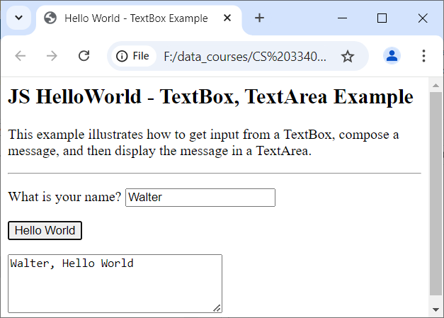
<head>
<script type="text/javascript">
function helloWorld() {
var txtName = document.getElementById("txtName");
var message = txtName.value + ", " + "Hello World"
alert(message);
var txaResult = document.getElementById("txaMessage");
txaResult.value = message;
txtName.value = null;
txtName.focus();
}
</script>
</head>
<body>
<form id="hello">
<p>
<label for="txtName">What is your name?</label>
<input id="txtName" type="text" />
</p>
<p><input type="button" onclick="helloWorld()" value="Hello World"></p>
<p><textarea id="txaMessage" rows="4" cols="30"></textarea></p>
</form>

</body>

Note:
- The button has an onclick attribute (event) which is specified to call the helloWorld() JS function.
- We can get a reference to any HTML element with a unique Id by using: document.getElementById(...)
- The .value property is used to get or set what is displayed in any form control
- The .focus() method returns focus to a control

Programming the HTML DOM
This is an introduction to HTML DOM (document object model) programming and briefly the HTML BOM (browser object model). The DOM (and BOM) are API’s that provide JavaScript (JS) code access to all HTML elements on a webpage. For example, we can access the values a user types in (or selects), process them, and then display output.

Browser Object Model
Practically anything you could want to know about a web page is available in HTML BOM (Browser Object Model). An instance of each of these classes is available in any webpage. We will use the methods shown in red. The class diagram is not complete. There are many more properties and methods for each class. Reference:
https://www.w3schools.com/js/js_window.asp
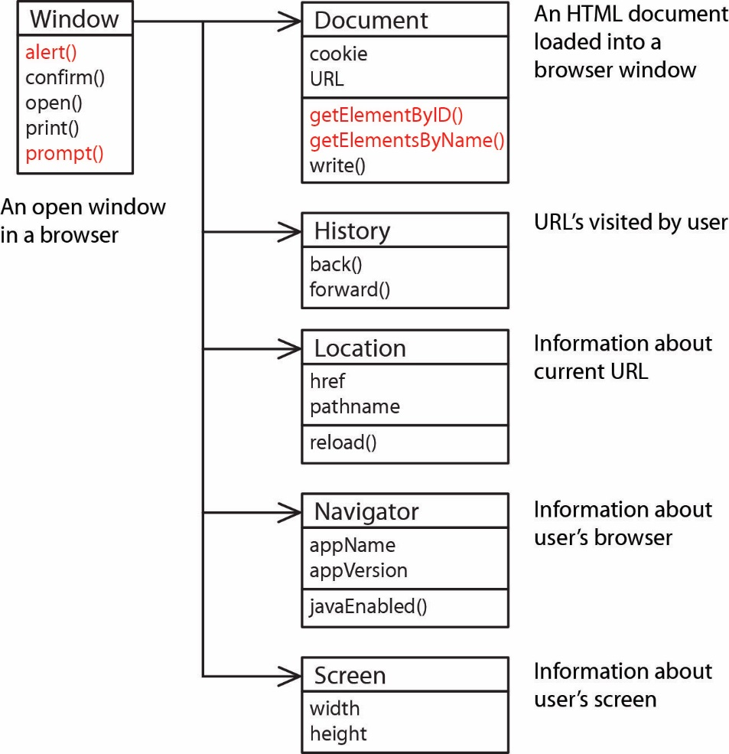
In the example in Section 2, we used the alert() method, e.g.
alert("Hello World");
However, we could have written this:
window.alert("Hello World");
Thus, we see that JS is pretty loose about some things: e.g. the window object is available in any page and since there is only one alert method, JS knows what to do. Similarly, we used this to obtain a reference to the textbox with the id “name”:
var txbName = document.getElementById("name");
Note that the line above gave a reference to the textbox itself. The line below shows that we use the textbox’s value property to obtain the value that was typed in. This will be explained a bit more later.
var name = txtName.value;
And, we could have used window to precede document, but usually don’t.
var txbName = window.document.getElementById("name");

HTML DOM Objects
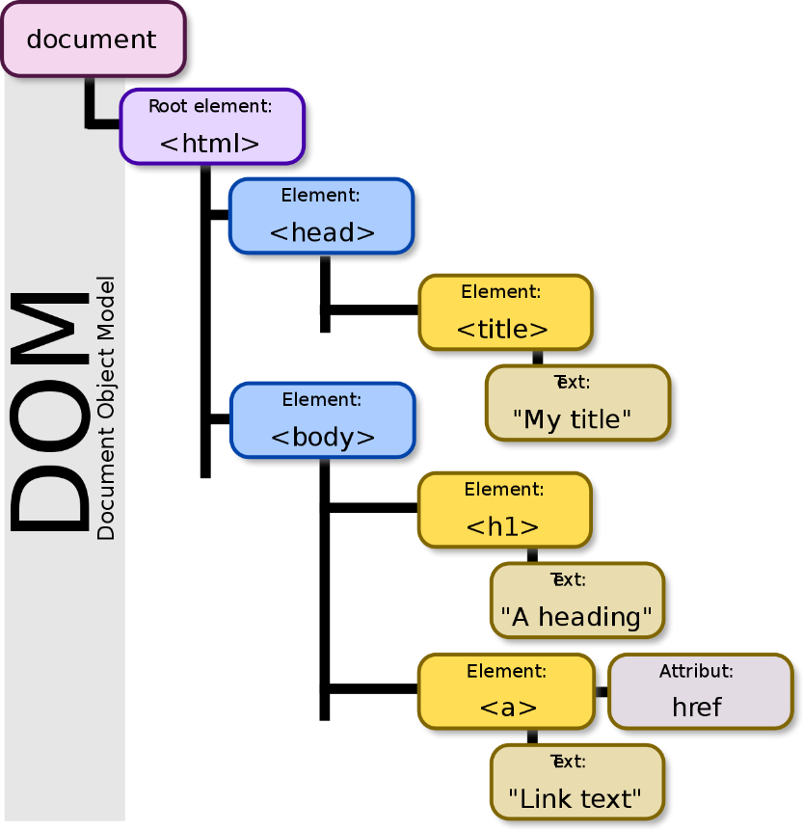
The Document Object Model (DOM) is an API for accessing, changing, and manipulating all aspects of an HTML (or XML) document. The DOM represents an HTML page as a tree. Each branch of the tree ends in an HTML element, elements can contain elements, and elements can contain attributes and text.
When an HTML page is rendered, the browser creates a DOM object which is an object-oriented representation of the page. Each element on the page has properties, methods, and events. Here, we are interested mostly in the form controls (button, text box, text area, check box, radio button, drop down); however, we will also access paragraphs, divs, and table cells. An abbreviated (somewhat generalized) class diagram is shown below:

You can see a visualization of the DOM for a page on this site: https://bioub.github.io/dom-visualizer/. You can also turn on the Developer Tools (select the 3 vertical dots in upper-right of Chrome, choose: More Tools, Developer Tools and select the Elements tab. Right-click an element on the page and choose: Inspect.

By Birger Eriksson - Own work, CC BY-SA 3.0, https://commons.wikimedia.org/w/index.php?curid=18034500
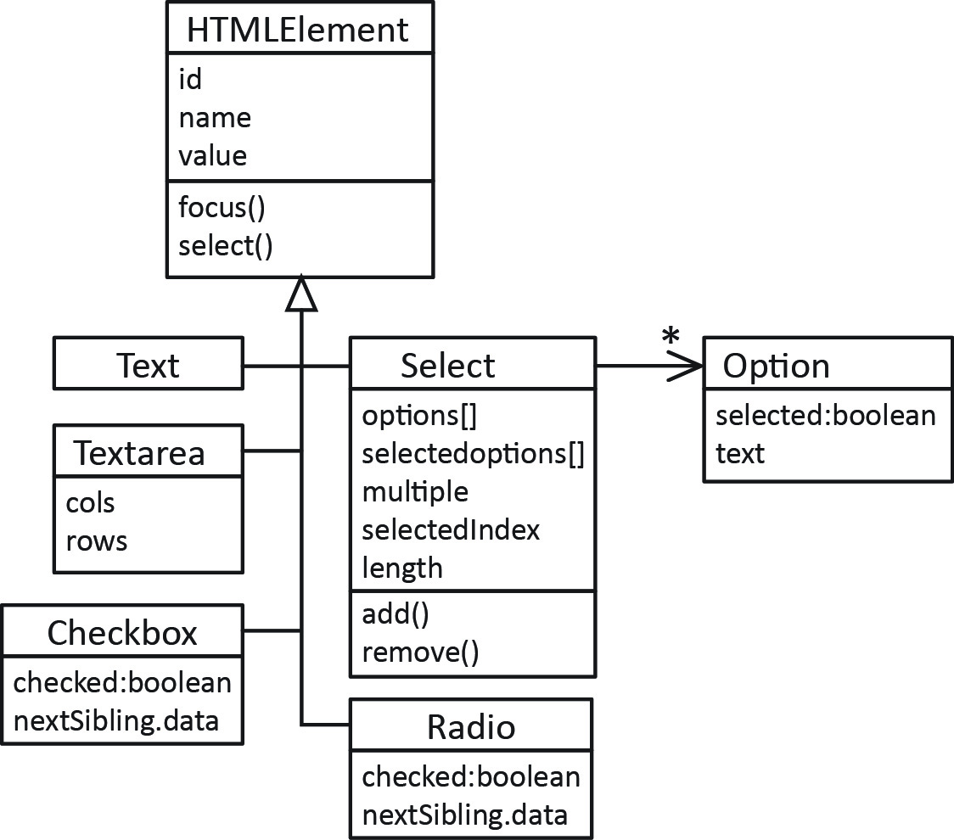
Note:
- We see that all the classes share a number of common properties and methods (every object has an id, name, and value, etc.).
- Each of these classes corresponds to an HTML tag. For instance, input type=text is represented by the Text class; however, I have used simplified names, not the actual class names.
- A fuller class diagram, with the actual interface names is shown below.

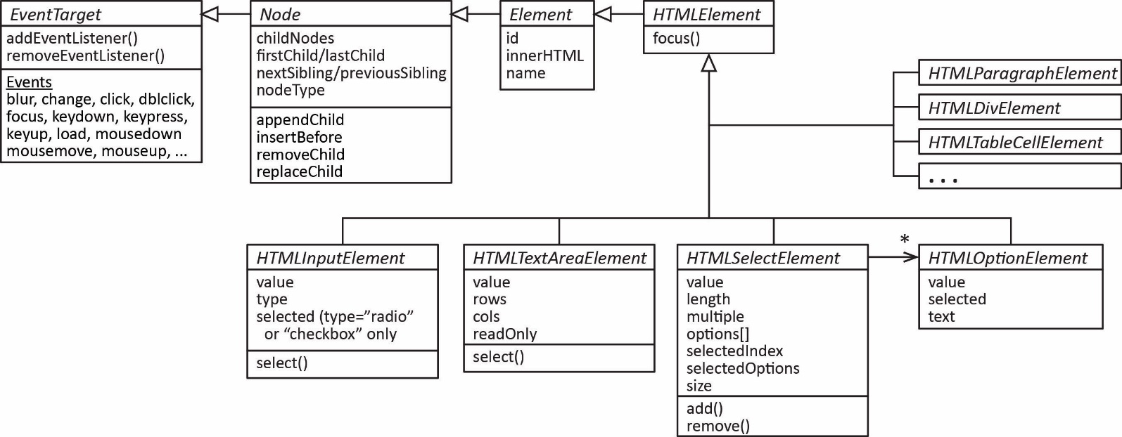
An excellent reference for the DOM:
https://developer.mozilla.org/en-US/docs/Web/API/Document_Object_Model
An excellent high-level discussion of the DOM:
https://web.stanford.edu/class/cs98si/slides/the-document-object-model.html
When you use the DOM to change a page (e.g. hide a paragraph), your source code on the browser does not change; however, the DOM itself is changed. We won’t actually be doing things like this. You can verify this by viewing the page’s source. does not change, just the DOM. In other words, after you execute JS that changes an element, for example hides a paragraph, and view the page source, it is the same as it was when the page first loaded. Internally, the DOM is changed, though. Can right-click element, and choose: Inspect to see.

Accessing Elements via the DOM

TextBox
The first question to address is where do we get the references for the objects in the DOM? The most common way is to use the getElementById method in the Document class. Every element should have a unique Id. v
Example: An HTML text box is defined:
<input type="text" id="txtName">
Then, in JS, we could obtain a reference to the textbox:
var tbox = document.getElementById("txtName");
Then, we could access the value typed in:
var name = tbox.value;
Or, we could set text into the textbox:
tbox.value = "what is your name?";
Or we could set the focus and select the text in a text box:
tbox.focus();
tbox.select();

Displaying Output
Consider the HTML and JS snippets shown below. Suppose we have a string variable, msg. The JS shows how we can display that in a TextArea, paragraph, div, and table.
HTML | JavaScript
<textarea id="txaResult"></textarea>  <p id="pResult"></p>  <div id="divResult"></div>  <table border="1">  <tr>  <td id="tdResult1"></td>  <td id="tdResult2"></td>  </tr>  </table> | // Display in TextArea  document.getElementById("txaResult").value = msg;  // Display in paragraph  document.getElementById("pResult").innerText = msg;  // Display in div  document.getElementById("divResult").innerText = msg;  // Display in table  document.getElementById("tdResult1").innerHTML =  "<b>" + msg + "</b>";  document.getElementById("tdResult2").innerText = msg;
Note:
Property | Description
.value | property used to get or set the value in a form controls (e.g. input(type=”text”), textarea, select, & others.).
.innerText | Get or set the text content of tags that are not form controls. For example: p, div, td.  document.getElementById("pMessage").innerText = message;
.innerHTML | Get or set the HTML content of tags that are not form controls. For example: p, div, td. In the example above, we could have used:  document.getElementById("pMessage").innerHTML = message;  We could have supplied some HTML as well as the message:  document.getElementById("pMessage").innerHTML = "<b>"+message+"</b>";
(There is also a .textContent property that is similar to .innerText except that it preserves spacing and CSS hidden text. Scroll down to see an example).
We can also use the alert function to display a string in a popup and the console.log method to display a string to the console. For example:
alert("msg=" + msg); console.log("msg=" + msg);

Check Boxes
Often, it is more convenient to process check boxes as a group. For instance, we may have check boxes where a user can select any number of deserts they want:
<input type="checkbox" name="chkDesert" value="1.25"/>Ice Cream ($1.25)<br>
<input type="checkbox" name="chkDesert" value="2.50"/>Apple Pie ($2.50)<br>
<input type="checkbox" name="chkDesert" value="0.75"/>Cookies ($0.75)<br>
Notice that the check boxes all have the same name attribute. This is convenient because we can now access them as an array of check boxes using the getElementsByName(name) method.
var chkDes = document.getElementsByName("chkDesert");
And, a general-purpose loop to process all the check boxes:
for (i=0; i<chkDes.length; i++) {
if ( chkDes[i].checked ) {
// Do something useful with chkDes[i].value
}
}
To access the text associated with the checkbox, see the code examples that are provided.

Radio Buttons
Radio buttons are similar:
<input type="radio" value="1.00" name="optDrink" id="d1"/>Soda ($1.00)<br>
<input type="radio" value="2.00" name="optDrink" id="d2"/>Beer ($2.00)<br>
<input type="radio" value="0.75" name="optDrink" id="d3"/>Coffee ($0.75)
Notice again that the radio buttons all have the same name attribute. Now, we access them as an array of radio buttons in JS:
var optD = document.getElementsByName("optDrink");
And, a general-purpose loop to process all the radio buttons:
for (i=0; i<optD.length; i++) {
if ( optD[i].checked ) {
// Do something useful with optD[i].value
break;
}
}
To access the text associated with the radio buttons, see the code examples that are provided.

Drop-Down (Single Selection)
A drop-down (single selection) for a user to select an interest rate might be defined like this:
<select size="1" id="ddIntRate">
<option value="0.040">4.00%</option>
<option value="0.045">4.50%</option>
<option value="0.050">5.00%</option>
</select>
To access the drop down:
var dd = document.getElementById("ddIntRate");
We can access the value of the selected item directly by using the value property:
alert(dd.value);
We can also obtain the index of the item that is selected by using the selectedIndex property (zero-based):
alert(dd.selectedIndex);
The Select class has an options array. Thus, an alternate way to obtain the value of the selected item is:
alert(dd.options[dd.selectedIndex].value);
Similarly, we can drill down into the options collection to see the individual items:
alert(dd.options[dd.selectedIndex].selected);
alert(dd.options[dd.selectedIndex].text);
alert(dd.options[dd.selectedIndex].value);
Due to a feature in JS, we can write the code above, shorter, as shown below. The two sets are equivalent. Essentially, treating the object reference as an array itself automatically drills down into the options collection. In .NET languages this is called an indexer. I’m not sure what it is called in JS.
alert(dd[dd.selectedIndex].selected);
alert(dd[dd.selectedIndex].text);
alert(dd[dd.selectedIndex].value);

Drop-Down (Multiple Selection)
A drop-down (multiple selection) for a user to select multiple food items might be defined like this:
<select size="4" id="ddFood" multiple>
<option value="3.25">Hamburger ($3.25)</option>
<option value="2.75">Tofo Burger ($2.75)</option>
<option value="1.00">Soda ($1.00)</option>
<option value="2.00">Beer ($2.00)</option>
<option value="4.00">Wings ($4.00)</option>
<option value="0.50">Cookie ($0.50)</option>
</select>
And, to access the drop down:
var dd = document.getElementById("ddFood");
And, a general-purpose loop to process all the selections:
for( i=0; i<dd.length; i++ ) {
if ( dd.options[i].selected ) {
// Do something useful with dd.options[i].value
}
}
There is a selectedoptions property that contains just the selected options. Thus,
for(i=0; i<dd.selectedoptions.length; i++ ) {
selOption = dd.selectedoptions[i]
// Do something useful with selOption.value, etc
}

Expectations
These are expectations I have of you for testing:
- Given a description of client-side dynamic behavior write the HTML and JavaScript to implement it. An abbreviated version of the HTML DOM is provided.
- Apply the onclick event and write a corresponding event handler.
- Write code to obtain input from form elements (text box, text area, drop-down, check boxes, radio buttons)
- Display output to a form element, div, paragraph, text area etc.

Appendix
- Prerequisite Material
  - HTML Forms
Study the highlighted sections from W3School’s HTML Forms Tutorial:
- HTML Forms – Read carefully.
- HTML Form Attributes – Read carefully the first 3 topics: The Action Attribute, The Target Attribute, The Method Attribute
- HTML Form Elements – Read carefully. Omit from, “The <fieldset> and <legend> Elements” down.
- HTML Input Types – Read carefully. Omit from, “Input Type Color” down.
- HTML Input Attributes – Scan.
- HTML Input Form Attributes – Omit
  - JavaScript
Study the highlighted sections from W3School’s Java Script Tutorial:
- JS HOME – Read carefully  - JS Introduction – Read carefully  - JS Where To – Read carefully  - JS Output – Read carefully  - JS Statements – Scan  - JS Syntax – Read carefully  - JS Comments – Scan  - JS Variables – Scan  - JS Operators – Scan  - JS Arithmetic – Scan  - JS Assignment - Scan  - JS Data Types – Scan  - JS Functions – Read carefully  - JS Objects – Omit  - JS Events – Read carefully  - JS Strings – Scan  - JS String Methods – Scan  - JS Numbers – Scan  - JS Number Methods – Scan  - JS Arrays – Read carefully. Omit: “Adding Array Elements”, “Associative Arrays?” and everything below “The Difference Between Arrays and Objects”  - JS Array Methods – Scan  - JS Array Sort – Scan  - Js Array Iteration – Scan, this shows newer ways, we will use syntax similar to java  - JS Dates – Omit  - JS Date Formats - Omit  - JS Date Get Methods – Omit  - JS Date Set Methods – Omit | - JS Array Methods – Omit  - JS Math – Scan  - JS Random - Omit  - JS Booleans – Scan  - JS Comparisons – Scan  - JS Conditions – Scan  - JS Switch – Scan  - JS Loop For – Scan  - JS Loop While – Scan  - JS Break – Scan  - JS Type Conversion – Omit  - JS Bitwise – Omit  - JS RegExp – Omit  - JS Errors – Omit  - JS Scope – Read carefully  - JS Hoisting – Omit  - JS Strict Mode – Omit  - JS this Keyword – OmitJS Let – Omit  - JS Const - Omit  - JS Debugging – Omit  - JS Style Guide – Scan  - JS Best Practices – Omit  - JS Mistakes – Omit  - JS Performance – Omit  - JS Reserved Words – Omit  - JS Versions – Omit  - JS Versions ES5 – Omit  - JS Versions ES6 - Omit  - JS JSON – Omit.

  - JavaScript HTML DOM
Study the highlighted sections from W3School’s JavaScript HTML DOM Tutorial:
- DOM Intro – Read carefully
- DOM Methods – Read carefully
- DOM Document – Read carefully. Omit “Adding and Deleting Elements” and “Finding HTML Objects”.
- DOM Elements – Read carefully. Omit last two sections starting with, “Finding HTML Elements by CSS Selectors .”
- DOM HTML – Read carefully.
- DOM CSS – Read carefully only the second section, “Using Events”
- DOM Animations – Omit
- DOM Events – Read carefully
- DOM EventListener – Useful, interesting, and powerful, but you can omit.
- DOM Navigation – Omit
- DOM Nodes – Omit
- DOM Collections - Omit
- DOM Node Lists – Omit
  - JavaScript Browser BOM
Study the highlighted sections from W3School’s JavaScript Browser BOM Tutorial:
- JS Window – Read carefully two sections only. Scan from, “Window Size” and below
- JS Screen – Omit
- JS Location – Omit
- JS History – Omit
- JS Navigator – Omit
- JS Popup Alert – Read carefully
- JS Timing – Omit
- JS Cookies – Omit

