VS Code Resources
Contents
1 Getting Started 1
2 Notes 1
Appendix 1 n/a 3

This is homework. There is nothing to turn in

Getting Started
Do the following:
- Download and install VSCode.
- Watch this video, Getting started with Visual Studio Code – 7 minutes. Shows JS, HTML, Python. Good.

Notes
- To view an HTML page you have written in a browser, try either of these two approaches:
  - In VSCode, open the page you want to display and choose: Run, Run Without Debugging. If this doesn’t work, the next approach will work.
  - Navigate to your HTML file on your hard drive, try one of these 3 approaches:
  - Double-click the file you want to display. This will open the page in a browser IF you have the html file extension registered with a browser.
  - IF NOT, try, right-click the file name (on your hard drive) and choose: Open With and choose your browser.
  - Copy the path to your workspace and paste it into a browser’s URL field. It will display the contents of the folder and you can choose the file you want to display.
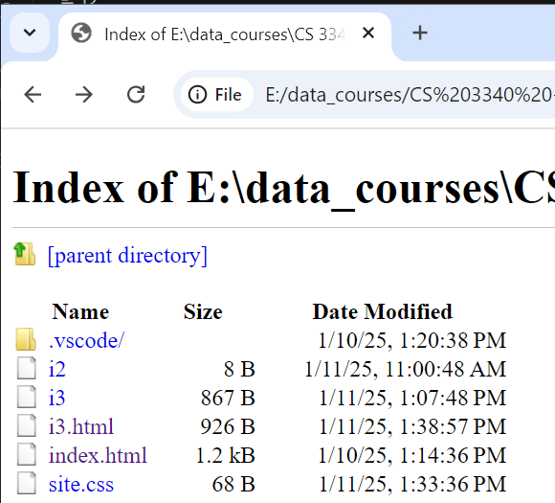

  - It is better to run your code on localhost (a server running on your computer). Some things will not work correctly if not. One was to do this is to install the “Live Server” extension in VS Code.

[copied from Google AI Search. Worked for me.]
The Live Server extension by Ritwick Dey is the easiest way to launch a local development server with live reload functionality, meaning your browser automatically refreshes when you save changes to your files.
Steps
- Install the Extension: Open the Extensions view by clicking the square icon on the left sidebar (or press Ctrl+Shift+X) and search for "Live Server". Install the one by Ritwick Dey.
- Open your Project Folder: Go to File > Open Folder... and select your project's root directory.
- Launch the Server: You have a few options to start the server:
  - Click the "Go Live" button that appears in the bottom-right corner of the VS Code status bar.
  - Right-click on your index.html file in the Explorer and select "Open with Live Server".
  - Open the Command Palette (F1 or Ctrl+Shift+P), type Live Server: Open With Live Server, and press Enter.

This will automatically open your default web browser to http://localhost:5500 (or another port) and serve your files.

Appendix
- n/a

