HW 1 – Problem 7

Contents
7 Problem 7– Responsive Design 1
Appendix 1 Code 2

Problem 7– Responsive Design
You have been provided a page that renders as shown below.
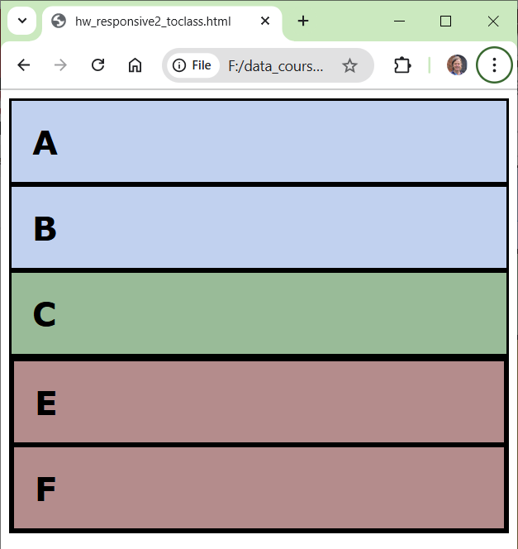
You will modify the CSS so that it looks like this on a screen with width greater than 800px:
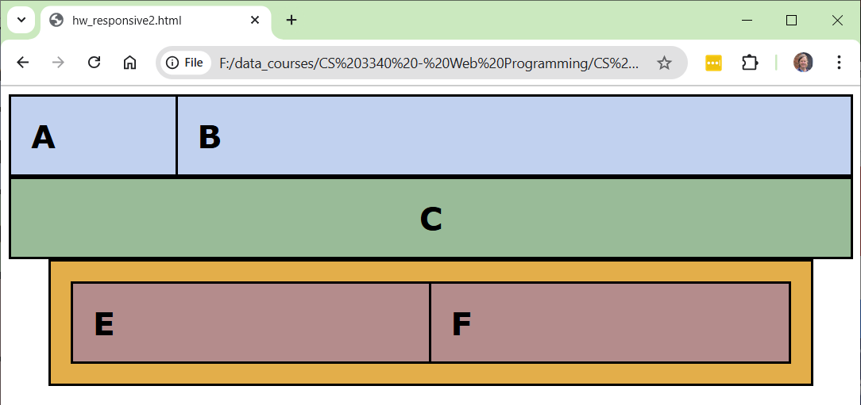
And renders like this when the screen is less than 800px:
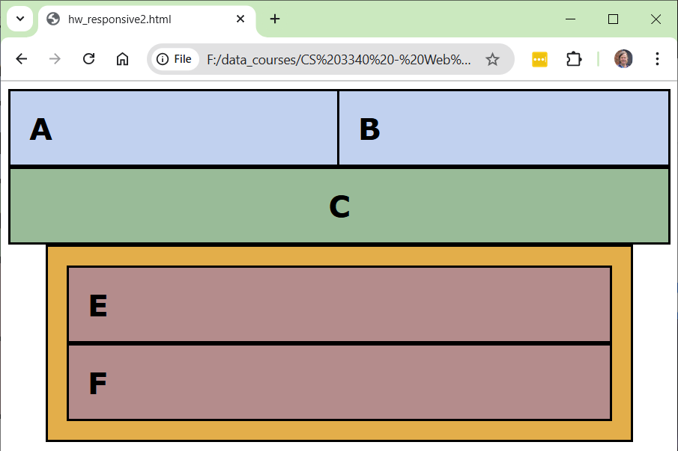
- Create a page, responsive.html.
- Copy the code in the Appendix in to responsive.html.
- Add to style rules to the (internal) CSS selectors that are provided. These are the properties I used:
float, margin, margin-right, pad, text-align, width
Note: You should not need to add any selectors, nor any more HTML.
- Code

<!DOCTYPE html>
<html>
<head>
<meta name="viewport" content="width=device-width, initial-scale=1.0">
<style>
/*---
Should not have to modify these 4 style definitions
---*/
* { box-sizing: border-box; }
body { font-family:Verdana; }
h1 { margin: 20px; }
div { padding:0px; margin: 0px; border-style: solid; }
/*---
Add rules to any of the selectors below to achieve the displays (viewport size dependent)
specified on the homework document
---*/
.divA {
background-color:#c1d1ef;
}
.divB {
background-color:#c1d1ef;
}
.divC {
background-color:#99bb98;
}
.divD {
background-color:#e3ae4a;
}

.divE {
background-color:#b48c8c;
}
.divF {
background-color:#b48c8c;
}
@media only screen and (max-width:800px) {
.divA {

}
.divE {

}
}
</style>
</head>

<body>
<div class="divA">
<h1>A</h1>
</div>
<div class="divB">
<h1>B</h1>
</div>

<div class="divC">
<h1>C</h1>
</div>

<div class="divD">
<div class="divE">
<h1>E</h1>
</div>
<div class="divF">
<h1>F</h1>
</div>
</div>
</body>
</html>

