HW 1 – Problems 5 & 6

Contents
1 Problem 5 – XML 1
2 Problem 6 – JSON 1

Problem 5 – XML
For this problem:
- Create a well-formed XML file for something that interests you and name this file, myxml.xml. The root should have at least 3 child elements.
- Modify the “Problem 5” link on default.html to link to this page.

Problem 6 – JSON
For this problem, choose an option
Option 1
- Create a page, json.html that reads this jSON from GitHub. The page should have these features:
  - (80%) The display should be similar to the one below.
  - (5%) Utilize CSS on the page. This should not be the CSS from the code that was provided. You should do something different – be creative!
  - (15%) Utilize a button(s) or some other feature so that the user can toggle between the display as shown below and a simpler display, with the same header, but only showing the member names in a list.
Notes:
- Your code must use the link to the raw page:
https://raw.githubusercontent.com/drgap/json_example/main/company.json
- Your code should work with any number of members (there are 3 in the test JSON file provided).
- Modify the “Problem 6” link on default.html to link to this page.
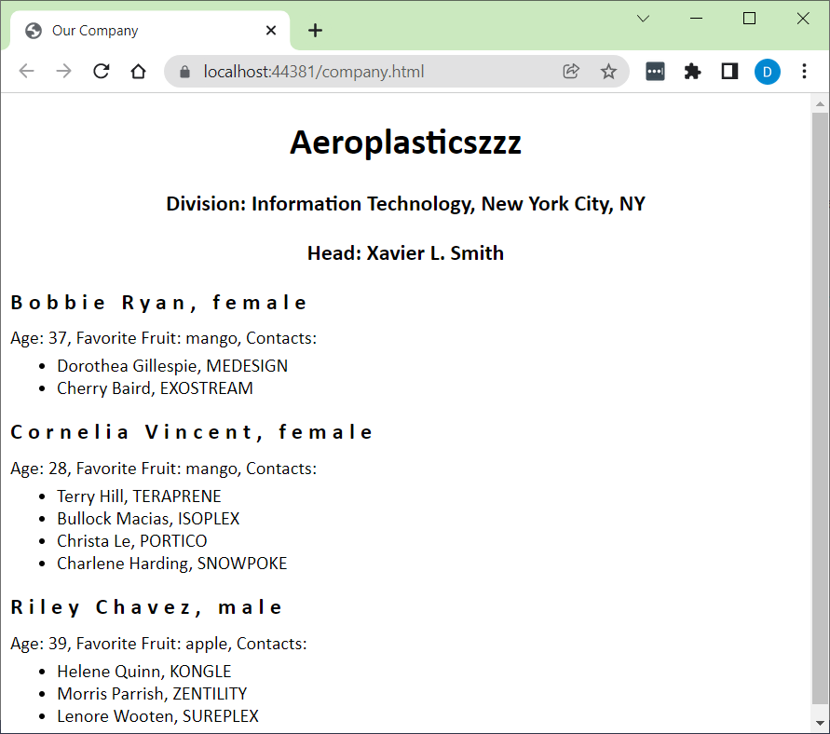
Option 2
You can use any JSON API! Here are several:
https://github.com/marcelscruz/public-apis?tab=readme-ov-file – Scroll down in Readme
https://rickandmortyapi.com/
https://www.omdbapi.com/ - Online movie database
https://swapi.dev/ - Starwars
https://freeapis.juheapi.com/apis

