HW 1, Problem 3

Problem 3 – Java Script
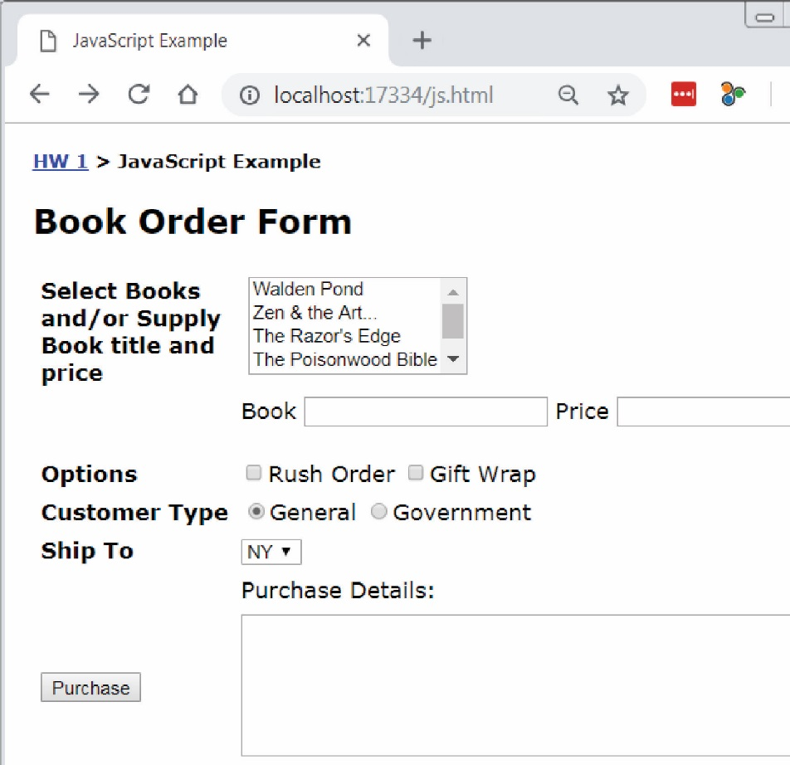
Write a web page named: javascript.html.
- Modify the “Problem 3” link on default.html to link to this page (javascript.html).
- The page should appear similar to what is shown on the right.
- Ignore the bread crumbs: “HW 1 > JavaScript Example”. You do not need this on your page.
- The easiest approach is to use a table to organize the input portion of the page. 2 columns are all that is needed. You are allowed to use a more advanced approach.
- All code must be written in JavaScript (not jQuery).
- The multi-select box must display these exact 5 books with the corresponding prices:
  - Walden Pond ($20)
  - Zen and the Art…($15)
  - The Razor’s Edge ($8)
  - The Poisonwood Bible ($15)
  - Wuthering Heights ($10)
- The user can select multiple books from the drop down.
- The user can optionally supply a book with a title and price in the textboxes.
- A rush order is $10 and gift wrapping is $5.
- A general customer receives no discount and is the default. A government customer receives a 10% discount on the entire purchase.
- The dropdown lists these exact three states and the corresponding price to ship to that state:
- NY ($5)
- CA ($7)
- SC ($3)
- All prices must be stored in the value attribute of the HTML tags. No prices should be hard-coded.

- When the purchase button is pressed the complete order is neatly displayed along with the total price. For example:
Example 1 |  | Example 2
Order  ----------------------  $15.00 – Zen and the Art…  $15.00 – The Poisonwood Bible  General Customer  $10.00 – Rush order  $3.00 – Ship to SC  ----------------------  Total: $43.00 |  | Order  ----------------------  $15.00 – Zen and the Art…  $15.00 – The Poisonwood Bible  $25.00 – On the Road (user specified)  Government Customer  $10.00 – Rush order  $5.00 – Gift wrap  $3.00 – Ship to SC  ----------------------  Sub Total: $73.00  Discount (10%): $7.30  Total: $65.70
- Each time the user presses the purchase button, a fresh calculation is done based on whatever is supplied, selected, etc. In other words, if the user supplies the data in Example 1 and presses Purchase, then the result is as shown above. Then, if they change from “General Customer” to “Government Customer”, add “Gift wrap”, and add a custom book, then the correct total should be displayed. Your code will do this correctly as long as you do not use any global variables.

