HW 1, Problem 1

Contents
0 Overview 1
1 Problem 1 – HTML 1

Overview
There are 8 problems in this assignment. In total, this assignment is 20% of your final grade. You may use AI to generate code; however, keep in mind that you will be tested on material from Problems 1-6 (handwritten). Only Problem 1 is described in this document.
HW 1 | Weight | Description
Problem 1 | 9% | HTML – Default page has links to all the other problems. About page has information about yourself. Page2 is in a subfolder and has links back to the Default page and the About page.
Problem 2 | 9% | CSS Example – Provide 5 examples using 5 different CSS selectors.
Problem 3 | 17% | JS Example – Book Order
Problem 4 | 13% | jQuery Example – Book Order
Problem 5 | 2% | XML Example
Problem 6 | 13% | JSON Example
Problem 7 | 13% | Responsive Design - float
Problem 8 | 13% | Responsive Design – Grid & Flexbox
Problem 9 | 13% | Bootstrap – Add Bootstrap to Problem 4
Total | 100%

Problem 1 – HTML
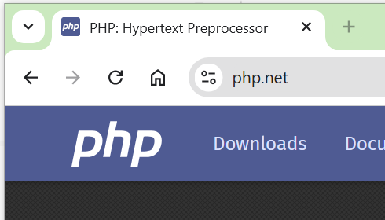
Create a VS Code workspace with the name: hw1_lastName.
Write these web pages:
- default.html –
  - Has a title that appears in the browser tab. For example, in the image on the right, the title is, “PHP: Hypertext Preprocessor”.
  - Has a header with your name.
  - Below the header there is a row with 8 links: Problem 1, Problem 2, …, Problem 8. The “Problem 1” link links to a page named: about.html (described next). The other links link to the subsequent problems in this HW and will be describe as you go along. Be sure to come back to this and supply the links as you work on subsequent problems.
- about.html –
  - In the top left of this page, provide a link, “Home” that returns to default.html.
  - Beside the “Home” link, provide a link, “Page 2” that links to a page, page2.html (described below) located in a subfolder named: info.
  - This page provides information about yourself (anything at all, for example, any/all/ or none of these: interests, hobbies, computing interests, career hopes, etc.)
  - You must use all of these tags: title, p, table (with headers, td, and using rowspan or colspan), a, ul, ol. You can use other tags.
- page2.html –
  - This page is located in a subfolder named, info. In other words, the file structure is:
hw1_lastname // folder
default.html
about.html
info // folder
page2.html
  - In the top left of this page, provide a link, “Home” that returns to default.html.
  - Beside the “Home” link, provide a link, “Back” that links back to about.html.

